??? ???? ?? ??-?????? ?? ????? ????? ?????
????? ?????? ?? ????? ???? ?????, ?? ?? ??? ?????? ???????
???? ???? | 14 ????? 2026
???? ???? | ????? ?????, ??????? ???, ?????? ??? ?????? ???? ???
???? ??? ???? | ?? 20 ??????; ??? ????? ???????
Car Search Agent - prototype report

????? ??????
?????? ??-????? ??????????? ?????? ????? ???? ?????, ????? ??? ????? ?????? (NLU), ????? ?????, ????? ????, ????? ?????? ????? ??? ??? ?????. ?????? ????? ?? ?? ?????? ????, ?? ??? ????? ??????, ??? ????? ?????? ????? ?? ???????? ????? ??????.
- NLU ???? ???? ????? ??? ??????: Precision=1.000, Recall=1.000, F1=1.000.
- ??????, baseline ????? ?-P@5 (0.425) ??? smart (0.200), ?? smart ???? ?? NDCG ???? (0.673).
- ????? ??? rerank ????? ?-P@5 ?? 0.175, ?? ?????? ?? ?????? ?? ??? ??????.
- ????? ????? ???????, ???????? ???? ???????? ????, ??? ???? ?????.

??? ?????????
????? ????? ??? ????? ??? ?????? ?? ???? ?? ?????? ??? ?????: ?????, ??? ???? ???????, ??? ???, ???? ?????, ????? ??????, ?????? ???? ?? ????? ???? ????. ??? ????? ???? ????? ?? ????? ?? ????? ??? ???? ?? ??????? ????? ??????.
????????? ????? ????? ????? ?????-?????? ?????? ????? ??? ?? ???? ?????? ???? ??????, ?? ????? ?????? ????? ????? ????? ????? ?????.

?????? ??????
??-?????? ???? ????? ????? ???????: ????? ?????? ??????, ????? ??????, ????? ??????, ????? ??????. ?? ?????? ????? ????? ??????? ?????? (???? ???? ???????, ???, ???? ??????) ?????? ?????? ???? (???? ???????, ???????, ??????? ?? ????? ???????).
- ????? ?????? ?????? ???? ???? CSV ??? ?? 505 ??????.
- ????? ?????? ????? ????? ???? ????? ??? parser ????? ?????.
- ????? ????? ?? ?? ?????, ??????? ????? ??? constraints ?????? ?????? ??????.
- ???? ?????? ?? ????, ???? ??? ????? ???? ???????.

?????? ????? ?????
?????? ???? ?? ???? ?????? ???? ?????? ?? ?????, ??? ?? ????? ???? ????????. ?? ????? ????? ???? ????? ??????, ???? ?? ???? ??????? ??????? ????? ??? ?????? ????? ?? ??????.
1. ????? ???????, ????? ??????? ?????? ??????? ?-feature extraction.
2. ????? ?????? ????? ????? ?? ???? ???????.
3. ????? parser ???????? ??????/?????? ?????? constraints ?-soft preferences.
4. ????? ???????? ????? ???? ??? ??? ?????.

????? ?????
????? ?????? ????? ?? ????? ?????: NLU, retrieval ?-ablation/???? ????. ????? ?????? ???? ??? ????? ???? ???? ?? ????? ??????? ????????. ????? ???? ????? Precision@5, Recall@5 ?-NDCG@5. ????? ?????? ????? ?????? ?? ???? semantic ??? ???? rerank.
- NLU: ????? ???? slots ??? expected_constraints.
- Retrieval: ????? P@5, R@5 ?-NDCG@5 ?? benchmark ?? 8 ???????.
- Ablation: ????? ?? ??? ??? semantic ??? ??? ??? rerank.
- Timing: ????? ??? ???? ?????, ????? ?????? ??????.

?????? ???????
??? | ???
NLU Precision | 1.000
NLU Recall | 1.000
NLU F1 | 1.000
Smart P@5 | 0.200
Baseline P@5 | 0.425
Smart NDCG@5 | 0.673
Baseline NDCG@5 | 0.673
No rerank P@5 | 0.175
??????? ??? ??-NLU ?? ??-?????? ??? ???? ??? ?????? ???????, ??? ??? ?????? ????? ???? ??????. baseline ???? ???? ????? ????? Precision@5 ???? ????, ???? ?????? ???? ??? ?? ????? ????? ???? ?????? NDCG.
?????? ??? ????, ????? ????? ????? ???? ??-baseline ?????, ?? ????? ?????? ???-????? ????? ??????????. ?????? ??? ??????? ??? ????? ??? ????, ??? ?? ???? ??????? ???? ?? ????? ??????.

?????? ????? ?????
- ???-????? ???? ????? ???: ?????? -> ???? -> ????? -> ????? -> ???? -> ?????.
- ???? ??? ???? ???? ?? smart ranking ??????? ?????? ??????, ????? ??????? ???? ???? ??? benchmark ???? ????.
- ????? ????? ?????, ???? ???? ?? ????? ??? ?? ???? ??? ?????? ?? ??????????? ?????.

???? A: ?????? ??? ?? ??-??????
???????? ????? ?????? ?? ?????? ??????. ?? ????? ???? ????? ????? ??? ?????? ?? ?? ?? ??????? ??? ?? ?? ??????.
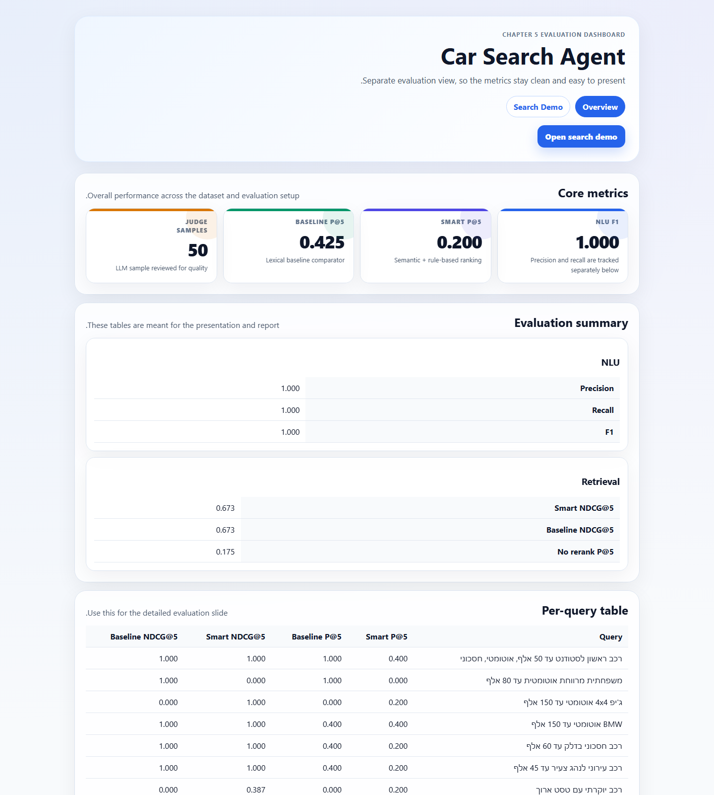
???? A1. ?? ??????? ?????: ???????, ?????? ?????, ablation ????? ????.
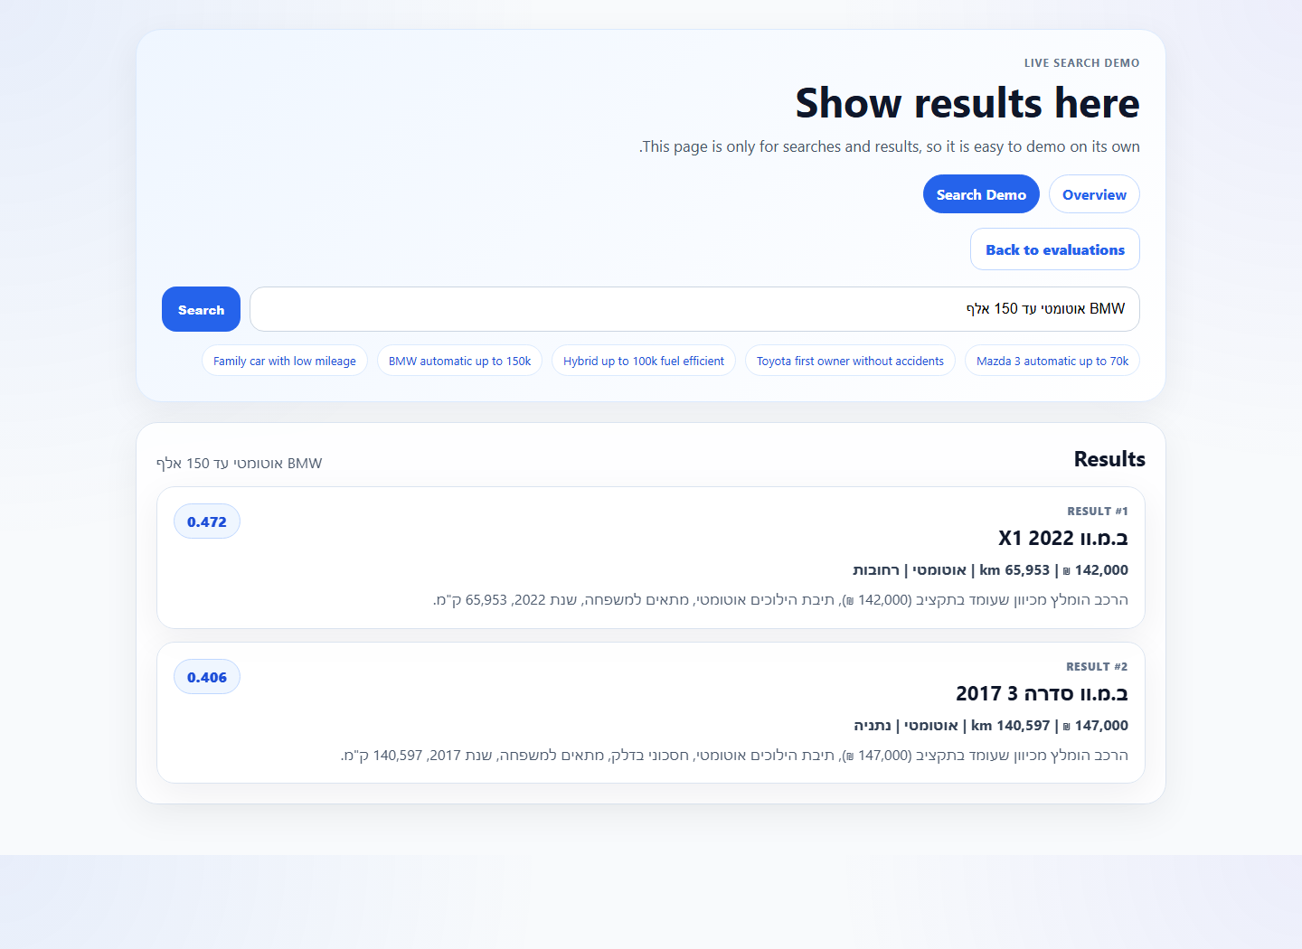
???? A2. ?? ????: ?????? ?????? ?? ?????? ??????? ??????? ?????.

???? B: ?????? ?????? ???????
??????? ????? ?????? ?? ?? ??????? ?-benchmark ??? ?????? ?-ablation ??-timing ??????. ?? ???? ????? ?? ????? ??????? ??? ?????? ?? ??? ????.
???? B1. ?????? ??????? ??? ?????? ??? ??????.
?????? | Smart P@5 | Baseline P@5 | Smart NDCG@5 | Baseline NDCG@5
רכב ראשון לסטודנט עד 50 אלף, אוטומטי, חסכוני | 0.400 | 1.000 | 1.000 | 1.000
משפחתית מרווחת אוטומטית עד 80 אלף | 0.000 | 1.000 | 0.000 | 1.000
ג'יפ 4x4 אוטומטי עד 150 אלף | 0.200 | 0.000 | 1.000 | 0.000
BMW אוטומטי עד 150 אלף | 0.400 | 0.400 | 1.000 | 1.000
רכב חסכוני בדלק עד 60 אלף | 0.200 | 0.400 | 1.000 | 1.000
רכב עירוני לנהג צעיר עד 45 אלף | 0.200 | 0.400 | 1.000 | 1.000
רכב יוקרתי עם טסט ארוך | 0.200 | 0.000 | 0.387 | 0.000
רכב יד ראשונה ללא תאונות | 0.000 | 0.200 | 0.000 | 0.387

???? B2. ?????? ablation ????? ???? ???????.
Variant | P@5 / mean | Recall / median | NDCG / peak
No semantic | 0.425 | 0.750 | 0.673
No rerank | 0.175 | 0.625 | 0.530
Smart timing | 31.66 ms | 30.50 ms | 140.6 KB
Baseline timing | 2.86 ms | 2.57 ms | 14.3 KB

???? B3. ????? ???? ?-LLM judge.
Metric | Value
Sampled pairs | 50
Score 0 | 33
Score 1 | 17

???? C: ????? ???? ???
??? ??????, ?? ???? ????? ?????? ??? ??? ????? ?-2 ????. ????? ?? ?? ???? ????? ?????? ???, ???? ????? ???? ?????? ???? ?????? ??? ?????? ??????:
- ????? ?????? ???? (2 ????): [?????? ??? ????? ?-Drive / YouTube / ???????? ????? ????]
?????? ??? ?????? ??? ??? ?????: ???? ??????, ???? ??? ?? ??????? ??? ????, ????? ????? ??? ?? ????? ?? ????? ????.

