|  |  |
| --- | --- |
| Dataset name: | FordA |

|  |  |
| --- | --- |
| OL algo | KNN, RF, Naïve Bayes, ANN |
| OFS algo | AI, OSFS, F-OSFS, SAOLA |
| Window size | 100,200 |

Accuracy per window size:

W/O:

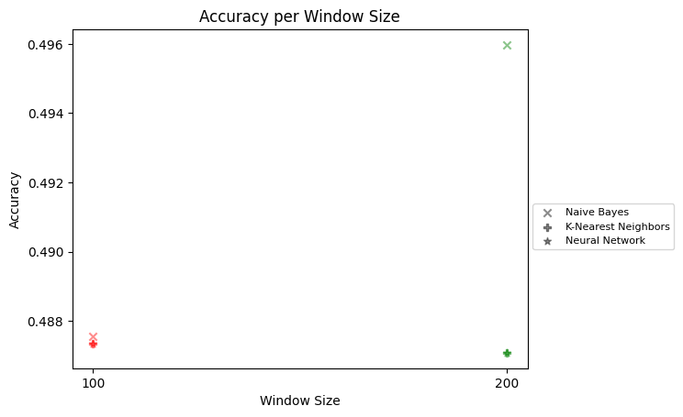

AI:



OSFS:

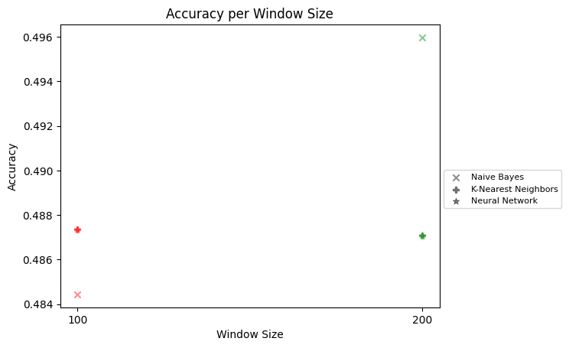

F-OSFS:

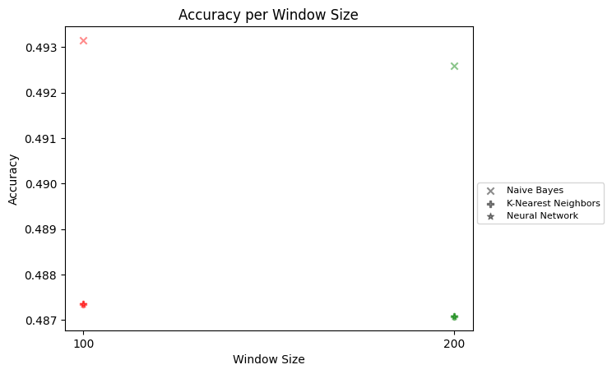

SAOLA:

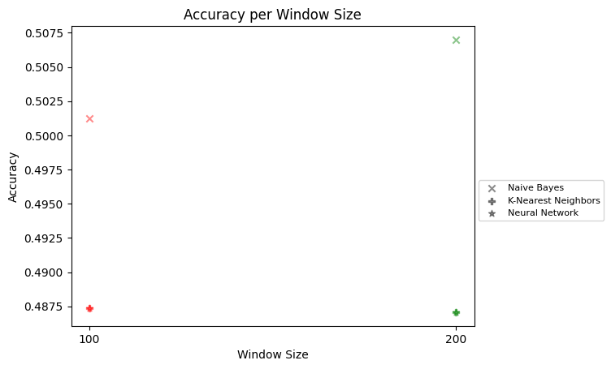

Mean runtime (ms) for OFS algo:

|  |  |
| --- | --- |
| SAOLA | 520.2689666666658 |
| Alpha Investing | 1032.5714666666663 |
| OSFS | 1533.9393666666629 |
| Fast OSFS | 847.1284499999996 |

Mean runtime (ms) for OL algo:

|  |  |
| --- | --- |
| Neural Network | 1.570100000001684 |
| K-Nearest Neighbors (k=3) | 7.662487499998871 |
| K-Nearest Neighbors (k=5) | 7.662487499998871 |
| Naive Bayes | 3.379575000000301 |
| Random Forest | 3.379575000000301 |