|  |  |
| --- | --- |
| Experiment params: | |
| OL algorithm: | K-Nearest Neighbors 3({'n_neighbors': 3, 'max_window_size': 300}) |
| OFS algorithm: | -(None) |
| Window size: | 300 |
| Mean OL algorithm runtime: | 22.269800000000117 ms |
| Mean OFS algorithm runtime: | nan ms |
| accuracy: | 0.5057413879181228 |
| Selected features | [] |

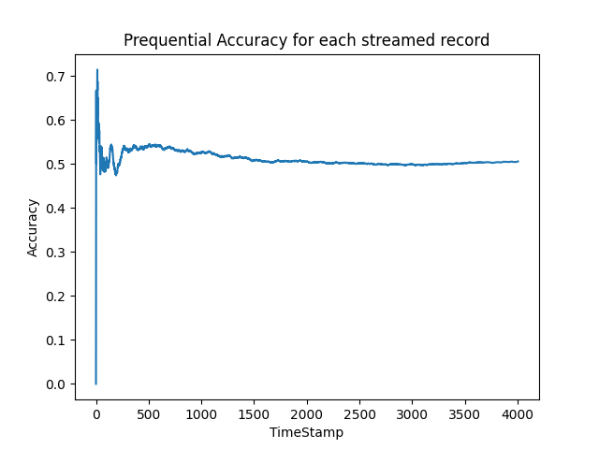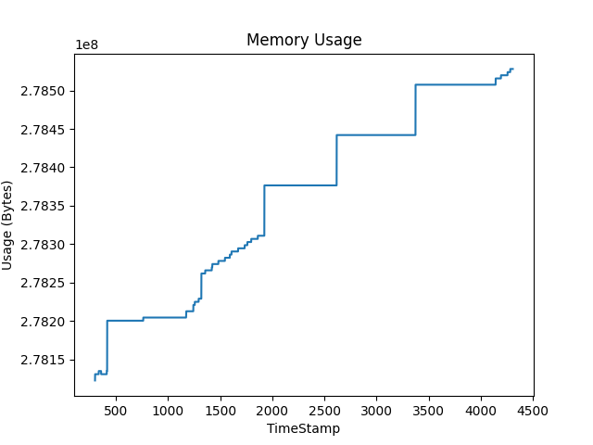

|  |  |
| --- | --- |
| Experiment params: | |
| OL algorithm: | K-Nearest Neighbors 5({'n_neighbors': 5, 'max_window_size': 300}) |
| OFS algorithm: | -(None) |
| Window size: | 300 |
| Mean OL algorithm runtime: | 19.36709999999664 ms |
| Mean OFS algorithm runtime: | nan ms |
| accuracy: | 0.4965052421367948 |
| Selected features | [] |

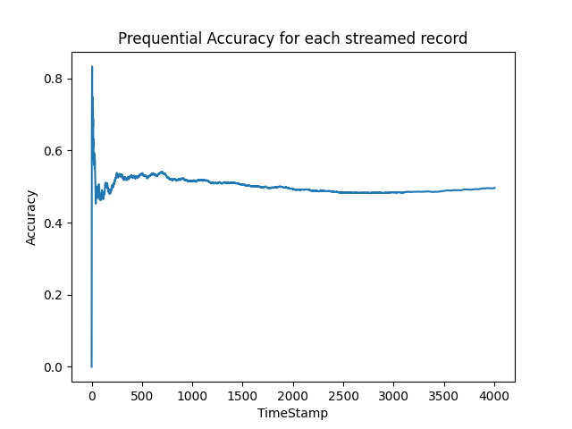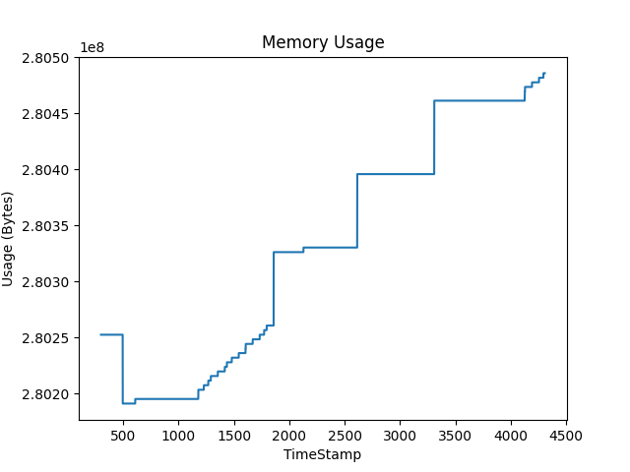

|  |  |
| --- | --- |
| Experiment params: | |
| OL algorithm: | Naive Bayes({}) |
| OFS algorithm: | -(None) |
| Window size: | 300 |
| Mean OL algorithm runtime: | 280.6215000000094 ms |
| Mean OFS algorithm runtime: | nan ms |
| accuracy: | 0.38816774837743384 |
| Selected features | [] |

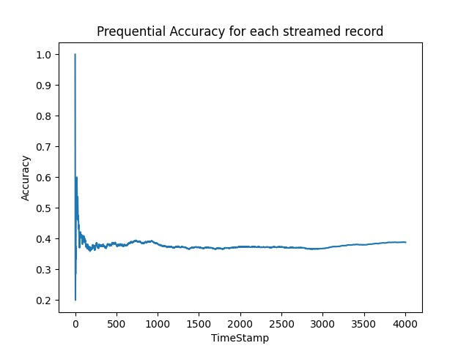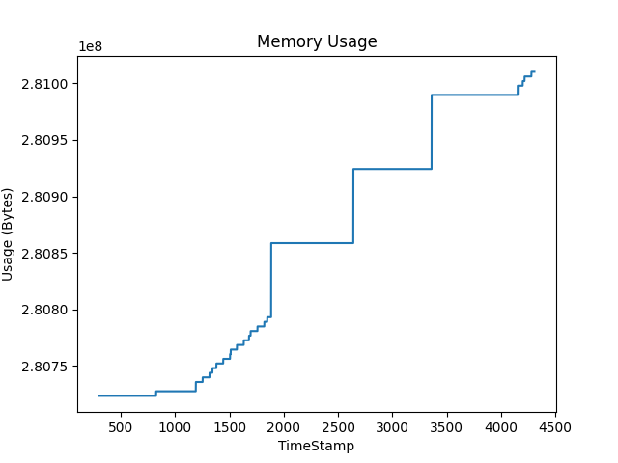

|  |  |
| --- | --- |
| Experiment params: | |
| OL algorithm: | Neural Network({}) |
| OFS algorithm: | -(None) |
| Window size: | 300 |
| Mean OL algorithm runtime: | 24.65829999999869 ms |
| Mean OFS algorithm runtime: | nan ms |
| accuracy: | 0.5606590114827759 |
| Selected features | [] |

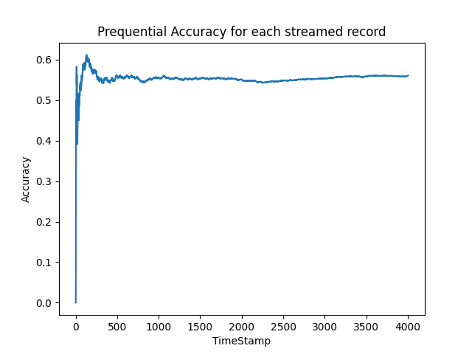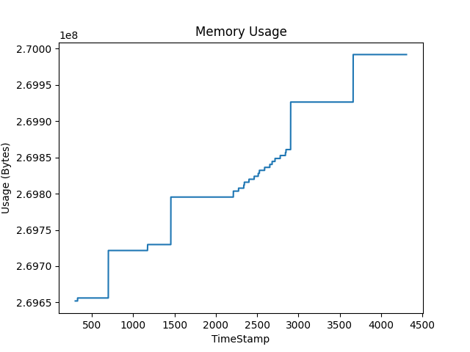

|  |  |
| --- | --- |
| Experiment params: | |
| OL algorithm: | Random Forest({}) |
| OFS algorithm: | -(None) |
| Window size: | 300 |
| Mean OL algorithm runtime: | 22337.155600000016 ms |
| Mean OFS algorithm runtime: | nan ms |
| accuracy: | 0.5344483275087369 |
| Selected features | [] |

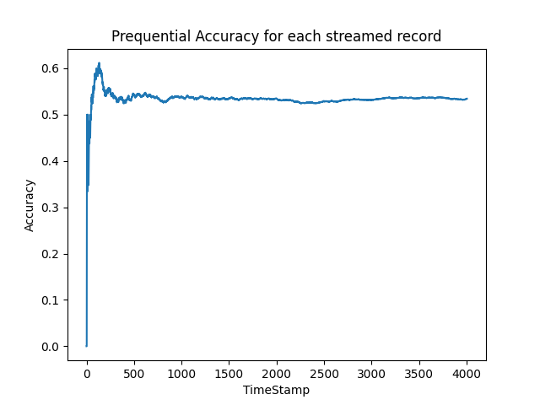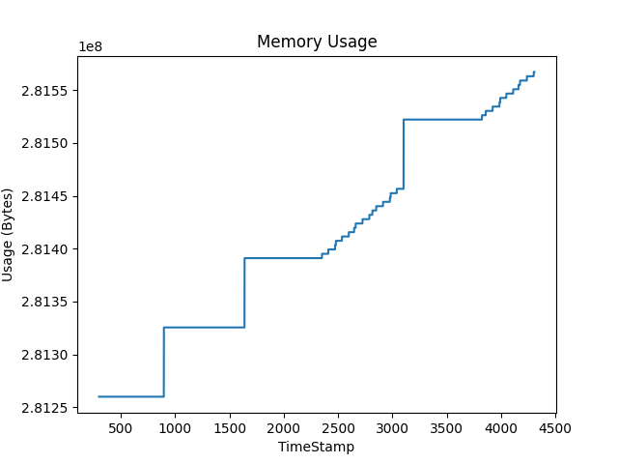

|  |  |
| --- | --- |
| Experiment params: | |
| OL algorithm: | K-Nearest Neighbors 3({'n_neighbors': 3, 'max_window_size': 300}) |
| OFS algorithm: | Alpha Investing({'alpha': 0.05, 'dw': 0.05}) |
| Window size: | 300 |
| Mean OL algorithm runtime: | 11.280499999998028 ms |
| Mean OFS algorithm runtime: | 376.8529999999828 ms |
| accuracy: | 0.4028956565152272 |
| Selected features | [[0]] |

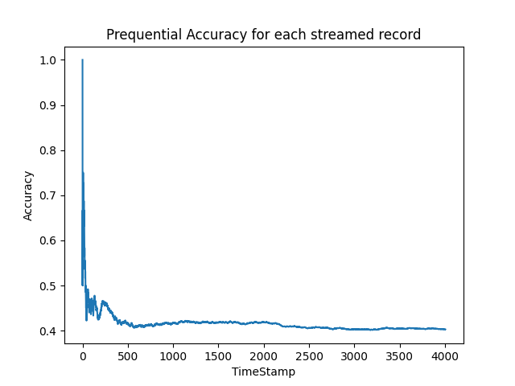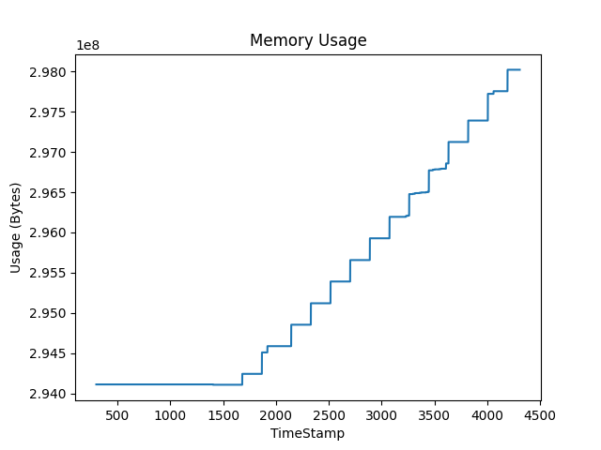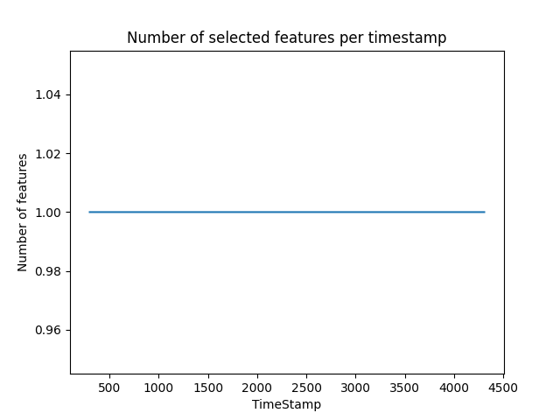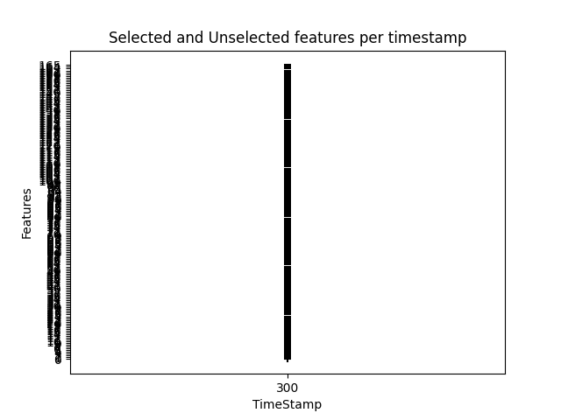

|  |  |
| --- | --- |
| Experiment params: | |
| OL algorithm: | K-Nearest Neighbors 5({'n_neighbors': 5, 'max_window_size': 300}) |
| OFS algorithm: | Alpha Investing({'alpha': 0.05, 'dw': 0.05}) |
| Window size: | 300 |
| Mean OL algorithm runtime: | 13.195999999993546 ms |
| Mean OFS algorithm runtime: | 423.27779999999393 ms |
| accuracy: | 0.4056415376934598 |
| Selected features | [[0]] |

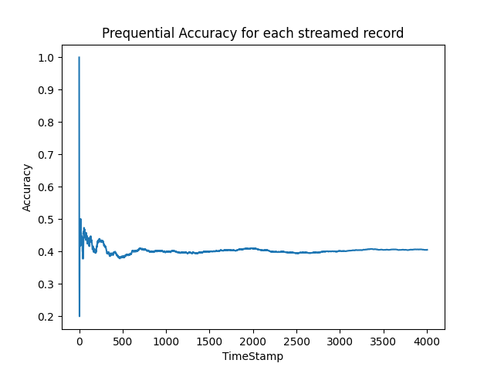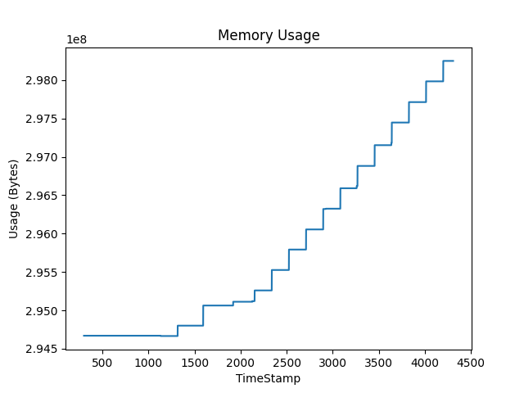

|  |  |
| --- | --- |
| Experiment params: | |
| OL algorithm: | Naive Bayes({}) |
| OFS algorithm: | Alpha Investing({'alpha': 0.05, 'dw': 0.05}) |
| Window size: | 300 |
| Mean OL algorithm runtime: | 2.7359999999987394 ms |
| Mean OFS algorithm runtime: | 410.51840000000084 ms |
| accuracy: | 0.545681477783325 |
| Selected features | [[0]] |

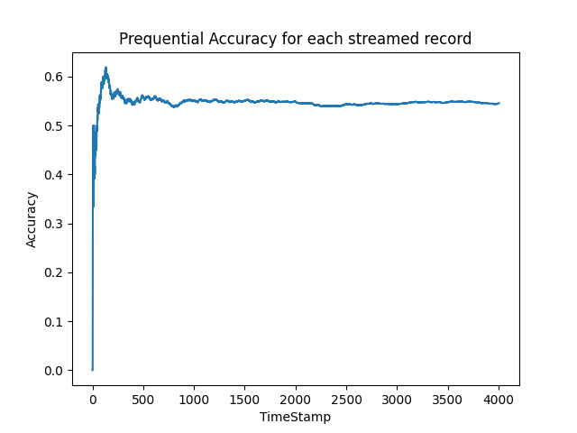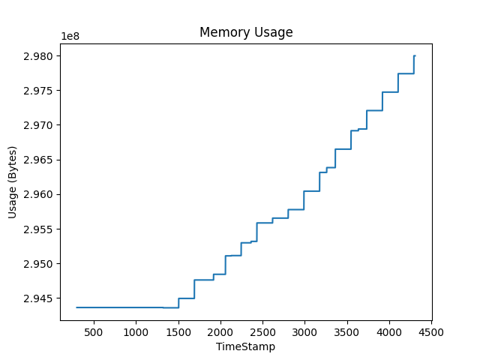

|  |  |
| --- | --- |
| Experiment params: | |
| OL algorithm: | Neural Network({}) |
| OFS algorithm: | Alpha Investing({'alpha': 0.05, 'dw': 0.05}) |
| Window size: | 300 |
| Mean OL algorithm runtime: | 3.9808999999877415 ms |
| Mean OFS algorithm runtime: | 402.8342000000009 ms |
| accuracy: | 0.2271592611083375 |
| Selected features | [[0]] |

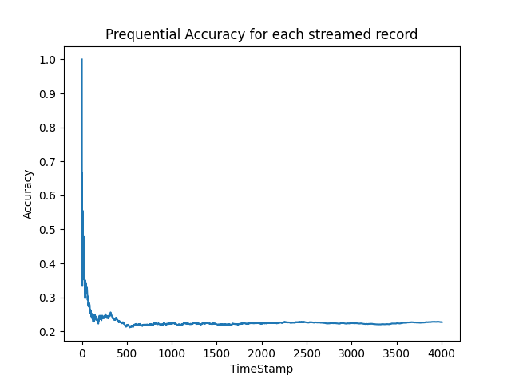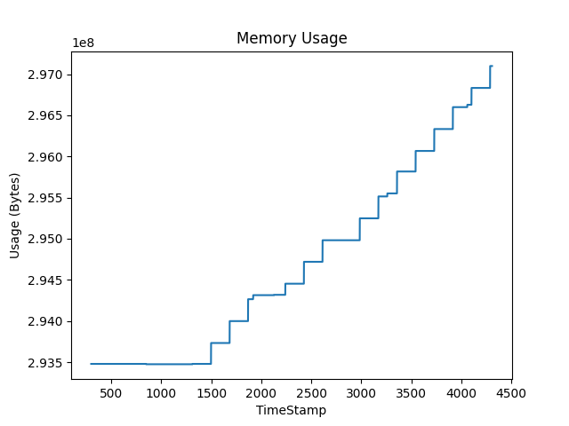

|  |  |
| --- | --- |
| Experiment params: | |
| OL algorithm: | Random Forest({}) |
| OFS algorithm: | Alpha Investing({'alpha': 0.05, 'dw': 0.05}) |
| Window size: | 300 |
| Mean OL algorithm runtime: | 3134.9723000000154 ms |
| Mean OFS algorithm runtime: | 403.6037000000192 ms |
| accuracy: | 0.44083874188716926 |
| Selected features | [[0]] |

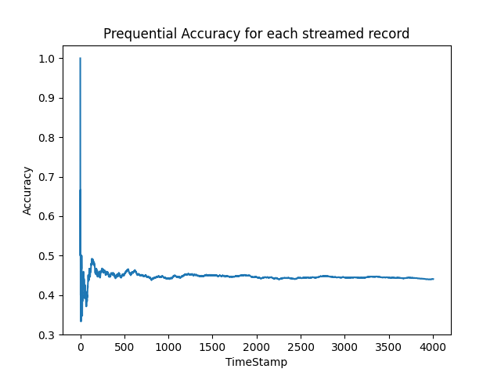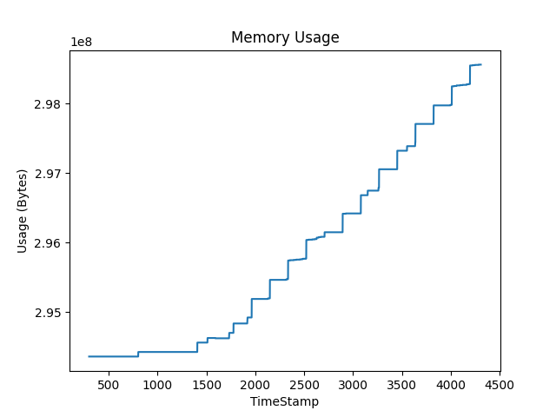

|  |  |
| --- | --- |
| Experiment params: | |
| OL algorithm: | K-Nearest Neighbors 3({'n_neighbors': 3, 'max_window_size': 300}) |
| OFS algorithm: | Fast OSFS({'alpha': 0.05, 'fast': True}) |
| Window size: | 300 |
| Mean OL algorithm runtime: | 13.089799999988827 ms |
| Mean OFS algorithm runtime: | 499.0705999999818 ms |
| accuracy: | 0.5264603095356964 |
| Selected features | [[144, 43, 135]] |

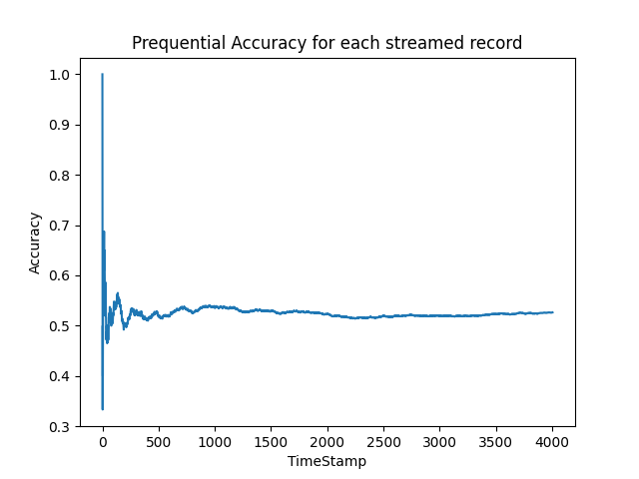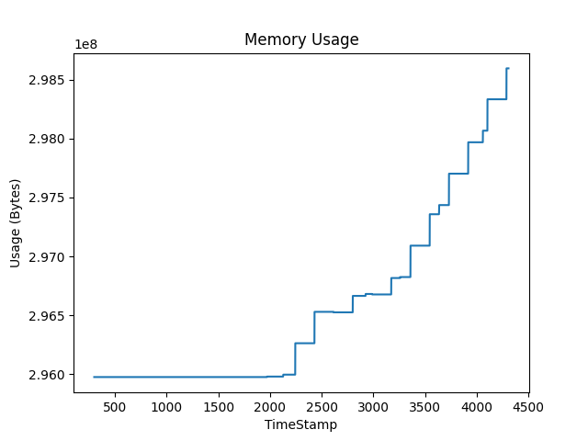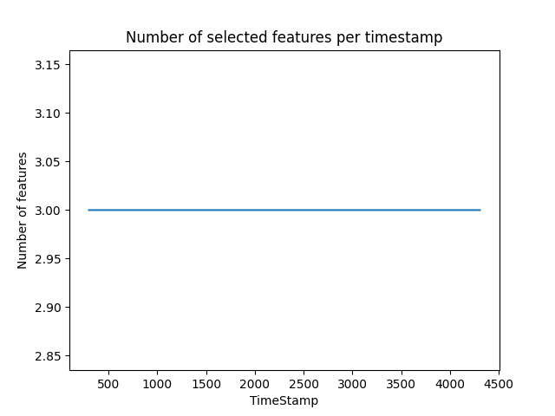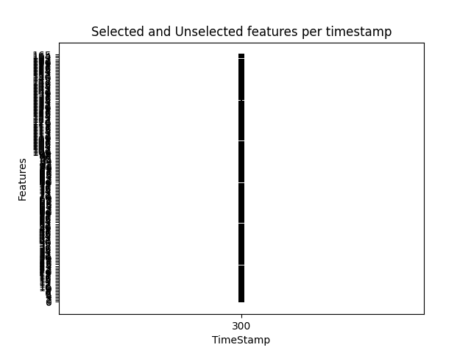

|  |  |
| --- | --- |
| Experiment params: | |
| OL algorithm: | K-Nearest Neighbors 5({'n_neighbors': 5, 'max_window_size': 300}) |
| OFS algorithm: | Fast OSFS({'alpha': 0.05, 'fast': True}) |
| Window size: | 300 |
| Mean OL algorithm runtime: | 24.45829999999205 ms |
| Mean OFS algorithm runtime: | 476.8627000000265 ms |
| accuracy: | 0.5084872690963554 |
| Selected features | [[144, 43, 135]] |

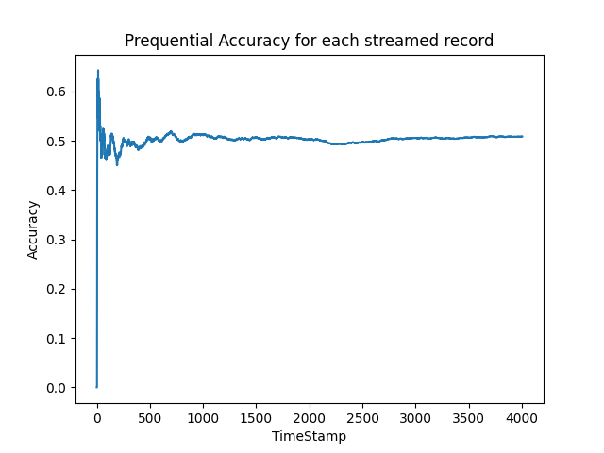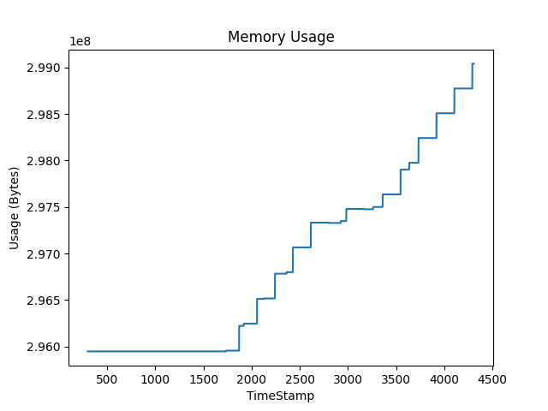

|  |  |
| --- | --- |
| Experiment params: | |
| OL algorithm: | Naive Bayes({}) |
| OFS algorithm: | Fast OSFS({'alpha': 0.05, 'fast': True}) |
| Window size: | 300 |
| Mean OL algorithm runtime: | 7.005200000037348 ms |
| Mean OFS algorithm runtime: | 485.6123999999795 ms |
| accuracy: | 0.5536694957563655 |
| Selected features | [[144, 43, 135]] |

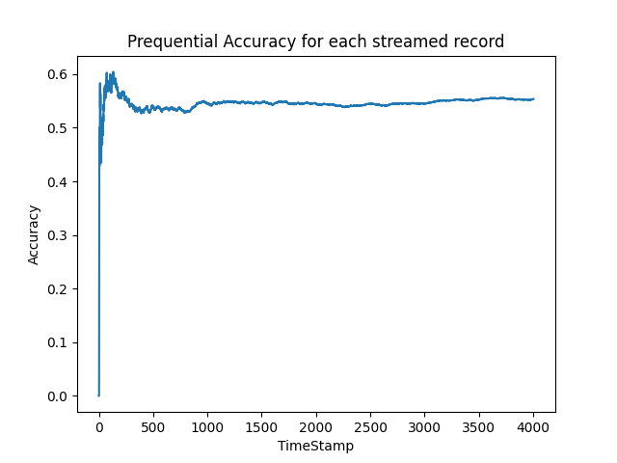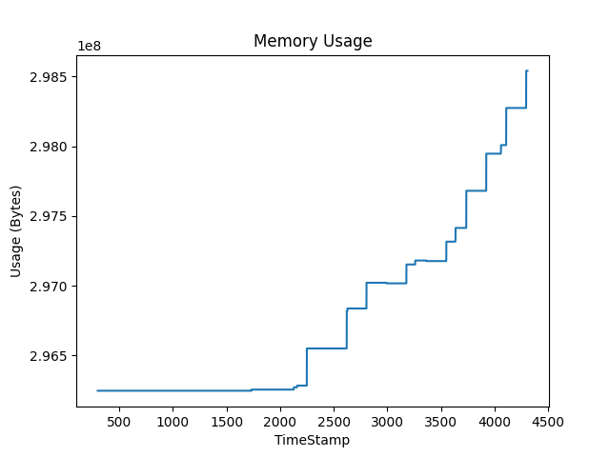

|  |  |
| --- | --- |
| Experiment params: | |
| OL algorithm: | Neural Network({}) |
| OFS algorithm: | Fast OSFS({'alpha': 0.05, 'fast': True}) |
| Window size: | 300 |
| Mean OL algorithm runtime: | 3.9922999999930653 ms |
| Mean OFS algorithm runtime: | 468.2391999999709 ms |
| accuracy: | 0.42411382925611585 |
| Selected features | [[144, 43, 135]] |

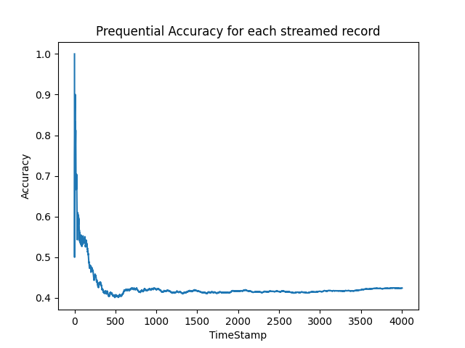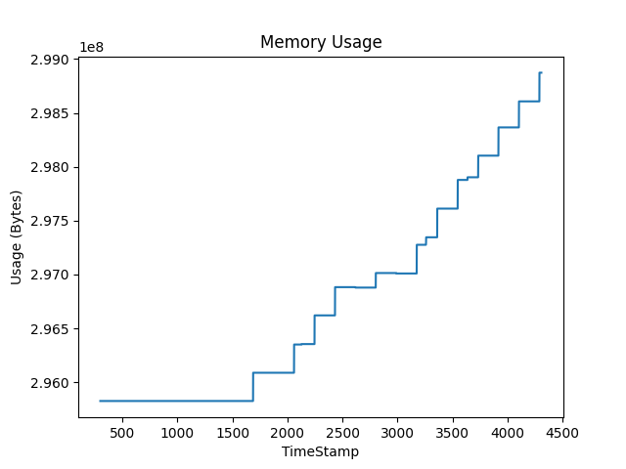

|  |  |
| --- | --- |
| Experiment params: | |
| OL algorithm: | Random Forest({}) |
| OFS algorithm: | Fast OSFS({'alpha': 0.05, 'fast': True}) |
| Window size: | 300 |
| Mean OL algorithm runtime: | 4827.366499999982 ms |
| Mean OFS algorithm runtime: | 493.3072999999695 ms |
| accuracy: | 0.5551672491263105 |
| Selected features | [[144, 43, 135]] |

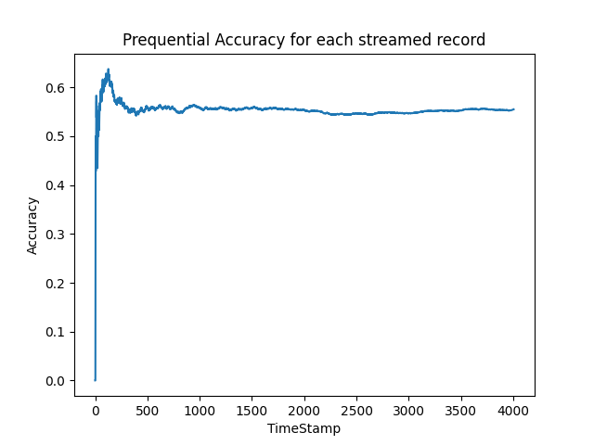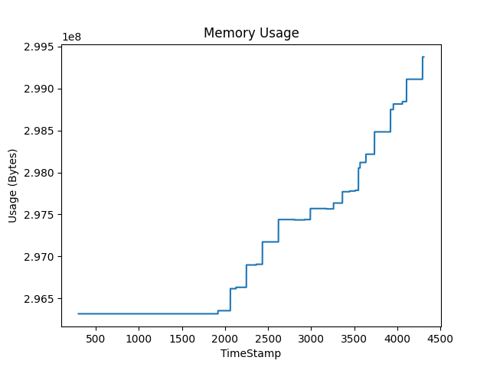

|  |  |
| --- | --- |
| Experiment params: | |
| OL algorithm: | K-Nearest Neighbors 3({'n_neighbors': 3, 'max_window_size': 300}) |
| OFS algorithm: | OSFS({'alpha': 0.05, 'fast': False}) |
| Window size: | 300 |
| Mean OL algorithm runtime: | 11.780699999974331 ms |
| Mean OFS algorithm runtime: | 785.109699999964 ms |
| accuracy: | 0.46854717923115324 |
| Selected features | [[43, 71]] |

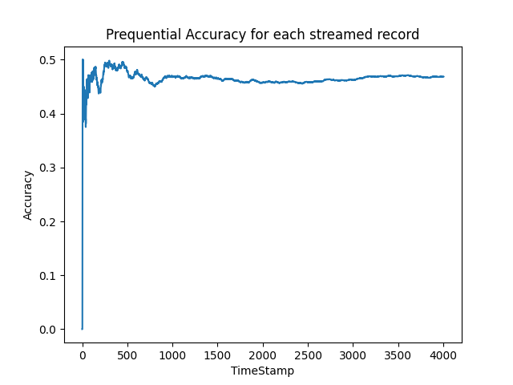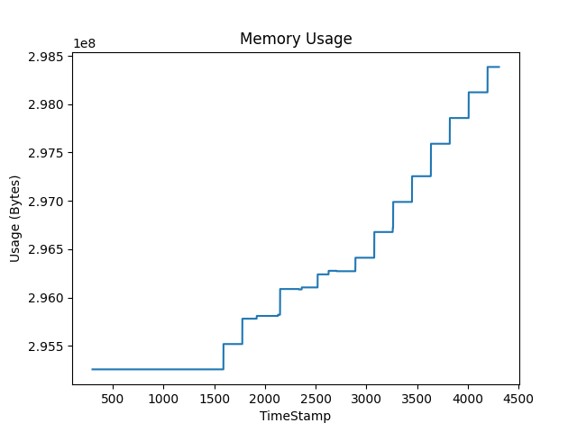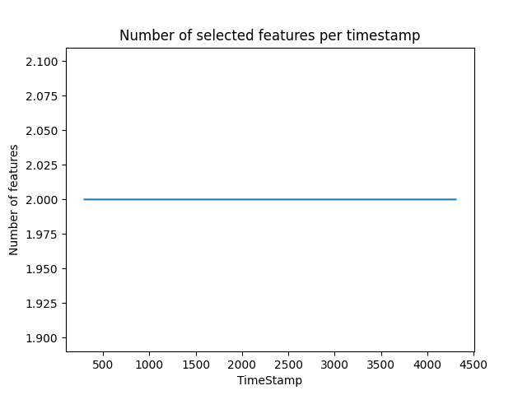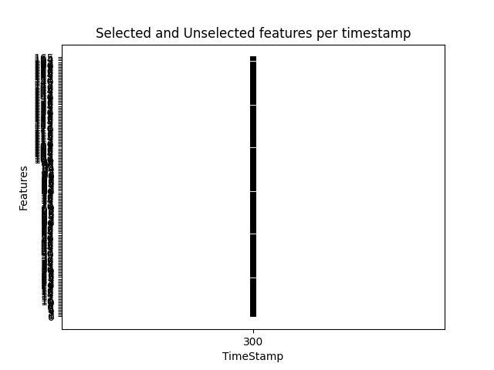

|  |  |
| --- | --- |
| Experiment params: | |
| OL algorithm: | K-Nearest Neighbors 5({'n_neighbors': 5, 'max_window_size': 300}) |
| OFS algorithm: | OSFS({'alpha': 0.05, 'fast': False}) |
| Window size: | 300 |
| Mean OL algorithm runtime: | 11.568000000011125 ms |
| Mean OFS algorithm runtime: | 800.3744000000097 ms |
| accuracy: | 0.46754867698452324 |
| Selected features | [[43, 71]] |

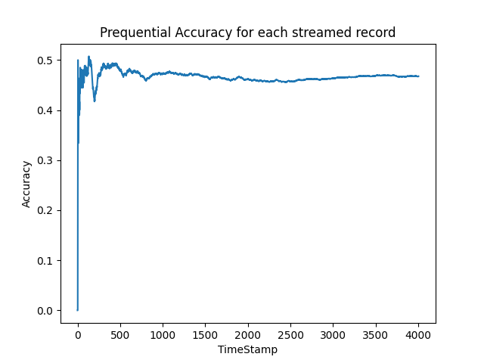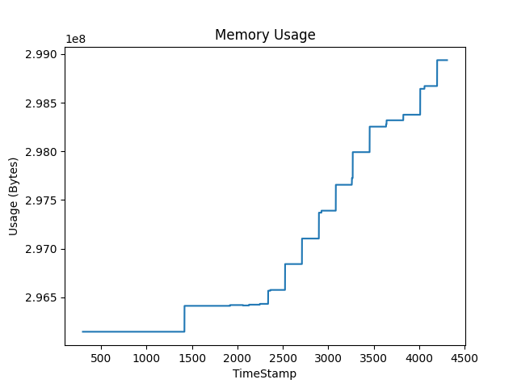

|  |  |
| --- | --- |
| Experiment params: | |
| OL algorithm: | Naive Bayes({}) |
| OFS algorithm: | OSFS({'alpha': 0.05, 'fast': False}) |
| Window size: | 300 |
| Mean OL algorithm runtime: | 4.5676999999955115 ms |
| Mean OFS algorithm runtime: | 808.1126000000154 ms |
| accuracy: | 0.5341987019470794 |
| Selected features | [[43, 71]] |

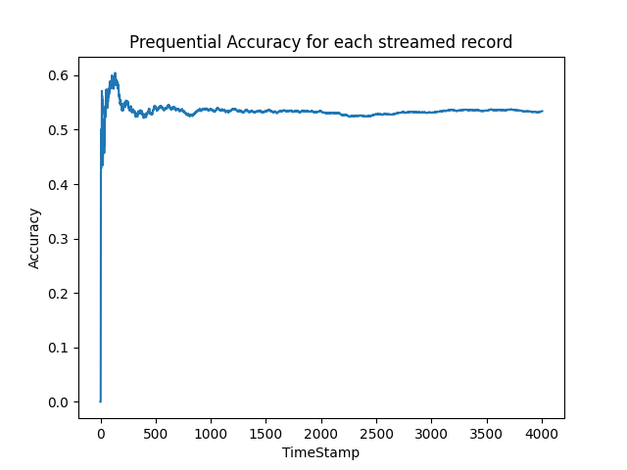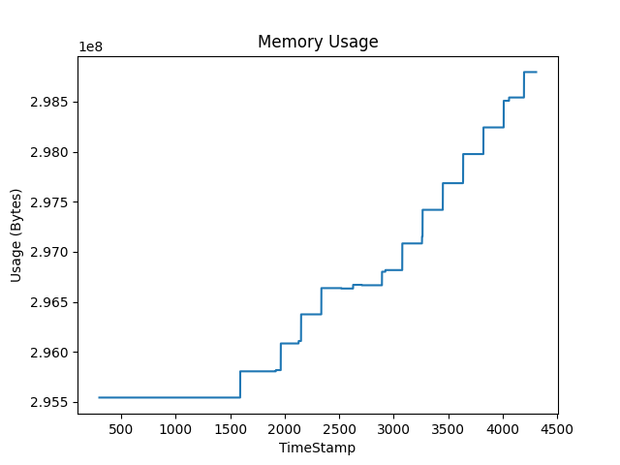

|  |  |
| --- | --- |
| Experiment params: | |
| OL algorithm: | Neural Network({}) |
| OFS algorithm: | OSFS({'alpha': 0.05, 'fast': False}) |
| Window size: | 300 |
| Mean OL algorithm runtime: | 4.600600000003396 ms |
| Mean OFS algorithm runtime: | 876.0851000000116 ms |
| accuracy: | 0.536944583125312 |
| Selected features | [[43, 71]] |

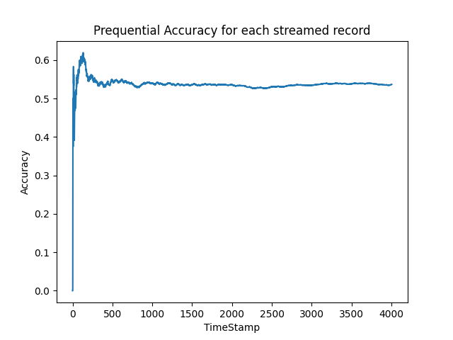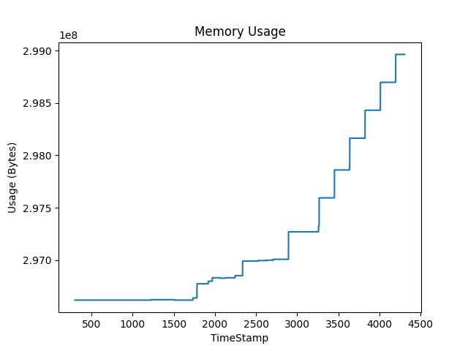

|  |  |
| --- | --- |
| Experiment params: | |
| OL algorithm: | Random Forest({}) |
| OFS algorithm: | OSFS({'alpha': 0.05, 'fast': False}) |
| Window size: | 300 |
| Mean OL algorithm runtime: | 3215.3359000000137 ms |
| Mean OFS algorithm runtime: | 865.9609000000046 ms |
| accuracy: | 0.48602096854717924 |
| Selected features | [[43, 71]] |

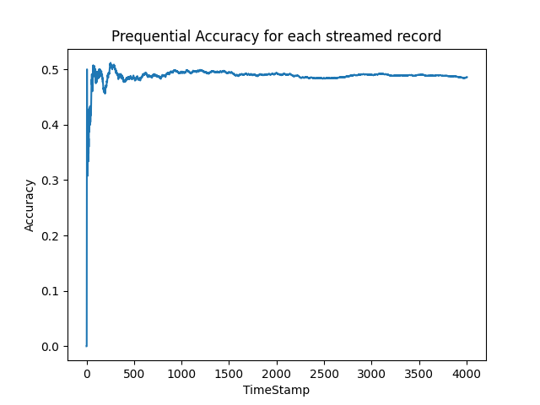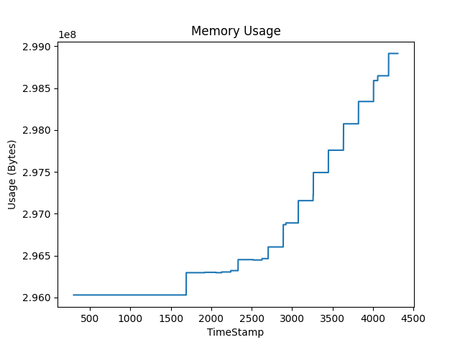

|  |  |
| --- | --- |
| Experiment params: | |
| OL algorithm: | K-Nearest Neighbors 3({'n_neighbors': 3, 'max_window_size': 300}) |
| OFS algorithm: | SAOLA({'alpha': 0.05}) |
| Window size: | 300 |
| Mean OL algorithm runtime: | 13.195499999994809 ms |
| Mean OFS algorithm runtime: | 209.41139999999336 ms |
| accuracy: | 0.4905142286570145 |
| Selected features | [[43, 30]] |

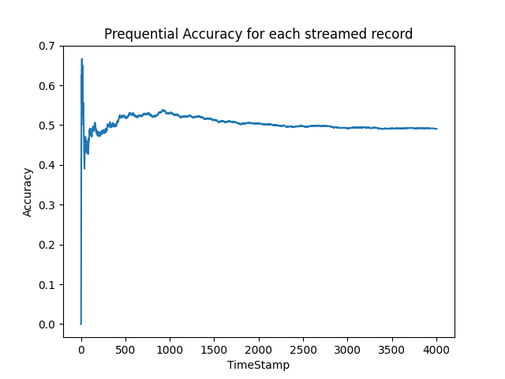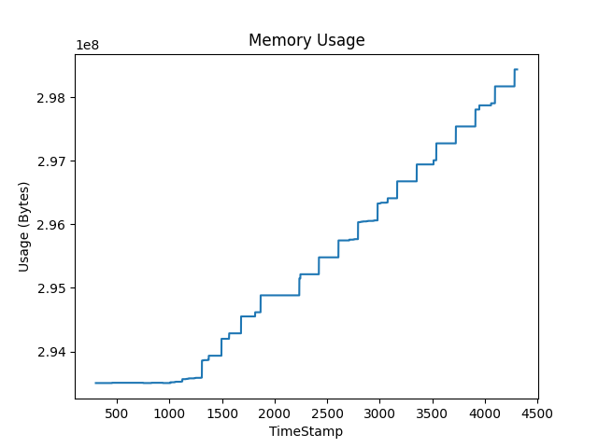

|  |  |
| --- | --- |
| Experiment params: | |
| OL algorithm: | K-Nearest Neighbors 5({'n_neighbors': 5, 'max_window_size': 300}) |
| OFS algorithm: | SAOLA({'alpha': 0.05}) |
| Window size: | 300 |
| Mean OL algorithm runtime: | 12.380600000000186 ms |
| Mean OFS algorithm runtime: | 180.6669999999997 ms |
| accuracy: | 0.482026959560659 |
| Selected features | [[43, 30]] |

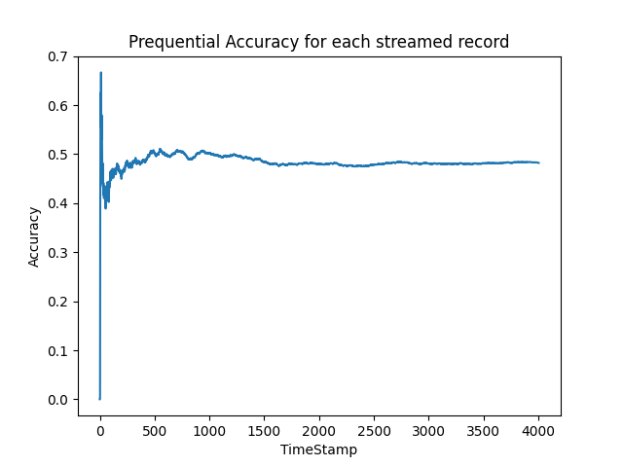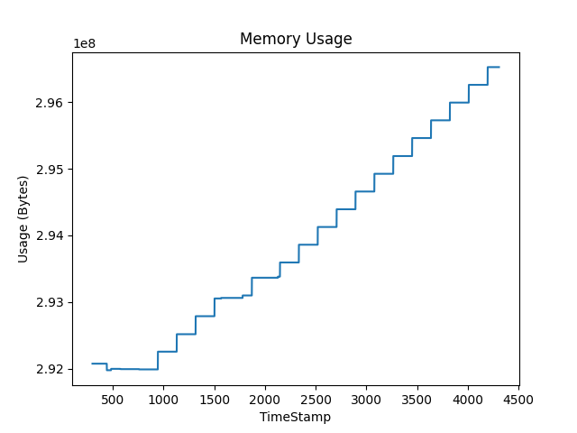

|  |  |
| --- | --- |
| Experiment params: | |
| OL algorithm: | Naive Bayes({}) |
| OFS algorithm: | SAOLA({'alpha': 0.05}) |
| Window size: | 300 |
| Mean OL algorithm runtime: | 5.204999999989468 ms |
| Mean OFS algorithm runtime: | 202.6900999999839 ms |
| accuracy: | 0.54717923115327 |
| Selected features | [[43, 30]] |

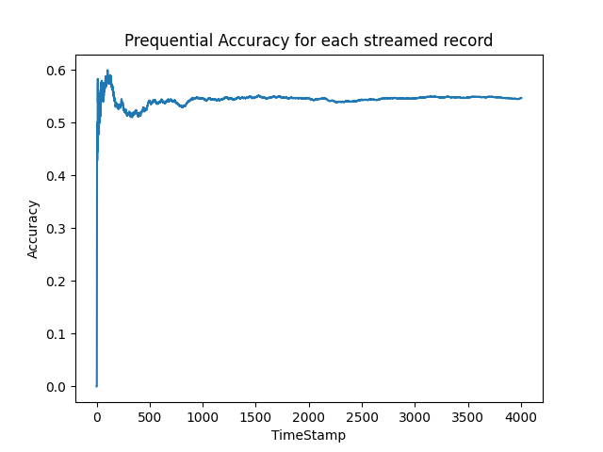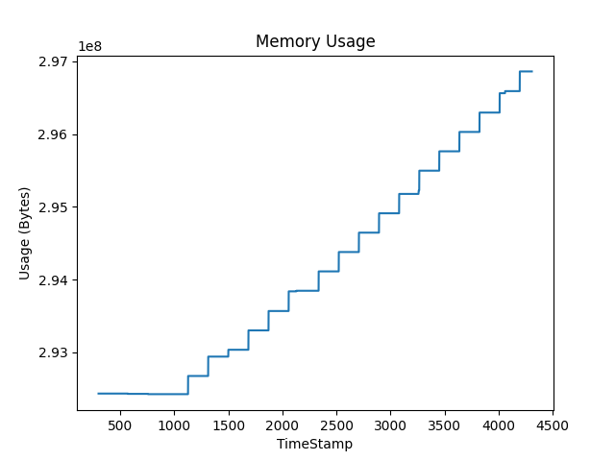

|  |  |
| --- | --- |
| Experiment params: | |
| OL algorithm: | Neural Network({}) |
| OFS algorithm: | SAOLA({'alpha': 0.05}) |
| Window size: | 300 |
| Mean OL algorithm runtime: | 4.280599999987089 ms |
| Mean OFS algorithm runtime: | 190.87170000000242 ms |
| accuracy: | 0.3469795307039441 |
| Selected features | [[43, 30]] |

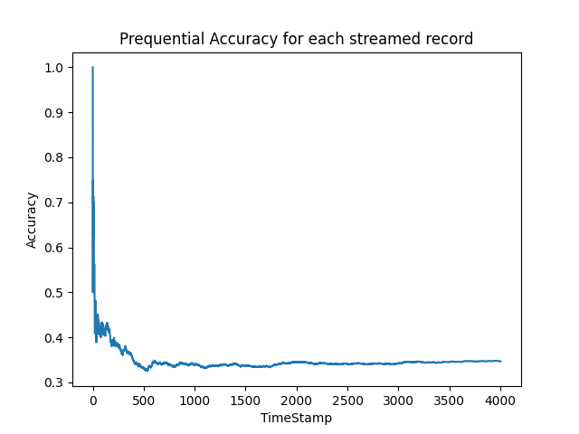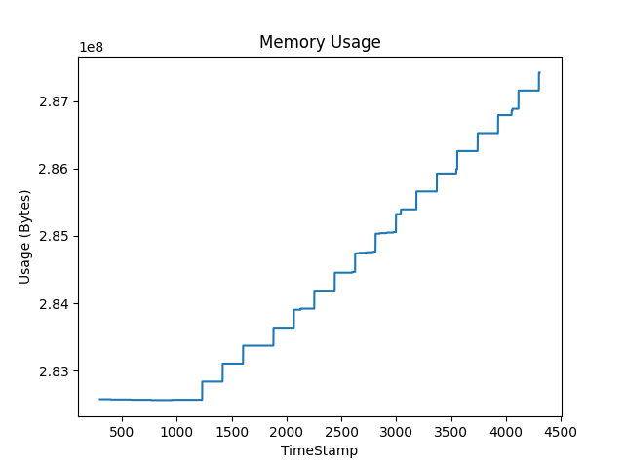

|  |  |
| --- | --- |
| Experiment params: | |
| OL algorithm: | Random Forest({}) |
| OFS algorithm: | SAOLA({'alpha': 0.05}) |
| Window size: | 300 |
| Mean OL algorithm runtime: | 3336.4398999999876 ms |
| Mean OFS algorithm runtime: | 214.2300000000148 ms |
| accuracy: | 0.5047428856714927 |
| Selected features | [[43, 30]] |

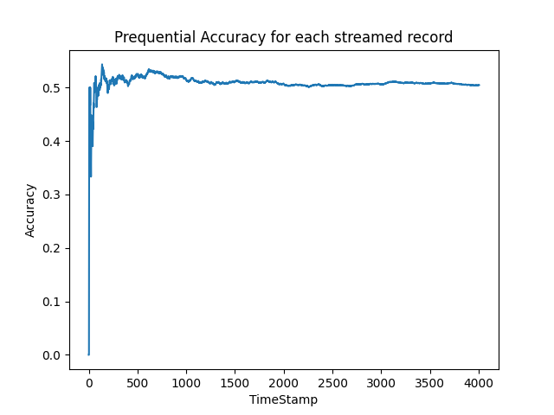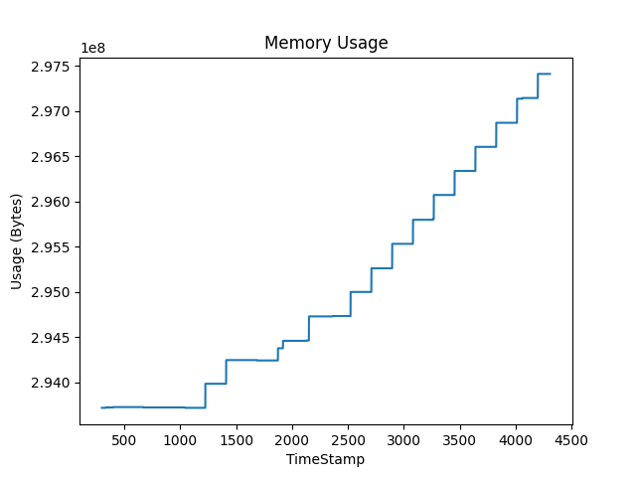

|  |  |
| --- | --- |
| Experiment params: | |
| OL algorithm: | K-Nearest Neighbors 3({'n_neighbors': 3, 'max_window_size': 500}) |
| OFS algorithm: | -(None) |
| Window size: | 500 |
| Mean OL algorithm runtime: | 42.52229999997326 ms |
| Mean OFS algorithm runtime: | nan ms |
| accuracy: | 0.5654230162900683 |
| Selected features | [] |

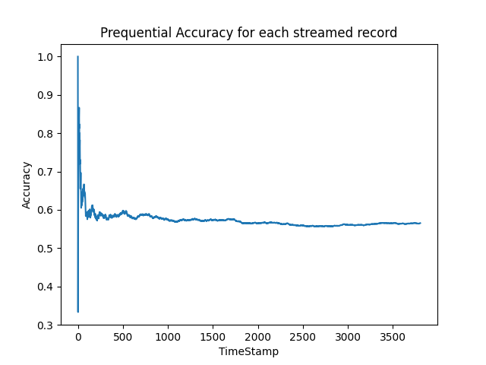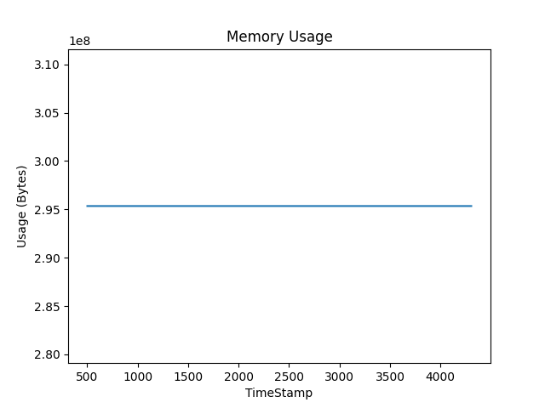

|  |  |
| --- | --- |
| Experiment params: | |
| OL algorithm: | K-Nearest Neighbors 5({'n_neighbors': 5, 'max_window_size': 500}) |
| OFS algorithm: | -(None) |
| Window size: | 500 |
| Mean OL algorithm runtime: | 39.63350000003629 ms |
| Mean OFS algorithm runtime: | nan ms |
| accuracy: | 0.5362585391487126 |
| Selected features | [] |

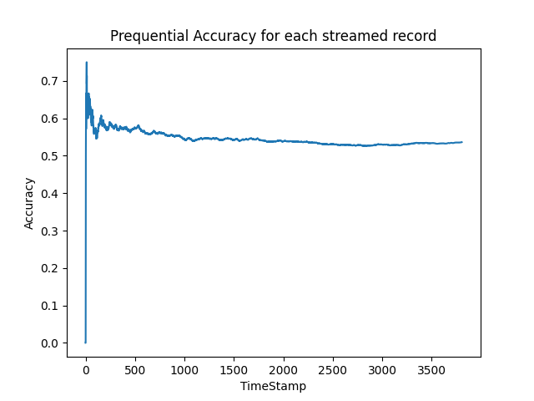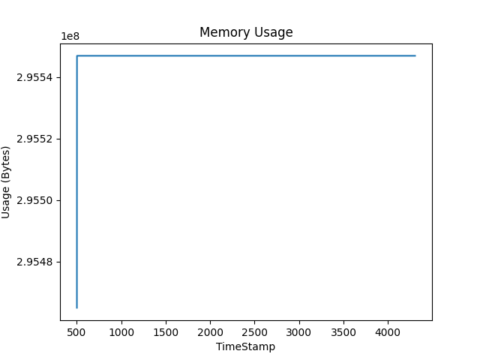

|  |  |
| --- | --- |
| Experiment params: | |
| OL algorithm: | Naive Bayes({}) |
| OFS algorithm: | -(None) |
| Window size: | 500 |
| Mean OL algorithm runtime: | 521.9880000000785 ms |
| Mean OFS algorithm runtime: | nan ms |
| accuracy: | 0.3896479243300053 |
| Selected features | [] |

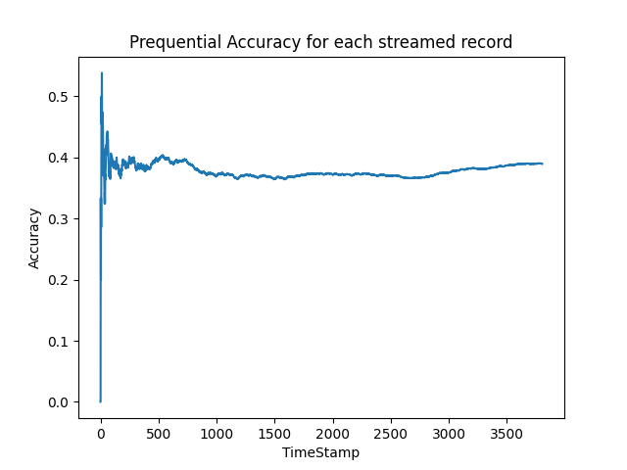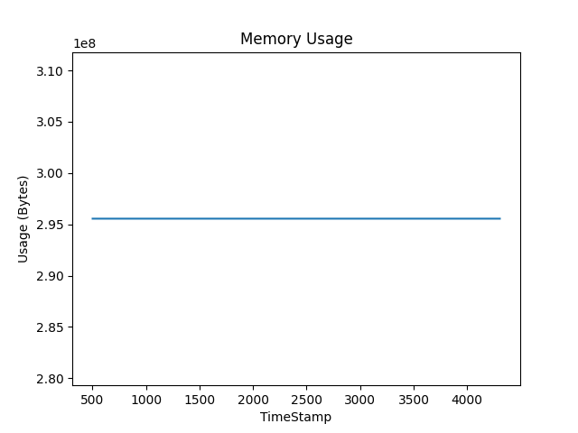

|  |  |
| --- | --- |
| Experiment params: | |
| OL algorithm: | Neural Network({}) |
| OFS algorithm: | -(None) |
| Window size: | 500 |
| Mean OL algorithm runtime: | 17.317800000000716 ms |
| Mean OFS algorithm runtime: | nan ms |
| accuracy: | 0.5057803468208093 |
| Selected features | [] |

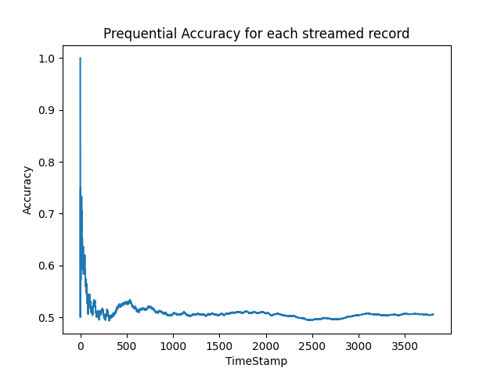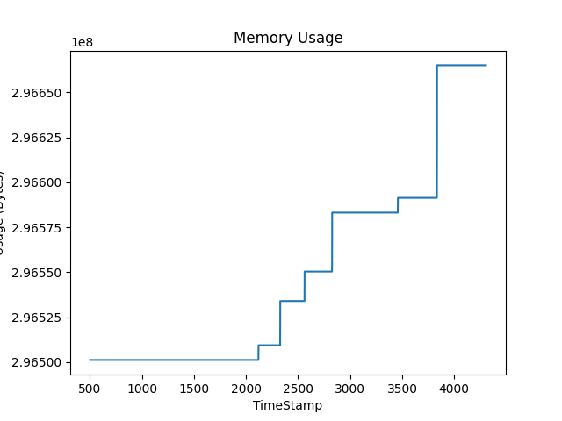

|  |  |
| --- | --- |
| Experiment params: | |
| OL algorithm: | Random Forest({}) |
| OFS algorithm: | -(None) |
| Window size: | 500 |
| Mean OL algorithm runtime: | 37133.81820000007 ms |
| Mean OFS algorithm runtime: | nan ms |
| accuracy: | 0.5617446137677351 |
| Selected features | [] |

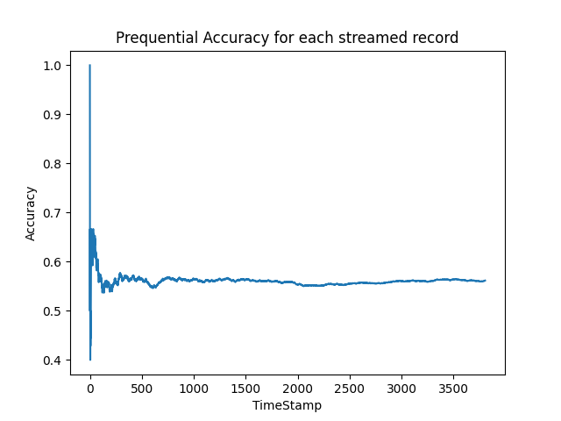

|  |  |
| --- | --- |
| Experiment params: | |
| OL algorithm: | K-Nearest Neighbors 3({'n_neighbors': 3, 'max_window_size': 500}) |
| OFS algorithm: | Alpha Investing({'alpha': 0.05, 'dw': 0.05}) |
| Window size: | 500 |
| Mean OL algorithm runtime: | 20.404100000064318 ms |
| Mean OFS algorithm runtime: | 414.4076000000041 ms |
| accuracy: | 0.4837099316868103 |
| Selected features | [[0, 98, 99]] |

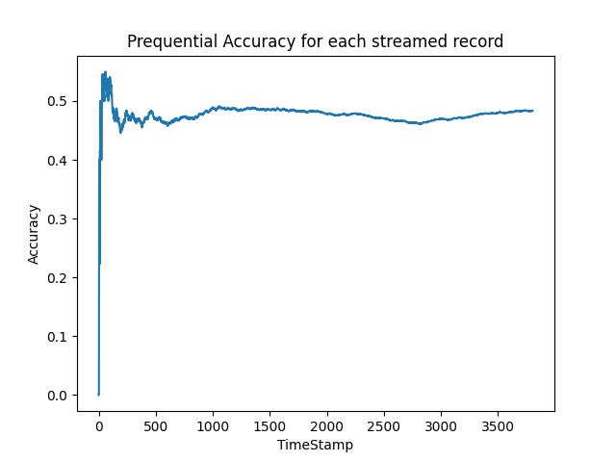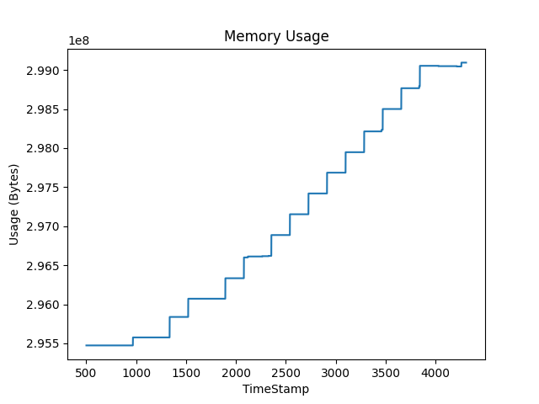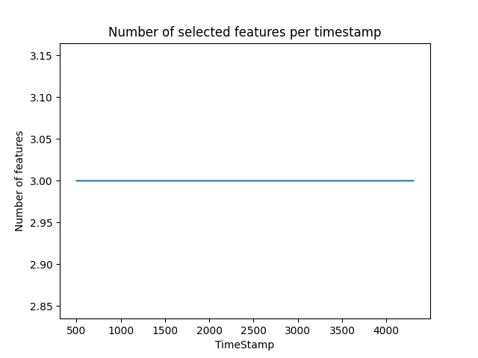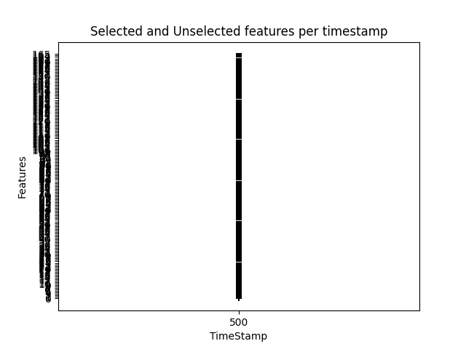

|  |  |
| --- | --- |
| Experiment params: | |
| OL algorithm: | K-Nearest Neighbors 5({'n_neighbors': 5, 'max_window_size': 500}) |
| OFS algorithm: | Alpha Investing({'alpha': 0.05, 'dw': 0.05}) |
| Window size: | 500 |
| Mean OL algorithm runtime: | 21.257600000012644 ms |
| Mean OFS algorithm runtime: | 408.6999000001015 ms |
| accuracy: | 0.4910667367314766 |
| Selected features | [[0, 98, 99]] |

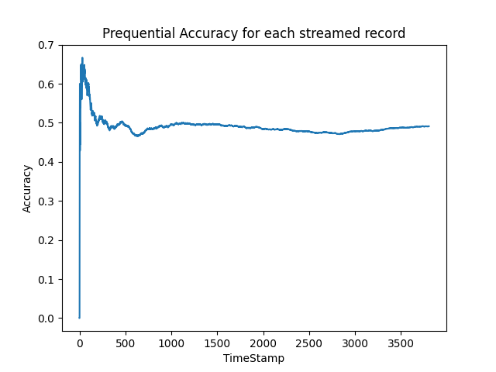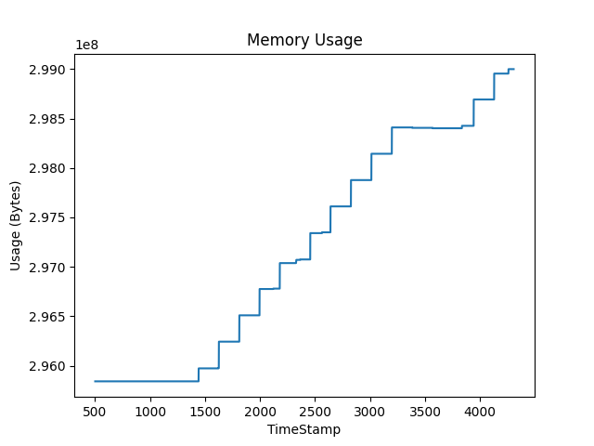

|  |  |
| --- | --- |
| Experiment params: | |
| OL algorithm: | Naive Bayes({}) |
| OFS algorithm: | Alpha Investing({'alpha': 0.05, 'dw': 0.05}) |
| Window size: | 500 |
| Mean OL algorithm runtime: | 11.964499999976397 ms |
| Mean OFS algorithm runtime: | 407.35209999991184 ms |
| accuracy: | 0.5504466631634262 |
| Selected features | [[0, 98, 99]] |

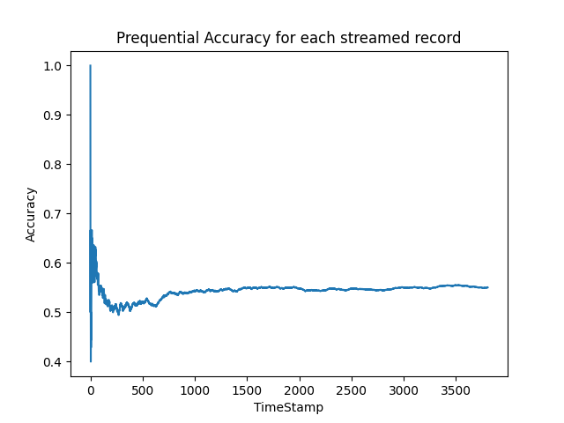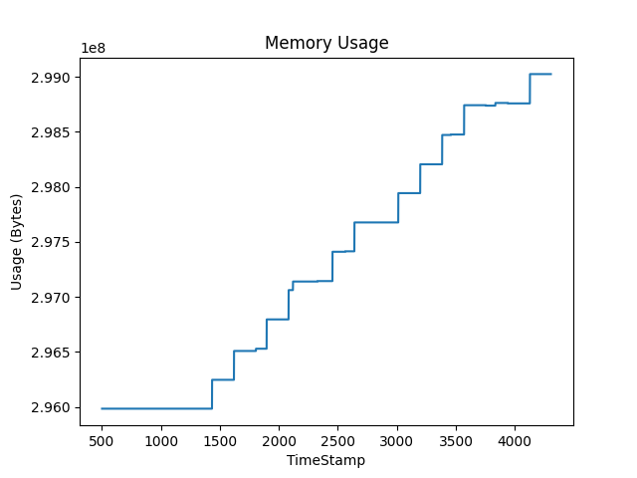

|  |  |
| --- | --- |
| Experiment params: | |
| OL algorithm: | Neural Network({}) |
| OFS algorithm: | Alpha Investing({'alpha': 0.05, 'dw': 0.05}) |
| Window size: | 500 |
| Mean OL algorithm runtime: | 8.491700000035962 ms |
| Mean OFS algorithm runtime: | 744.6373000000222 ms |
| accuracy: | 0.43799264319495534 |
| Selected features | [[0, 98, 99]] |

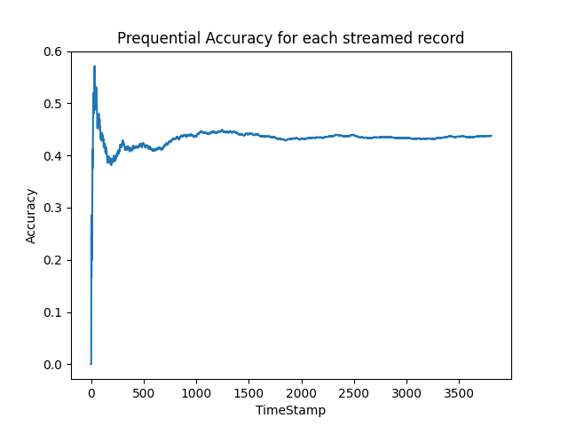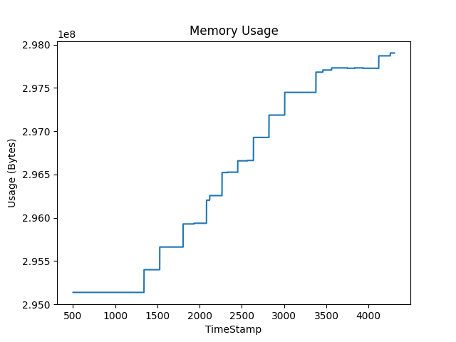

|  |  |
| --- | --- |
| Experiment params: | |
| OL algorithm: | Random Forest({}) |
| OFS algorithm: | Alpha Investing({'alpha': 0.05, 'dw': 0.05}) |
| Window size: | 500 |
| Mean OL algorithm runtime: | 8263.958399999978 ms |
| Mean OFS algorithm runtime: | 440.86910000009993 ms |
| accuracy: | 0.5735680504466631 |
| Selected features | [[0, 98, 99]] |

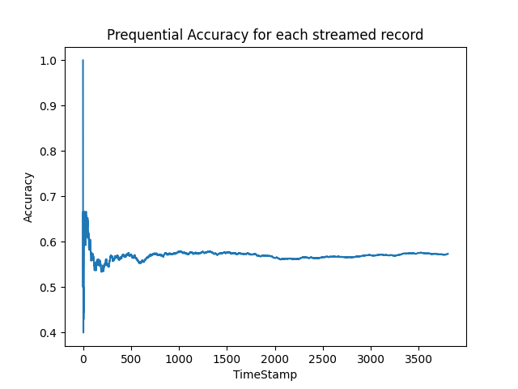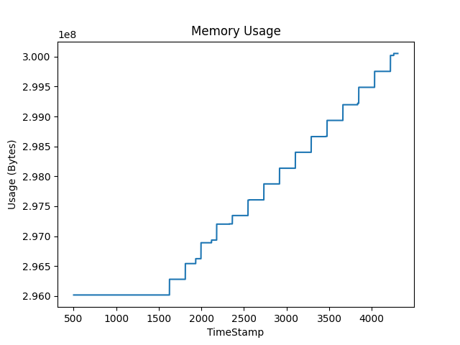

|  |  |
| --- | --- |
| Experiment params: | |
| OL algorithm: | K-Nearest Neighbors 3({'n_neighbors': 3, 'max_window_size': 500}) |
| OFS algorithm: | Fast OSFS({'alpha': 0.05, 'fast': True}) |
| Window size: | 500 |
| Mean OL algorithm runtime: | 20.50629999996545 ms |
| Mean OFS algorithm runtime: | 1355.7731999999305 ms |
| accuracy: | 0.5961639516552811 |
| Selected features | [[98, 37, 135, 43]] |

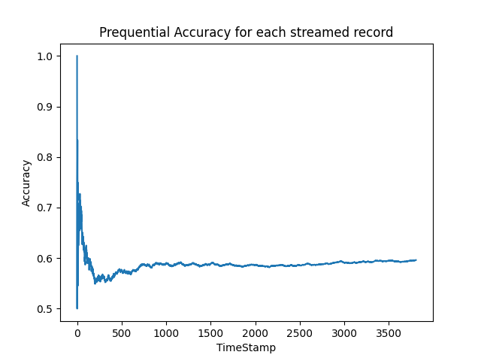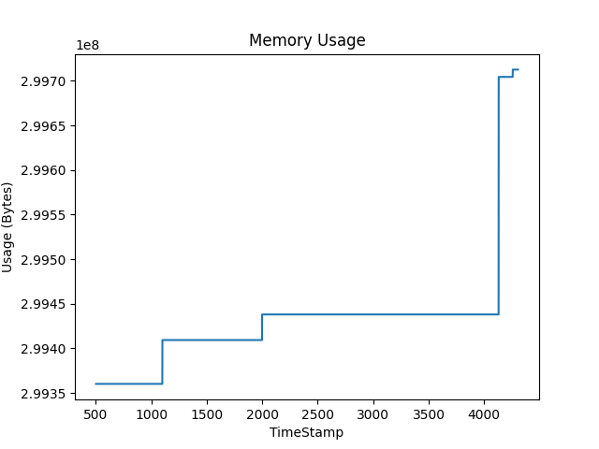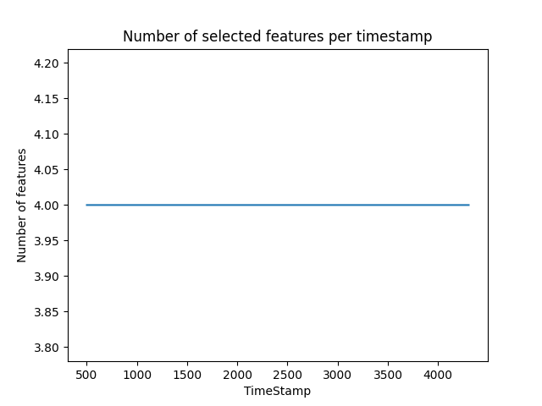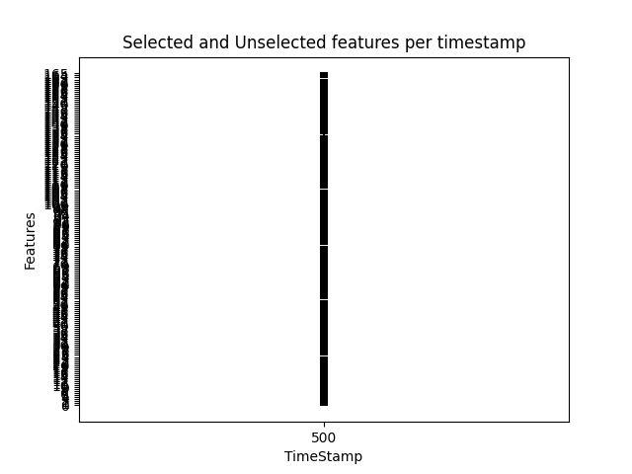

|  |  |
| --- | --- |
| Experiment params: | |
| OL algorithm: | K-Nearest Neighbors 5({'n_neighbors': 5, 'max_window_size': 500}) |
| OFS algorithm: | Fast OSFS({'alpha': 0.05, 'fast': True}) |
| Window size: | 500 |
| Mean OL algorithm runtime: | 20.787499999983083 ms |
| Mean OFS algorithm runtime: | 1291.801600000099 ms |
| accuracy: | 0.5696269048870205 |
| Selected features | [[98, 37, 135, 43]] |

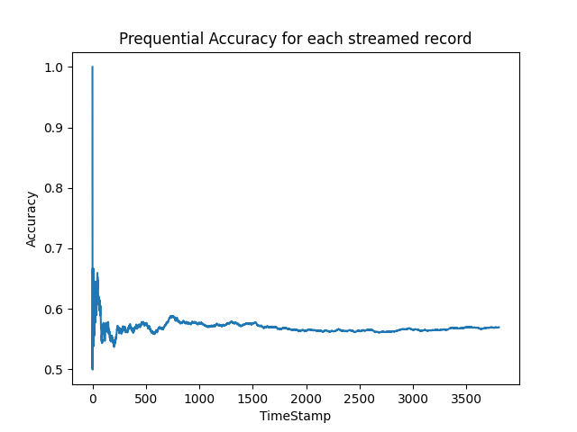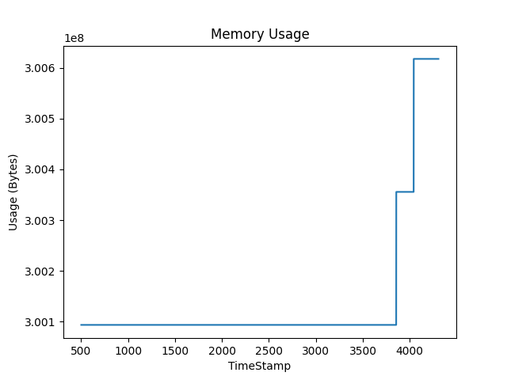

|  |  |
| --- | --- |
| Experiment params: | |
| OL algorithm: | Naive Bayes({}) |
| OFS algorithm: | Fast OSFS({'alpha': 0.05, 'fast': True}) |
| Window size: | 500 |
| Mean OL algorithm runtime: | 23.51839999994354 ms |
| Mean OFS algorithm runtime: | 1284.2881999999918 ms |
| accuracy: | 0.5578034682080925 |
| Selected features | [[98, 37, 135, 43]] |

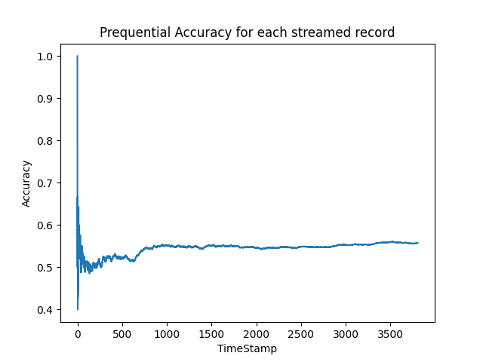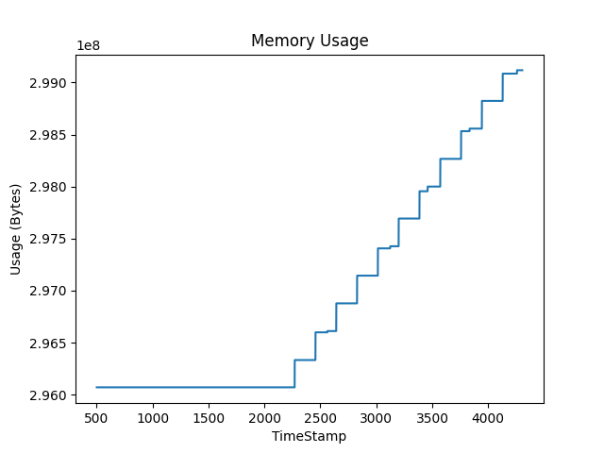

|  |  |
| --- | --- |
| Experiment params: | |
| OL algorithm: | Neural Network({}) |
| OFS algorithm: | Fast OSFS({'alpha': 0.05, 'fast': True}) |
| Window size: | 500 |
| Mean OL algorithm runtime: | 4.476899999986017 ms |
| Mean OFS algorithm runtime: | 1275.247199999967 ms |
| accuracy: | 0.39753021544929057 |
| Selected features | [[98, 37, 135, 43]] |

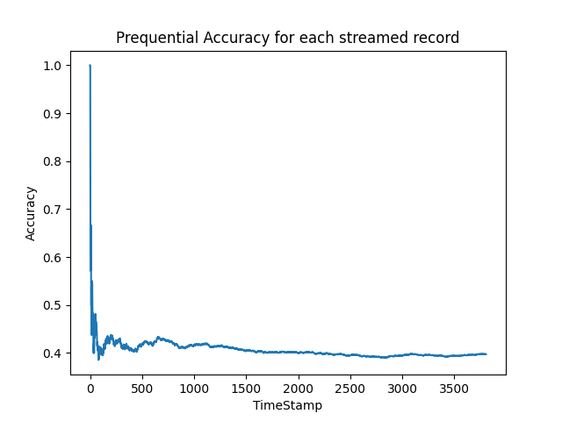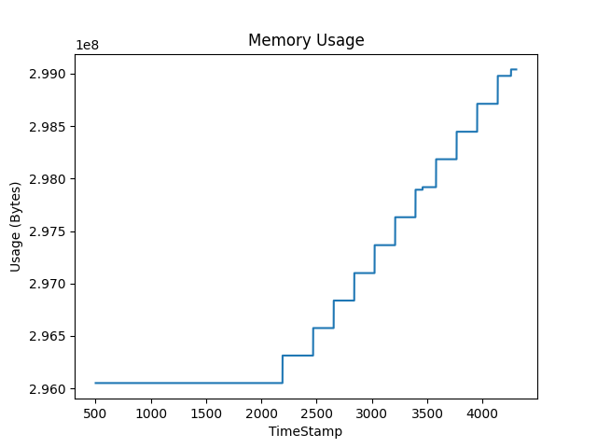

|  |  |
| --- | --- |
| Experiment params: | |
| OL algorithm: | Random Forest({}) |
| OFS algorithm: | Fast OSFS({'alpha': 0.05, 'fast': True}) |
| Window size: | 500 |
| Mean OL algorithm runtime: | 8395.0916 ms |
| Mean OFS algorithm runtime: | 1236.45149999993 ms |
| accuracy: | 0.5625328428796637 |
| Selected features | [[98, 37, 135, 43]] |

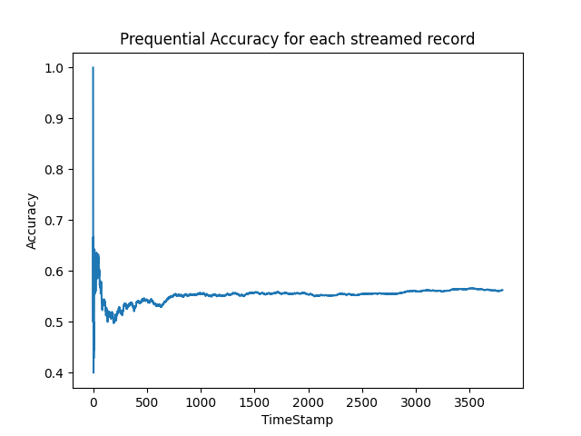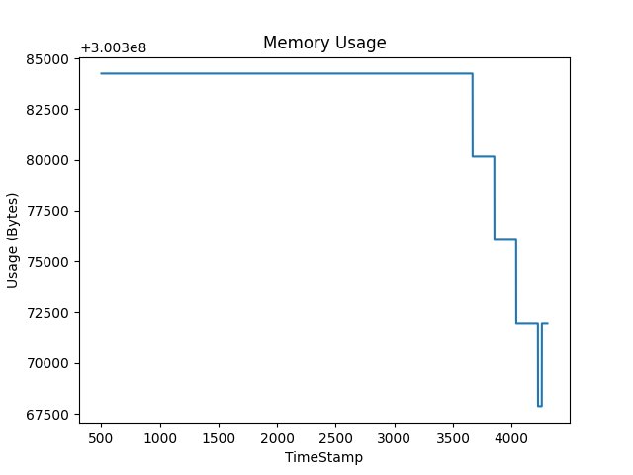

|  |  |
| --- | --- |
| Experiment params: | |
| OL algorithm: | K-Nearest Neighbors 3({'n_neighbors': 3, 'max_window_size': 500}) |
| OFS algorithm: | OSFS({'alpha': 0.05, 'fast': False}) |
| Window size: | 500 |
| Mean OL algorithm runtime: | 20.774100000039653 ms |
| Mean OFS algorithm runtime: | 2966.5526 ms |
| accuracy: | 0.5796111403047819 |
| Selected features | [[43, 133, 135]] |

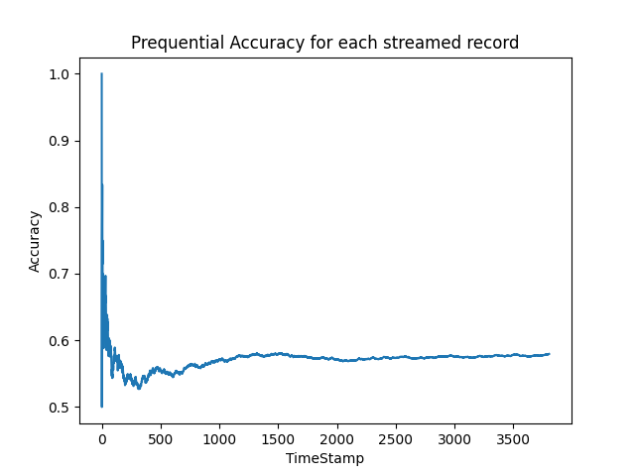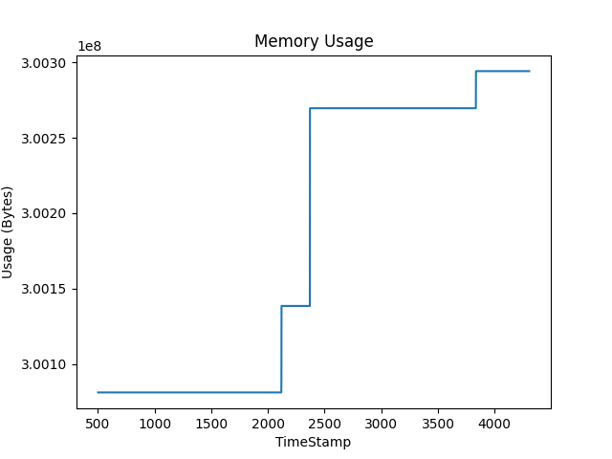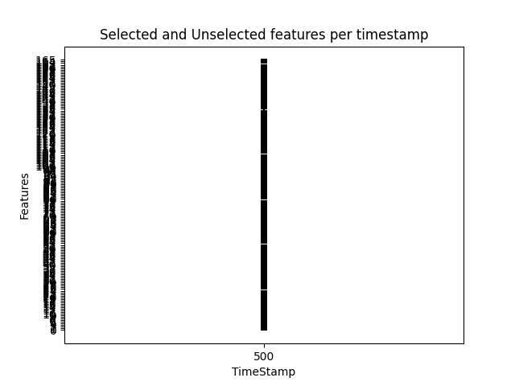

|  |  |
| --- | --- |
| Experiment params: | |
| OL algorithm: | K-Nearest Neighbors 5({'n_neighbors': 5, 'max_window_size': 500}) |
| OFS algorithm: | OSFS({'alpha': 0.05, 'fast': False}) |
| Window size: | 500 |
| Mean OL algorithm runtime: | 21.579000000087944 ms |
| Mean OFS algorithm runtime: | 2968.756800000051 ms |
| accuracy: | 0.5691014188124015 |
| Selected features | [[43, 133, 135]] |

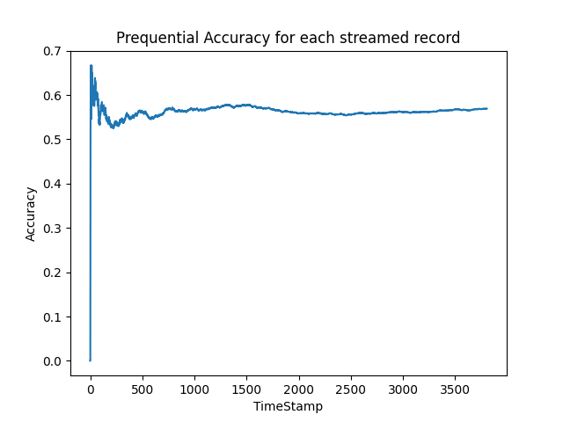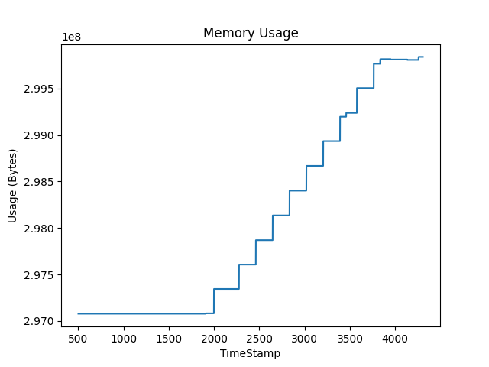

|  |  |
| --- | --- |
| Experiment params: | |
| OL algorithm: | Naive Bayes({}) |
| OFS algorithm: | OSFS({'alpha': 0.05, 'fast': False}) |
| Window size: | 500 |
| Mean OL algorithm runtime: | 10.042099999964194 ms |
| Mean OFS algorithm runtime: | 2965.8593999999994 ms |
| accuracy: | 0.5659485023646873 |
| Selected features | [[43, 133, 135]] |

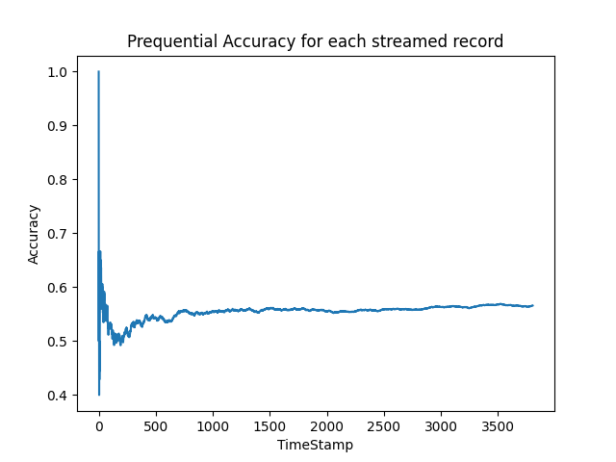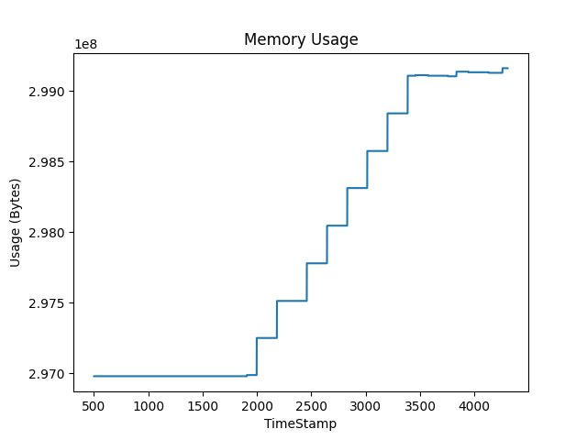

|  |  |
| --- | --- |
| Experiment params: | |
| OL algorithm: | Neural Network({}) |
| OFS algorithm: | OSFS({'alpha': 0.05, 'fast': False}) |
| Window size: | 500 |
| Mean OL algorithm runtime: | 4.406499999959124 ms |
| Mean OFS algorithm runtime: | 2998.3676000000514 ms |
| accuracy: | 0.3673147661586968 |
| Selected features | [[43, 133, 135]] |

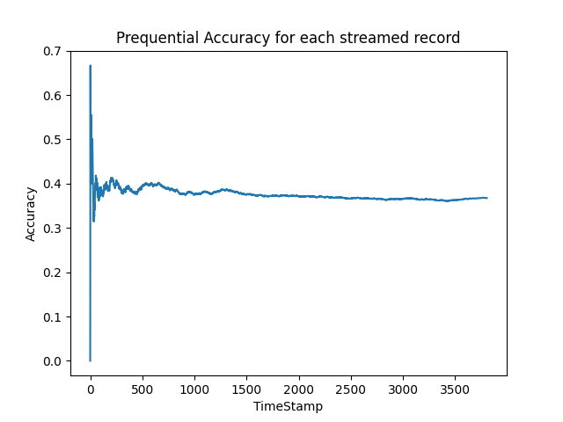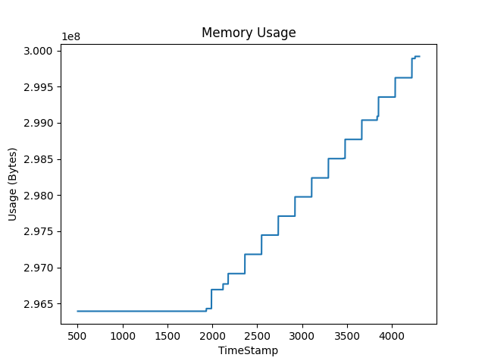

|  |  |
| --- | --- |
| Experiment params: | |
| OL algorithm: | Random Forest({}) |
| OFS algorithm: | OSFS({'alpha': 0.05, 'fast': False}) |
| Window size: | 500 |
| Mean OL algorithm runtime: | 9914.650699999926 ms |
| Mean OFS algorithm runtime: | 2951.8299999999726 ms |
| accuracy: | 0.5717288491854966 |
| Selected features | [[43, 133, 135]] |

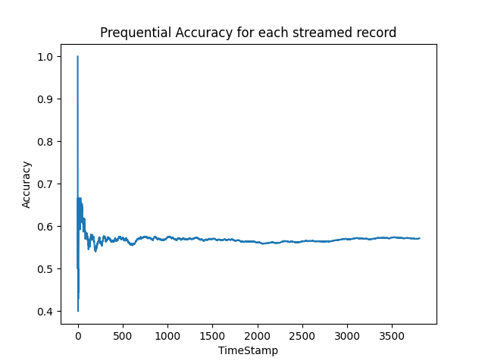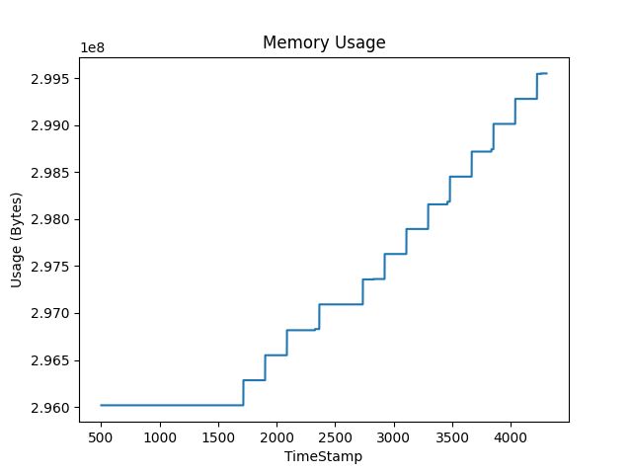

|  |  |
| --- | --- |
| Experiment params: | |
| OL algorithm: | K-Nearest Neighbors 3({'n_neighbors': 3, 'max_window_size': 500}) |
| OFS algorithm: | SAOLA({'alpha': 0.05}) |
| Window size: | 500 |
| Mean OL algorithm runtime: | 20.16080000009879 ms |
| Mean OFS algorithm runtime: | 235.00990000002275 ms |
| accuracy: | 0.4931686810299527 |
| Selected features | [[43, 30]] |

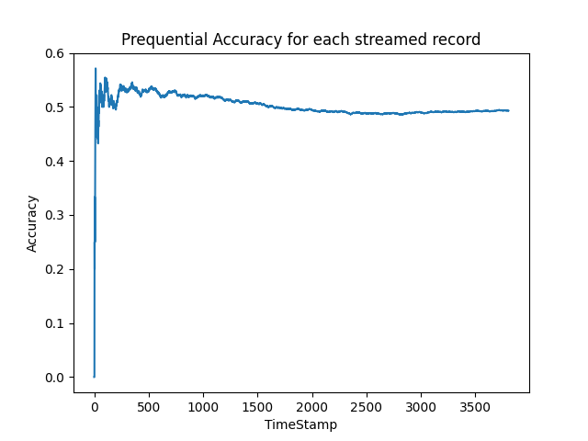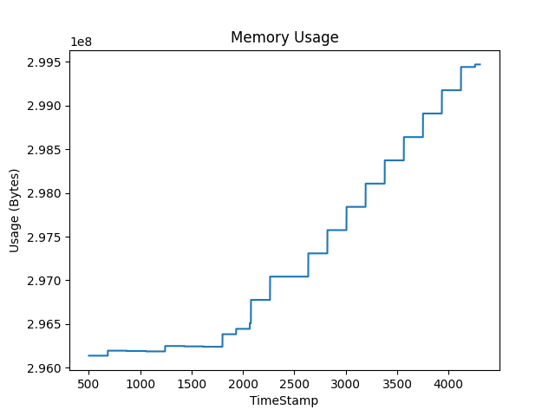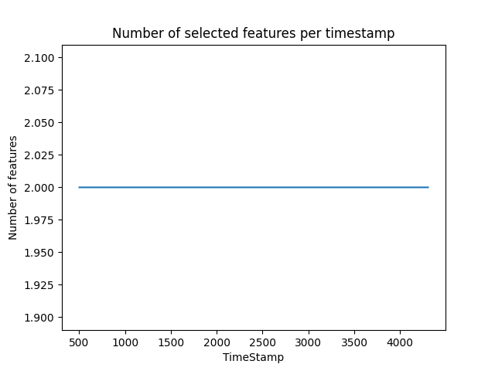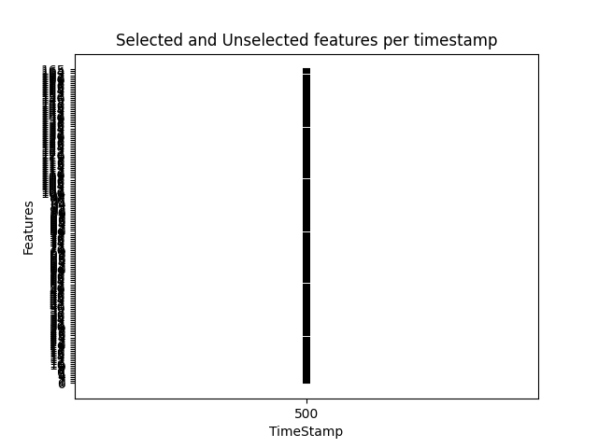

|  |  |
| --- | --- |
| Experiment params: | |
| OL algorithm: | K-Nearest Neighbors 5({'n_neighbors': 5, 'max_window_size': 500}) |
| OFS algorithm: | SAOLA({'alpha': 0.05}) |
| Window size: | 500 |
| Mean OL algorithm runtime: | 21.327000000042062 ms |
| Mean OFS algorithm runtime: | 202.93529999992188 ms |
| accuracy: | 0.4908039936941671 |
| Selected features | [[43, 30]] |

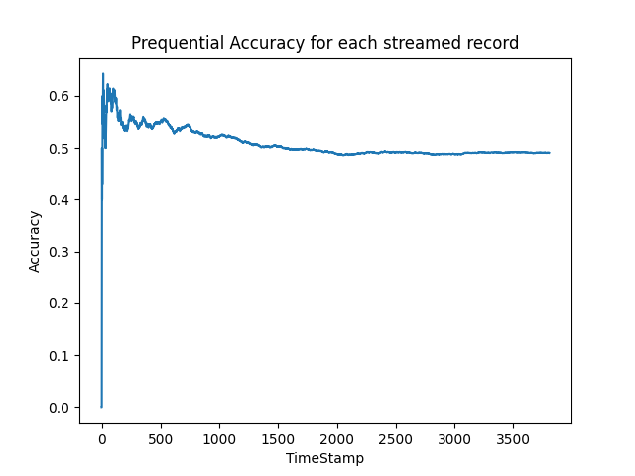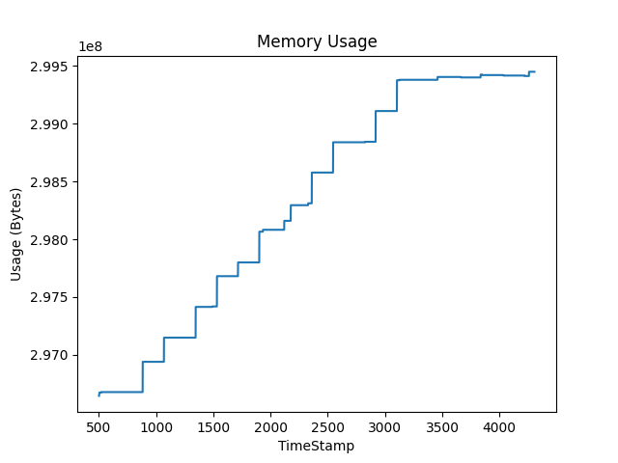

|  |  |
| --- | --- |
| Experiment params: | |
| OL algorithm: | Naive Bayes({}) |
| OFS algorithm: | SAOLA({'alpha': 0.05}) |
| Window size: | 500 |
| Mean OL algorithm runtime: | 8.248600000001716 ms |
| Mean OFS algorithm runtime: | 208.86059999997997 ms |
| accuracy: | 0.5480819758276406 |
| Selected features | [[43, 30]] |

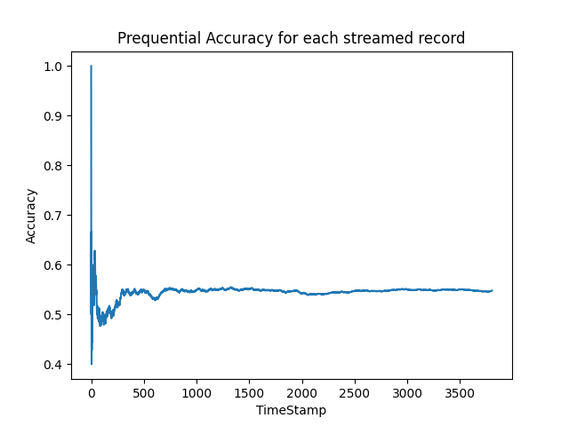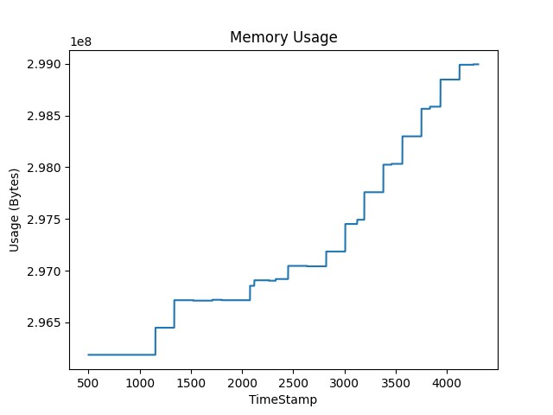

|  |  |
| --- | --- |
| Experiment params: | |
| OL algorithm: | Neural Network({}) |
| OFS algorithm: | SAOLA({'alpha': 0.05}) |
| Window size: | 500 |
| Mean OL algorithm runtime: | 4.364399999985835 ms |
| Mean OFS algorithm runtime: | 214.61909999993622 ms |
| accuracy: | 0.36889122438255384 |
| Selected features | [[43, 30]] |

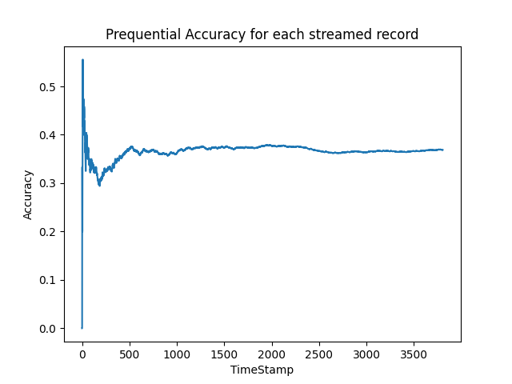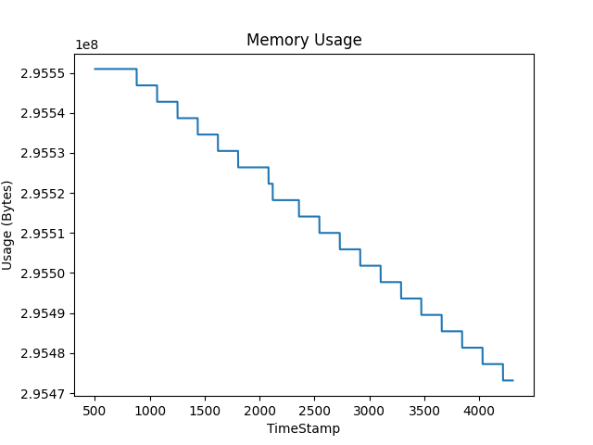

|  |  |
| --- | --- |
| Experiment params: | |
| OL algorithm: | Random Forest({}) |
| OFS algorithm: | SAOLA({'alpha': 0.05}) |
| Window size: | 500 |
| Mean OL algorithm runtime: | 5405.5283000000145 ms |
| Mean OFS algorithm runtime: | 200.27559999994082 ms |
| accuracy: | 0.5170782974251182 |
| Selected features | [[43, 30]] |

