Roi Herzig 300360310

Moshe Raboh 300611878

**Introduction To Machine Learning – EX 1**

1. **B:**  
   The accuracy of prediction of KNN with k=10 over 1000 training images (n=1000) is 0.157.  
   We would expect from a completely random predicate accuracy of prediction of 0.1 (we have 10 different labels).  
   **C:**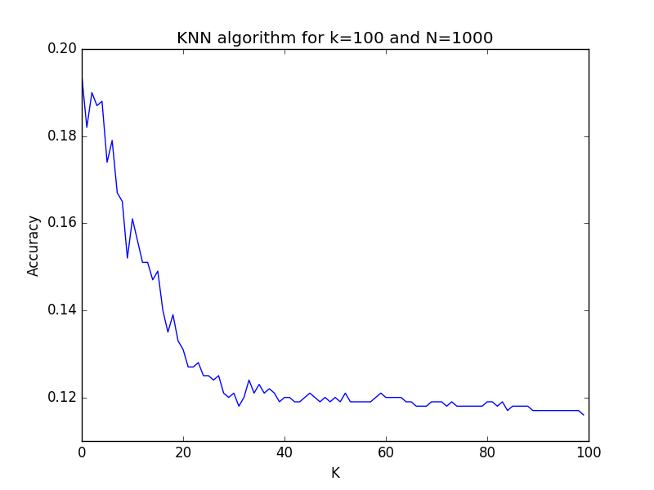The best k is 1- (about the same accuracy).  
   As we can see in the graph:  
   for small Ks (1 to 3) we get the highest accuracy. We can see that the accuracy descend and approaches 0.1 when k growth.  
   0.1 is the accuracy is the accuracy we would expect from a completely random predicator.

We would expect for such a behavior, since:

1. Euclidian distance is not accurate (however better than a random predicator)
2. The influence of each of the k nearest neighbors is equal (meaning that the nearest neighbors and the k nearest neighbor will equally influence the result).  
   Since that the training set is sparse (only 1000 images).

**D:  
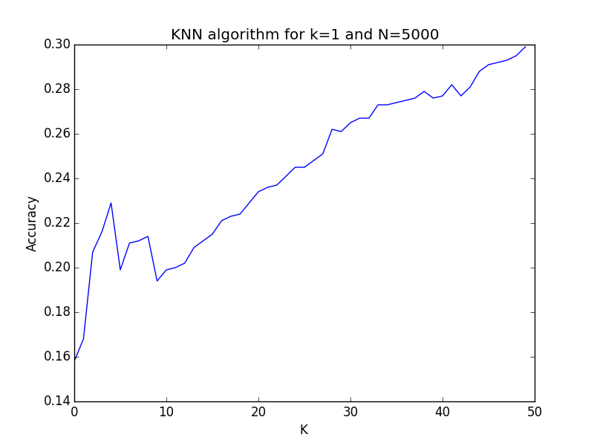**According to the graph we can see that we get better accuracy with bigger training size.   
We ran it with k=1 (the best results from above).  
This is the expected results, since it will be possible to find better (closer) single nearest neighbor which better reflect (statistically of course) the true label.

**2.**

**B:**

Given the distribution, the hypothesis with the smallest error will be hypothesis of 2 intervals ((0, 0.25), (0.5, 0.75)).  
The error is 15% (2*0.25*0.2 + 2*0.25*0.1 = 0.15)

**C:**