Roi Herzig ID: 300360310 EMAIL:roeiherzig@mail.tau.ac.il

Moshe Raboh ID:300611878 EMAIL:shikorab@gmail.com

**Introduction To Machine Learning – EX 3**

1. **A:**Directory: " /specific/a/home/cc/students/csguests/roeiherzig/ML/EX3"See function "part_a" in file "q6.py"

* We performed a grid search to find the best learning rate. The graph below shows the accuracy of both mean validation accuracy and mean training accuracy over the best range we found on the grid search.  
  We extracted the best learning rate from the graph.
* We used the best learning rate while the grid search for the best C. The graph below shows the accuracy of both mean validation accuracy and mean training accuracy over the best range we found on the grid search.  
  We extracted the best C from the graph.
* We used number of iterations**=??????**

**B:**

Directory: " /specific/a/home/cc/students/csguests/roeiherzig/ML/EX3"See function "part_b" in file "q6.py"

Name of the image: “part_1b.png”

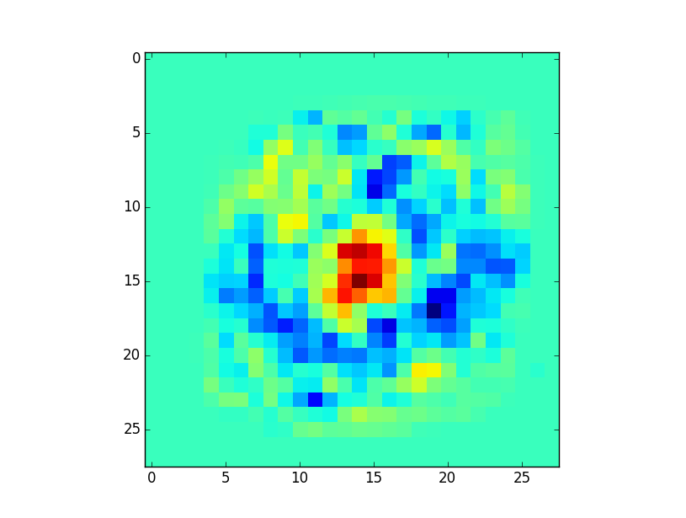

TBD - intuition

**C:**Directory: " /specific/a/home/cc/students/csguests/roeiherzig/ML/EX2"See function "part_c" in file "q1.py"  
Mean accuracy of the full train samples: 99.13%

**D:**Directory: " /specific/a/home/cc/students/csguests/roeiherzig/ML/EX2"See function "part_d" in file "q1.py"Image file: "part_1d_rotat0.png" and “part_1d_rotat8.png”

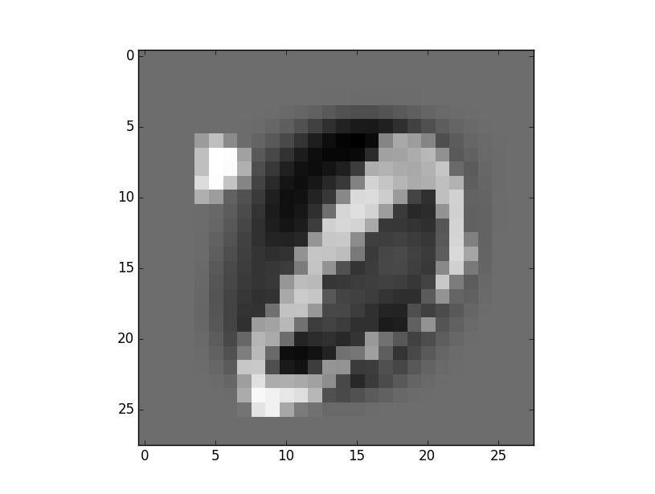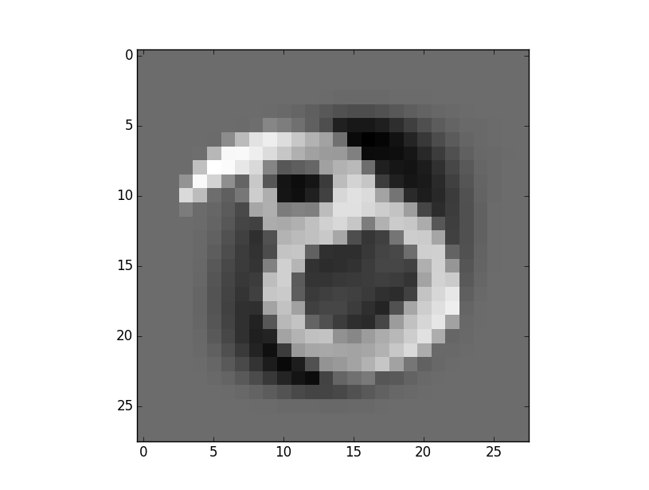

In both cases, we can see images are miss-classified because the images are distorted. We can see that our classifier is not invariant to some affine transformation such as scale, translation and rotation.

**2.**

**A:**Directory: " /specific/a/home/cc/students/csguests/roeiherzig/ML/EX2"Module main in file "q2.py"

The image file name: "q2_part_a.png"  
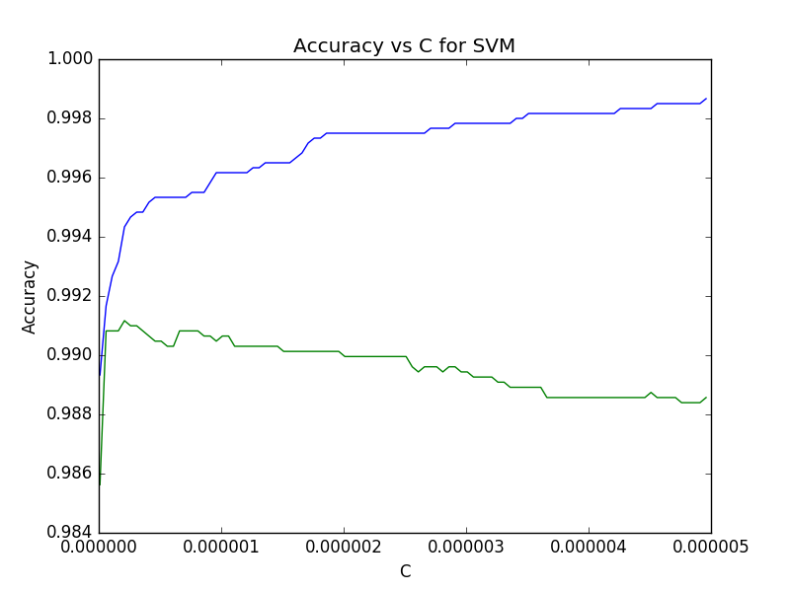**B:**  
When c is large, we try to fit as close as possible to the training data with a risk overfitting,  
We can see the overfitting in the graph, for large c the training accuracy getting smaller while the validation accuracy getting larger.   
When c is small, there is no penalty for misclassification, so we might underfitting, and will get small accuracy in both validation and training.

**C:**Directory: " /specific/a/home/cc/students/csguests/roeiherzig/ML/EX2"Function main in file "q2.py" (done in main module)

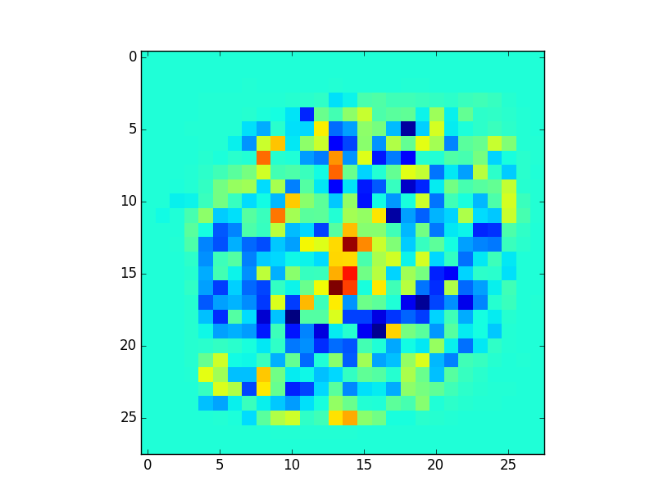

**D:**

Directory: " /specific/a/home/cc/students/csguests/roeiherzig/ML/EX2"Function main in file "q2.py"

(also done in module main)

The best c is 2.09999996059e-07 for error: 0.991167301697

**3.**

**A:**Directory: " /specific/a/home/cc/students/csguests/roeiherzig/ML/EX2"See function "part_a" in file "q3.py"

The image file name: "q3_part_a.png"  
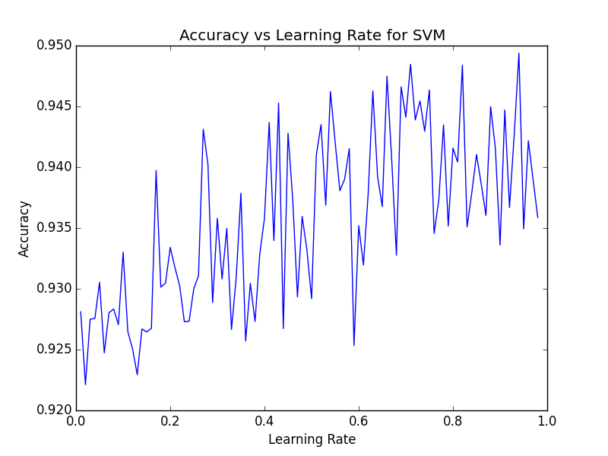

We performed a grid search to find the best learning rate while T is fixed to 1000 and C is fixed to 1. The best learning rate is 0.94

**B:**  
Directory: " /specific/a/home/cc/students/csguests/roeiherzig/ML/EX2"See function "part_b" in file "q3.py"

The image file name: "q3_part_b.png"

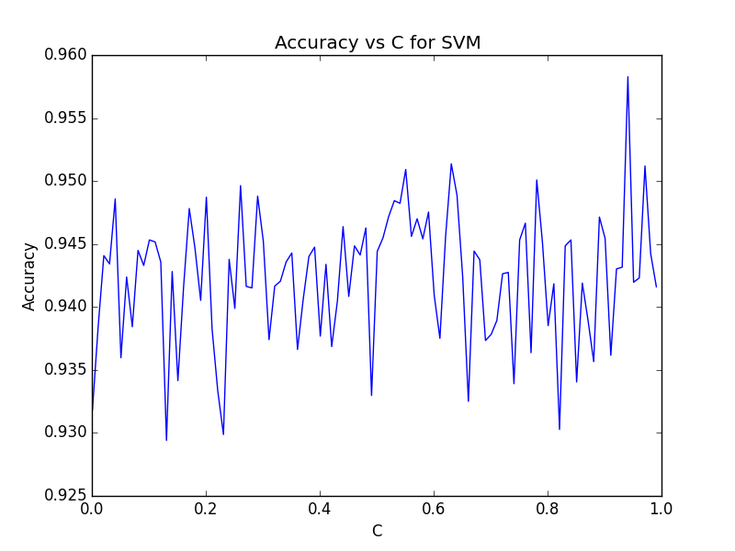

We performed a grid search to find the best C while T is fixed to 1000 and learning_rate is fixed to 0.94. The best C is 0.94.

**C:**Directory: " /specific/a/home/cc/students/csguests/roeiherzig/ML/EX2"See function "part_c" in file "q3.py"

The image file name: "q3_part_c.png"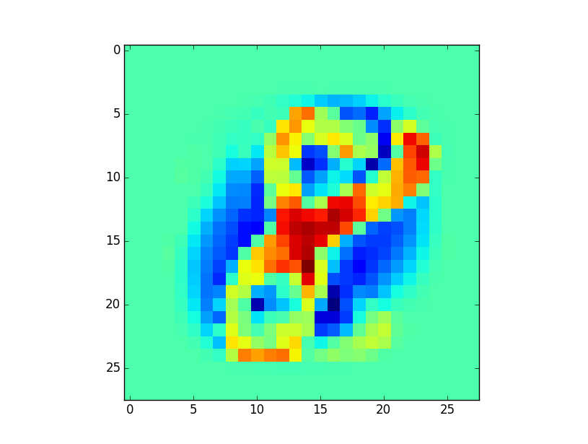

Using the best C and learning rate from previous sections, we trained our SGD SVM classifier with T=1000. The image above is the weight matrix. As we can see, the weights that are related to the different features between 8 and the 0 will be the most significant while predicting a sample.

**D:**

Directory: " /specific/a/home/cc/students/csguests/roeiherzig/ML/EX2"See function "part_d" in file "q3.py"

The accuracy of the best classifier on the test set is 0.97