# Advanced Methods in NLP – Assignment 1

1. **Question:** Prove that softmax is invariant to constant offset in the input, that is, for any input vector $\vec{x}$ and any constant C,

$$softmax\left(\overset{⃑}{x}\right)=softmax(\overset{⃑}{x}+c)$$

Where $\overset{⃑}{x}+c$ means adding the constant C to every dimension of $\overset{⃑}{x}$. Remember that

$$softmax\left(\overset{⃑}{x}\right)=\frac{e^{x_{i}}}{\sum_{j}{e^{x_{j}}}}$$

**Answer**: We will show that softmax is invariant to translation:

$$softmax\left(\overset{⃑}{x}+C\right)=\frac{e^{x_{i}+C}}{\sum_{j}{e^{x_{j}+C}}}=\frac{e^{C}e^{x_{i}}}{e^{C}\sum_{j}{e^{x_{j}}}}=\frac{e^{x_{i}}}{\sum_{j}{e^{x_{j}}}}=softmax\left(\overset{⃑}{x}\right)$$

1. **See softmax.py**
2. **Question:** Derive the gradients of the sigmoid function and show that it can rewritten as a function value (i.e, in some expression where only $σ(x)$, but not x, is present).

Assume that he input x is a scalar for this question.

Recall the sigmoid function is: $σ\left(x\right)=\frac{1}{1+e^{-x}}$.

**Answer:**

$\frac{dσ\left(x\right)}{dx}=-{\left(\frac{1}{1+e^{-x}}\right)}^{2}\frac{d}{dx}\left(1+e^{-x}\right)=-{\left(\frac{1}{1+e^{-x}}\right)}^{2}e^{-x}\left(-1\right)$ $=\left(\frac{1}{1+e^{-x}}\right)\left(\frac{e^{-x}}{1+e^{-x}}\right)=σ\left(x\right)(1-σ\left(x\right))$

1. **See sigmoid.py**
2. **See gradcheck.py**

**Word2vec**

1. **Question:**  
   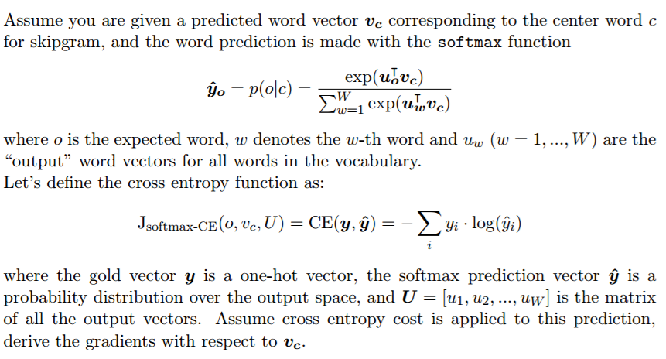

**Answer:**

The following is the gradients with respect to Vc.

$$\frac{∂J}{∂V_{c}}=-\frac{∂}{∂V_{c}}\log{\hat{y_{o}}}=-\frac{∂}{∂V_{c}}\left(\log{\hat{y_{o}}}\right)=-\frac{1}{\hat{y_{o}}}\frac{∂}{∂V_{c}}\left(\hat{y_{o}}\right)=$$

$$=-\frac{1}{\hat{y_{o}}}\left[\frac{u_{0}\exp\left(u_{0}^{T}V_{c}\right)}{\sum_{w=1}^{W}{\exp\left(u_{w}^{T}V_{c}\right)}}-\frac{\exp\left(u_{o}^{T}V_{c}\right)\sum_{w=1}^{W}{u_{w}\exp\left(u_{w}^{T}V_{c}\right)}}{{\left(\sum_{w=1}^{W}{\exp\left(u_{w}^{T}V_{c}\right)}\right)}^{2}}\right] \\ =-\left[u_{0}-\frac{\sum_{w=1}^{W}{u_{w}\exp\left(u_{w}^{T}V_{c}\right)}}{\sum_{w=1}^{W}{\exp\left(u_{w}^{T}V_{c}\right)}}\right]=-u_{0}+\sum_{w=1}^{W}{u_{w}P\left(w | c\right)} \\ =-u_{0}+{E[u]}_{p(w|c)}$$

1. **Question:**  
   

**Answer:**

* The gradients with respect to uw when w=o:
$$\frac{∂J}{∂u_{o}}=-\frac{∂}{∂u_{o}}\log{\hat{y_{o}}}=-\frac{1}{\hat{y_{o}}}\frac{∂}{∂u_{o}}\left(\hat{y_{o}}\right) \\ =-\frac{1}{\hat{y_{o}}}\left[\frac{v_{c}\exp\left(u_{0}^{T}V_{c}\right)}{\sum_{w=1}^{W}{\exp\left(u_{w}^{T}V_{c}\right)}}-\frac{v_{c}{\left(\exp\left(u_{o}^{T}V_{c}\right)\right)}^{2}}{{\left(\sum_{w=1}^{W}{\exp\left(u_{w}^{T}V_{c}\right)}\right)}^{2}}\right] \\ ={-v}_{c}+\frac{v_{c}\exp\left(u_{o}^{T}V_{c}\right)}{\sum_{w=1}^{W}{\exp\left(u_{w}^{T}V_{c}\right)}}=-v_{c}\left[1-\hat{y_{o}}\right]$$

* The gradients with respect to uw when w≠o:

$$\frac{∂J}{∂u_{w}}=-\frac{∂}{∂u_{w}}\log{\hat{y_{o}}}=-\frac{∂}{∂u_{w}}\log{\hat{y_{o}}}=-\frac{1}{\hat{y_{o}}}\frac{∂}{∂u_{w}}\left(\hat{y_{o}}\right) \\ =\frac{1}{\hat{y_{o}}}\frac{v_{c}\exp\left(u_{o}^{T}V_{c}\right)\exp\left(u_{w}^{T}V_{c}\right)}{{\left(\sum_{w=1}^{W}{\exp\left(u_{w}^{T}V_{c}\right)}\right)}^{2}}=\frac{v_{c}\exp\left(u_{w}^{T}V_{c}\right)}{\sum_{w=1}^{W}{\exp\left(u_{w}^{T}V_{c}\right)}}=v_{c}\hat{y_{w}}$$

**Question:**  
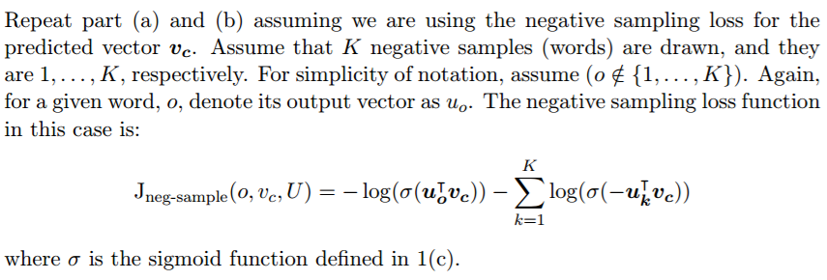

**Answer:**

As we saw in 1.c: $\frac{dσ\left(x\right)}{dx}=σ\left(x\right)(1-σ\left(x\right))$, therefore,

$$\frac{∂J_{neg-samples}}{∂V_{c}}=-\frac{u_{o}}{σ\left(u_{o}^{T}v_{c}\right)}σ\left(u_{o}^{T}v_{c}\right)\left(1-σ\left(u_{o}^{T}v_{c}\right)\right)-\sum_{k=1}^{K}{\left(σ\left(-u_{o}^{T}v_{c}\right)-1\right)u_{o}}=u_{o}\left(σ\left(u_{o}^{T}v_{c}\right)-1\right)-\sum_{k=1}^{K}{u_{o}\left(σ\left(-u_{o}^{T}v_{c}\right)-1\right)}$$

$$\frac{∂J_{neg-samples}}{∂u_{w}}=-\frac{V_{c}δ_{wo}}{σ\left(u_{o}^{T}v_{c}\right)}σ\left(u_{o}^{T}v_{c}\right)\left(1-σ\left(u_{o}^{T}v_{c}\right)\right)-\sum_{k=1}^{K}{\left(σ\left(-u_{o}^{T}v_{c}\right)-1\right)V_{c}}=V_{c}δ_{wo}\left(σ\left(u_{o}^{T}v_{c}\right)-1\right)-\sum_{k=1}^{K}{V_{c}δ_{wo}\left(σ\left(-u_{o}^{T}v_{c}\right)-1\right)}$$

1. 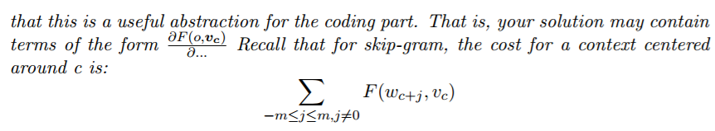**Question:**  
   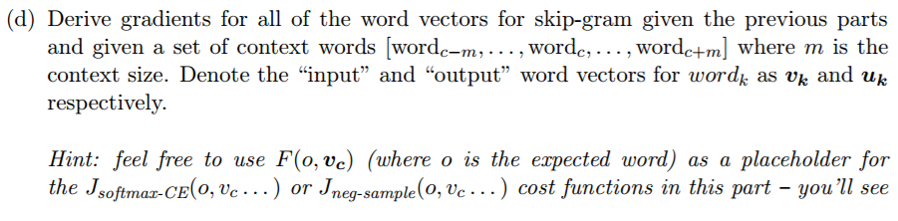

**Answer:**

As we saw in the previous parts we will denote $F(o,v_{c})$ as a placeholder for the cost functions and $\frac{dF(o,v_{c})}{du}$ and $\frac{dF(o,v_{c})}{dv_{c}}$.

For skip-gram the gradients for the cost of one context window are:

$$\frac{∂J_{skip-gram}({word}_{c-m….c+m})}{∂V_{c}}=\sum_{-m≤j≤m,j≠0}{\frac{∂F(w_{c+j},v_{c})}{∂V_{c}}}$$

$$\frac{∂J_{skip-gram}({word}_{c-m….c+m})}{∂w_{i}}=\sum_{-m≤j≤m,j≠0}{\frac{∂F(w_{c+j},v_{c})}{∂w_{i}}}$$

1. **See word2vec.py**
2. **See sgd.py**
3. **See knn.py**
4. **See run.py**