# Advanced Methods in NLP – Assignment 1

* 1. Implemented in file ngram_model.py.  
     run: python ngram_model.py  
     Results:

#trigrams: 413540

#bigrams: 122930

#unigrams: 2000

#tokens: 1231340

#perplexity: 36.7114693392

* 1. Implemented in file ngram model.py function lambda_grid_search()

run: python ngram_model.py

We preformed grid search:

* First we set lambda2=0.4 and grid search lambda1 for minimum perplexity
* Then, we set lambda1 to the best found and grid search lambda2 for minimum perplexity.

Results:  
 - best lambda1 is 0.451  
 - best lambda2 is 0.428  
 - best perplexity is 36.434527232

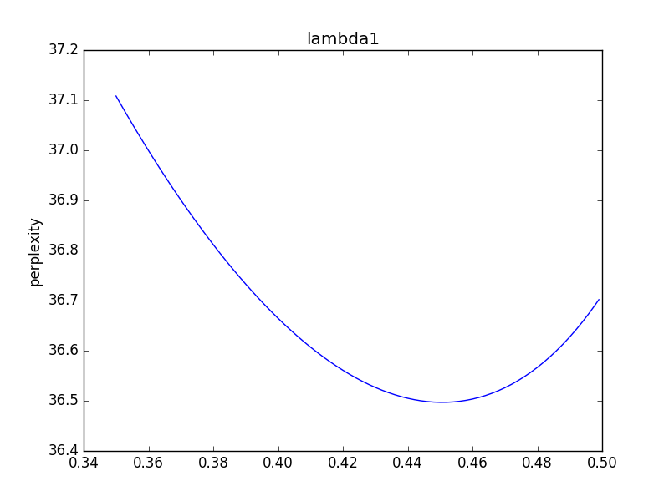

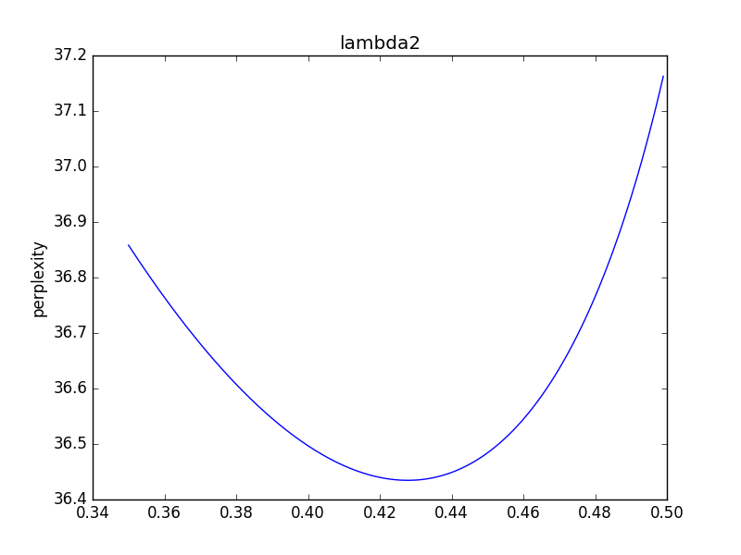

**Neural language model**

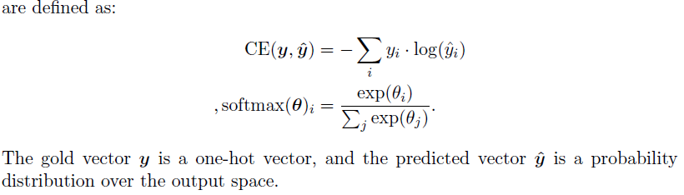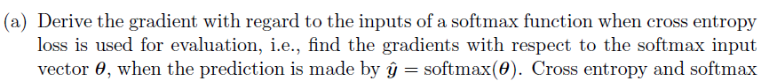

$$\frac{∂CE}{∂θ_{i}}=-\frac{∂}{∂θ_{i}}\log{\hat{y_{i}}}=-\frac{1}{\hat{y_{i}}}\frac{∂}{∂θ_{i}}\left(\hat{y_{i}}\right)=$$

$$=-\frac{1}{\hat{y_{i}}}\left[\frac{\exp\left(θ_{i}\right)}{\sum_{j=1}^{W}{\exp\left(θ_{j}\right)}}-\frac{{\left(\exp\left(θ_{i}\right)\right)}^{2}}{{\left(\sum_{j=1}^{W}{\exp\left(θ_{j}\right)}\right)}^{2}}\right] \\ =-\left[1-\hat{y_{i}}\right]=\hat{y_{i}}-1$$

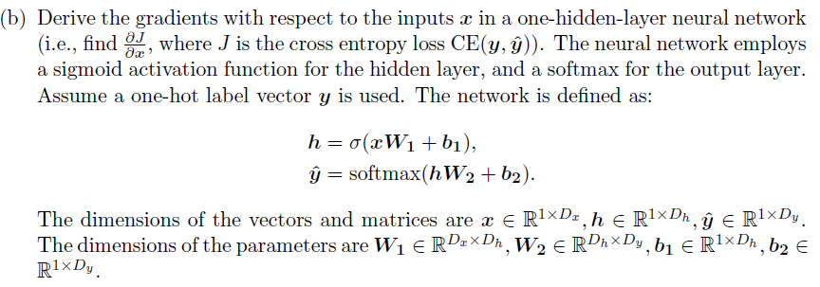

$$\frac{∂CE}{∂x_{i}}=\frac{∂CE}{∂θ_{i}}\frac{∂θ_{i}}{∂h_{i}}\frac{∂h_{i}}{∂x_{i}}=\left[\hat{y_{i}}-1\right]\left[{W2}_{i}\right]\left[h(x_{i})(1-h(x_{i})){W1}_{i}\right]$$

We have already calculated $\frac{∂CE}{∂θ_{i}}$ from previous section. In addition, we calculated $\frac{∂h_{i}}{∂x_{i}}$ (sigmoid derivative) in HW1.