# Advanced Methods in NLP – Assignment 1

* 1. Implemented in file ngram_model.py.  
     run: python ngram_model.py  
     Results:

#trigrams: 413540

#bigrams: 122930

#unigrams: 2000

#tokens: 1231340

#perplexity: 36.7114693392

* 1. Implemented in file ngram model.py function lambda_grid_search()

run: python ngram_model.py

We preformed grid search:

* First we set lambda2=0.4 and grid search lambda1 for minimum perplexity
* Then, we set lambda1 to the best found and grid search lambda2 for minimum perplexity.

Results:  
 - best lambda1 is 0.451  
 - best lambda2 is 0.428  
 - best perplexity is 36.434527232

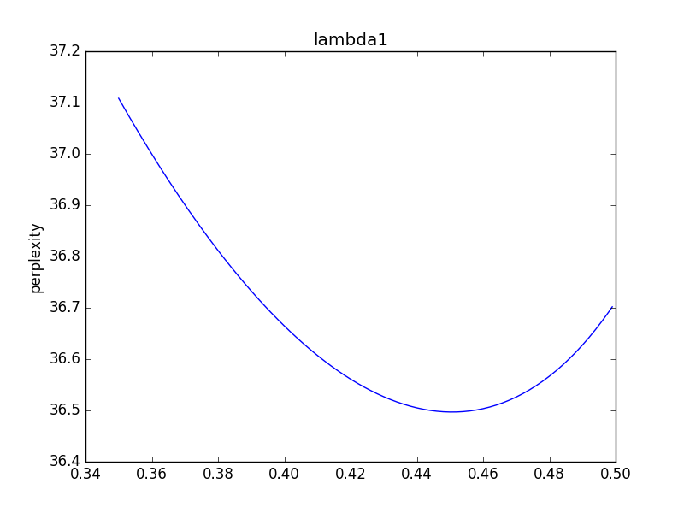

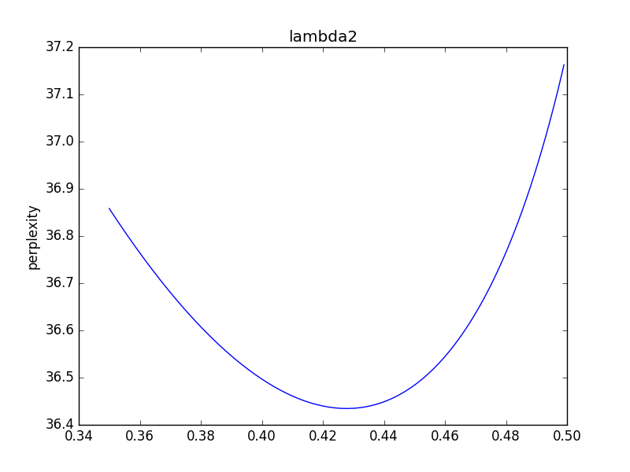

**Neural language model**

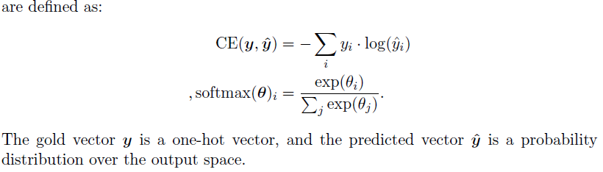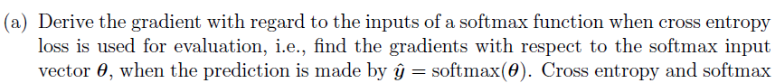

$$\frac{∂CE}{∂θ_{i}}=-\frac{∂}{∂θ_{i}}\log{\hat{y_{i}}}=-\frac{1}{\hat{y_{i}}}\frac{∂}{∂θ_{i}}\left(\hat{y_{i}}\right)=$$

$$=-\frac{1}{\hat{y_{i}}}\left[\frac{\exp\left(θ_{i}\right)}{\sum_{j=1}^{W}{\exp\left(θ_{j}\right)}}-\frac{{\left(\exp\left(θ_{i}\right)\right)}^{2}}{{\left(\sum_{j=1}^{W}{\exp\left(θ_{j}\right)}\right)}^{2}}\right] \\ =-\left[1-\hat{y_{i}}\right]=\hat{y_{i}}-1$$

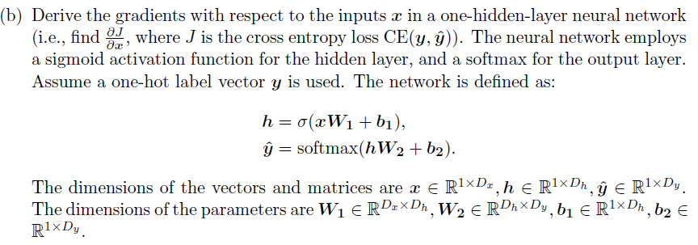

$$\frac{∂CE}{∂x_{i}}=\frac{∂CE}{∂θ_{i}}\frac{∂θ_{i}}{∂h_{i}}\frac{∂h_{i}}{∂x_{i}}=\left[\hat{y_{i}}-1\right]\left[{W2}_{i}\right]\left[h(x_{i})(1-h(x_{i})){W1}_{i}\right]$$

We have already calculated $\frac{∂CE}{∂θ_{i}}$ from previous section. In addition, we calculated $\frac{∂h_{i}}{∂x_{i}}$ (sigmoid derivative) in HW1.

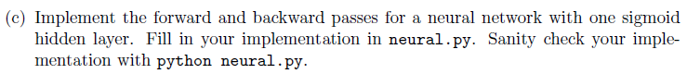

Implemented in file neural.py

Run: "python nerural.py"

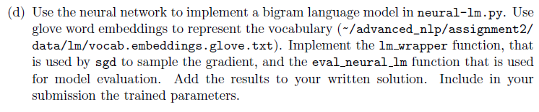

Implemented in neural_lm.py  
 Run: "python neural_lm.py"  
 The trained parameters saved under "saved_params_*.npy

Output:  
#params: 104550  
#train examples: 1118296  
iter 1000: expcost 5.286485 - cost 5.286485  
iter 2000: expcost 5.315578 - cost 5.868346  
iter 3000: expcost 5.278475 - cost 4.573526  
iter 4000: expcost 5.299101 - cost 5.690996  
iter 5000: expcost 5.266599 - cost 4.649052  
iter 6000: expcost 5.256994 - cost 5.074501  
iter 7000: expcost 5.204735 - cost 4.211819  
iter 8000: expcost 5.184658 - cost 4.803187  
iter 9000: expcost 5.174991 - cost 4.991324  
iter 10000: expcost 5.117166 - cost 4.018479  
iter 11000: expcost 5.095722 - cost 4.688299  
iter 12000: expcost 5.089447 - cost 4.970218  
iter 13000: expcost 5.109615 - cost 5.492810  
iter 14000: expcost 5.082564 - cost 4.568593  
iter 15000: expcost 5.066533 - cost 4.761941  
iter 16000: expcost 5.090010 - cost 5.536085  
iter 17000: expcost 5.075422 - cost 4.798232  
iter 18000: expcost 5.075031 - cost 5.067610  
iter 19000: expcost 5.073811 - cost 5.050622  
iter 20000: expcost 5.050655 - cost 4.610707  
iter 21000: expcost 5.027491 - cost 4.587370  
iter 22000: expcost 4.988164 - cost 4.240953  
iter 23000: expcost 4.960205 - cost 4.428979  
iter 24000: expcost 4.941922 - cost 4.594553  
iter 25000: expcost 4.949239 - cost 5.088261  
iter 26000: expcost 4.887178 - cost 3.708009  
iter 27000: expcost 4.886177 - cost 4.867171  
iter 28000: expcost 4.852245 - cost 4.207524  
iter 29000: expcost 4.878483 - cost 5.377017  
iter 30000: expcost 4.817329 - cost 3.655402  
iter 31000: expcost 4.831440 - cost 5.099539  
iter 32000: expcost 4.826084 - cost 4.724321  
iter 33000: expcost 4.813067 - cost 4.565740  
iter 34000: expcost 4.802932 - cost 4.610375  
iter 35000: expcost 4.807286 - cost 4.890003  
iter 36000: expcost 4.772416 - cost 4.109901  
iter 37000: expcost 4.797524 - cost 5.274563  
iter 38000: expcost 4.821694 - cost 5.280925  
iter 39000: expcost 4.803210 - cost 4.452024  
iter 40000: expcost 4.790578 - cost 4.550558  
training took 19408 seconds  
dev perplexity : 112.998698807