**CAPITULO IV.**

**Análisis de resultados …………………………………………………………... 30**

Metrics to show on the results:

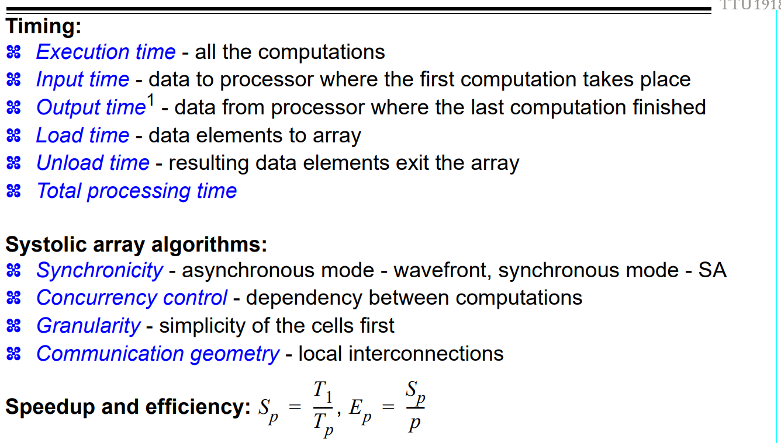

Ejemplo de análisis de resultados

[Borghesi] The overall processing time, once the image is stored in the V.M., is linearly dependent on the size of the filter and on the hardware configuration of the coprocessor. In its minimum configuration, the coprocessor can perform iD convolution of a 512 X 512 pixel image with an eight-coefficient filter in 35 msec (obviously a complete 2D convolution takes 70 msec). This figure directly derives from the processing power of the basic eight-cell A.U., which reaches 128 million operations per second.

The overall precision level provided by the present architecture has been demonstrated to be adequate for most ap- plications in the machine-vision field and is also useful if compared with floating-point software implementations.