1: Here https://schepen-kring.nl/nl/dashboard/admin/yachts/new and also by update a boat i want the same things down below. First remove the footer which cost us a lot of space which we need. I also see i cannot scroll high enough to hide the blue “New Vessel Registration”section to get the images much more clear.

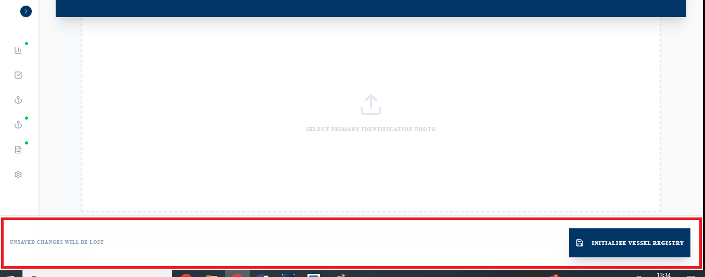

2: Add tabs above this blue section, this form gone work with AI + pinecone etc and need several steps. At the end of the tabs means latest tab is the CREATE / SAVE Tab. System need to build on this way when i close down by step 3 for example then it automaticly save what i filled untill step 3 so i can go further later. Even when i`am online or offline. We always store automaticly the step what we did. This finished and stored tabs become blue instead of grey.

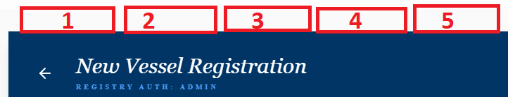

3: The image section need to come under tab 1 “Images”. Here at every image we need as earlier discussed the AI API`s to Gemini to understand all images and also to make all images perfect color and turn them automaticly etc. So when upload max 30 images at once the AI system gone work. We save all images as WEBP files because this is much smaller KB and much better and cheaper for AI.

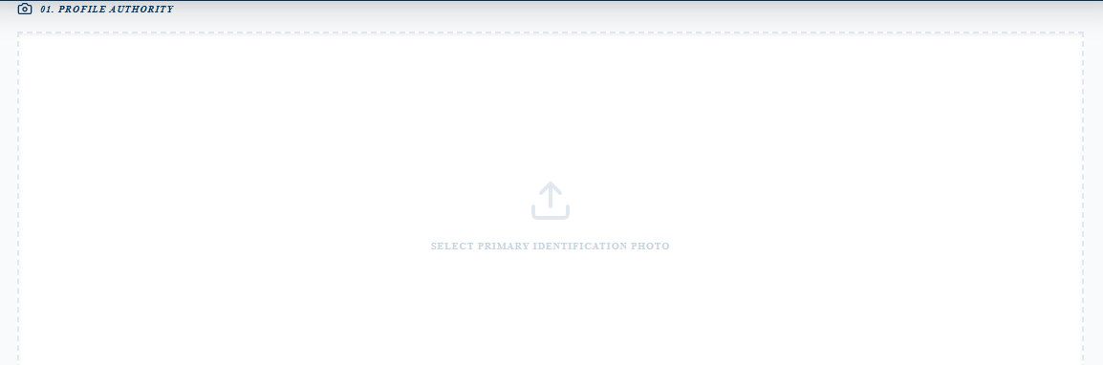

4: To be honest i dont know what this is doing? But AI image analyse need to happen as explained on step 1 when we click NEXT to step 2. So we dont need this section.

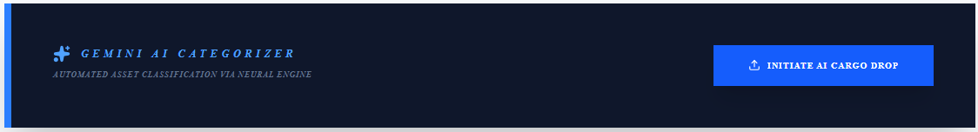

We also dont need that other 5 image sections below the page because only step 1 is for images nothing else so delete that also.
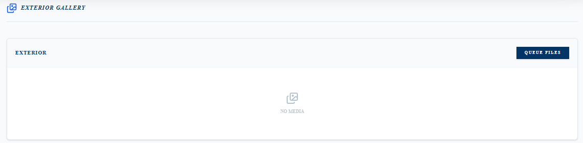

5: The section Essential Registry Data need to come under tab 2 together with Technical Dossier. Make all headers little bit bigger and darker they are hard to read now. Everything untill Display Specifications see next task. The biggest headache is that we need to send all this things as JSON to Gemini together with all uploaded images from step 1. Means when we go from step 1 to this step 2 then system show a loader untill Gemini is finished. We show all images as WEBP files because this is much smaller KB and much better and cheaper for Gemini see step 1

Goal: With a trained AI system (Gemini + Pinecone) this form is automaticly filled for 90% already! It will be cool if possible when we do mouseover on a record for example FLYBRIDGE that it show the image where AI found this record to check manuelly if it is right / wrong.
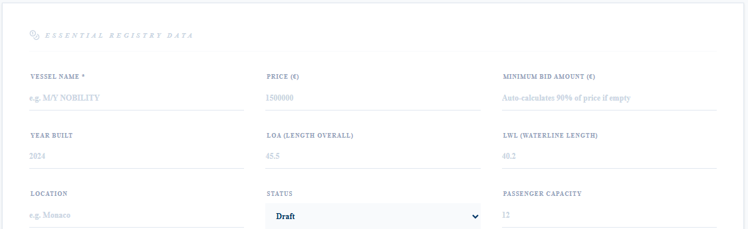

6: Display Specifications we dont need 99% from all boats, this options are good but we move it to the latest step. “Display”

7: As 3th step after “Images” and “Specs” we gone show “Text”. We got the images analysed, we got the right checkmarks at the right options. Now we send this to Gemini and we ask for 3 texts. Dutch / English / Germany so we also show 3 language flags to select which language we want to read / update. We also show tekst to speech in the selected language. Instead of read we can listen to tekst. When all texts are good we store this 3 texts and at frontend we use the right language based on the chosen language at header.

8: Most of the times 1 shipowner keep and sell his boat every 3 year. Which means boats are coming back. Which means based on the uploaded images the system recognize the boat to fill in all steps automaticly. On this way we easy RE-USE a boat to put it online. In fact it is a OFFLINE boat which we put online again but salesguys not always remember all 1000 boats which they sold last 3 year thats why system need to help.

9: Step 4 – Checklist Builder (Admin CRUD) We need a reusable Checklist Template Builder in the admin panel. (So under step 4 ADMIN can create / Update Questions like a FAQ).
Each checklist question which we store in a “boat_check” DB must contain:
- question_text
- type → ENUM:
  - YES_NO
  - MULTI
  - TEXT
  - DATE
- required → boolean
- ai_prompt → custom prompt explaining how AI should determine the answer
- evidence_sources → array:
  - photos
  - spec_json
  - documents
- weight or priority → low / medium / high
- Applicable boat type (generic or specific category) For example only show when Sailship or motorboat is selected by previous step.
This allows us to create questions under tab 4 which can be unique for a boat type. For each checklist question, the UI must show:
- “Wood interior?”
→ AI: YES (92%)
→ Button with a link to modal which show: image 3 (interior)
- “Ship broken?”
→ AI: YES (80%)
→ Button with a link to modal which show: image “Photo 5 (outside)”

C) Human Review User can:
- Accept AI answer
- Override answer
- Mark as verified
Generate a downloadable Control Report PDF which we also show at boat frontend based on questions which are important for people who want to buy a boat which are mostly answered by AI.
10: Google Merchant is finished you said. So when we create a boat in the latest step i want “Advertising” here you show for example 12 logo`s which we can (de)select means color / grey logo show. Based on this we send this boat to Google Merchant but also to Yachtshift. I`am almost sure you can tell the Yachtshift api to which websites Yachtshift need to send the boat so we use this logo`s also for (de)select.

11: We want super cheap video generation from ~30 boat photos at step 1 + text/voice at step 3, so we should NOT use expensive AI video APIs. Instead we use FFmpeg (open-source video engine) on our own server.

What is FFmpeg?
FFmpeg is a command-line tool (not a SaaS API). We install it on our VPS/container and our backend (Laravel) calls it to render videos.

Goal
Generate an MP4 slideshow video from:
- up to 30 uploaded images (we already store images as WEBP)
- chosen background music
- Step 3 voiceover (TTS audio file)
- optional text overlays (highlights)
Output must be YouTube compatible MP4 (H264 + AAC).

Why this approach
- Costs few penny per video (CPU render + storage).
- Fully template-based (consistent NauticSecure style)
- Scales easily with a job queue

Pipeline we want
- User uploads photos (Step 1)
- AI generates script/highlights (cheap) + optional TTS creates voice.mp3
- Backend queues a video_job
- Worker runs FFmpeg to render final.mp4
- Save video to storage (S3/local) and attach to listing

Server setup
Install FFmpeg on Ubuntu:
sudo apt update
sudo apt install ffmpeg
ffmpeg -version

Rendering (example commands)

A) Slideshow from images (3 sec per image)
(we can copy/convert WEBP to a temp folder and ensure correct ordering)
ffmpeg -y -framerate 1/3 -pattern_type glob -i "*.webp" \
-c:v libx264 -r 30 -pix_fmt yuv420p slideshow.mp4

B) Add background music
ffmpeg -y -i slideshow.mp4 -i music.mp3 \
-c:v copy -c:a aac -shortest with_music.mp4

C) Add voiceover (mix with music if needed)
ffmpeg -y -i slideshow.mp4 -i voice.mp3 \
-c:v copy -c:a aac -shortest final.mp4
(If we want music + voice together: use amix in filter_complex.)

Implementation notes
- Use Laravel Queue (Redis) for video_jobs so rendering runs async in a worker.
- Store job status: queued / processing / done / failed + error logs.
- Keep a fixed template: intro/outro, logo watermark, transitions, captions (later).
- Make sure output is H264 + AAC for max compatibility.

