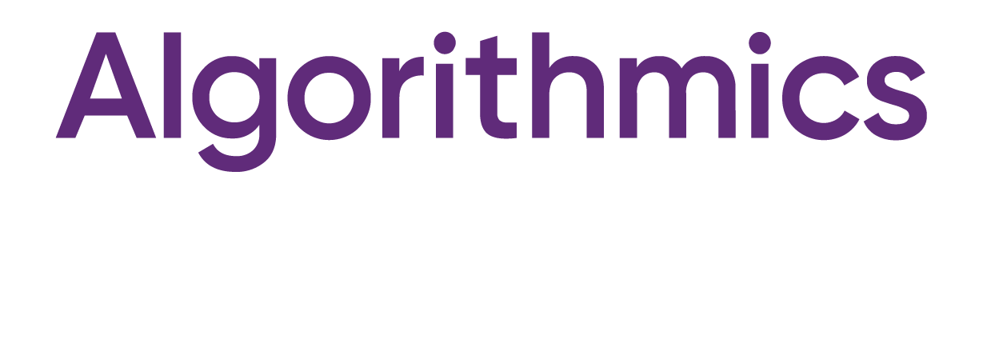

International school of programming

Phnom Penh

Yim Soyashin

Module 4

**Module:**

Python Start 1

**Course:**

**Course:**

**Recommendation:**

**Achievements:**

**A child learnt:**