We have been analysing data since the dawn of human civilization, in Sumeria, where the country of Iraq is now located, we have discovered one of the first ever databases inscribed onto a clay tablet containing lists of ploughmen employed by the state. The wages of these ploughmen are calculated from this raw data thus the discipline of data analytics was born. Inscriptions on clay tablets were of course eventually replaced by paper and in the ninth century Sumeria is also where algebra and the decimal system were invented, both of which made the calculations and the structure of data more efficient. Data has been collected and analysed since ancient times for various purposes such as censuses, planning activities, agriculture, taxation and trade (Dercyk, 2020).

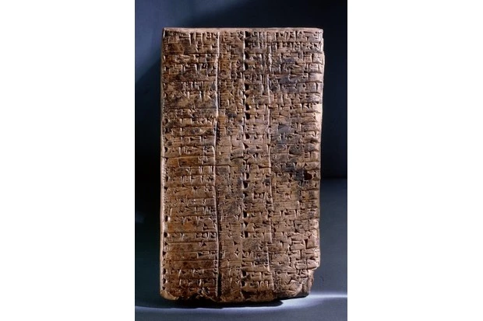

Prior to computers and machines it used to take over seven years for the United States Census Bureau to finish collecting data for their final census count and report, a tabulating machine was used at the end of the nineteenth century which made use of punch cards to speed up the census process to the point where it could be finished in a year and a half (Foote, 2021). The emergence of computing in the mid twentieth century has enabled the capabilities of data analytics to expand exponentially. Businesses and organisations started using computers to process and analyse data, mainframe systems were developed, and static reports were born, these static reports could be read but not edited once it was completed by the programmer, basic search and custom filtering was introduced but still tied to whatever the programmer thought was useful to present. Data within these static reports was often presented as a single list, the relational model was introduced, and networks of tables were utilised allowing for dynamic data collection (Codd, 1970).

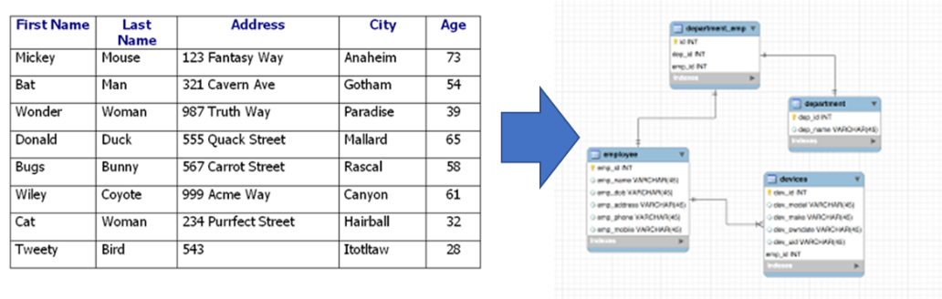With the introduction of relational models in databases, the need for a dedicated standardised logical language arose, SQL (Structured Query Language) was designed in the 1970s at IBM by Donald D. Chamberlin and Raymond F. Boyce and offered a standard for managing and manipulating databases, in 1979 the first commercially available relational database management system, Oracle, implemented the language of SQL. The language was extremely concise and did not allow any room for errors thus the formal job of the trained data analyst was born. Relational databases and SQL allowed for data analysis on demand and is still widely used today even though they are unfortunately quite rigid (Dercyk, 2020).

Data mining began in the 1990s, it was the process of discovering patterns within large data sets, it was a direct result of the evolution of relational database technology and the leaps and reductions in cost in the field of data storage, allowing businesses and organisations to store more data and also analyse it quickly and efficiently to the point where a business could create models to predict the needs and behavioural patterns of their customers (Foote, 2021).

With the advent of the personal computer and the internet’s rise in popularity in the 1990s, these relational databases could not keep up with the demand of the time, the constant stream of data and the variety of data types from many sources led to non-relational databases also known as NoSQL (Not Only SQL), which was coined by Carlo Strozzi in 1998 but the modern concept of NoSQL truly began around 2009 when big data companies such as Amazon, Google and Facebook faced challenges managing massive amounts of data (Lacefield, 2018).

Big Data is a term coined by Roger Magoulas when he was describing the overwhelming volume of data being stored and processed in the mid-2000s, it was impossible to deal with using the corporate tools available. In 2005, Apache Hadoop was developed as an open-source framework which could process both structured and unstructured data from many different digital sources, it was followed up by Apache Spark and Apache Cassandra in the late 2000s, furthering the ability to process big data. These frameworks bypassed the need for all large data to be structured which would have been impossible given the size and complexity of the data (Dercyk, 2020).

Data Visualisation’s history can be traced back to ancient times when mankind used maps, charts and diagrams to represent information, however in the modern day, enabled by a surge in computing power after the rise of Big Data and the size and complexity of what was being stored grew the demand for Data Visualisation. Businesses and organisations had to be able to make sense of what was being stored often in the form of easily understandable visual representations such as charts and graphs (Dercyk, 2020).

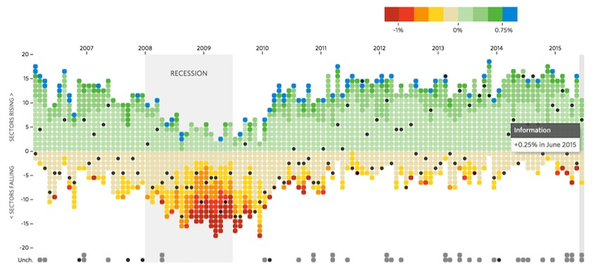

Codd, E. F. (1970). A Relational Model of Data for Large Shared Data Banks. *Information Retrieval Vol 13*, 377-387.

Dercyk, B. (2020, September 15). *A brief, brief history of Data Analytics*. Retrieved from LinkedIn: https://www.linkedin.com/pulse/brief-history-data-analytics-deryck-brailsford-%E5%AD%99%E5%BE%B7%E7%91%9E

Foote, K. D. (2021, September 20). *A Brief History of Analytics*. Retrieved from Dataversity: https://www.dataversity.net/brief-history-analytics/

Lacefield, J. (2018, August 29). *The Evolution of NoSQL*. Retrieved from Datastax: https://www.datastax.com/blog/evolution-nosql