**Formula Builder UI**

**Author:** Rohan Gaikwad

**Email:** [rohangaikwad@itantaanalytics.com](mailto:rohangaikwad@itantaanalytics.com)

**Contact:** +91 8237925724

**Version:** 1.0.0

**Introduction**

This document provides a brief overview of the formula builder with respect to UI and technical implementation details.

**Overview**

* First screen will have below interface with ADD New formula and EDIT Formula options along with DEL Formula.

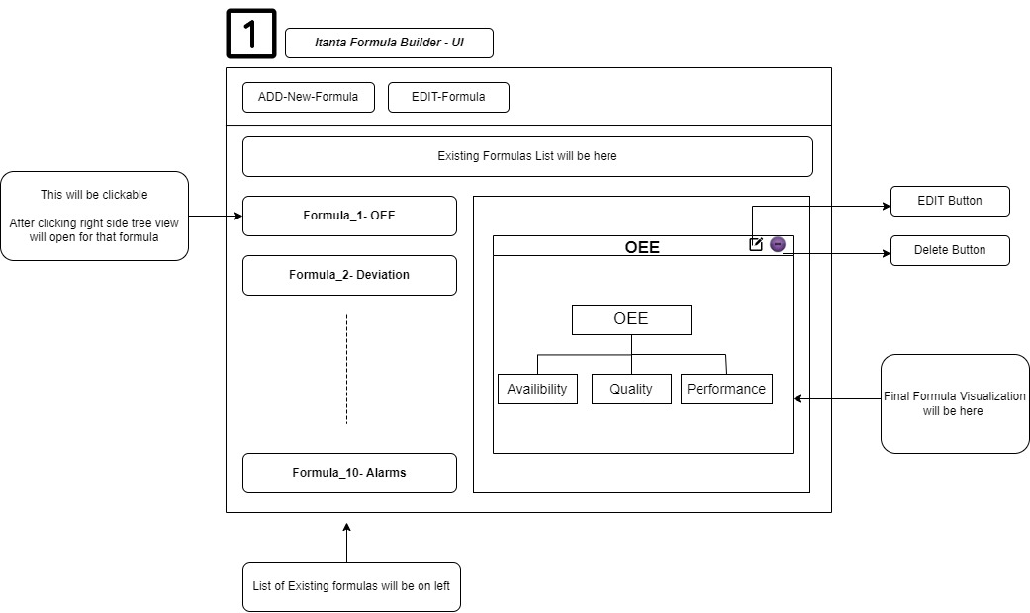

Left side will have all the list of Existing Formulas. User can click on individual formula to open it’s tree view representation on right side. There will be two options with each formula i.e.. Edit and Delete.

User can click on the any of the sub formula i.e.. in above case ( click on Quality, Performance, Availability ) and it’s own configuration will open up in new tab.

* Once User Clicks on Add new Formula OR any of the Sub-Formula from Tree in right side view below configuration will open up

This will the basic configuration of formula i.e.. name , result collection and the start interval configuration.

Start Interval will be of two types i.e..

* Interval Based
  + Take Mahale OEE Example where we need to write result collection with a object for every 5min interval independent of the any condition.
* OnChange Data Logging Based
  + Alarms Example where duration of the alarm is need to be calculated when certain condition is met i.e.. status == 0 ( system is OFF alarm )

Any one of the Interval Configuration can be given here

1. Once the Basic Configurations are provided and clicked on save and proceed next individual tag configurator will open up

* + First click on the ADD Result Tag to create a dummy tag which will appear in the result collection object box on right side. (Default tagName – CUSTOM_TAG_1 , can be edited by user)
  + Once tag appeared in result collection box click on tag itself to open it’s configurations.
  + From Select user will select the Data-Source from available data sources and once data-source is selected it’s tags will be seen in the left side section with groups in text columns, number columns and time_columns along with already configured tags (*** will explain further***)
  + User Can Drag and drop tags from left side and aggregator from bottom of the screen and placed them together along with mathematical operations to form the relation.
  + Right side of screen will be the configurator for providing the type of the tag, filters, tag_names , etc.
  + The resultant formula will be displayed at the top section.

**How to form Hierarchy ?**

Consider following formula

Performance = (ProdCount * Cycle Time) / ( Run Hr - Loss )

For now consider only numerator

i.e.. ***Performance = Prodcount * Cycle Time***

In this formula as well ProdCount is also a calculated tag , it’s not directly coming from data. Hence formula can be represented as

In this case when formula forms hierarchy first visualize the entire tree and start configurating with the bottom most derived tags .

Here Value is tag coming from data we go one level up and we’ll configure ProdCount first as one of result tag which on saving will appear in left side tag list from where it can be utilized.

In this way hierarchical formula can be constructed by starting the configurations of the bottommost sub-formulas / tags first and levelling one way up.

**Implementation Details**

|  |  |  |  |
| --- | --- | --- | --- |
| **Formula Type** | **Aggregation Based** | **OnChange Based** | **Complex** |
| Supported | Yes | Yes | Custom Script |
| Meaning | Write Result doc for every interval by calculating certain parameters without depending upon data logging | Write Result doc only when certain tag value is changed |  |
| Example | Mahle – OEE,  AGCL – Consumption | Britannia – Alarms, Deviation,  AGCL - Alarms |  |

|  |  |  |  |
| --- | --- | --- | --- |
| **Tag Type** | **Data-Tag** | **Derived Tag** | **Dynamic Tag** |
| No. of Data-sources | 1 | 1 | More than 1 |
| Default | True | False | False |
| Meaning | Just Copy paste from data collection  Acts as a distinct column | Calculated over data-columns | Calculated using More than 1 data-sources  Generally, use when Manual Input is involved |