**Task 2**

1. Write a SQL query to retrieve the name, account type and email of all customers

**Select concat(c.first_name,' ',c.last_name) as name,a.account_type,c.email**

**from customers c inner join accounts a**

**on c.customer_id = a.customer_id**

**order by first_name;**

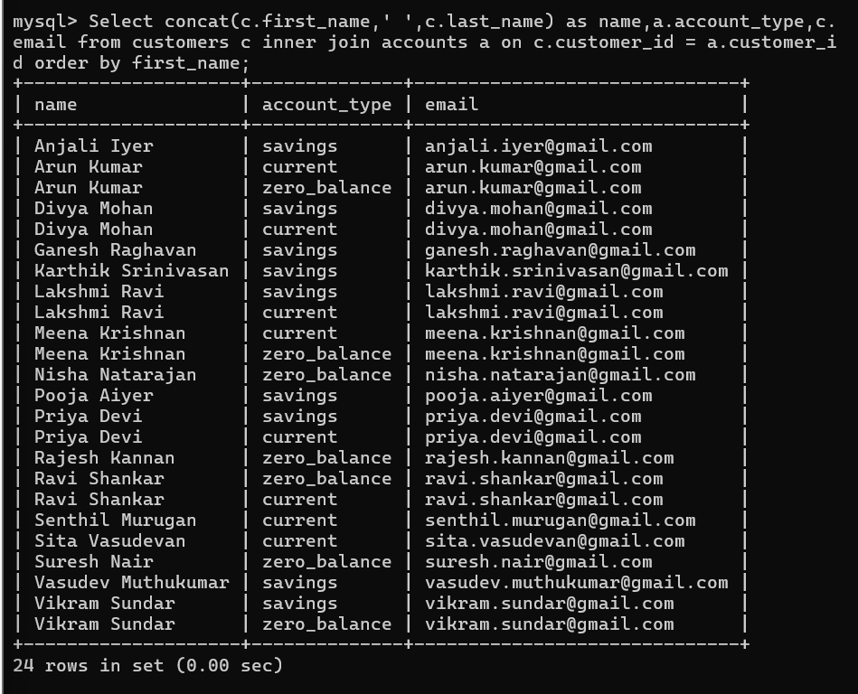

2. Write a SQL query to list all transaction corresponding customer

**SELECT c.customer_id,**

**c.first_name,**

**c.last_name,**

**t.transaction_id,**

**t.transaction_type,**

**t.amount,**

**t.transaction_date**

**FROM customers c**

**JOIN accounts a ON c.customer_id = a.customer_id**

**JOIN transactions t ON a.account_id = t.account_id;**

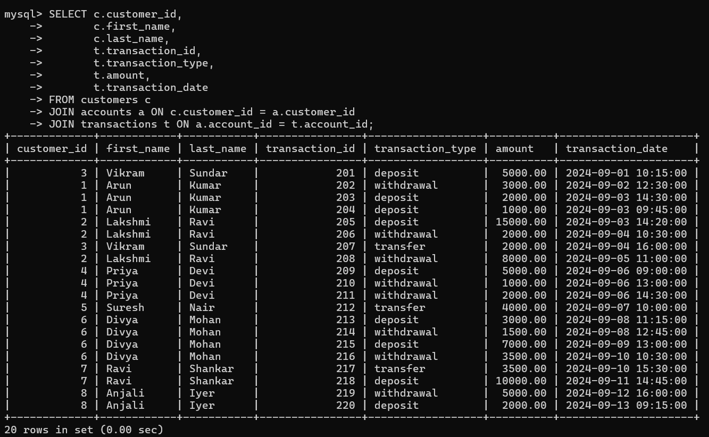

3. Write a SQL query to increase the balance of a specific account by a certain amount.

**update accounts set balance = balance + 1000 Where account_id = 111;**

4. Write a SQL query to Combine first and last names of customers as a full_name.

**SELECT concat(first_name,' ',last_name) as name from customers;**

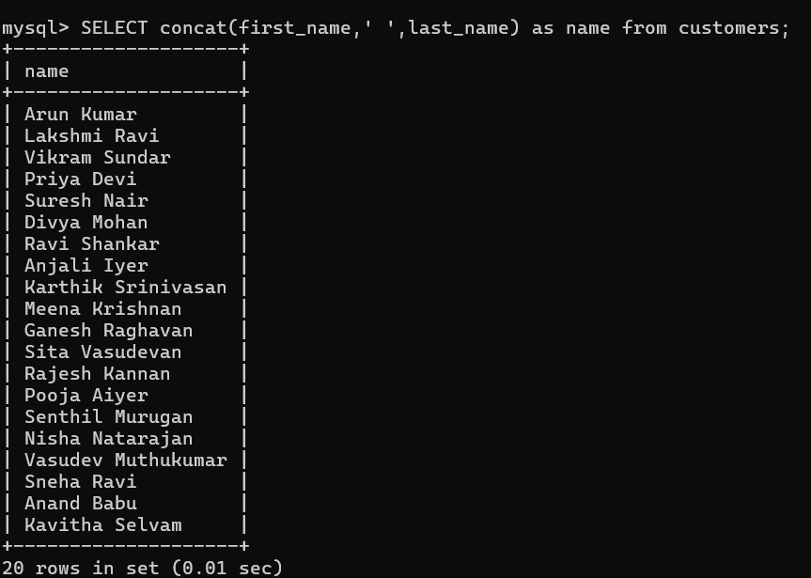

5. Write a SQL query to remove accounts with a balance of zero where the account type is savings

**DELETE FROM accounts WHERE account_type='savings' and balance=0;**

6. Write a SQL query to Find customers living in a specific city.

**SELECT concat(first_name,' ',last_name), address**

**FROM customers**

**WHERE address**

**LIKE '%chennai%';**

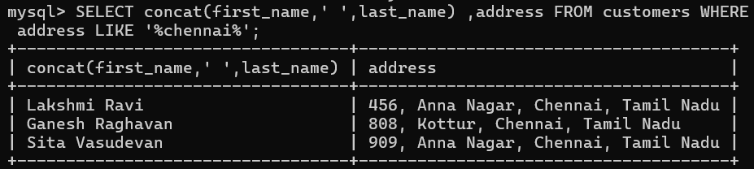

7. Write a SQL query to Get the account balance for a specific account

**select balance from accounts where account_id=112;**

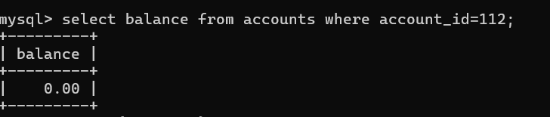

8. Write a SQL query to List all current accounts with a balance greater than $1,000.

**Select account_id,customer_id,account_type,balance**

**from accounts**

**where account_type='current' and balance >= 15000**;

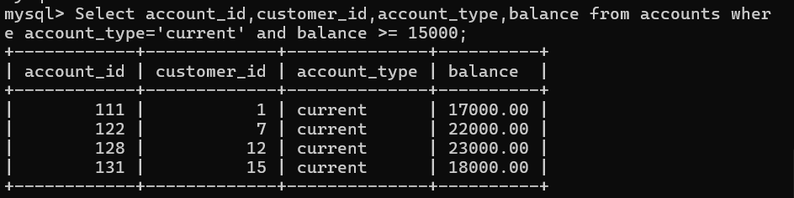

9. Write a SQL query to Retrieve all transactions for a specific account

**select transaction_type as Trasnsactions,amount**

**from transactions**

**where account_id=111;**

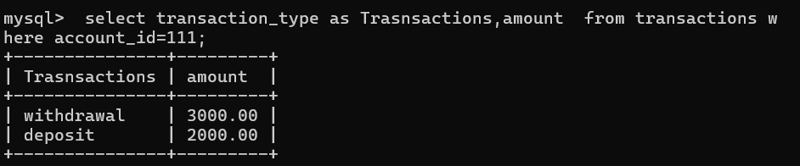

10. Write a SQL query to Calculate the interest accrued on savings accounts based on a given interest rate.

**Select account_id , customer_id, balance,(balance*0.02) as Intrest**

**From Accounts Where account_type=’savings’;**

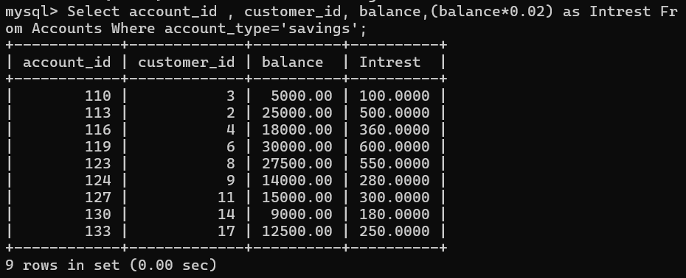

11. Write a SQL query to Identify accounts where the balance is less than a specified overdraft limit.

**select account_id from accounts where balance < 10000;**

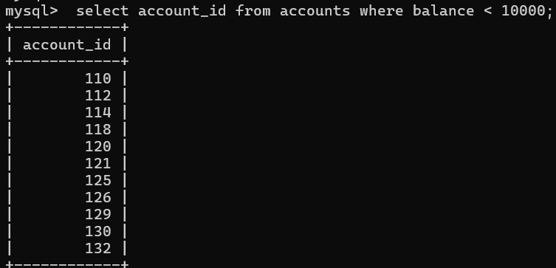

12. Write a SQL query to Find customers not living in a specific city.

**SELECT concat(first_name,' ',last_name) as name**

**FROM customers**

**where address not like '%chennai%';**

