**Task 3**

1. Write a SQL query to Find the average account balance for all customers

**select customer_id,avg(balance) as average**

**from accounts**

**group by customer_id;**

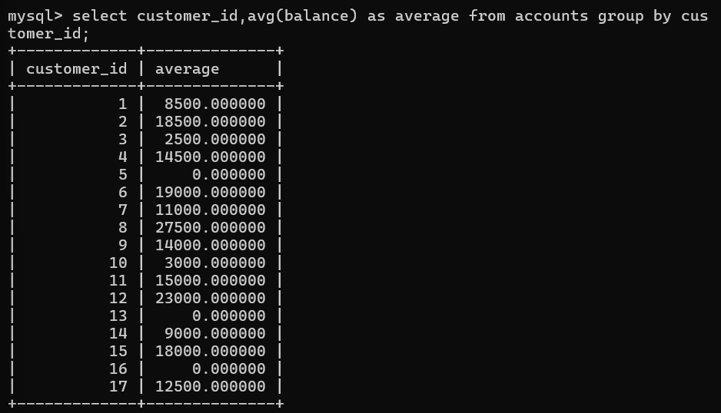

2. Write a SQL query to Retrieve the top 10 highest account balances**.**

**select customer_id,account_id,balance from accounts order by balance desc limit 10;**

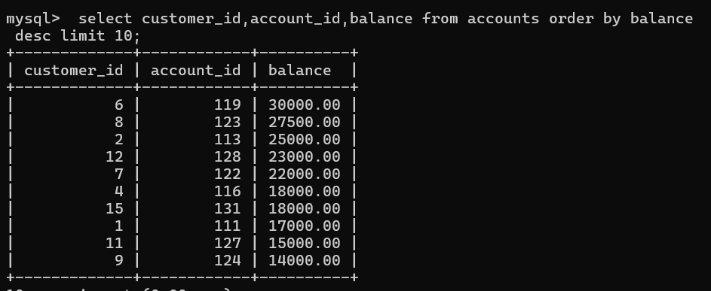

3. Write a SQL query to Calculate Total Deposits for All Customers in specific date

**SELECT SUM(amount) AS total_deposit, DATE(transaction_date) AS transaction_date**

**FROM transactions**

**WHERE transaction_type = 'deposit' AND DATE(transaction_date) = '2023-09-15'**

**GROUP BY DATE(transaction_date);**

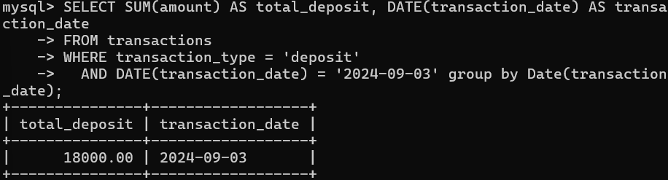

4. Write a SQL query to Find the Oldest and Newest Customers.

**SELECT c.customer_id, c.first_name, c.last_name, a.account_joining_date**

**FROM customers c**

**JOIN accounts a ON c.customer_id = a.customer_id**

**WHERE a.account_joining_date IN (**

**(SELECT MIN(account_joining_date) FROM accounts),**

**(SELECT MAX(account_joining_date) FROM accounts)**

**);**

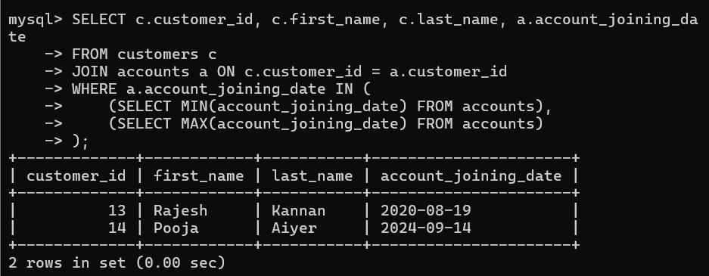

5. Write a SQL query to Retrieve transaction details along with the account type.

**select a.account_type,t.amount as transaction_amount,**

**t.transaction_type from accounts a**

**join transactions t on**

**a.account_id=t.account_id;**

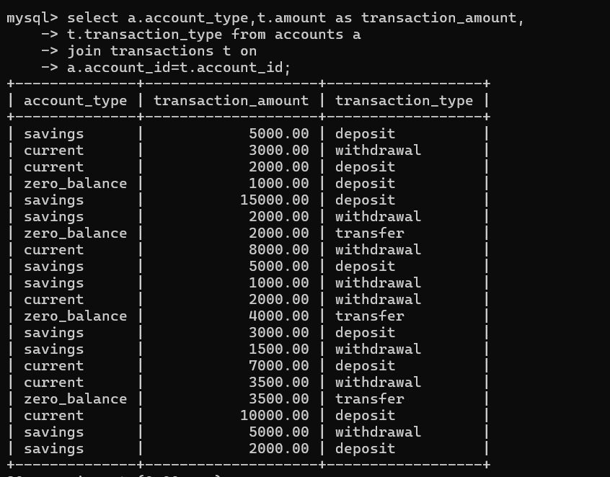

6. Write a SQL query to Get a list of customers along with their account details.

**select c.first_name,c.last_name,a.account_id,a.account_type,**

**a.balance from customers c join accounts a**

**on c.customer_id = a.customer_id;**

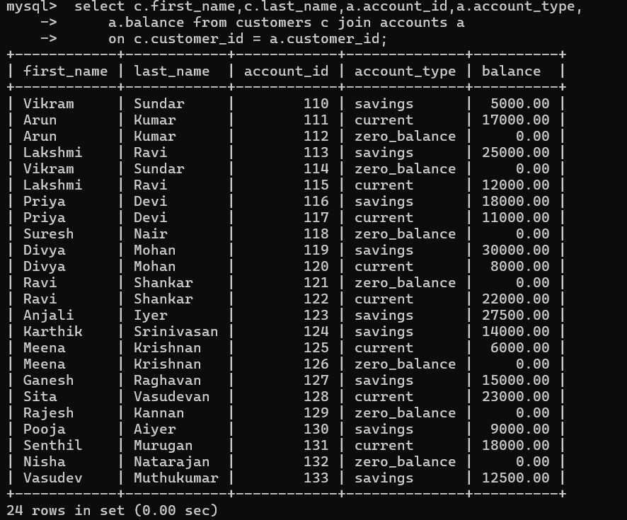

7.Write a SQL query to Retrieve transaction details along with customer information for a specific account?

**SELECT c.first_name,**

**c.last_name,**

**a.account_id,**

**t.transaction_type,**

**t.amount**

**FROM customers c**

**JOIN accounts a ON c.customer_id = a.customer_id**

**JOIN transactions t ON t.account_id = a.account_id**

**Where a.account_id=111;**

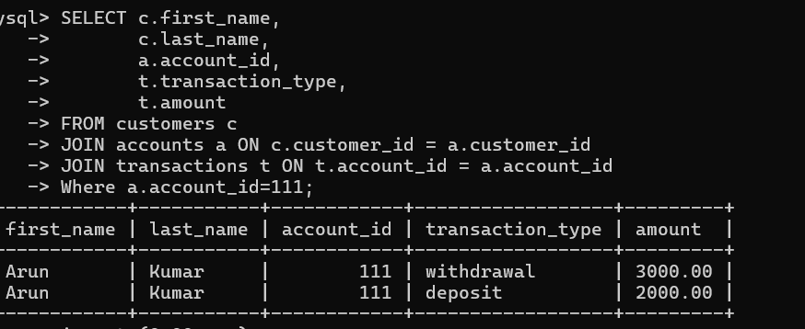

8. Write a SQL query to Identify customers who have more than one account

**Select c.customer_id,c.first_name,c.last_name,**

**count(a.customer_id) as total_accounts**

**from customers c join accounts a**

**on c.customer_id = a.customer_id**

**group by a. customer_id**

**having count(a.customer_id)>1;**

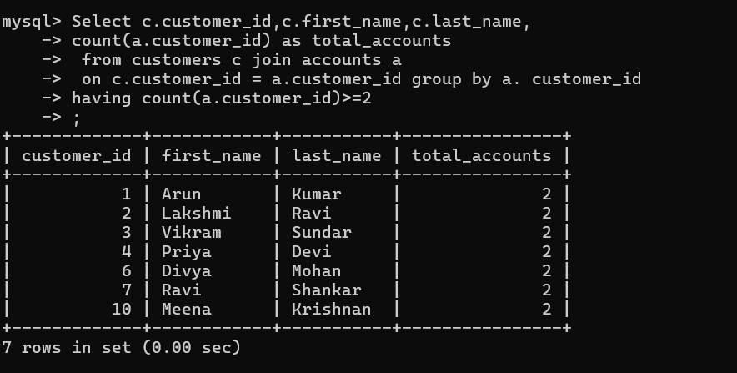

9. Write a SQL query to Calculate the difference in transaction amounts between deposits and withdrawals

**select**

**(select SUM(amount) from transactions WHERE transaction_type = 'deposit')**

**-**

**(select SUM(amount) from transactions WHERE transaction_type = 'withdrawal')**

**as difference;**

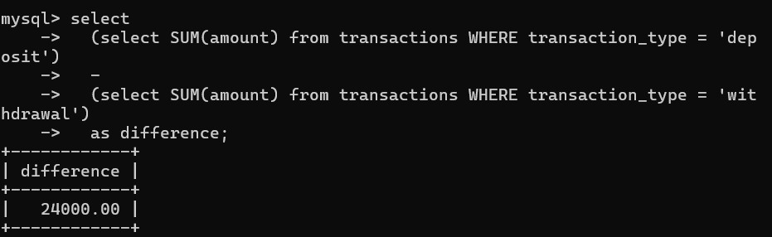

10. Write a SQL query to Calculate the average daily balance for each account over a specified period

**SELECT a.account_id,**

**AVG(balance) AS avg_daily_balance**

**FROM accounts a**

**JOIN transactions t ON a.account_id = t.account_id**

**WHERE t.transaction_date BETWEEN '2024-09-06' AND '2024-09-08'**

**GROUP BY a.account_id;**

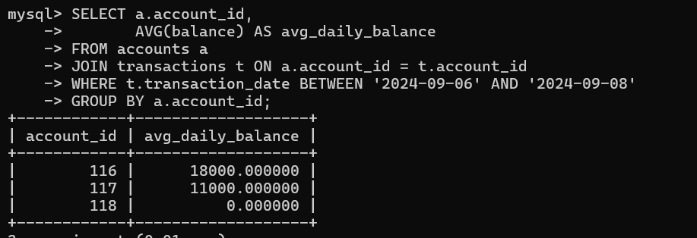

11. Calculate the total balance for each account type

**select account_type,sum(balance) as Total_amount**

**from accounts**

**Group by account_type;**

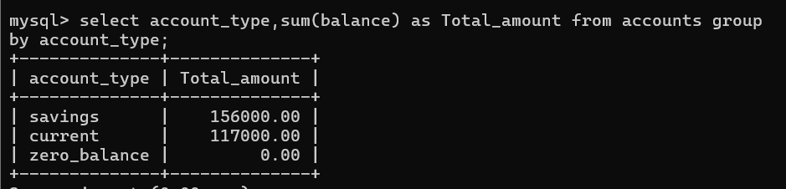

12. Identify accounts with the highest number of transactions order by descending order.

**select account_id,count(account_id) as Tot_No_Transaction**

**from transactions**

**group by account_id**

**order by count(account_id) desc;**

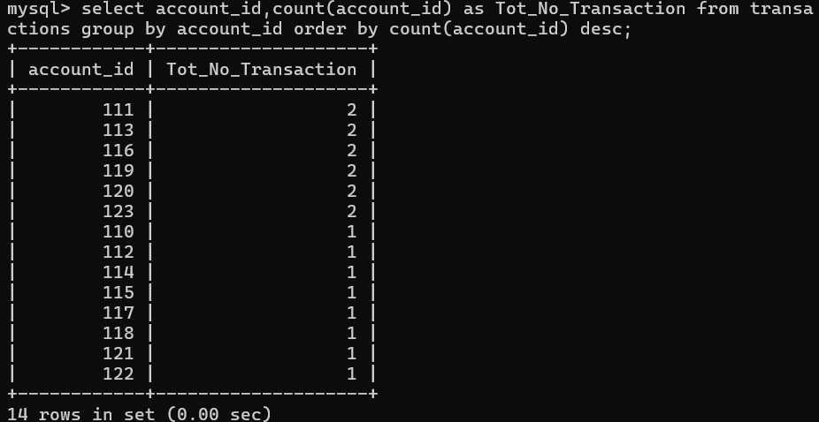

13. List customers with high aggregate account balances, along with their account types.

**select c.customer_id,c.first_name,a.account_type,sum(a.balance) as Total_balance from customers c join accounts a**

**on c.customer_id = a.customer_id**

**group by a.account_type,c.customer_id**

**order by total_balance DESC;**

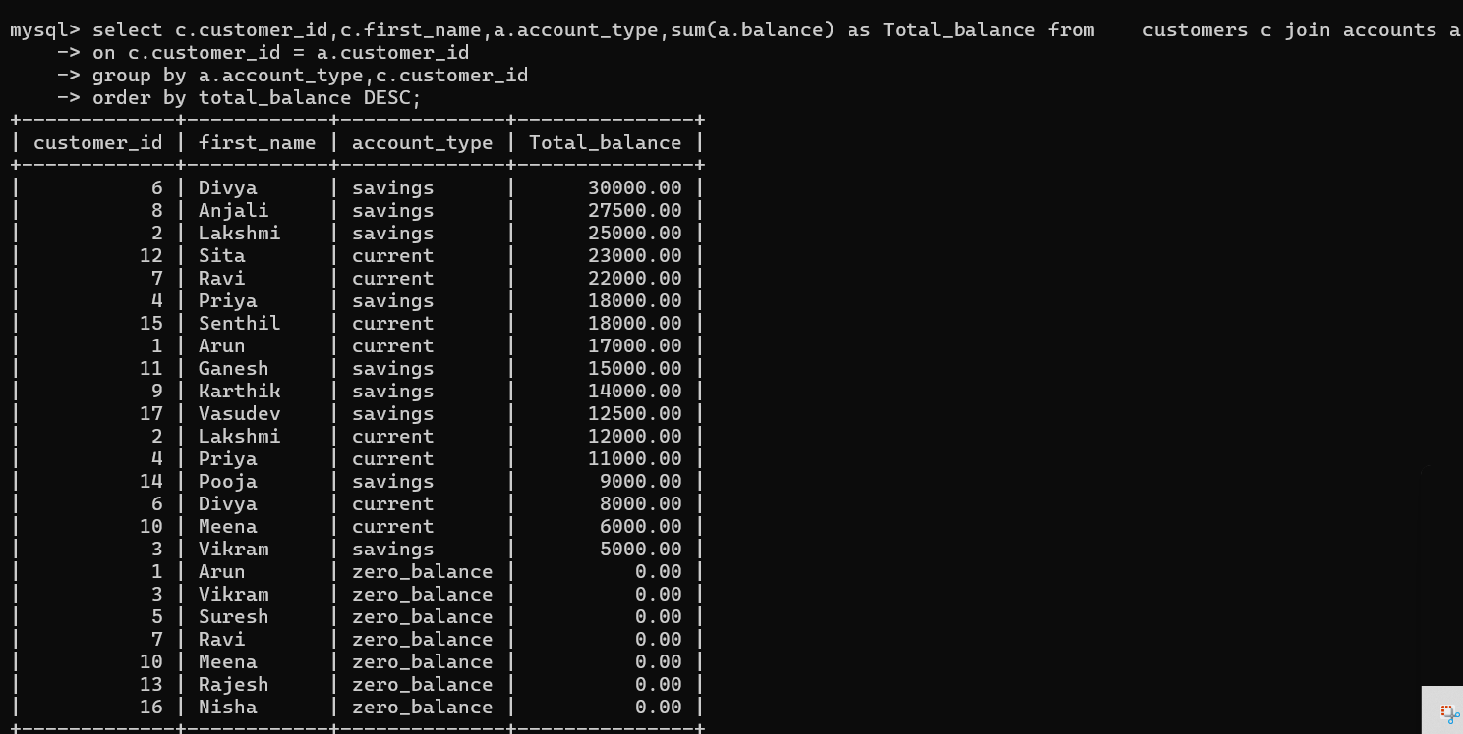

14. Identify and list duplicate transactions based on transaction amount, date, and account

**Select t.account_id, t.amount, t.transaction_date, COUNT(*) AS transaction_count**

**From Transactions t**

**Group by t.account_id, t.amount, t.transaction_date**

**Having transaction_count > 1**

**Order by t.account_id, t.transaction_date;**

