**Task 4**

1. Retrieve the customer(s) with the highest account balance

**SELECT c.customer_id,**

**c.first_name,**

**c.last_name,**

**a.account_id,**

**a.balance**

**FROM customers c**

**JOIN accounts a ON c.customer_id = a.customer_id**

**WHERE a.balance = (SELECT MAX(balance) FROM accounts );**

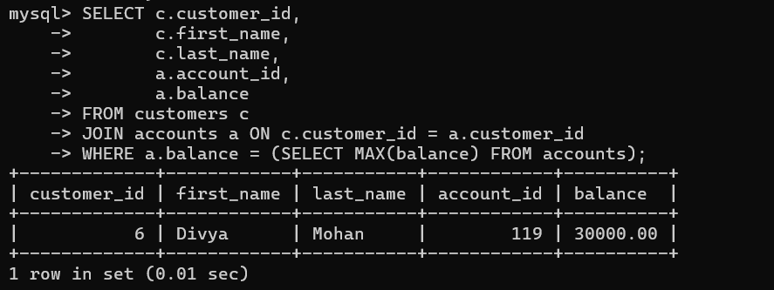

2. Calculate the average account balance for customers who have more than one account

**select customer_id,avg(balance)**

**from accounts**

**where customer_id IN (select customer_id**

**from accounts**

**group by customer_id**

**having count(customer_id) > 1)**

**Group by customer_id;**

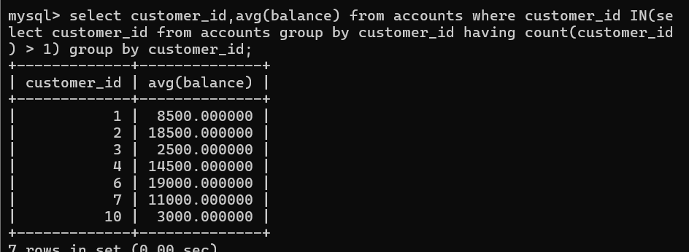

3. Retrieve accounts with transactions whose amounts exceed the average transaction amount.

**Select account_id from accounts**

**where balance > (Select avg(amount) from transactions);**

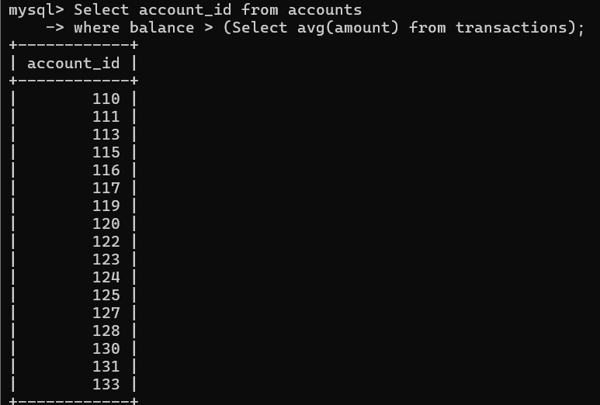

4. Identify customers who have no recorded transactions.

**Select c.customer_id,**

**c.first_name,**

**c.last_name,**

**a.account_id**

**From customers c**

**Join accounts a ON c.customer_id = a.customer_id**

**Where a.account_id NOT IN (Select account_id From transactions);**

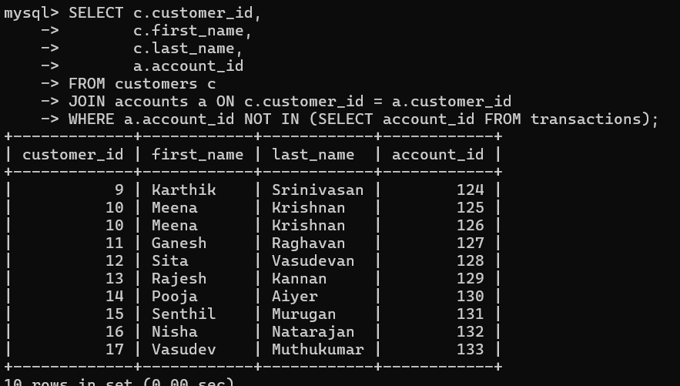

5. Calculate the total balance of accounts with no recorded transactions.

**select sum(balance) from accounts**

**where account_id not in**

**(select account_id from transactions);**

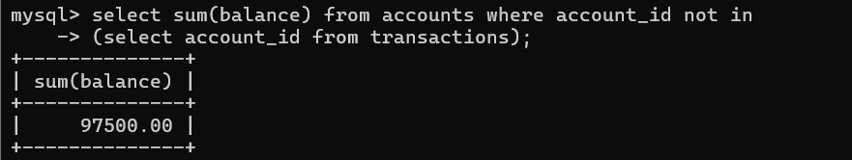

6. Retrieve transactions for accounts with the lowest balance.

**select account_id,transaction_type,amount**

**from transactions**

**where account_id in(select account_id**

**from accounts**

**where balance = (select min(balance) from accounts));**

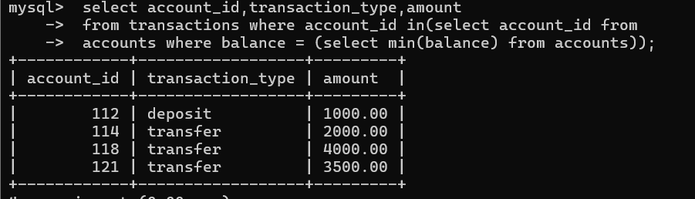

7. Identify customers who have accounts of multiple types.

**Select c.customer_id, c.first_name, c.last_name**

**From customers c**

**Join accounts a ON c.customer_id = a.customer_id**

**Where c.customer_id IN (**

**Select customer_id**

**From accounts**

**Group by customer_id**

**Having Count(Distinct account_type) > 1**

**)**

**Group by c.customer_id;**

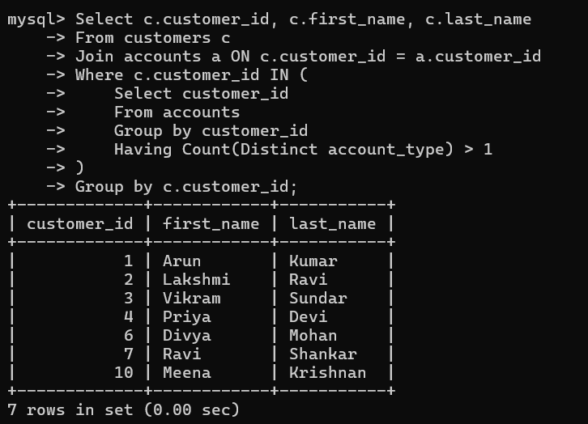

8. Calculate the percentage of each account type out of the total number of accounts.

**select account_type,**

**count(*) as total_accounts,**

**(count(*) * 100.0 /**

**(select count(*) from accounts)) as percentage_of_total**

**from accounts**

**group by account_type;**

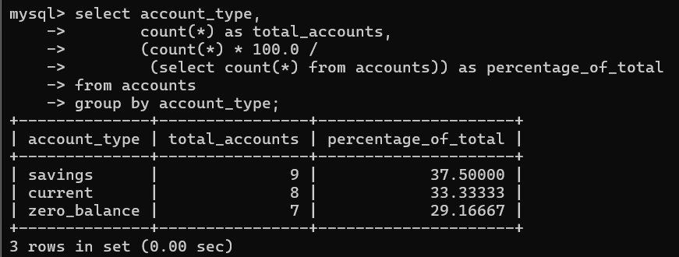

9. Retrieve all transactions for a customer with a given customer_id.

**Select t.account_id,**

**t.transaction_id,**

**t.transaction_type,**

**t.amount**

**From transactions t**

**Where t.account_id IN (Select a.account_id**

**From accounts a**

**Where a.customer_id = 1);**

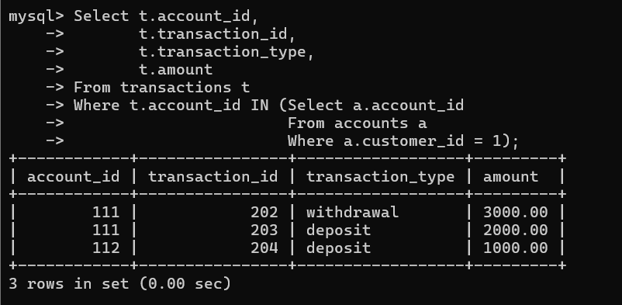

10. Calculate the total balance for each account type, including a subquery within the SELECT clause

**select a.account_type,(select sum(a2.balance) from accounts a2**

**where a2.account_type=a.account_type) as Total_balance**

**from accounts a**

**group by account_type;**

