sudo apt-get update sudo apt-get upgrade
sudo apt-get dist-upgrade
#INSTALAR DRIVER DE NVIDIA DESDE software&updates nvidia-smi #Verificando que el driver este instalado lspci | grep -i nvidia
python3
sudo apt-get install python3-pip python3-dev sudo apt-get install build-essential cmake git unzip

sudo apt-get install pkg-config libopenblas-dev liblapack-dev

sudo apt-get install libatlas-base-dev gfortran

sudo apt-get install python3-numpy python3-scipy python3-matplotlib python3-yaml

sudo apt-get install libavcodec-dev libavformat-dev libswscale-dev libv4l-dev

sudo apt-get install libxvidcore-dev libx264-dev

sudo apt-get install libhdf5-serial-dev python3-h5py

sudo apt-get install graphviz

sudo pip3 install pydot-ng scikit-learn pillow
sudo apt-get install libjpeg8-dev libtiff5-dev sudo apt-get install libgtk-3-dev
sudo apt install qtbase5-dev
pip3 install opencv-contrib-python

python3
>>>import cv2
>>> cv2. version

gcc --version

wget https://developer.download.nvidia.com/compute/cuda/repos/ubuntu1804/x86_64/cuda- repo-ubuntu1804_10.0.130-1_amd64.deb

sudo dpkg -i cuda-repo-ubuntu1804_10.0.130-1_amd64.deb

sudo apt-key adv --fetch-keys https://developer.download.nvidia.com/compute/cuda/repos/ ubuntu1804/x86_64/7fa2af80.pub

sudo apt-get update && sudo apt full-upgrade

sudo apt-get install cuda-10-0

echo $PATH #agregar ruta al path
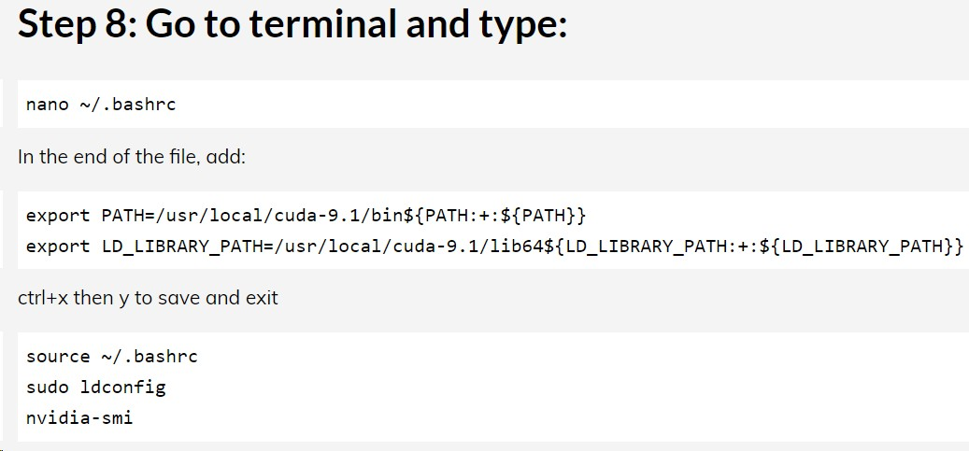

nano ~/.bashrc
export PATH=/usr/local/cuda-10.0/bin${PATH:+:${PATH}}
export LD_LIBRARY_PATH=/usr/local/cuda-10.0/lib64${LD_LIBRARY_PATH:+:${LD_LIBRARY_PATH}}

source ~/.bashrc sudo ldconfig
# Reboot the cpu nvidia-smi

nvcc --version

nvcc -V
lspci -v
cat /proc/driver/nvidia/version

cuda-install-samples-10.0.sh ~/ExamplesCUDA
# ir al directorio

make -j4
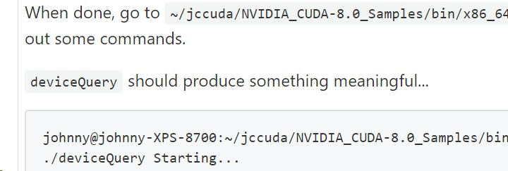

Para instalar CuDNN https://developer.nvidia.com/rdp/cudnn-archive
versión 7.0.5
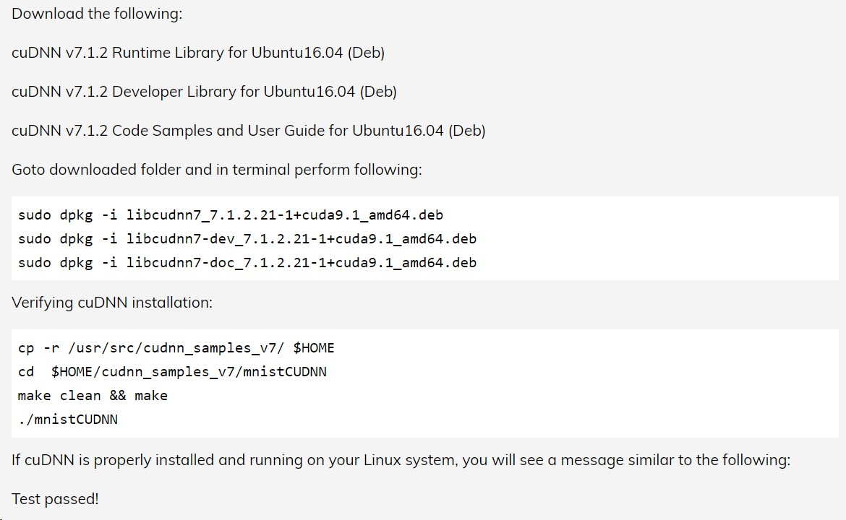

sudo apt-get install python3-venv
# create virtual environment for tensorflow python3 -m venv tf_env
source tf_env /bin/activate #deactivate para cerrar el entorno sudo pip3 install tensorflow-gpu==1.5

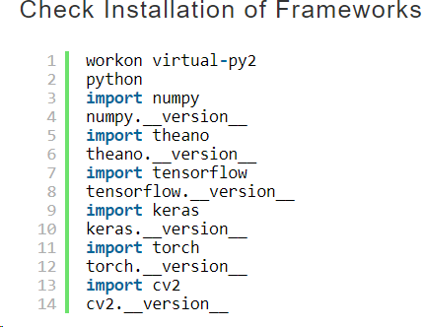

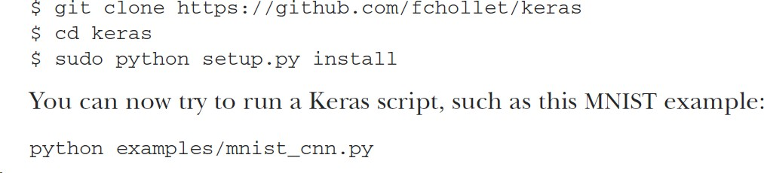

apt-get update && apt-get install -y --allow-downgrades --no-install-recommends \ libcudnn7=7.0.5.15-1+cuda9.0 \
libcudnn7-dev=7.0.5.15-1+cuda9.0 && \ rm -rf /var/lib/apt/lists/*

