CodeWithKris Research Volunteer Agreement
Thank you for signing up as a volunteer for the CodeWithKris Research.
We DO NOT charge for Training and Learning. Depending on skills and efforts, persons with disabilities can learn and work at their own pace based on end client approval.
Depending on the communication skills and learning efforts, we expect each participant will be able to earn about USD10 to 25 per appointment (depends on individual client and market conditions). This is not a Job offer. We try our best to match PwDs with Client needs.
For this task we believe it should not take more than ten minutes to complete it once you understand what needs to be done. Our team or partners will support you as and when required. Looking forward to collaborating with you more often continually.
Grad-a-Gig Inc (https:/www.gradagig.com) is a Social Impact for profit Business with Cooperative Business Model like AMUL.
Our objective is to create opportunities for Persons with Disabilities (with special focus on Speech/Visual impairment) to earn, become own boss working at own pace (without need to look for jobs), by teaching to Communicate with Clients and respond on a live basis to complete business-related tasks for example to Go To Marketing to generate sales as well as Software Project Development.
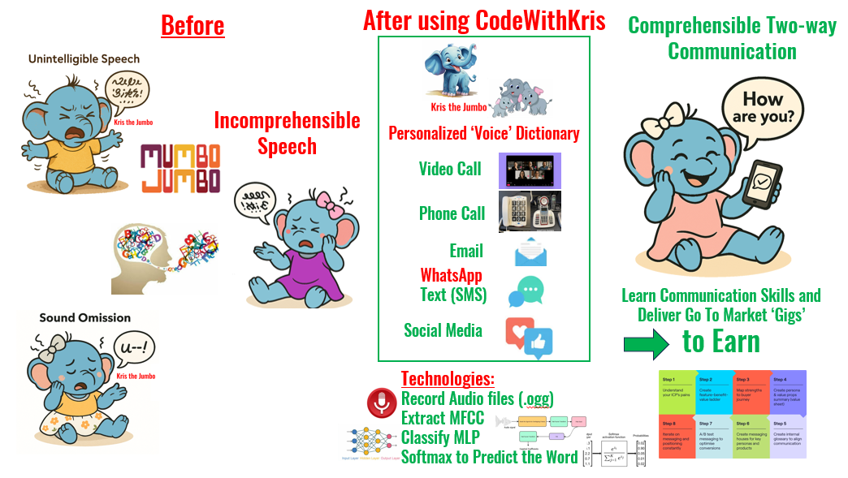
For past 5+ years, even though I had been personally contacting 200+ Corporate, law firm HR/Senior Leaders, I have not been able to make any progress. Now with Vaidee, Rajiv, Brayan, I am confident we will make progress and build the prototype to demonstrate the feasibility. We need your support and cooperation to make it successful. Win – Win for all.
We are presenting our research paper at the 14th Pan-Pacific Conference on Rehabilitation.
https://events.polyu.edu.hk/14thppcr/home
We need your help to record voices for the predefined Scripts below. More the Data better the accuracy of the result. Please introduce to as many Speech Impaired to help do a Trial. We hope our apps will benefit more Persons with Disabilities to learn and earn.
What will Success look like:
Persons with Disabilities are happy to be self-sustainable with dignity, able to “Communicate” with business colleagues and others without being excluded socially, and able to learn skills to earn at their own pace working remotely.
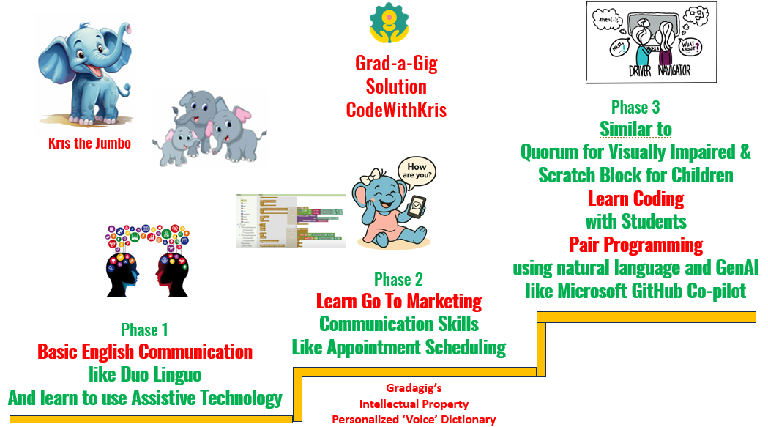
An example of such task is shown below. We will be adding more different tasks where Persons with Disabilities can participate in the Knowledge Based Gigs and earn for their efforts. If successful we also aim to teach ‘Coding’ skills pairing with Students, Carers and AI in the future. We hope each of them also teach others with similar challenges and build an inclusive society. Before we can scale to create larger impact, we need to prove that this business model is a sustainable on long term with two to five persons with disabilities like Josy, Naresh, Priya and others.
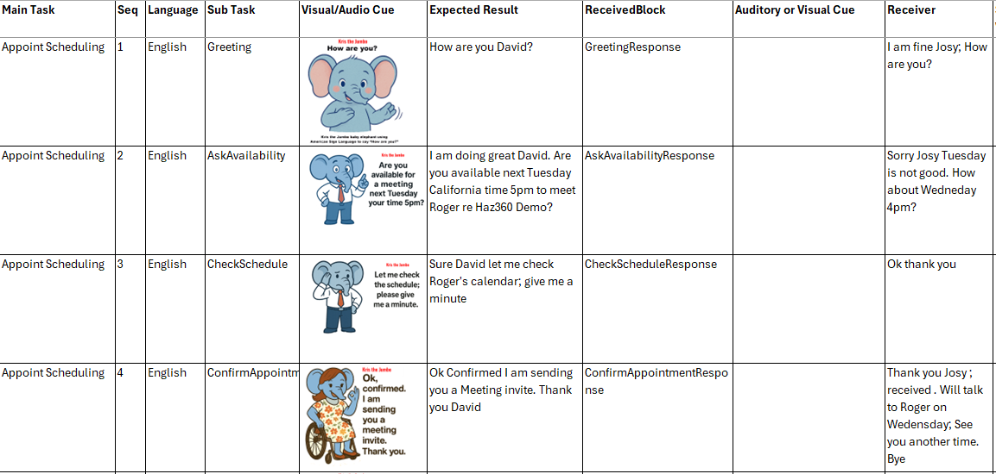
As we grow and acquire client project contracts with clear scope and budget (revenue), each and every person contributing as volunteer may be given an opportunity (depending on performance during training and subject to end client approval) to deliver the project, complete the tasks, and will be rewarded suitably as a business owner, not just an employee, but also will be added as shareholder in a pool similar to the concept of Airline or Bank Credit Card Loyalty Reward programs. Details of which will be announced later. It is meaningless now without any scale of revenue. Our first focus is to generate revenues and coach persons with disabilities can deliver results – Make Appointment with Prospective Clients in the target industry segment learning about the Product or Service, learn objection handling and generating qualified leads.
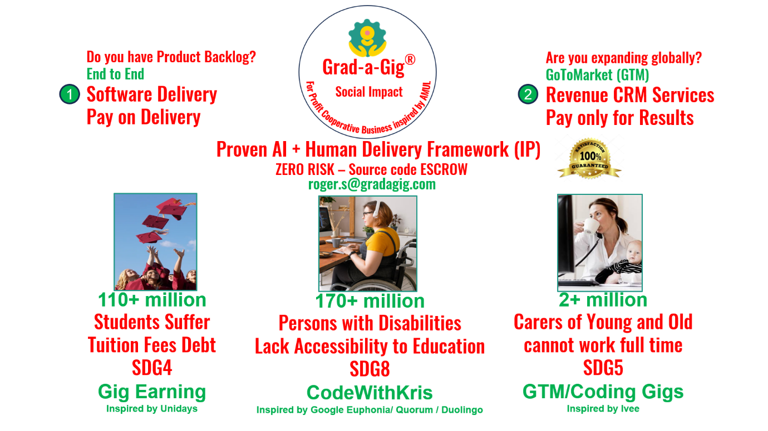
Once training is successfully completed and each participant is confident to work on a real life Customer Project, and if Customers approve to include the participant in the Project Team, each one will be paid a remuneration, which will be agreed mutually between both participant and the customer on a case-by-case basis depending the project requirement at that time. This approach will evolve over a period of time as we do not have any client agreed to outsource us any project.
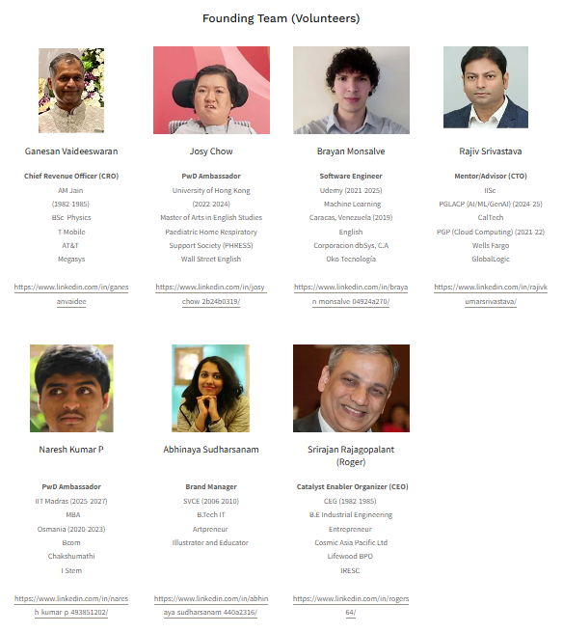
For this Research Training each participant upon login will be shown visual/audio cues related to a set of sample tasks for Appointment Scheduling - that is calling a Customer and Making an Appointment for a Meeting and Send a Confirmation Email (as shown above in the picture).
Participant need to understand the specific sub tasks like Greeting, Ask for availability, Check Schedule, Confirm and send an email. One of our members or partners can be contacted if anyone has doubts.
Each participant will record their voice for these specific Scripts. These voice data will be used to test whether our AI program is able to recognize similar sounding voice in the future when any Persons with Disability use our Communication Practice and Test and execute corresponding business tasks making two way live communication between the participant and a client feasible. We are still in research phase, and this will be improvised based on feedback from each participant, clients and others.
We will keep each participant informed on the overall R&D project result and the progress of GradaGig and what would be the next steps for your future participation.
Thank you once again for your Volunteer Support and Looking forward to training you and enabling you earn by delivering Knowledge Based Gigs soon. Please also introduce to your friends who may also benefit using CodeWithKris.
Please confirm to proceed to sign up and share information about yourselves like below:
We will use this for only the intended purposes, and we will NOT ask you about any other Personal Bank or other information, we will NOT ask for any Payment from you and will put our best to keep all the data confidential.

Yes, I understand the business objectives of CodeWithKris and agree to be a volunteer for the research.

User Id (auto generated by the system)
Email Id: Unique (Duplicate not allowed)
Password : User can set their own password
Date of Signup : System automatically update
Date of Inactive: System updated ( if User prefer not to continue)
First Name:
Last Name:
Age:
Gender:
Education:
Category of Disability: Speech, Hearing, Visual, Physical, Other
Speech Impairment Level: Unintelligible (Mumbo-jumbo), Partial, Very Clear
City:
Country:
Mother Tongue:
English level: No skill Beginner Intermediate Fluent
Read
Write
Listen
Speak
Preferred Language:
Sign Language skills:
Aspiration:
Fun fact:

All information will be used only for research and Gradagig training and earning opportunity and to improve the Quality of our Solution.

End of Document

