Mobile Application Build Prompt for Non-Coders
Copy and paste the prompt below into an AI app builder (such as FlutterFlow, Glide, Bubble, or an AI code assistant like v0/Cursor) to generate the mobile application based on the attached wireframes and our core product context.
COPY FROM HERE DOWN:

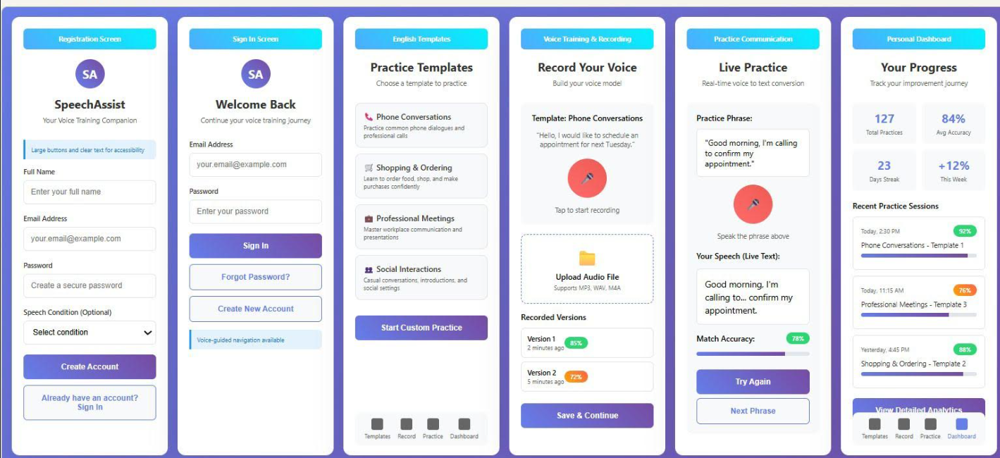
Role & Objective: Act as an expert mobile app developer and UI/UX designer. I am a non-technical business user. Build a fully functional, clean, and responsive mobile application based on the provided wireframes (titled "SpeechAssist / Voice Training Companion") and adapted for our speech-accessibility platform, CodeWithKris.
Core Product Context:
- Product: CodeWithKris (Speech-Impaired Voice Training & Practice Companion).
- Target Audience: Individuals with speech impairments, speech therapy clients, and users looking to build confidence and clarity in verbal communication.
- Key Focus: A personalized voice-training companion providing structured practice templates, real-time voice-to-text conversion, accuracy matching, and progress tracking.
Screen-by-Screen Specifications (Derived from Wireframes)
- Registration Screen (Registration)
  - Header: App Name ("SpeechAssist") with subtitle ("Your Voice Training Companion").
  - UI Elements: Large, accessible touch targets, clear text labels.
  - Inputs: Full Name, Work/Personal Email, Secure Password, Speech Condition (Optional Dropdown).
  - Action Button: "Create Account" (Leading to Sign In or Dashboard).
- Sign In Screen (Sign In)
  - Header: Welcome Back / Continue your voice training journey.
  - Inputs: Email Address, Password.
  - Action Buttons: "Sign In", "Forgot Password?", "Create New Account".
  - Footer Note: "Voice-guided navigation available."
- Templates / Module Selection (English Templates equivalent -> Practice Templates)
  - Header: Choose a template to practice.
  - Cards/Options:
    - Phone Conversations (Practice common phone dialogues and professional calls)
    - Shopping & Ordering (Learn to order food, shop, and make purchases confidently)
    - Professional Meetings (Master workplace communication and presentations)
    - Social Interactions (Casual conversations, introductions, and social settings)
  - Action Button: "Start Custom Practice".
- Voice Training & Recording (Voice Training equivalent -> Record Your Voice)
  - Header: Record Your Voice / Build your voice model.
  - Context Box: Template details & instructions (e.g., "Hello, I would like to schedule an appointment for next Tuesday.").
  - Interactive Elements: Large tap-to-record microphone button, alternative "Upload Audio File" zone (Supports MP3, WAV, M4A).
  - History List: Recent recorded versions with status indicators (e.g., Version 1 - 85%, Version 2 - 72%).
  - Action Button: "Save & Continue".
- Live Practice / Real-Time Audit (Live Practice equivalent -> Practice Communication)
  - Header: Real-time voice to text conversion.
  - Display Box: Practice Phrase to read aloud.
  - Interactive: Live speech-to-text transcription box showing your live speech.
  - Status Indicator: Match Accuracy progress bar (e.g., 78%).
  - Action Buttons: "Try Again", "Next Phrase".
- Personal Dashboard (Personal Dashboard equivalent -> Your Progress)
  - Header: Track your improvement journey.
  - Key Metrics Cards: Total Practices (127), Avg Accuracy (84%), Days Streak (23), Weekly Progress (+12%).
  - Recent Activity Feed: List of recent practice sessions with timestamps and accuracy tags.
  - Navigation Bar: Fixed bottom bar with icons for Templates, Record, Practice, and Dashboard.
Technical & Design Instructions
- Design System: Clean, minimalist accessibility-first UI. Use a soft purple/indigo palette with high-contrast text and oversized interactive buttons for ease of use.
- Responsiveness: Optimized for mobile screens (iOS & Android aspect ratios).
- Simplicity: Ensure all code or block structures are clearly commented so I can easily edit text or logic without writing code.
END OF PROMPT

