Haz360MOC
Draft Ideas
Updated by Roger
4 Jul 2023
21 Jul 26

Customizable Workflow

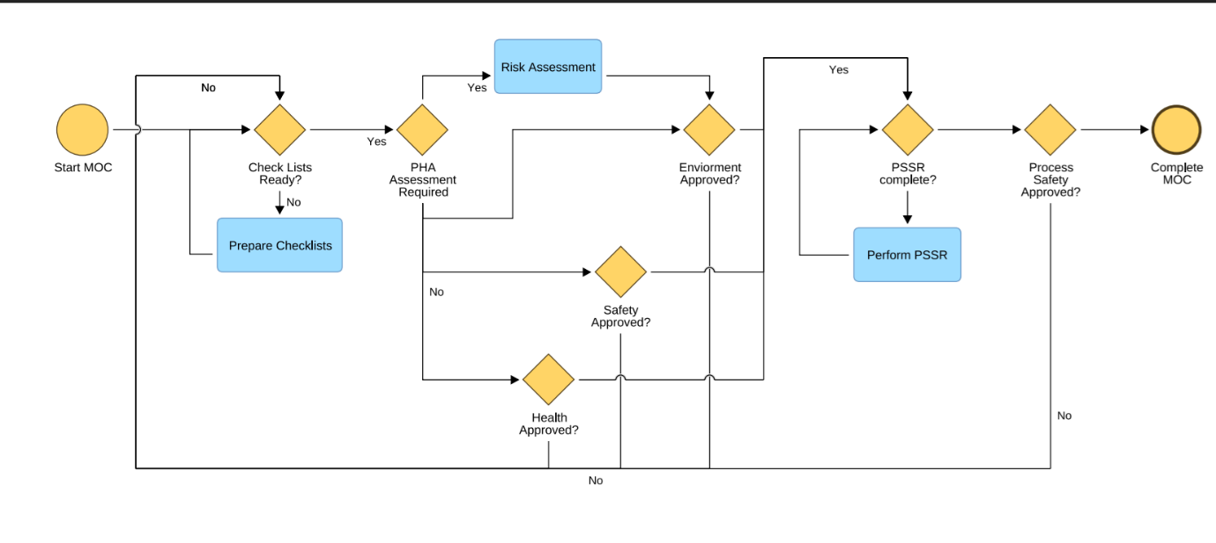
Draft Ideas to Manage MOC (in Haz360)

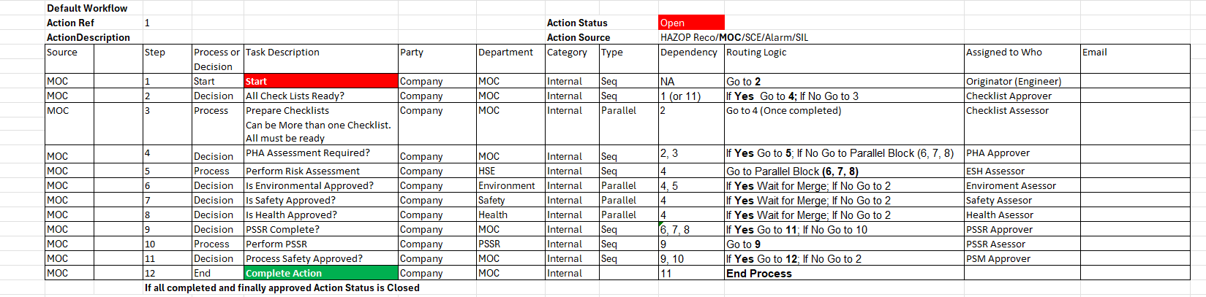

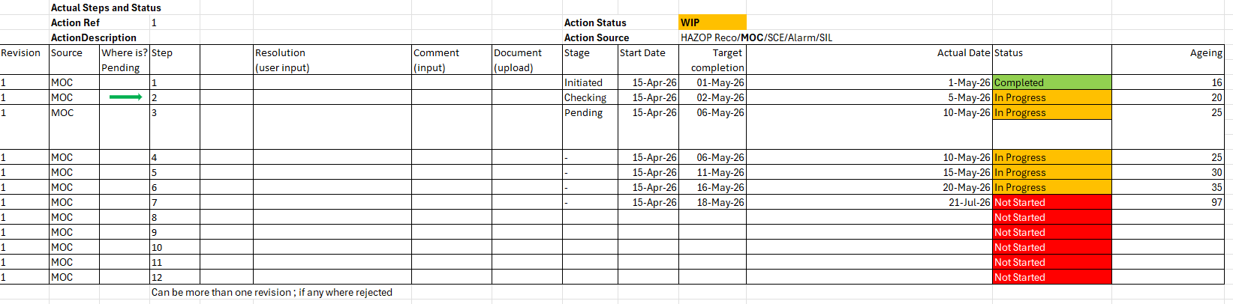

In Project 272 in 11281188

Below is a draft done in 2023 for SCGC using Action Tracking just for demo. Not correct workflow. Suppose follow the MOC Format and send any Action Assigned to Action Tracking
(all HAZOP, SIL, MOC etc Actions Assigned sent to Action Tracker as a common workflow.
Depending on each Workflow different Departments will complete different tasks and upload completed docs.

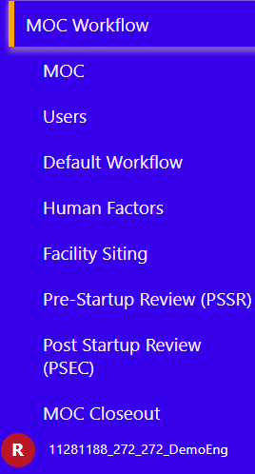

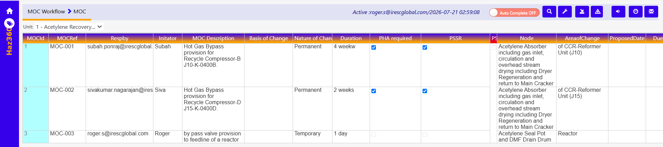
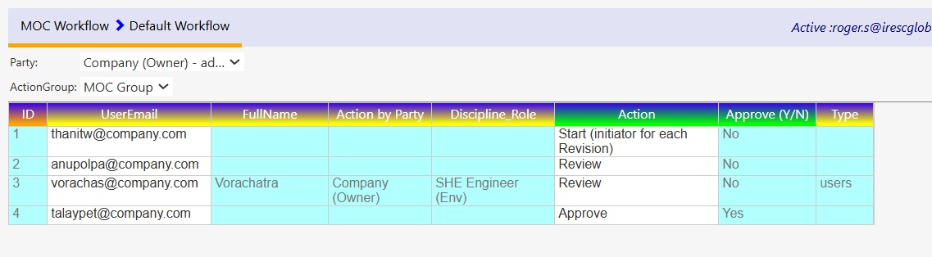
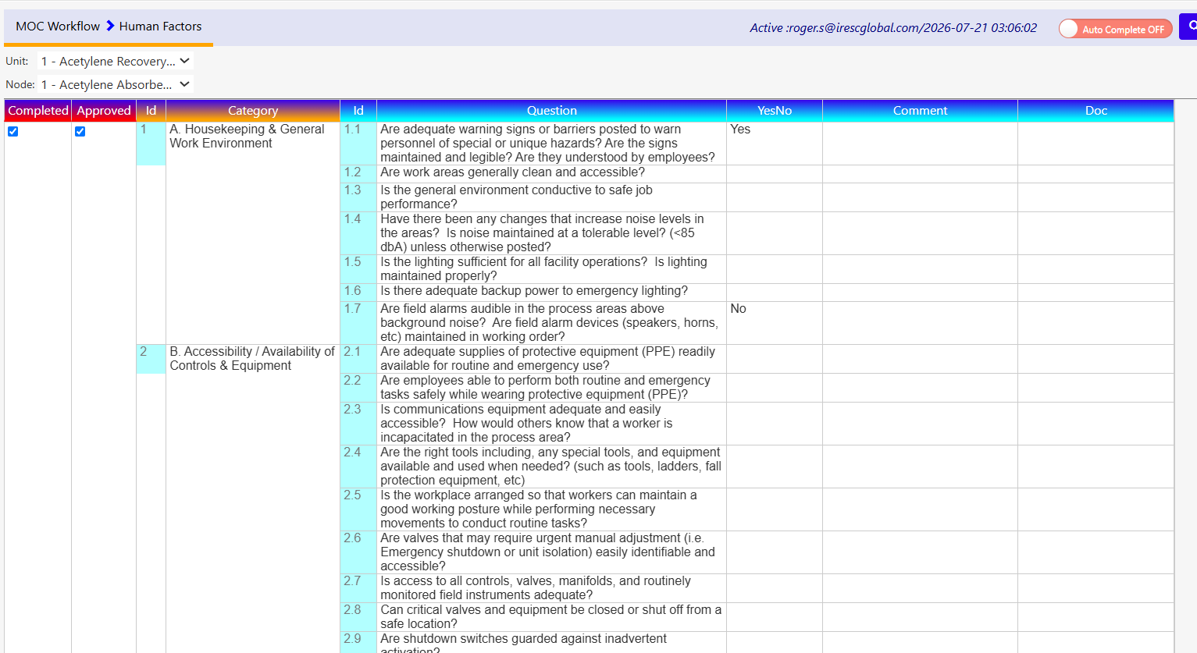
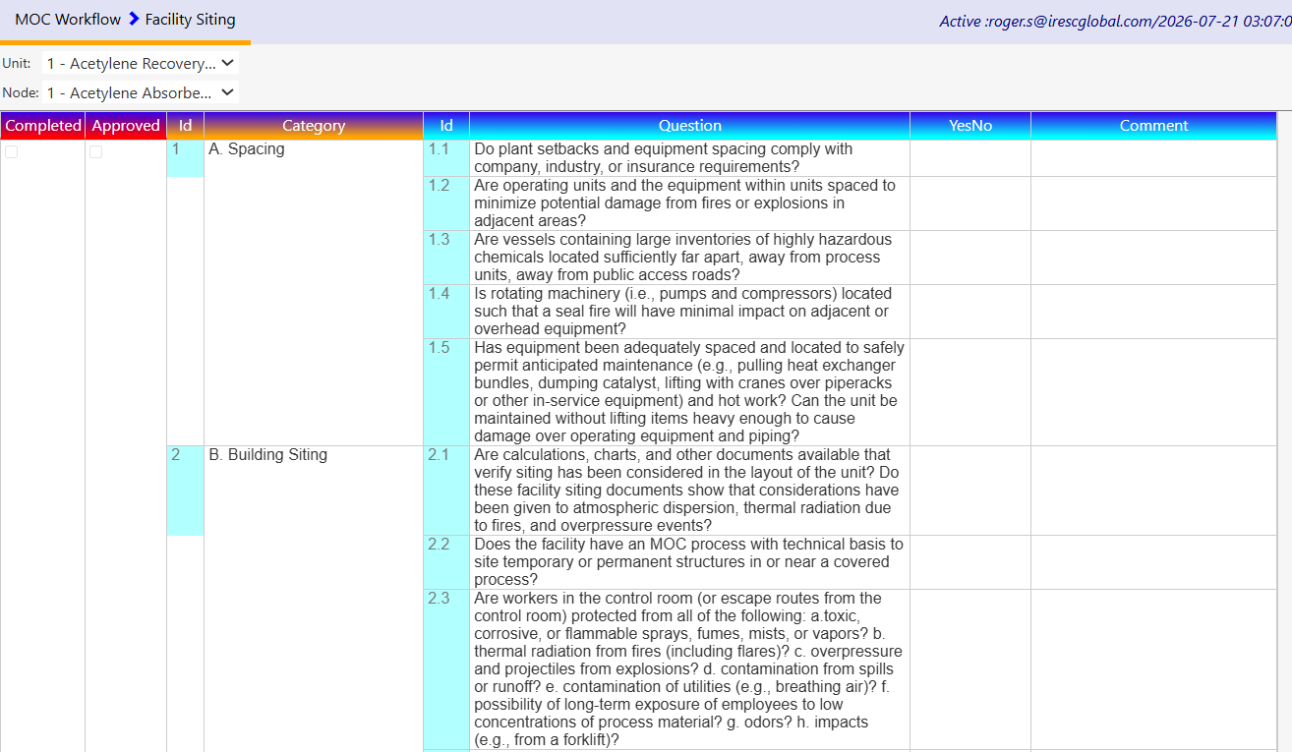
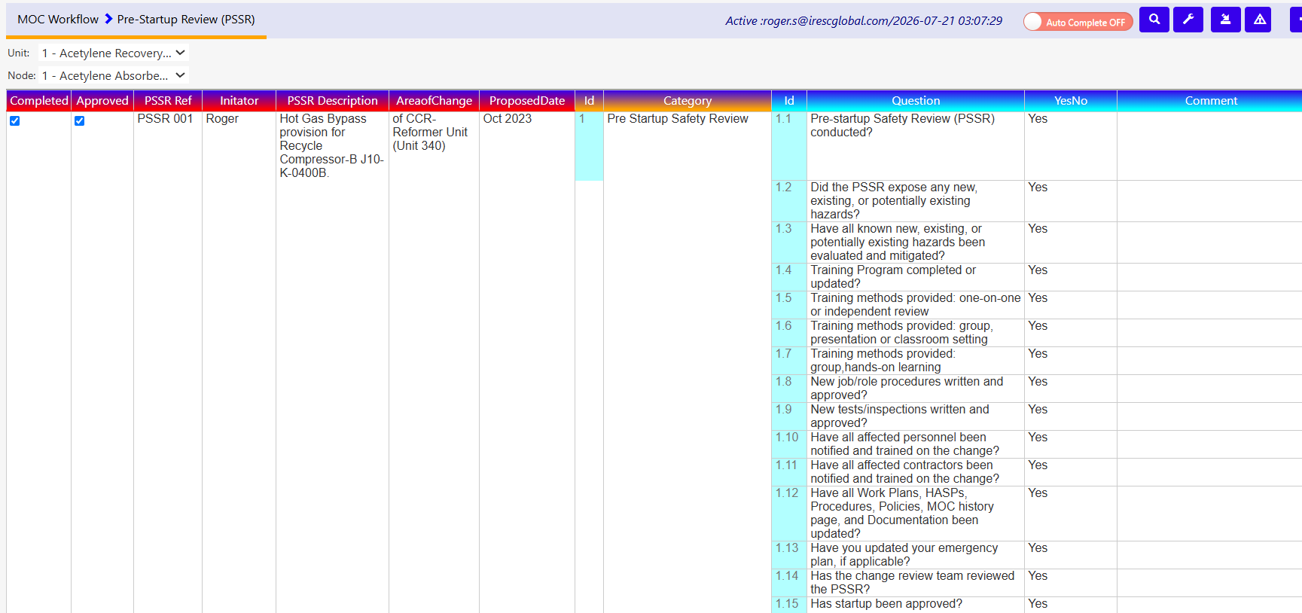

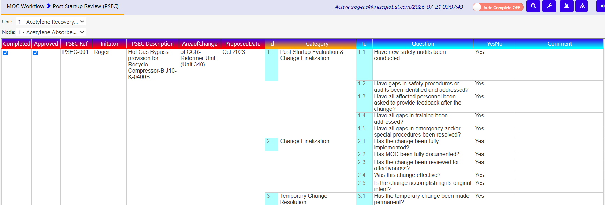

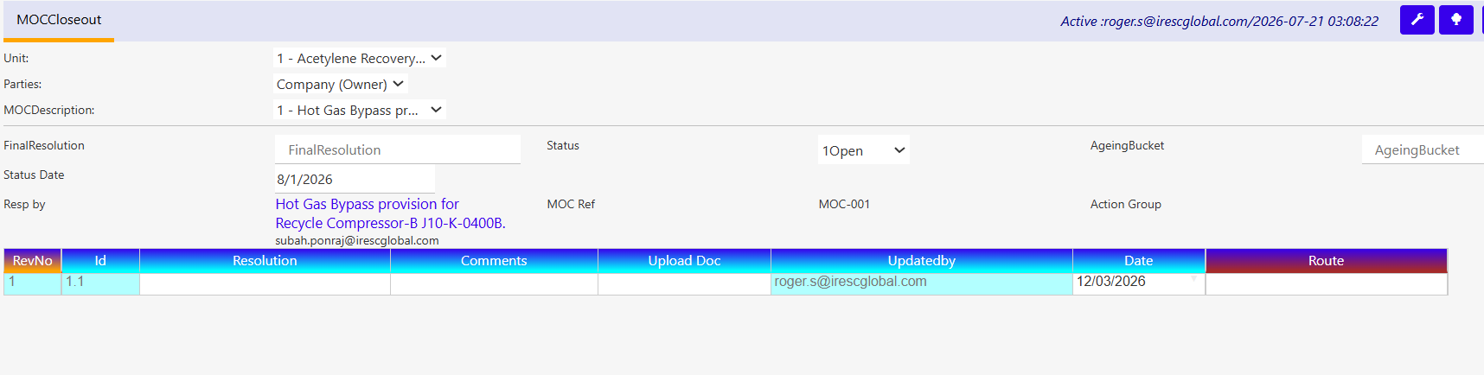
End of Document

