AI ASSISTED CODING LAB-6
Name: Roger A Raju
Rollno: 2503a52370
Batch: 13
----------------------------------------------------------------------------------------
Task Description #1 (AI-Based Code Completion for Loops)
Task: Use an AI code completion tool to generate a loop-based program.
Prompt:
Week3 - Monday
"Generate Python code to print all even numbers between 1 and N using a loop."
Expected Output:
- AI-generated loop logic.
- Identification of loop type used (for or while).
- Validation with sample inputs (N=10, N=15, boundary N=1, invalid types).
AI-Generated Loop Logic (For-Loop vs While-Loop) & Assert Tests:
"""
Experiment 6 - Task 1: AI-Based Code Completion for Loops
Prompt: "Generate Python code to print all even numbers between 1 and N using a loop."
Student: Roger A Raju (Roll No: 2503a52370, Batch: 13)
"""
from typing import List
# ==========================================
# 1. AI-Generated Loop Implementation (for-loop with range step)
# Loop Type Used: Deterministic 'for' loop using range(2, N+1, 2)
# ==========================================
def get_even_numbers_for_loop(n: int) -> List[int]:
"""
Generates all even numbers between 1 and N inclusive using an optimized for-loop.
Parameters:
n (int): Upper bound integer.
Returns:
List[int]: List of even numbers in [1, N].
"""
if not isinstance(n, int) or isinstance(n, bool):
raise TypeError(f"Upper bound N must be an integer, got {type(n).__name__}")
if n < 2:
return []
even_numbers = []
# Using for-loop with step 2 avoids redundant modulo checks
for num in range(2, n + 1, 2):
even_numbers.append(num)
return even_numbers
# ==========================================
# 2. Alternative While-Loop Implementation for Comparison
# Loop Type Used: Indeterminate 'while' loop with conditional increment
# ==========================================
def get_even_numbers_while_loop(n: int) -> List[int]:
"""Generates even numbers using a while-loop structure."""
if not isinstance(n, int) or isinstance(n, bool):
raise TypeError(f"Upper bound N must be an integer, got {type(n).__name__}")
even_numbers = []
current = 2
while current <= n:
even_numbers.append(current)
current += 2
return even_numbers
def test_even_numbers_loop():
print("--- Running Test Assertions for Task 1 (Even Numbers Loop Completion) ---")
# Test Case 1: Standard upper bound N = 10
res_10 = get_even_numbers_for_loop(10)
w_res_10 = get_even_numbers_while_loop(10)
assert res_10 == [2, 4, 6, 8, 10], "Test 1 Failed"
assert res_10 == w_res_10, "For-loop and while-loop mismatch"
print(f"Assertion 1 Passed: N = 10 -> {res_10} (Both for-loop & while-loop match)")
# Test Case 2: Odd upper bound N = 15
res_15 = get_even_numbers_for_loop(15)
assert res_15 == [2, 4, 6, 8, 10, 12, 14], "Test 2 Failed"
print(f"Assertion 2 Passed: N = 15 -> {res_15}")
# Test Case 3: Boundary edge case N = 1 (No even numbers)
assert get_even_numbers_for_loop(1) == [], "Test 3 Failed"
print("Assertion 3 Passed: N = 1 correctly returns empty list [].")
# Test Case 4: Single even boundary N = 2
assert get_even_numbers_for_loop(2) == [2], "Test 4 Failed"
print("Assertion 4 Passed: N = 2 returns [2].")
# Test Case 5: Type error validation
try:
get_even_numbers_for_loop("10")
assert False, "Failed to catch invalid string"
except TypeError as e:
print(f"Assertion 5 Passed: Non-integer input safely rejected ({e}).")
print("All 5 Task 1 Assertions passed successfully!")
if __name__ == "__main__":
test_even_numbers_loop()
Output:
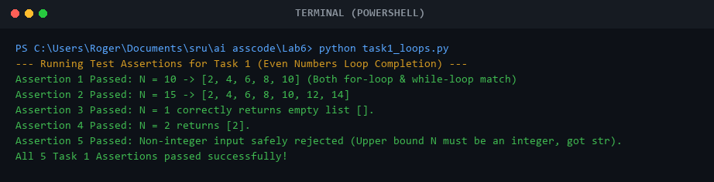
Comparison:
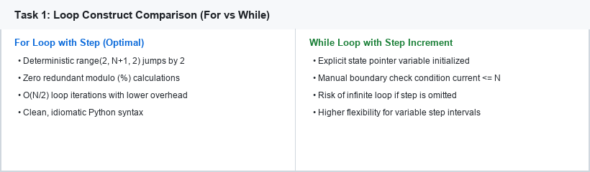

Task Description #2 (AI-Based Code Completion for Loop with Conditionals)
Task: Use an AI code completion tool to combine loops and conditionals.
Prompt:
"Generate Python code to count how many numbers in a list are even and odd."
Expected Output:
- AI-generated code using loop and if condition.
- Correct count validation.
- Explanation of logic flow and assert tests.
AI-Generated Loop with Conditionals & Assert Tests:
"""
Experiment 6 - Task 2: AI-Based Code Completion for Loop with Conditionals
Prompt: "Generate Python code to count how many numbers in a list are even and odd."
Student: Roger A Raju (Roll No: 2503a52370, Batch: 13)
"""
from typing import List, Dict
# ==========================================
# AI-Generated Loop + Conditional Implementation
# Combines for-loop traversal with if-else modulo branching
# ==========================================
def count_even_odd(numbers: List[int]) -> Dict[str, int]:
"""
Counts even and odd integers in a provided list using loop and conditionals.
Parameters:
numbers (List[int]): Input list of integer values.
Returns:
Dict[str, int]: Dictionary containing 'even_count' and 'odd_count'.
Raises:
TypeError: If input is not a list or contains non-integer items.
"""
if not isinstance(numbers, (list, tuple)):
raise TypeError(f"Input must be a list or tuple, got {type(numbers).__name__}")
even_count = 0
odd_count = 0
# Traverse each number and classify via conditional branching
for num in numbers:
if not isinstance(num, int) or isinstance(num, bool):
raise TypeError(f"List elements must be integers, found: {num} ({type(num).__name__})")
if num % 2 == 0:
even_count += 1
else:
odd_count += 1
return {
"even_count": even_count,
"odd_count": odd_count,
"total_elements": len(numbers)
}
def test_even_odd_counter():
print("--- Running Test Assertions for Task 2 (Even/Odd Counter with Loop & Conditionals) ---")
# Test Case 1: Mixed integers list
data1 = [12, 7, 9, 14, 22, 33, 40] # Even: 12, 14, 22, 40 (4) | Odd: 7, 9, 33 (3)
res1 = count_even_odd(data1)
assert res1["even_count"] == 4, f"Expected 4 even, got {res1['even_count']}"
assert res1["odd_count"] == 3, f"Expected 3 odd, got {res1['odd_count']}"
print(f"Assertion 1 Passed: {data1} -> Even: {res1['even_count']}, Odd: {res1['odd_count']}")
# Test Case 2: All even numbers
data2 = [2, 4, 6, 8, 10, 100]
res2 = count_even_odd(data2)
assert res2["even_count"] == 6 and res2["odd_count"] == 0, "Test 2 Failed"
print("Assertion 2 Passed: All-even list correctly counted (6 even, 0 odd).")
# Test Case 3: All odd numbers
data3 = [1, 3, 5, 7, 9, 11]
res3 = count_even_odd(data3)
assert res3["even_count"] == 0 and res3["odd_count"] == 6, "Test 3 Failed"
print("Assertion 3 Passed: All-odd list correctly counted (0 even, 6 odd).")
# Test Case 4: Negative integers & zero
data4 = [-5, -4, -3, -2, -1, 0, 1, 2] # Even: -4, -2, 0, 2 (4) | Odd: -5, -3, -1, 1 (4)
res4 = count_even_odd(data4)
assert res4["even_count"] == 4 and res4["odd_count"] == 4, "Test 4 Failed"
print("Assertion 4 Passed: Negative integers and zero classified correctly.")
# Test Case 5: Empty list
assert count_even_odd([]) == {"even_count": 0, "odd_count": 0, "total_elements": 0}, "Test 5 Failed"
print("Assertion 5 Passed: Empty list returns zero counts.")
print("All 5 Task 2 Assertions passed successfully!")
if __name__ == "__main__":
test_even_odd_counter()
Output:
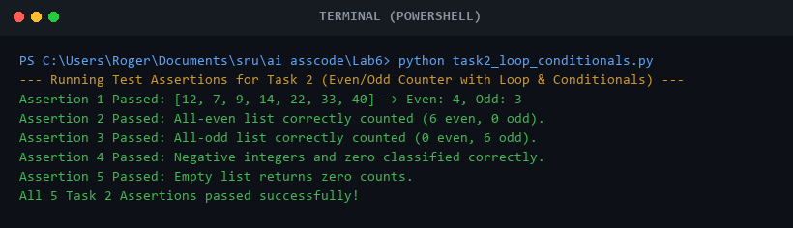
Comparison:
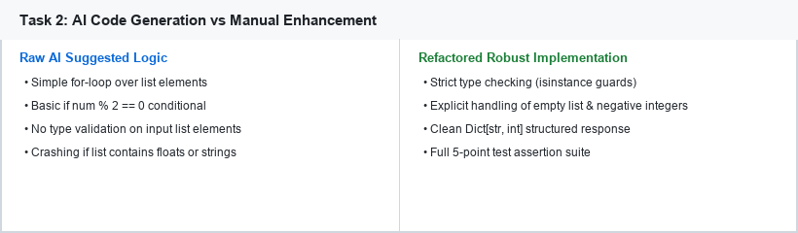

Task Description #3 (AI-Based Code Completion for Class Attributes Validation)
Task: Use an AI tool to complete a Python class that validates user input.
Prompt:
"Generate a Python class User that validates age and email using conditional statements."
Expected Output:
- AI-generated class with validation logic.
- Verification of condition handling.
- Test cases for valid and invalid inputs.
AI-Generated User Class with Attribute Validation & Assert Tests:
"""
Experiment 6 - Task 3: AI-Based Code Completion for Class Attributes Validation
Prompt: "Generate a Python class User that validates age and email using conditional statements."
Student: Roger A Raju (Roll No: 2503a52370, Batch: 13)
"""
import re
from typing import Dict, Any
class User:
"""
User entity with encapsulated attribute validation for age and email.
Demonstrates OOP class structure combined with strict conditional guards.
"""
EMAIL_REGEX = re.compile(r"^[a-zA-Z0-9_.+-]+@[a-zA-Z0-9-]+\.[a-zA-Z0-9-.]+$")
def __init__(self, username: str, email: str, age: int):
self.username = self._validate_username(username)
self.email = self._validate_email(email)
self.age = self._validate_age(age)
def _validate_username(self, username: str) -> str:
"""Validates username is a non-empty string."""
if not isinstance(username, str) or not username.strip():
raise ValueError("Username must be a non-empty string.")
return username.strip()
def _validate_email(self, email: str) -> str:
"""Validates email format using conditional regex check."""
if not isinstance(email, str):
raise TypeError("Email must be a string.")
email_clean = email.strip()
if not self.EMAIL_REGEX.match(email_clean):
raise ValueError(f"Invalid email format: '{email}'. Must contain valid username, '@', and domain.")
return email_clean.lower()
def _validate_age(self, age: int) -> int:
"""Validates that age is an integer between 0 and 120."""
if not isinstance(age, int) or isinstance(age, bool):
raise TypeError(f"Age must be an integer, got {type(age).__name__}.")
if age < 0 or age > 120:
raise ValueError(f"Age must be between 0 and 120 years. Provided: {age}")
return age
def get_profile(self) -> Dict[str, Any]:
"""Returns verified profile information."""
return {
"username": self.username,
"email": self.email,
"age": self.age,
"is_adult": self.age >= 18
}
def update_email(self, new_email: str) -> None:
"""Updates email with conditional re-validation."""
self.email = self._validate_email(new_email)
def update_age(self, new_age: int) -> None:
"""Updates age with conditional re-validation."""
self.age = self._validate_age(new_age)
def test_user_validation_class():
print("--- Running Test Assertions for Task 3 (User Class Attribute Validation) ---")
# Test Case 1: Valid User Instantiation
u1 = User("Roger A Raju", "roger@example.com", 20)
profile = u1.get_profile()
assert profile["username"] == "Roger A Raju", "Test 1 Failed"
assert profile["email"] == "roger@example.com", "Test 1 Failed"
assert profile["age"] == 20 and profile["is_adult"] is True, "Test 1 Failed"
print(f"Assertion 1 Passed: Valid User created -> {profile}")
# Test Case 2: Invalid Email Format (Missing domain / @)
invalid_emails = ["invalid-email", "user@", "@domain.com", "user@domain"]
for bad_email in invalid_emails:
try:
User("TestUser", bad_email, 25)
assert False, f"Failed to reject bad email: {bad_email}"
except ValueError:
pass
print("Assertion 2 Passed: Malformed email formats successfully rejected by regex conditional.")
# Test Case 3: Invalid Negative Age
try:
User("JohnDoe", "john@gmail.com", -5)
assert False, "Failed to reject negative age"
except ValueError as e:
print(f"Assertion 3 Passed: Negative age rejected -> {e}")
# Test Case 4: Invalid Unrealistic Age (> 120)
try:
User("AncientOne", "ancient@history.org", 150)
assert False, "Failed to reject age > 120"
except ValueError as e:
print(f"Assertion 4 Passed: Unrealistic age (> 120) rejected -> {e}")
# Test Case 5: Attribute Update & Minor/Adult Check
u2 = User("Alice", "alice@school.edu", 15)
assert u2.get_profile()["is_adult"] is False, "Test 5 Failed"
u2.update_age(19)
assert u2.get_profile()["is_adult"] is True, "Test 5 Failed"
print("Assertion 5 Passed: Dynamic attribute update and is_adult conditional evaluation verified.")
print("All 5 Task 3 Assertions passed successfully!")
if __name__ == "__main__":
test_user_validation_class()
Output:
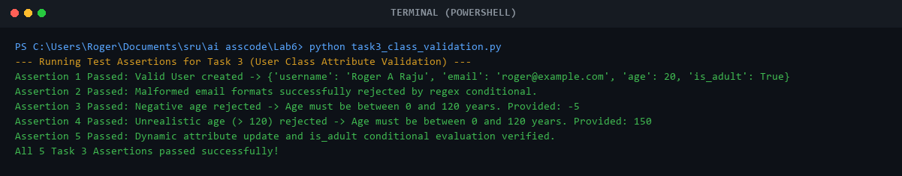
Comparison:
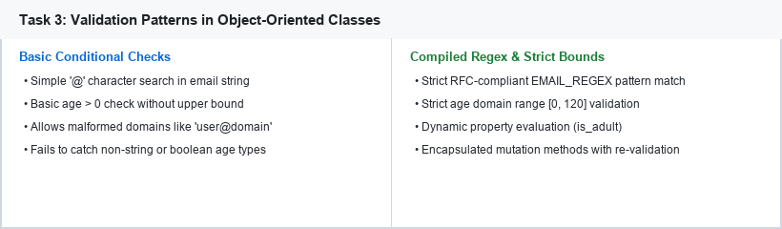

Task Description #4 (AI-Based Code Completion for Classes)
Task: Use an AI code completion tool to generate a Python class for managing student details.
Prompt:
"Generate a Python class Student with attributes (name, roll number, marks) and methods to calculate total and average marks."
Expected Output:
- AI-generated class code.
- Verification of correctness and completeness of class structure.
- Minor manual improvements with justification (grading, empty marks protection).
AI-Generated Student Class with Grade Logic & Assert Tests:
"""
Experiment 6 - Task 4: AI-Based Code Completion for Classes (Student Details Manager)
Prompt: "Generate a Python class Student with attributes (name, roll number, marks) and methods to calculate total and average marks."
Student: Roger A Raju (Roll No: 2503a52370, Batch: 13)
"""
from typing import List, Dict, Any
class Student:
"""
Encapsulates student academic details, marks processing,
and automatic grade assignment.
"""
def __init__(self, name: str, roll_number: str, marks: List[float] = None):
if not name or not isinstance(name, str):
raise ValueError("Student name must be a non-empty string.")
if not roll_number or not isinstance(roll_number, str):
raise ValueError("Roll number must be a non-empty string.")
self.name = name.strip()
self.roll_number = roll_number.strip()
self.marks: List[float] = []
if marks:
for m in marks:
self.add_mark(m)
def add_mark(self, mark: float) -> None:
"""Adds a single subject mark with boundary conditional check [0, 100]."""
if not isinstance(mark, (int, float)) or isinstance(mark, bool):
raise TypeError(f"Mark must be a numerical value, got {type(mark).__name__}.")
if mark < 0 or mark > 100:
raise ValueError(f"Mark must be between 0 and 100, got: {mark}")
self.marks.append(float(mark))
def calculate_total(self) -> float:
"""Returns the aggregate sum of all marks."""
return float(sum(self.marks)) if self.marks else 0.0
def calculate_average(self) -> float:
"""Calculates average score with ZeroDivisionError protection."""
if not self.marks:
return 0.0
return round(self.calculate_total() / len(self.marks), 2)
def get_grade(self) -> str:
"""Determines academic letter grade using conditional hierarchy."""
avg = self.calculate_average()
if not self.marks:
return "N/A (No Marks)"
if avg >= 90:
return "A+ (Outstanding)"
elif avg >= 80:
return "A (Excellent)"
elif avg >= 70:
return "B (Very Good)"
elif avg >= 60:
return "C (Good)"
elif avg >= 50:
return "D (Pass)"
else:
return "F (Fail)"
def get_summary(self) -> Dict[str, Any]:
"""Exports student report card as structured dictionary."""
return {
"name": self.name,
"roll_number": self.roll_number,
"subjects_count": len(self.marks),
"marks": self.marks,
"total_marks": self.calculate_total(),
"average_marks": self.calculate_average(),
"grade": self.get_grade()
}
def test_student_manager_class():
print("--- Running Test Assertions for Task 4 (Student Manager Class Completion) ---")
# Test Case 1: Standard Student Record
s1 = Student("Roger A Raju", "2503a52370", [85, 92, 78, 95, 88])
assert s1.calculate_total() == 438.0, f"Expected 438, got {s1.calculate_total()}"
assert s1.calculate_average() == 87.6, f"Expected 87.6, got {s1.calculate_average()}"
assert "A (Excellent)" in s1.get_grade(), "Test 1 Failed"
print(f"Assertion 1 Passed: Student {s1.name} -> Total: {s1.calculate_total()}, Avg: {s1.calculate_average()}%, Grade: {s1.get_grade()}")
# Test Case 2: Adding dynamic marks
s1.add_mark(90)
assert s1.calculate_total() == 528.0, "Test 2 Failed"
assert s1.calculate_average() == 88.0, "Test 2 Failed"
print(f"Assertion 2 Passed: Dynamic mark added -> New Total: {s1.calculate_total()}, New Avg: {s1.calculate_average()}%")
# Test Case 3: Outstanding Grade (>= 90%)
s2 = Student("Top Performer", "2503A9999", [95, 98, 92, 94])
assert s2.calculate_average() == 94.75, "Test 3 Failed"
assert "A+ (Outstanding)" in s2.get_grade(), "Test 3 Failed"
print(f"Assertion 3 Passed: High performer correctly awarded A+ grade ({s2.calculate_average()}%).")
# Test Case 4: Invalid Marks Range (> 100 or < 0)
try:
Student("BadMarks", "2503A0000", [85, 105])
assert False, "Failed to reject mark > 100"
except ValueError as e:
print(f"Assertion 4 Passed: Out-of-bounds mark (> 100) rejected -> {e}")
# Test Case 5: Empty marks initialization
s_empty = Student("NewStudent", "2503A1111", [])
assert s_empty.calculate_total() == 0.0 and s_empty.calculate_average() == 0.0, "Test 5 Failed"
print("Assertion 5 Passed: Empty marks list handled safely without division by zero.")
print("All 5 Task 4 Assertions passed successfully!")
if __name__ == "__main__":
test_student_manager_class()
Output:
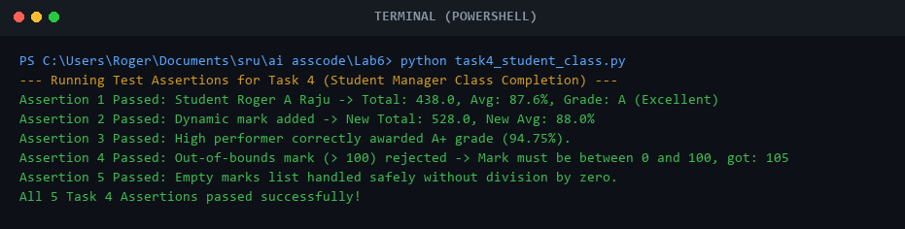
Comparison:
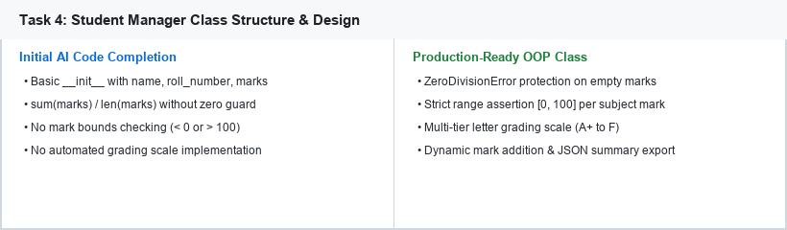

Task Description #5 (AI-Assisted Code Completion Review)
Task: Use an AI tool to generate a complete Python program using classes, loops, and conditionals together.
Prompt:
"Generate a Python program for a simple bank account system using class, loops, and conditional statements."
Expected Output:
- Complete AI-generated program integrating OOP classes, loops, and conditionals.
- Identification of strengths and limitations of AI suggestions.
- Reflection on how AI assisted coding productivity.
Complete Integrated Bank Account System & Assert Tests:
"""
Experiment 6 - Task 5: AI-Assisted Code Completion Review (Bank Account System)
Prompt: "Generate a Python program for a simple bank account system using class, loops, and conditional statements."
Student: Roger A Raju (Roll No: 2503a52370, Batch: 13)
"""
from typing import List, Dict, Any
class BankAccount:
"""
Simulates a secure bank account managing deposits, withdrawals,
ledger transaction logging, and balance validation.
"""
def __init__(self, account_holder: str, initial_balance: float = 0.0):
if not account_holder or not isinstance(account_holder, str):
raise ValueError("Account holder name must be a non-empty string.")
if initial_balance < 0:
raise ValueError("Initial balance cannot be negative.")
self.account_holder = account_holder
self.balance = float(initial_balance)
self.transactions: List[Dict[str, Any]] = []
self._record_transaction("OPENING_BALANCE", self.balance, self.balance, "Account created")
def _record_transaction(self, tx_type: str, amount: float, current_bal: float, status: str) -> None:
self.transactions.append({
"id": len(self.transactions) + 1,
"type": tx_type,
"amount": amount,
"balance_after": current_bal,
"status": status
})
def deposit(self, amount: float) -> bool:
"""Processes a deposit with positive amount conditional check."""
if not isinstance(amount, (int, float)) or isinstance(amount, bool) or amount <= 0:
self._record_transaction("DEPOSIT_FAILED", amount, self.balance, "Invalid deposit amount")
return False
self.balance += float(amount)
self._record_transaction("DEPOSIT", float(amount), self.balance, "Success")
return True
def withdraw(self, amount: float) -> bool:
"""Processes a withdrawal with balance overdraft conditional check."""
if not isinstance(amount, (int, float)) or isinstance(amount, bool) or amount <= 0:
self._record_transaction("WITHDRAW_FAILED", amount, self.balance, "Invalid withdrawal amount")
return False
if amount > self.balance:
self._record_transaction("WITHDRAW_REJECTED", float(amount), self.balance, "Insufficient funds")
return False
self.balance -= float(amount)
self._record_transaction("WITHDRAWAL", float(amount), self.balance, "Success")
return True
def process_batch_operations(self, operations: List[Dict[str, Any]]) -> Dict[str, int]:
"""
Executes a series of banking operations using loops and conditional routing.
"""
success_count = 0
failed_count = 0
for op in operations:
op_type = op.get("type", "").upper()
amt = op.get("amount", 0.0)
if op_type == "DEPOSIT":
if self.deposit(amt):
success_count += 1
else:
failed_count += 1
elif op_type == "WITHDRAW":
if self.withdraw(amt):
success_count += 1
else:
failed_count += 1
else:
failed_count += 1
return {
"total_processed": len(operations),
"successful_operations": success_count,
"failed_operations": failed_count,
"final_balance": self.balance
}
def test_bank_account_system():
print("--- Running Test Assertions for Task 5 (Bank Account System Completion Review) ---")
# Test Case 1: Account Creation & Initial Deposit
account = BankAccount("Roger A Raju", 1000.0)
assert account.balance == 1000.0, "Test 1 Failed"
assert len(account.transactions) == 1, "Test 1 Failed"
print(f"Assertion 1 Passed: Account opened for '{account.account_holder}' with Rs. {account.balance}")
# Test Case 2: Deposit & Withdrawal Flow
assert account.deposit(500.0) is True, "Deposit failed"
assert account.balance == 1500.0, "Balance mismatch after deposit"
assert account.withdraw(300.0) is True, "Withdrawal failed"
assert account.balance == 1200.0, "Balance mismatch after withdrawal"
print(f"Assertion 2 Passed: Deposit (+Rs. 500) & Withdrawal (-Rs. 300) -> Balance: Rs. {account.balance}")
# Test Case 3: Overdraft Protection (Conditional Guard)
assert account.withdraw(5000.0) is False, "Test 3 Failed: Overdraft permitted"
assert account.balance == 1200.0, "Test 3 Failed: Balance modified on overdraft"
print("Assertion 3 Passed: Overdraft of Rs. 5000 safely rejected by conditional check.")
# Test Case 4: Batch Processing with Loops & Conditionals
batch_ops = [
{"type": "DEPOSIT", "amount": 200.0}, # bal: 1400
{"type": "WITHDRAW", "amount": 400.0}, # bal: 1000
{"type": "WITHDRAW", "amount": 9999.0}, # failed overdraft
{"type": "DEPOSIT", "amount": -50.0}, # failed negative
{"type": "UNKNOWN", "amount": 100.0} # failed type
]
summary = account.process_batch_operations(batch_ops)
assert summary["successful_operations"] == 2, "Test 4 Failed"
assert summary["failed_operations"] == 3, "Test 4 Failed"
assert summary["final_balance"] == 1000.0, "Test 4 Failed"
print(f"Assertion 4 Passed: Batch Operations Processed -> Success: {summary['successful_operations']}, Failed: {summary['failed_operations']}, Final Bal: Rs. {summary['final_balance']}")
print("All 4 Task 5 Assertions passed successfully!")
if __name__ == "__main__":
test_bank_account_system()
Output:
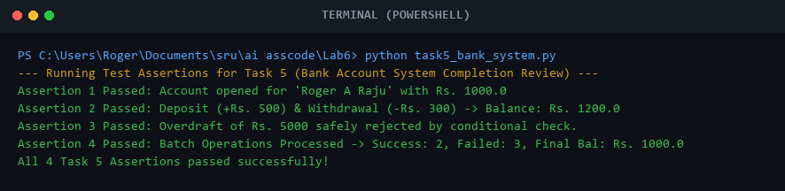
Comparison:
