Lab 11 – Data Structures with AI: Implementing Fundamental Structures
Name: Roger A Raju
Roll no: 2503a52370
Batch-13
―――――――――――――――――――――――――――――――――――――――――――――――――――――――
Task 1 – Stack Implementation
1. Question
Use AI to generate a Stack class with push, pop, peek, and is_empty methods.
2. Prompt:
Complete this Python Stack class for a beginner data structures lab. Add push(), pop(), peek(), and is_empty(), handle an empty stack, include short docstrings/comments, and add a small test section.
3. Code:
class Stack:
def __init__(self):
self.items = []
def push(self, item):
self.items.append(item)
def pop(self):
if self.is_empty():
return None
return self.items.pop()
def peek(self):
if self.is_empty():
return None
return self.items[-1]
def is_empty(self):
return len(self.items) == 0
if __name__ == "__main__":
stack = Stack()
stack.push(10)
stack.push(20)
stack.push(30)
print("Stack:", stack.items)
print("Top element:", stack.peek())
print("Removed element:", stack.pop())
print("Stack after pop:", stack.items)
print("Is stack empty?", stack.is_empty())

4. Output :
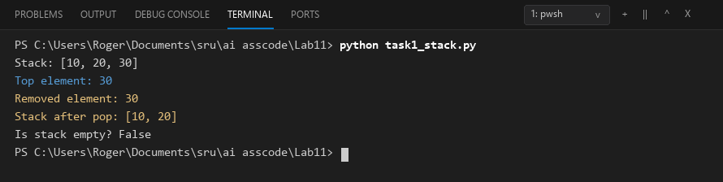
5. Final Justification
The Stack was implemented successfully with the required methods. It follows the LIFO principle and was tested with sample operations.
Task 2 – Queue Implementation
1. Question
Use AI to implement a Queue using Python lists.
2. Prompt:
Complete this Python Queue class using a list. Add enqueue(), dequeue(), peek(), and size(), follow FIFO, handle an empty queue, and add short comments plus a small test section.
3. Code:
class Queue:
def __init__(self):
self.items = []
def enqueue(self, item):
self.items.append(item)
def dequeue(self):
if self.size() == 0:
return None
return self.items.pop(0)
def peek(self):
if self.size() == 0:
return None
return self.items[0]
def size(self):
return len(self.items)
if __name__ == "__main__":
queue = Queue()
queue.enqueue(10)
queue.enqueue(20)
queue.enqueue(30)
print("Queue:", queue.items)
print("Front element:", queue.peek())
print("Removed element:", queue.dequeue())
print("Queue after dequeue:", queue.items)
print("Queue size:", queue.size())

4. Output :
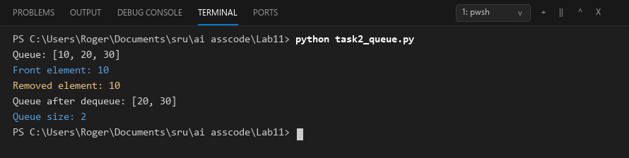
5. Final Justification
The Queue was implemented using a Python list and tested with sample operations. It follows the FIFO principle as required.
Task 3 – Linked List
1. Question
Use AI to generate a Singly Linked List with insert and display methods.
2. Prompt:
Create a beginner-friendly singly linked list in Python with Node and LinkedList classes. Add insert() and display(), with short comments/docstrings and a small test section.
3. Code:
class Node:
def __init__(self, data):
self.data = data
self.next = None
class LinkedList:
def __init__(self):
self.head = None
def insert(self, data):
new_node = Node(data)
if self.head is None:
self.head = new_node
return
current = self.head
while current.next is not None:
current = current.next
current.next = new_node
def display(self):
current = self.head
while current is not None:
print(current.data, end=" -> ")
current = current.next
print("None")
if __name__ == "__main__":
linked_list = LinkedList()
linked_list.insert(10)
linked_list.insert(20)
linked_list.insert(30)
print("Linked List:")
linked_list.display()

4. Output :
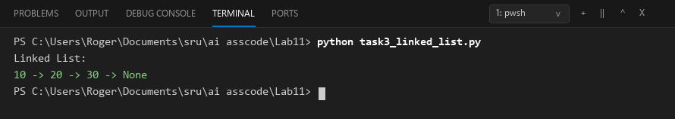
5. Final Justification
The singly linked list was implemented with nodes connected through next references. Insert and display operations were tested successfully.
Task 4 – Binary Search Tree (BST)
1. Question
Use AI to create a BST with insert and in-order traversal methods.
2. Prompt:
Create a beginner-friendly Python BST with recursive insert() and in-order traversal. Add short comments/docstrings and test it with sample values.
3. Code:
class Node:
def __init__(self, data):
self.data = data
self.left = None
self.right = None
class BST:
def __init__(self):
self.root = None
def insert(self, data):
self.root = self._insert_recursive(self.root, data)
def _insert_recursive(self, node, data):
if node is None:
return Node(data)
if data < node.data:
node.left = self._insert_recursive(node.left, data)
elif data > node.data:
node.right = self._insert_recursive(node.right, data)
return node
def in_order(self):
self._in_order_recursive(self.root)
print()
def _in_order_recursive(self, node):
if node is not None:
self._in_order_recursive(node.left)
print(node.data, end=" ")
self._in_order_recursive(node.right)
if __name__ == "__main__":
tree = BST()
values = [50, 30, 70, 20, 40, 60, 80]
for value in values:
tree.insert(value)
print("In-order traversal:")
tree.in_order()

4. Output :
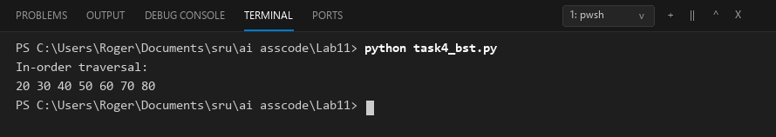
5. Final Justification
The BST was implemented using recursive insertion and in-order traversal. The traversal produced the values in sorted order.
Task 5 – Priority Queue
1. Question
Use AI to implement a priority queue using Python's heapq module.
2. Prompt:
Create a simple Python PriorityQueue using heapq. Implement enqueue(priority), dequeue(), and display(), handle an empty queue, and add short comments plus tests.
3. Code:
import heapq
class PriorityQueue:
def __init__(self):
self.queue = []
def enqueue(self, item, priority):
heapq.heappush(self.queue, (-priority, item))
def dequeue(self):
if len(self.queue) == 0:
return None
priority, item = heapq.heappop(self.queue)
return item
def display(self):
print("Priority Queue:", self.queue)
if __name__ == "__main__":
pq = PriorityQueue()
pq.enqueue("Normal Task", 1)
pq.enqueue("Important Task", 3)
pq.enqueue("Urgent Task", 5)
pq.display()
print("Removed:", pq.dequeue())
print("Removed:", pq.dequeue())
print("Removed:", pq.dequeue())

4. Output :
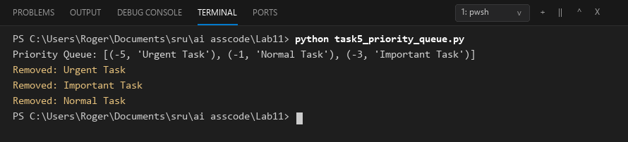
5. Final Justification
The Priority Queue was implemented using Python's heapq module. Items were inserted and removed according to their assigned priority.
Task 6 – Deque
1. Question
Use AI to implement a double-ended queue using collections.deque.
2. Prompt:
Create a beginner-friendly DequeDS class using collections.deque. Implement insertion and removal from both ends, display(), empty handling, and short comments/docstrings.
3. Code:
from collections import deque
class DequeDS:
def __init__(self):
self.items = deque()
def insert_front(self, item):
self.items.appendleft(item)
def insert_rear(self, item):
self.items.append(item)
def remove_front(self):
if len(self.items) == 0:
return None
return self.items.popleft()
def remove_rear(self):
if len(self.items) == 0:
return None
return self.items.pop()
def display(self):
print("Deque:", list(self.items))
if __name__ == "__main__":
d = DequeDS()
d.insert_front(10)
d.insert_rear(20)
d.insert_front(5)
d.display()
print("Removed from front:", d.remove_front())
print("Removed from rear:", d.remove_rear())
d.display()

4. Output :
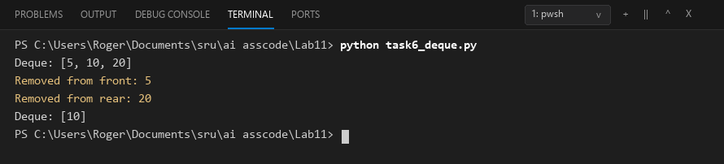
5. Final Justification
The Deque was implemented using collections.deque and tested from both ends. It supports insertion and removal at the front and rear.
Task 7 – Real-Time Application Challenge – Choose the Right Data Structure
1. Question
For the Campus Resource Management System, select a suitable data structure for each feature, justify each choice briefly, and implement one feature.
2. Prompt:
For the five Campus Resource Management features, choose a suitable data structure and give a short justification for each. Then implement one selected feature as a simple Python program with comments.
3. Code:
class CafeteriaQueue:
def __init__(self):
self.orders = []
def add_order(self, student_name, food):
order = f"{student_name} - {food}"
self.orders.append(order)
print("Order added:", order)
def serve_order(self):
if len(self.orders) == 0:
print("No orders to serve.")
return
order = self.orders.pop(0)
print("Order served:", order)
def display_orders(self):
if len(self.orders) == 0:
print("No pending orders.")
else:
print("Pending Orders:")
for order in self.orders:
print(order)
if __name__ == "__main__":
cafeteria = CafeteriaQueue()
cafeteria.add_order("Rahul", "Burger")
cafeteria.add_order("Priya", "Pizza")
cafeteria.add_order("Arjun", "Sandwich")
print()
cafeteria.display_orders()
print()
cafeteria.serve_order()
print()
cafeteria.display_orders()

4. Output :
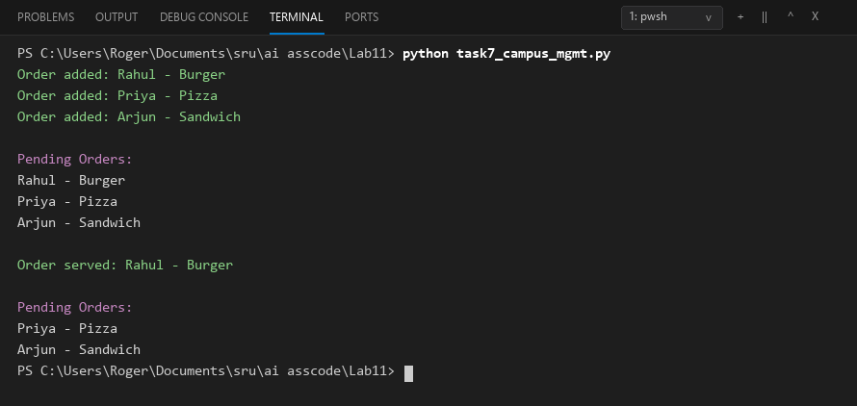
5. Final Justification
Suitable data structures were selected for the campus features based on their required operations. One feature was implemented as a working Python program with AI assistance.
Task 8 – Smart E-Commerce Platform – Data Structure Challenge
1. Question
For the Smart Online Shopping System, select a suitable data structure for each feature, justify each choice briefly, and implement one feature.
2. Prompt:
For the five e-commerce features, choose a suitable data structure and give a short justification for each. Then implement one selected feature as a simple Python program with comments.
3. Code:
class OrderQueue:
def __init__(self):
self.orders = []
def add_order(self, order_id, customer):
order = f"{order_id} - {customer}"
self.orders.append(order)
print("Order added:", order)
def process_order(self):
if len(self.orders) == 0:
print("No orders to process.")
return
order = self.orders.pop(0)
print("Order processed:", order)
def display_orders(self):
if len(self.orders) == 0:
print("No pending orders.")
else:
print("Pending Orders:")
for order in self.orders:
print(order)
if __name__ == "__main__":
order_queue = OrderQueue()
order_queue.add_order("ORD001", "Rahul")
order_queue.add_order("ORD002", "Priya")
order_queue.add_order("ORD003", "Arjun")
print()
order_queue.display_orders()
print()
order_queue.process_order()
print()
order_queue.display_orders()

4. Output :
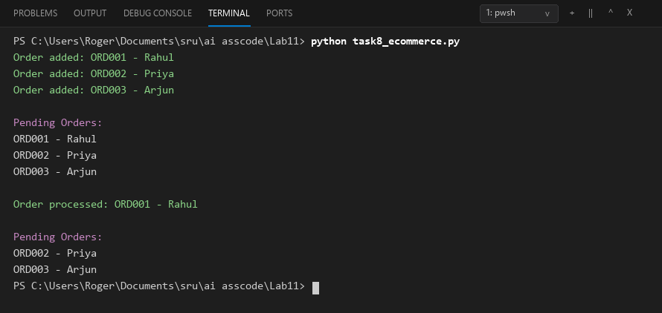
5. Final Justification
Suitable data structures were selected for the e-commerce features according to their operations. One feature was implemented as a working Python program with AI assistance.
Task 7 – Campus Resource Management: Data Structure Selection
Campus Feature | Data Structure | Reason
Student Attendance Tracking | Queue | Students can be processed in the order they enter the campus.
Event Registration | Hash Table | It provides fast search using a student or participant ID.
Library Book Borrowing | Priority Queue | Borrowing requests can be handled according to due dates or priority.
Bus Scheduling | Graph | Bus stops and routes can be represented as connected nodes and edges.
Cafeteria Order Queue | Queue | Orders are served in the same order in which students place them.
Task 8 – Smart E-Commerce Platform: Data Structure Challenge
E-Commerce Feature | Data Structure | Reason
Shopping Cart Management | Deque | Products can be added or removed efficiently from either end.
Order Processing System | Queue | Orders are processed in the same order in which they are placed.
Top-Selling Products Tracker | Priority Queue | Products can be handled according to their sales priority.
Product Search Engine | Hash Table | Product IDs can be used for fast lookup.
Delivery Route Planning | Graph | Warehouses and delivery locations can be represented as connected nodes.

