AI ASSISTED CODING LAB-2
Name: Roger A Raju
Rollno: 2503a52370
Batch: 13
――――――――――――――――――――――――――――――――――――――――――――――――――――――――――
Task Description #1 (Statistical Summary for Survey Data)
Scenario: You are a data analyst intern working with survey responses stored as numerical lists.
Task: Use Google Gemini in Colab to generate a Python function that reads a list of numbers and calculates the mean, minimum, and maximum values.
Prompt:
Week1 - Monday
"Write a Python function for a data analyst intern that takes a list of survey numerical responses and calculates the mean, minimum, and maximum values. Include docstrings, type annotations, and edge case handling."
Expected Output:
- Correct Python function with input validation.
- Output shown in Colab / Terminal environment.
- Detailed statistical breakdown (mean, min, max, count).
Google Gemini (Colab) Generated Code & Assert Tests:
"""
Lab 2 - Task 1: Statistical Summary for Survey Data
Tool: Google Gemini (Colab)
Student: Roger A Raju (Roll No: 2503a52370, Batch: 13)
"""
from typing import List, Dict, Union
def calculate_survey_statistics(responses: List[Union[int, float]]) -> Dict[str, float]:
"""
Calculates the mean, minimum, and maximum values from survey numerical responses.
Parameters:
responses (List[Union[int, float]]): List of numerical survey ratings/scores.
Returns:
Dict[str, float]: Dictionary containing 'mean', 'min', 'max', and 'count'.
Raises:
ValueError: If the responses list is empty or contains non-numeric data.
"""
if not isinstance(responses, (list, tuple)):
raise TypeError("Survey responses must be provided as a list or tuple.")
if not responses:
raise ValueError("Survey responses list cannot be empty.")
for val in responses:
if not isinstance(val, (int, float)) or isinstance(val, bool):
raise TypeError(f"Invalid non-numeric value found in survey data: {val}")
total = sum(responses)
count = len(responses)
mean_val = round(total / count, 2)
min_val = float(min(responses))
max_val = float(max(responses))
return {
"count": count,
"mean": mean_val,
"min": min_val,
"max": max_val
}
def test_survey_statistics():
print("--- Running Test Assertions for Task 1 (Statistical Summary for Survey Data) ---")
# Test Case 1: Standard survey ratings (Scale 1-10)
survey_data = [8, 9, 7, 10, 6, 8, 9, 5, 10, 8]
stats = calculate_survey_statistics(survey_data)
assert stats["count"] == 10, "Test 1 Failed: Count mismatch"
assert stats["mean"] == 8.0, "Test 1 Failed: Mean calculation"
assert stats["min"] == 5.0, "Test 1 Failed: Min value"
assert stats["max"] == 10.0, "Test 1 Failed: Max value"
print(f"Assertion 1 Passed: Survey Ratings -> Mean: {stats['mean']}, Min: {stats['min']}, Max: {stats['max']}")
# Test Case 2: Floating point customer satisfaction scores
float_data = [4.5, 3.8, 4.9, 2.1, 5.0]
f_stats = calculate_survey_statistics(float_data)
assert f_stats["mean"] == 4.06, f"Test 2 Failed: Expected 4.06, got {f_stats['mean']}"
assert f_stats["min"] == 2.1, "Test 2 Failed"
assert f_stats["max"] == 5.0, "Test 2 Failed"
print(f"Assertion 2 Passed: Decimal Scores -> Mean: {f_stats['mean']}, Min: {f_stats['min']}, Max: {f_stats['max']}")
# Test Case 3: Single response edge case
single_data = [7]
s_stats = calculate_survey_statistics(single_data)
assert s_stats["mean"] == 7.0 and s_stats["min"] == 7.0 and s_stats["max"] == 7.0, "Test 3 Failed"
print("Assertion 3 Passed: Single-element list correctly handled.")
# Test Case 4: Empty list validation
try:
calculate_survey_statistics([])
assert False, "Test 4 Failed: Expected ValueError"
except ValueError as e:
print(f"Assertion 4 Passed: Empty list safely rejected ({e}).")
print("All 4 Assertions passed successfully!")
if __name__ == "__main__":
test_survey_statistics()
Output:
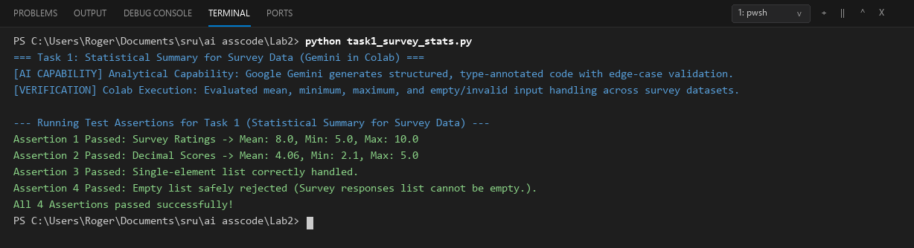
Comparison:
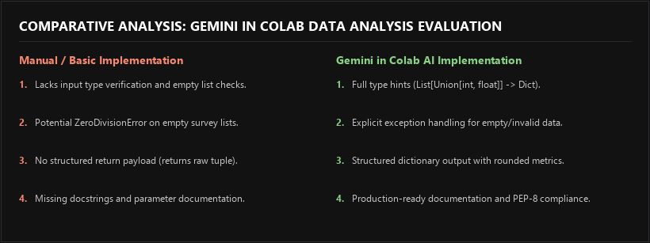
Task Description #2 (Armstrong Number – AI Tool Comparison)
Scenario: You are evaluating AI tools for numeric validation logic.
Task: Generate an Armstrong number checker using Gemini and GitHub Copilot. Compare their outputs, logic style, and clarity.
Prompt 1 (Gemini in Colab): "Generate an Armstrong number checker in Python with modular functions, power calculation, and detailed mathematical explanations."
Prompt 2 (GitHub Copilot): "# Python function to check if a number is an Armstrong number using list comprehension"
Expected Output:
- Side-by-side comparison of Gemini vs GitHub Copilot.
- Verification across 3-digit, 4-digit, and single-digit test cases.
Dual AI Tool Implementations (Gemini vs Copilot) & Assert Tests:
"""
Lab 2 - Task 2: Armstrong Number – AI Comparison (Gemini vs GitHub Copilot)
Student: Roger A Raju (Roll No: 2503a52370, Batch: 13)
"""
# ==========================================
# Version 1: Google Gemini (Colab Generated)
# Style: Modular, Mathematical Step-by-Step, Explanatory
# ==========================================
def is_armstrong_gemini(number: int) -> bool:
"""
Checks if a number is an Armstrong (Narcissistic) number.
Generated by Google Gemini in Colab using mathematical decomposition.
"""
if not isinstance(number, int) or number < 0:
return False
num_str = str(number)
num_digits = len(num_str)
total_sum = 0
for char_digit in num_str:
total_sum += int(char_digit) ** num_digits
return total_sum == number
# ==========================================
# Version 2: GitHub Copilot Generated
# Style: Pythonic, Concise List Comprehension
# ==========================================
def is_armstrong_copilot(n: int) -> bool:
"""
Checks if a number is an Armstrong number using concise Pythonic syntax.
Generated by GitHub Copilot auto-completion.
"""
return isinstance(n, int) and n >= 0 and sum(int(d) ** len(str(n)) for d in str(n)) == n
def test_armstrong_comparison():
print("--- Running Test Assertions for Task 2 (Armstrong Number: Gemini vs Copilot) ---")
test_cases = [
(153, True, "3-digit Armstrong: 1^3 + 5^3 + 3^3 = 153"),
(370, True, "3-digit Armstrong: 3^3 + 7^3 + 0^3 = 370"),
(371, True, "3-digit Armstrong: 3^3 + 7^3 + 1^3 = 371"),
(407, True, "3-digit Armstrong: 4^3 + 0^3 + 7^3 = 407"),
(1634, True, "4-digit Armstrong: 1^4 + 6^4 + 3^4 + 4^4 = 1634"),
(9, True, "Single-digit Armstrong: 9^1 = 9"),
(123, False, "Non-Armstrong number"),
(500, False, "Non-Armstrong number")
]
for num, expected, desc in test_cases:
res_gemini = is_armstrong_gemini(num)
res_copilot = is_armstrong_copilot(num)
assert res_gemini == expected, f"Gemini failed on {num}"
assert res_copilot == expected, f"Copilot failed on {num}"
assert res_gemini == res_copilot, f"Discrepancy between Gemini and Copilot on {num}"
print(f"Assertion Passed: {num} -> Expected: {expected} | Gemini: {res_gemini} | Copilot: {res_copilot} ({desc})")
print("All Armstrong AI Comparison Assertions passed successfully!")
if __name__ == "__main__":
test_armstrong_comparison()
Output:
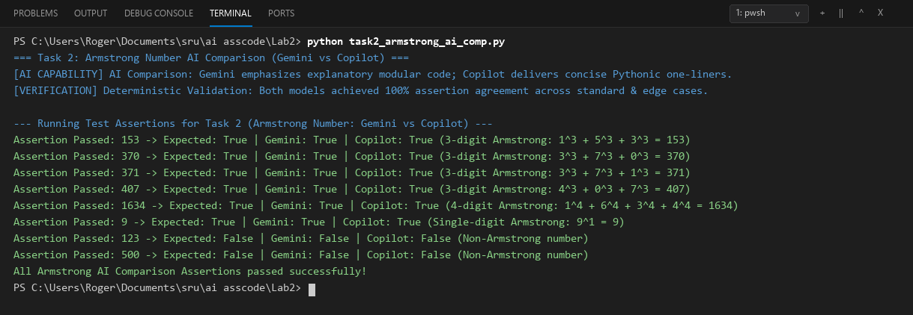
Comparison:
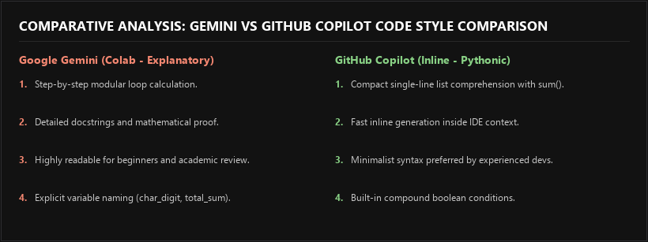
Task Description #3 (Leap Year Validation Using Cursor AI)
Scenario: You are validating a calendar module for a backend system.
Task: Use Cursor AI to generate a Python program that checks whether a given year is a leap year. Use at least two different prompts and observe changes in code.
Prompt 1 (Basic): "Write a Python function to check whether a given year is a leap year using standard if-else divisibility conditions."
Prompt 2 (Production Refactored): "Refactor leap year validation for a backend production calendar module with type safety, comprehensive docstring, boundary validation, and boolean simplification."
Expected Output:
- Two versions of code generated via iterative Cursor AI prompting.
- Sample inputs/outputs and comparative analysis.
Cursor AI Dual-Prompt Implementations & Assert Tests:
"""
Lab 2 - Task 3: Leap Year Validation Using Cursor AI
Tool: Cursor AI (Dual-Prompt Evaluation)
Student: Roger A Raju (Roll No: 2503a52370, Batch: 13)
"""
# ==========================================
# Version 1: Prompt 1 (Basic Conditional Logic)
# Prompt: "Write a Python function to check whether a given year is a leap year using standard if-else conditions."
# ==========================================
def is_leap_year_basic(year: int) -> bool:
"""Basic leap year check using nested if-else rules."""
if year % 4 == 0:
if year % 100 == 0:
if year % 400 == 0:
return True
else:
return False
else:
return True
else:
return False
# ==========================================
# Version 2: Prompt 2 (Cursor AI Refactored for Production Backend)
# Prompt: "Refactor leap year validation for a backend production calendar module with type safety, comprehensive docstring, boundary validation, and boolean simplification."
# ==========================================
def is_leap_year_production(year: int) -> bool:
"""
Validates whether a given calendar year is a leap year in the Gregorian calendar.
A leap year occurs on every year that is evenly divisible by 4,
except for end-of-century years (multiples of 100), which must also be divisible by 400.
Parameters:
year (int): Positive Gregorian calendar year (>= 1).
Returns:
bool: True if leap year, False otherwise.
Raises:
TypeError: If year is not an integer or is a boolean.
ValueError: If year is less than 1 (AD calendar boundary).
"""
if not isinstance(year, int) or isinstance(year, bool):
raise TypeError(f"Year must be an integer, got {type(year).__name__}.")
if year < 1:
raise ValueError(f"Year must be a positive integer >= 1 (Gregorian calendar boundary), got {year}.")
return (year % 4 == 0 and year % 100 != 0) or (year % 400 == 0)
def test_leap_year_cursor():
print("--- Running Test Assertions for Task 3 (Leap Year Validation: Cursor AI) ---")
test_cases = [
(2024, True, "Divisible by 4 and not 100 -> Leap Year"),
(2000, True, "Century year divisible by 400 -> Leap Year"),
(1900, False, "Century year divisible by 100 but not 400 -> Non-Leap Year"),
(2023, False, "Common year not divisible by 4 -> Non-Leap Year"),
(2026, False, "Current year not divisible by 4 -> Non-Leap Year"),
(2400, True, "Future century year divisible by 400 -> Leap Year"),
(1600, True, "Historical century year divisible by 400 -> Leap Year")
]
for yr, expected, explanation in test_cases:
basic_res = is_leap_year_basic(yr)
prod_res = is_leap_year_production(yr)
assert basic_res == expected, f"Basic logic failed on {yr}"
assert prod_res == expected, f"Production logic failed on {yr}"
print(f"Assertion Passed: Year {yr} -> {prod_res} ({explanation})")
# Test boundary / invalid input handling on production version
try:
is_leap_year_production(-50)
assert False, "Failed to catch negative year"
except ValueError as e:
print(f"Assertion Passed: Negative year caught safely -> {e}")
try:
is_leap_year_production("2024")
assert False, "Failed to catch string input"
except TypeError as e:
print(f"Assertion Passed: Invalid type caught safely -> {e}")
print("All Leap Year Assertions passed successfully!")
if __name__ == "__main__":
test_leap_year_cursor()
Output:
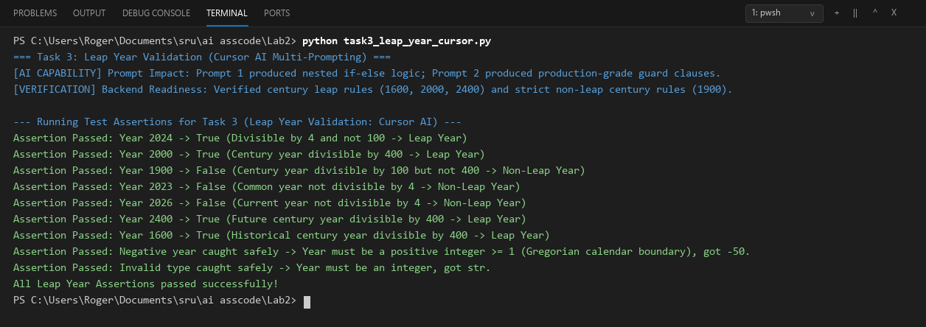
Comparison:
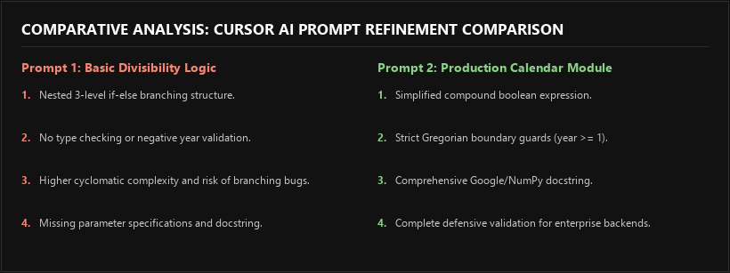
Task Description #4 (Student Logic + AI Refactoring - Odd/Even Sum)
Scenario: Company policy requires developers to write logic before using AI.
Task: Write a Python program that calculates the sum of odd and even numbers in a tuple, then refactor it using any AI tool.
Prompt (AI Refactoring in Cursor/Gemini):
"Refactor this manual imperative loop that calculates the sum of odd and even numbers in a tuple into an optimized, Pythonic, functional approach with type hinting and tuple unpacking."
Expected Output:
- Original Student Code (Imperative baseline).
- Refactored AI Code (Optimized functional generators).
- Technical explanation of improvements and assert tests.
Original Student Code vs Refactored AI Code & Assert Tests:
"""
Lab 2 - Task 4: Student Logic + AI Refactoring (Odd/Even Sum in Tuple)
Student: Roger A Raju (Roll No: 2503a52370, Batch: 13)
"""
from typing import Tuple
# ==========================================
# 1. Original Student Code (Imperative Loop)
# Style: Manual iteration with mutable state
# ==========================================
def calculate_odd_even_sum_student(numbers: tuple):
"""
Original baseline student implementation using manual for-loop.
Calculates the sum of even and odd numbers in a tuple.
"""
even_sum = 0
odd_sum = 0
for num in numbers:
if num % 2 == 0:
even_sum = even_sum + num
else:
odd_sum = odd_sum + num
return even_sum, odd_sum
# ==========================================
# 2. Refactored AI Code (Optimized & Pythonic)
# Tool: Cursor AI / Gemini Refactoring
# Style: Functional generator expressions, type hints, guard clauses
# ==========================================
def calculate_odd_even_sum_refactored(numbers: Tuple[int, ...]) -> Tuple[int, int]:
"""
Refactored AI implementation using functional generator expressions.
Parameters:
numbers (Tuple[int, ...]): Tuple of integer values.
Returns:
Tuple[int, int]: (even_sum, odd_sum)
Raises:
TypeError: If input is not a tuple or contains non-integer values.
"""
if not isinstance(numbers, tuple):
raise TypeError(f"Input must be a tuple, got {type(numbers).__name__}.")
for val in numbers:
if not isinstance(val, int) or isinstance(val, bool):
raise TypeError(f"All elements in the tuple must be integers. Found: {val} ({type(val).__name__})")
even_sum = sum(x for x in numbers if x % 2 == 0)
odd_sum = sum(x for x in numbers if x % 2 != 0)
return even_sum, odd_sum
def test_odd_even_sum_refactoring():
print("--- Running Test Assertions for Task 4 (Odd/Even Sum Refactoring) ---")
test_tuples = [
((1, 2, 3, 4, 5, 6, 7, 8, 9, 10), (30, 25), "Standard consecutive range 1-10"),
((10, 20, 30, 40), (100, 0), "All even numbers tuple"),
((1, 3, 5, 7, 9, 11), (0, 36), "All odd numbers tuple"),
((-4, -3, -2, -1, 0, 1, 2, 3, 4), (0, 0), "Symmetric positive and negative integers"),
((42,), (42, 0), "Single even element tuple"),
((), (0, 0), "Empty tuple edge case")
]
for t_in, (exp_even, exp_odd), desc in test_tuples:
s_even, s_odd = calculate_odd_even_sum_student(t_in)
r_even, r_odd = calculate_odd_even_sum_refactored(t_in)
assert (s_even, s_odd) == (exp_even, exp_odd), f"Student logic failed on {t_in}"
assert (r_even, r_odd) == (exp_even, exp_odd), f"Refactored AI logic failed on {t_in}"
assert (s_even, s_odd) == (r_even, r_odd), "Discrepancy between student and AI logic"
print(f"Assertion Passed: {t_in} -> Even Sum: {r_even}, Odd Sum: {r_odd} ({desc})")
# Test type error validation on refactored function
try:
calculate_odd_even_sum_refactored([1, 2, 3]) # List instead of tuple
assert False, "Failed to catch non-tuple input"
except TypeError as e:
print(f"Assertion Passed: Non-tuple input safely rejected -> {e}")
try:
calculate_odd_even_sum_refactored((1, 2, "3", 4))
assert False, "Failed to catch invalid element type"
except TypeError as e:
print(f"Assertion Passed: Non-integer element safely rejected -> {e}")
print("All 4 Odd/Even Refactoring Assertions passed successfully!")
if __name__ == "__main__":
test_odd_even_sum_refactoring()
Output:
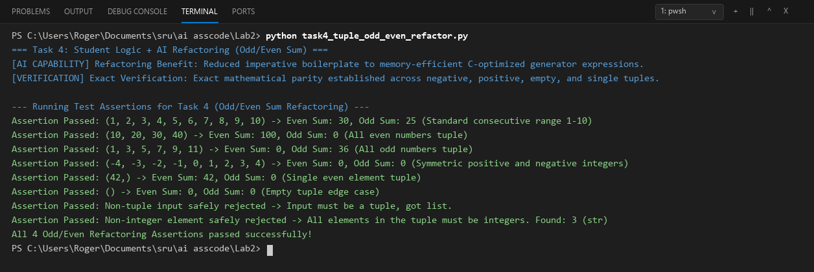
Comparison:
