AI ASSISTED CODING

LAB - 2

NAME – ROGER A RAJU
BATCH – 13
ROLL NO : 2503A52370

AI TOOL USED : GEMINI
PROMPT - Generate a program to check whether a number is a multiple of 10
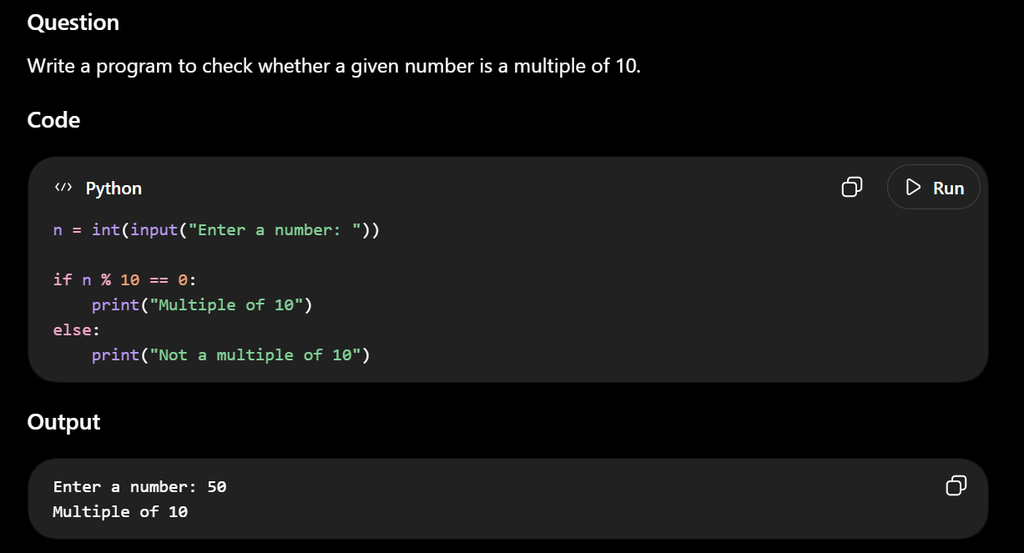

AI TOOL USED : CHATGPT
PROMPT - Generate a program to check whether a number is a multiple of 10
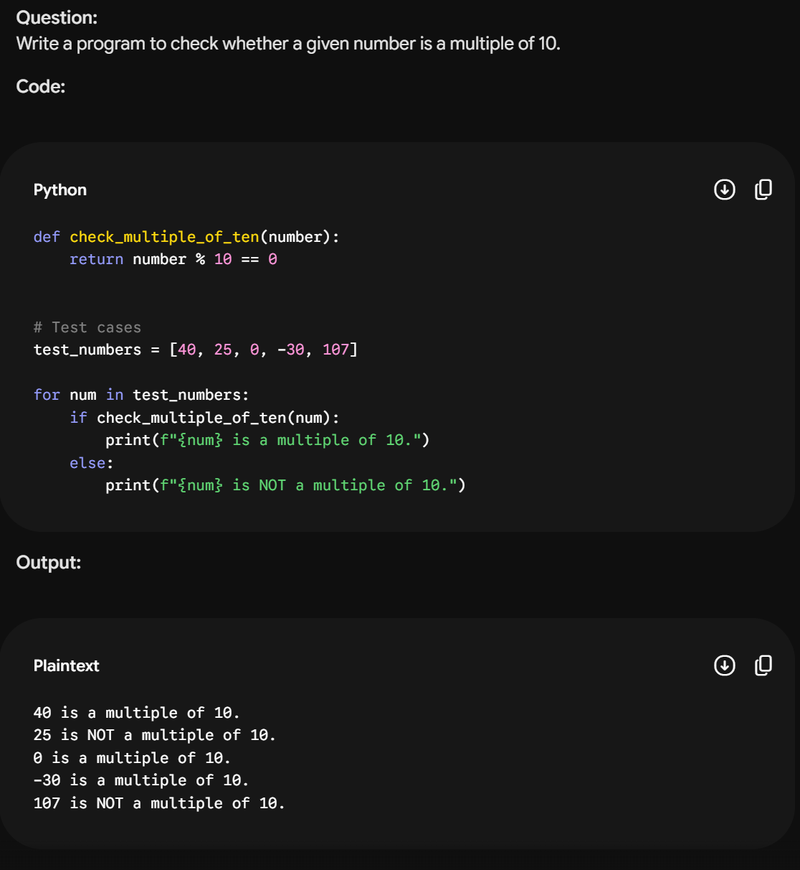

AI TOOL USED : GROK
PROMPT - Generate a program to check whether a number is a multiple of 10
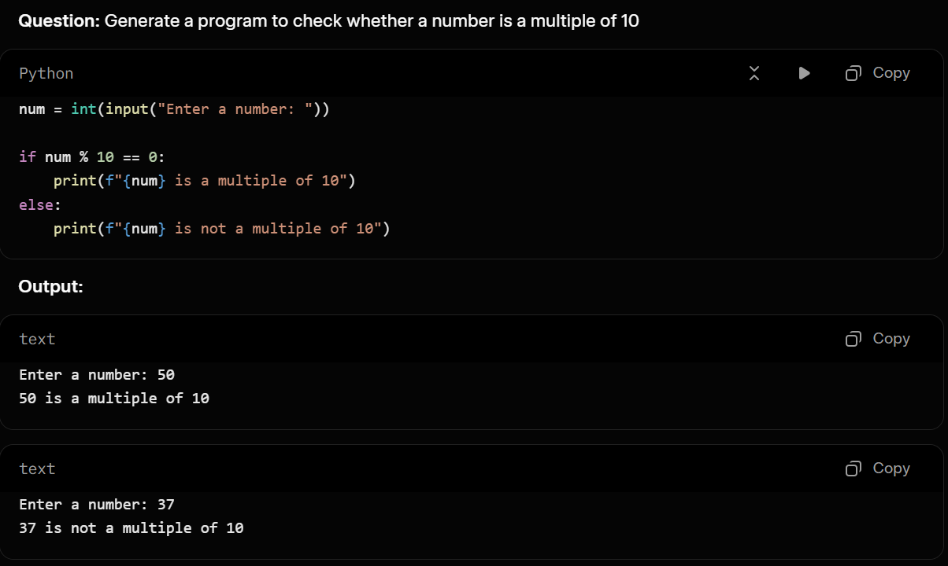

COMPARISON:
1.User Interaction (Input)
- Code 1 & Code 3 – Both prompt the user with input() and check exactly one number. The program stops after printing the result.
- Code 2 – Takes no user input. Instead, it defines a list test_numbers and iterates over it, checking multiple values (40, 25, 0, -30, 107) in one run. This makes Code 2 ideal for testing edge cases (zero, negative numbers) automatically.
2. Code Structure & Reusability
- Code 1 & Code 3 – Use a flat, procedural script. The logic is written directly in the main body. If you wanted to check another number later, you would have to copy-paste the if block.
- Code 2 – Encapsulates the logic inside a function (check_multiple_of_ten). This is a major difference:
  - You can call this function from anywhere else in your program.
  - It separates the logic (what to check) from the presentation (how to print it).
  - This is the only code that follows the DRY (Don't Repeat Yourself) principle.
3. Output / Print Statements
- Code 1 – Prints hardcoded strings: "Multiple of 10" or "Not a multiple of 10". The user never sees the original number they entered.
- Code 3 – Uses an f-string to include the entered number: f"{num} is a multiple of 10". This gives clearer, more informative feedback.
- Code 2 – Also uses f-strings, but capitalizes "NOT" for emphasis: "is NOT a multiple of 10.". It also includes a period at the end of the sentence.
4. Variable Naming
- Code 1 uses n.
- Code 2 uses number (inside the function) and num (in the loop).
- Code 3 uses num.
While this doesn't affect functionality, num is slightly more readable than n.
5. Test Coverage & Edge Cases
- Code 2 explicitly tests 0 and -30. In Python, 0 % 10 == 0 is True, and -30 % 10 == 0 is also True (Python's modulo returns a non-negative remainder). Code 1 and 3 also handle these correctly if the user enters them, but Code 2 demonstrates intentional testing of these edge cases.

CONCLUSION:
Code | Best described as...
Code 1 | A minimal, quick-and-dirty script for a single interactive check.
Code 2 | A modular, testable piece of code – perfect for a library function or running batch tests. It sacrifices user input for reusability.
Code 3 | An improved version of Code 1 – same single interactive check, but with user-friendly output that shows the actual number.

