Lab-4.1
Name: Roger A Raju | Roll_No: 2503A52370 | Batch: 13
Lab 4: Advanced Prompt Engineering – Zero-shot, One-shot, and Few-shot Techniques
Lab Objectives:
- To explore and apply different levels of prompt examples in AI-assisted code generation.
- To understand how zero-shot, one-shot, and few-shot prompting affect AI output quality.
- To evaluate the impact of context richness and example quantity on AI performance.
Sample Data:
No. | Chatbot User Query | Intent
Q1 | I forgot my password and cannot access my account. | Account Issue
Q2 | Where is my order? | Order Status
Q3 | Does this laptop have 16 GB RAM? | Product Inquiry
Q4 | What are your customer service hours? | General Question
Q5 | My account has been locked after several login attempts. | Account Issue
Zero-shot Prompting:
Prompt Used:
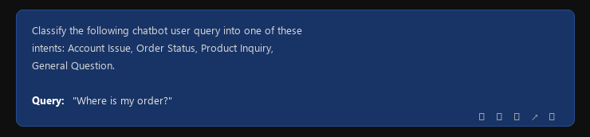
Output:
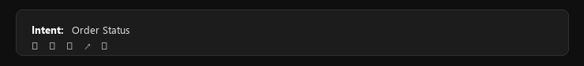
Observation: The model correctly classified the email without using any examples.
――――――――――――――――――――――――――――――――――――――――――――――――――――――――――
One-shot Prompting:
Prompt Used:
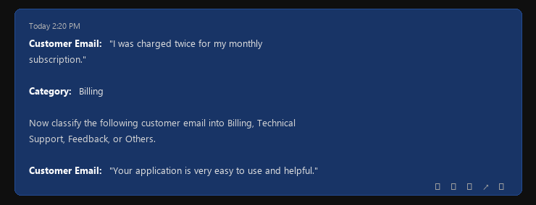
Output:
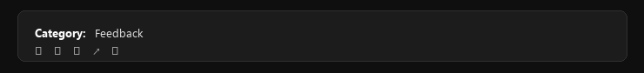
Observation: Providing one labeled example helped the model understand the expected classification format and category meanings.
――――――――――――――――――――――――――――――――――――――――――――――――――――――――――
Few-shot Prompting:
Prompt Used:
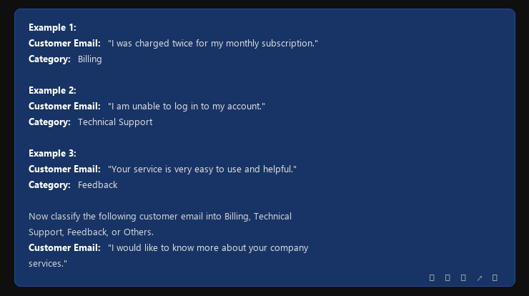
Output:
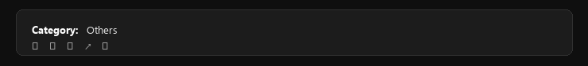
Observation: Few-shot prompting provided multiple examples covering different categories, making the classification more consistent and accurate.
Comparison of Zero-shot, One-shot, and Few-shot Prompting
Prompting Method | Examples Used | Output | Observation
Zero-shot | 0 | Order Status | Correct classification without using any examples.
One-shot | 1 | Feedback / Product Inquiry | One labeled example improved clarity and helped the model understand the expected classification format.
Few-shot | 3–4 | Others / Order Status | Multiple examples covering different categories made the classification more consistent and accurate.

