AI ASSISTED CODING
LAB ASSIGNMENT - 6
NAME : ROGER A RAJU
BATCH : 13 (23CSBTB13)
ROLL NO : 2503A52370
COURSE CODE : 23CS002PC304
ACADEMIC YEAR : 2025-2026 (III Year / II Sem)
―――――――――――――――――――――――――――――――――――――――――――――――――――――――
Task Description-1 (Classes – Data Validation)
PROMT:
• Prompt AI to generate a Student class with attributes: name, roll_no, and marks. Add a method is_pass() that returns whether the student has passed (marks ≥ 40).
INPUT:
class Student:
"""Represents a student with basic attributes and score validation."""
def __init__(self, name: str, roll_no: int, marks: float):
if not isinstance(name, str) or not name.strip():
raise ValueError("Name must be a non-empty string.")
if not isinstance(roll_no, int) or roll_no <= 0:
raise ValueError("Roll number must be a positive integer.")
if not isinstance(marks, (int, float)):
raise TypeError("Marks must be numeric (int or float).")
if not (0 <= marks <= 100):
raise ValueError("Marks must fall between 0 and 100 inclusive.")
self.name = name.strip()
self.roll_no = roll_no
self.marks = float(marks)
def is_pass(self) -> bool:
"""Determines if student scored the passing threshold (marks >= 40)."""
return self.marks >= 40
def __repr__(self) -> str:
status = "Pass" if self.is_pass() else "Fail"
return f"Student(name='{self.name}', roll_no={self.roll_no}, marks={self.marks}, status='{status}')"
if __name__ == "__main__":
s1 = Student("Aarav Sharma", 101, 78.5)
s2 = Student("Priya Patel", 102, 34.0)
print(f"{s1.name}: Passed? {s1.is_pass()}")
print(f"{s2.name}: Passed? {s2.is_pass()}")
try:
s3 = Student("Rahul", -5, 105)
except ValueError as e:
print(f"Validation Error: {e}")

OUTPUT:
Aarav Sharma: Passed? True
Priya Patel: Passed? False
Validation Error: Roll number must be a positive integer.
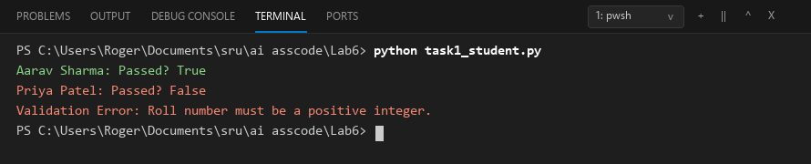

Task Description-2 (Loops – Pattern Generation)
PROMT:
• Ask AI to generate a function that prints a right-angled triangle star pattern using a for loop. Then regenerate the same pattern using a while loop.
INPUT (by using for loop):
def print_triangle_for(n: int) -> None:
"""Prints a right-angled triangle pattern of height n using a for loop."""
if n <= 0:
return
for i in range(1, n + 1):
print("*" * i)
print("--- For Loop Pattern ---")
print_triangle_for(5)

output:
--- For Loop Pattern ---
*
**
***
****
*****
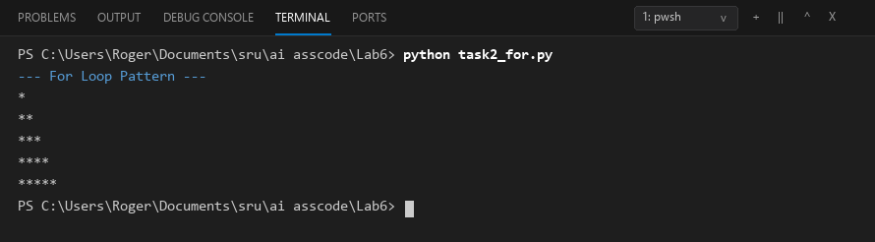

Input(by using while loop):
def print_triangle_while(n: int) -> None:
"""Prints a right-angled triangle pattern of height n using a while loop."""
if n <= 0:
return
i = 1
while i <= n:
print("*" * i)
i += 1
print("--- While Loop Pattern ---")
print_triangle_while(5)

output:
--- While Loop Pattern ---
*
**
***
****
*****
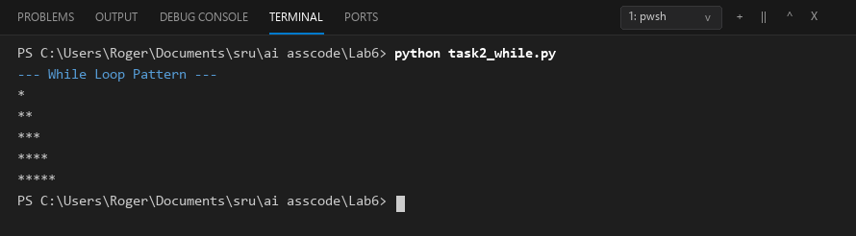

Task Description-3 (Conditional Statements – Number Analysis)
Promt:
• Ask AI to write a function that checks whether a given number is positive, negative, or zero using if-elif-else. Test the function with multiple inputs.
Input:
from typing import Union
def analyze_number(num: Union[int, float]) -> str:
"""Classifies a given number as 'Positive', 'Negative', or 'Zero'.
Args:
num: A numeric value (int or float).
Returns:
A string indicating the sign of the number.
"""
if not isinstance(num, (int, float)):
raise TypeError(f"Expected int or float, got {type(num).__name__}")
if num > 0:
return "Positive"
elif num < 0:
return "Negative"
else:
return "Zero"
if __name__ == "__main__":
test_cases = [15, -42, 0, 3.14159, -0.007, 0.0]
print(f"{'Input':>10} | {'Classification':<12}")
print("-" * 28)
for value in test_cases:
result = analyze_number(value)
print(f"{value:>10} | {result:<12}")

output:
Input | Classification
----------------------------
15 | Positive
-42 | Negative
0 | Zero
3.14159 | Positive
-0.007 | Negative
0.0 | Zero
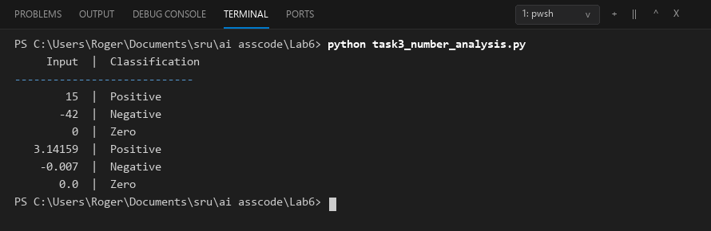

Task Description-4 (Nested Conditionals)
Promt:
• Generate a function check_discount(age, is_member) that determines discount eligibility:
• Age ≥ 60 → Senior discount
• Member → Additional discount
Use nested if statements.
Input:
def check_discount(age: int, is_member: bool) -> str:
"""Determines discount eligibility based on age and membership status
using nested conditionals.
"""
if not isinstance(age, int) or age < 0:
raise ValueError("Age must be a non-negative integer.")
if not isinstance(is_member, bool):
raise TypeError("is_member must be a boolean (True/False).")
if age >= 60:
if is_member:
return "Eligible for Senior Discount + Member Bonus (Highest Discount)"
else:
return "Eligible for Standard Senior Discount"
else:
if is_member:
return "Eligible for Member Discount"
else:
return "No Discount (Standard Rate)"
if __name__ == "__main__":
test_cases = [
(65, True),
(70, False),
(25, True),
(30, False),
]
for age, member in test_cases:
result = check_discount(age, member)
print(f"Age: {age}, Member: {str(member):<5} -> {result}")

output:
Age: 65, Member: True -> Eligible for Senior Discount + Member Bonus (Highest Discount)
Age: 70, Member: False -> Eligible for Standard Senior Discount
Age: 25, Member: True -> Eligible for Member Discount
Age: 30, Member: False -> No Discount (Standard Rate)
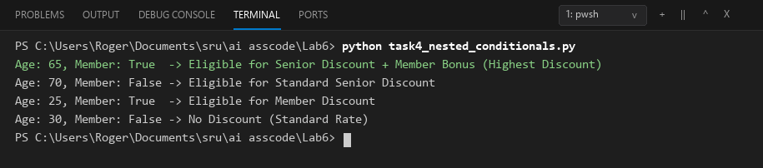

Task Description-5 (Class – Mathematical Opera)
Promt:
• Ask AI to create a Circle class with methods to calculate area () and circumference () given the radius.
Input:
import math
from typing import Union
class Circle:
"""Represents a geometric circle defined by its radius."""
def __init__(self, radius: Union[int, float]):
if not isinstance(radius, (int, float)):
raise TypeError("Radius must be an integer or float.")
if radius <= 0:
raise ValueError("Radius must be a positive number greater than zero.")
self.radius = float(radius)
def area(self) -> float:
"""Calculates the area: Area = Ï€ * r^2."""
return math.pi * (self.radius ** 2)
def circumference(self) -> float:
"""Calculates the circumference: C = 2 * Ï€ * r."""
return 2 * math.pi * self.radius
def __repr__(self) -> str:
return f"Circle(radius={self.radius})"
if __name__ == "__main__":
test_radii = [1.0, 5.0, 7.5]
print(f"{'Radius':>8} | {'Circumference':>15} | {'Area':>15}")
print("-" * 44)
for r in test_radii:
c = Circle(r)
print(f"{c.radius:8.2f} | {c.circumference():15.4f} | {c.area():15.4f}")

output:
Radius | Circumference | Area
--------------------------------------------
1.00 | 6.2832 | 3.1416
5.00 | 31.4159 | 78.5398
7.50 | 47.1239 | 176.7146
