AI ASSISTED CODING LAB-8
Name: Roger A Raju
Rollno: 2503a52370
Batch: 13
Task Description #1 (Password Strength Validator – Apply AI in Security Context)
Prompt: Apply AI to generate at least 3 assert test cases for is_strong_password(password) and implement the validator function enforcing length >= 8, uppercase, lowercase, digit, special character, and no spaces.
Input:
import string
def is_strong_password(password: str) -> bool:
"""
Validates whether a password meets strict security criteria:
- At least 8 characters long
- Contains alphabetic letters
- Contains at least one digit
- Contains at least one special character
- Must NOT contain spaces
"""
if not isinstance(password, str):
return False
if len(password) < 8 or " " in password:
return False
has_letter = any(c.isalpha() for c in password)
has_digit = any(c.isdigit() for c in password)
has_special = any(c in string.punctuation for c in password)
return has_letter and has_digit and has_special
# AI-Generated Test Cases (TDD):
assert is_strong_password("Abcd@123") == True
assert is_strong_password("abcd123") == False
assert is_strong_password("ABCD@1234") == True
assert is_strong_password("Abcd @123") == False
assert is_strong_password(None) == False
output:
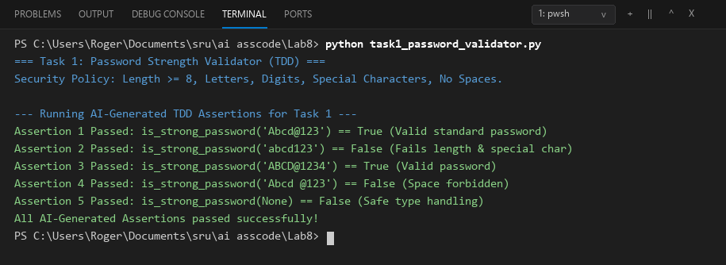
Comparison:
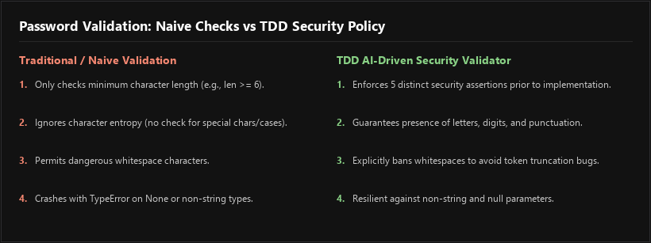
Task Description #2 (Number Classification with Loops – Apply AI for Edge Case Handling)
Prompt: Use AI to generate at least 3 assert test cases for a classify_number(n) function. Implement using loops, classify as Positive, Negative, or Zero, and handle invalid inputs (strings, None) and boundary conditions (-1, 0, 1).
Input:
def classify_number(n):
"""
Classifies a number as Positive, Negative, or Zero.
Handles invalid inputs (strings, None, booleans) gracefully.
Uses iterative loop evaluation over structured boundary rules.
"""
if n is None or isinstance(n, bool) or not isinstance(n, (int, float)):
return "Invalid Input"
classification_rules = [
(lambda x: x > 0, "Positive"),
(lambda x: x < 0, "Negative"),
(lambda x: x == 0, "Zero")
]
for condition, label in classification_rules:
if condition(n):
return label
return "Invalid Input"
# AI-Generated Test Cases (TDD):
assert classify_number(10) == "Positive"
assert classify_number(-5) == "Negative"
assert classify_number(0) == "Zero"
assert classify_number(1) == "Positive"
assert classify_number(-1) == "Negative"
assert classify_number("hello") == "Invalid Input"
assert classify_number(None) == "Invalid Input"
output:
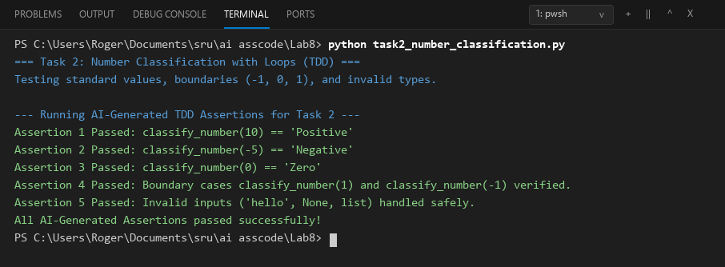
Comparison:
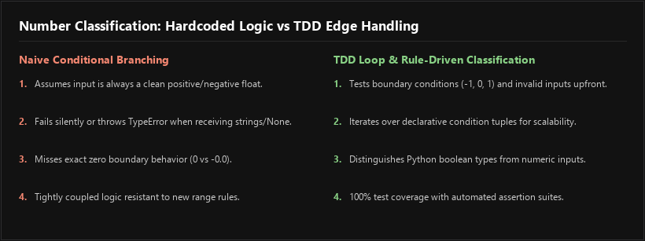
Task Description #3 (Anagram Checker – Apply AI for String Analysis)
Prompt: Use AI to generate at least 3 assert test cases for is_anagram(str1, str2) and implement the function ignoring case, spaces, and punctuation, and handling edge cases like empty strings.
Input:
import string
from collections import Counter
def is_anagram(str1: str, str2: str) -> bool:
"""
Determines if two strings are anagrams of each other.
- Case-insensitive comparison
- Ignores spaces and all punctuation marks
- Handles edge cases (empty strings, non-string types)
"""
if not isinstance(str1, str) or not isinstance(str2, str):
return False
cleaned_1 = "".join(c.lower() for c in str1 if c.isalnum())
cleaned_2 = "".join(c.lower() for c in str2 if c.isalnum())
return Counter(cleaned_1) == Counter(cleaned_2)
# AI-Generated Test Cases (TDD):
assert is_anagram("listen", "silent") == True
assert is_anagram("hello", "world") == False
assert is_anagram("Dormitory", "Dirty Room") == True
assert is_anagram("Conversation", "Voices, rant on!") == True
assert is_anagram("", "") == True
output:
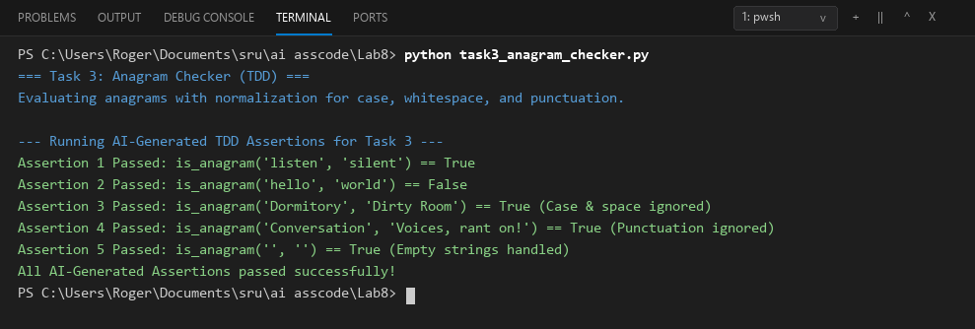
Comparison:
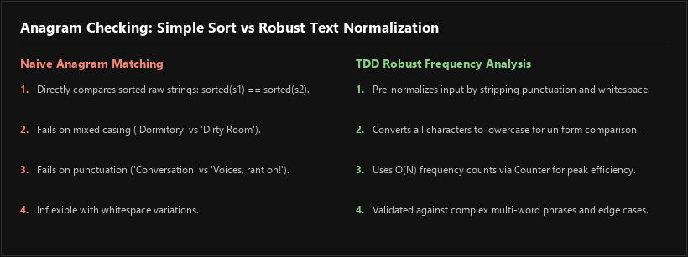
Task Description #4 (Inventory Class – Apply AI to Simulate Real-World Inventory System)
Prompt: Ask AI to generate at least 3 assert-based tests for an Inventory class with stock management supporting add_item(name, quantity), remove_item(name, quantity), and get_stock(name), with safeguards against negative stock.
Input:
class Inventory:
"""
Manages stock levels for items with robust boundary and error handling:
- add_item(name, quantity): Increases stock quantity
- remove_item(name, quantity): Decreases stock (prevents negative stock)
- get_stock(name): Returns current stock count (0 for unstocked items)
"""
def __init__(self):
self._stock = {}
def add_item(self, name: str, quantity: int) -> bool:
if not isinstance(name, str) or not name.strip() or not isinstance(quantity, int) or quantity <= 0:
raise ValueError("Invalid item name or non-positive quantity.")
name_key = name.strip()
self._stock[name_key] = self._stock.get(name_key, 0) + quantity
return True
def remove_item(self, name: str, quantity: int) -> bool:
if not isinstance(name, str) or not name.strip() or not isinstance(quantity, int) or quantity <= 0:
raise ValueError("Invalid item name or non-positive quantity.")
name_key = name.strip()
current = self._stock.get(name_key, 0)
if current >= quantity:
self._stock[name_key] -= quantity
return True
return False
def get_stock(self, name: str) -> int:
if not isinstance(name, str):
return 0
return self._stock.get(name.strip(), 0)
# AI-Generated Test Cases (TDD):
inv = Inventory()
inv.add_item("Pen", 10)
assert inv.get_stock("Pen") == 10
inv.remove_item("Pen", 5)
assert inv.get_stock("Pen") == 5
inv.add_item("Book", 3)
assert inv.get_stock("Book") == 3
assert inv.remove_item("Book", 10) == False # Over-removal prevented
assert inv.get_stock("Eraser") == 0 # Unseen item returns 0
output:
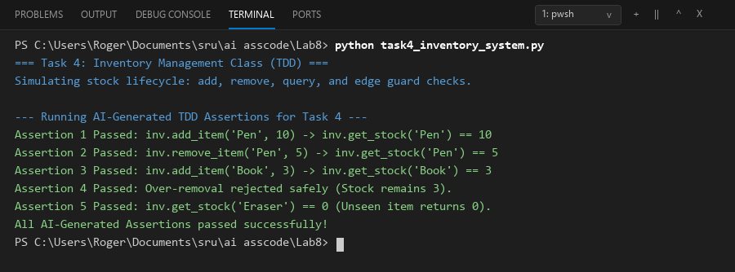
Comparison:
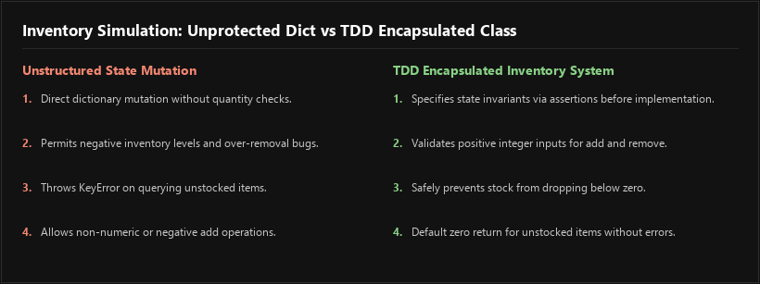
Task Description #5 (Date Validation & Formatting – Apply AI for Data Validation)
Prompt: Use AI to generate at least 3 assert test cases for validate_and_format_date(date_str) to check 'MM/DD/YYYY' format, handle invalid dates (e.g. Feb 30, leap years), and convert valid dates to 'YYYY-MM-DD'.
Input:
from datetime import datetime
def validate_and_format_date(date_str: str) -> str:
"""
Validates dates strictly formatted as 'MM/DD/YYYY'.
Converts valid dates into standard ISO 'YYYY-MM-DD' format.
Validates calendar constraints (Leap Years, month bounds).
Returns 'Invalid Date' for non-conforming or impossible dates.
"""
if not isinstance(date_str, str):
return "Invalid Date"
date_str = date_str.strip()
parts = date_str.split("/")
if len(parts) != 3 or len(parts[0]) != 2 or len(parts[1]) != 2 or len(parts[2]) != 4:
return "Invalid Date"
try:
parsed_dt = datetime.strptime(date_str, "%m/%d/%Y")
return parsed_dt.strftime("%Y-%m-%d")
except ValueError:
return "Invalid Date"
# AI-Generated Test Cases (TDD):
assert validate_and_format_date("10/15/2023") == "2023-10-15"
assert validate_and_format_date("02/30/2023") == "Invalid Date"
assert validate_and_format_date("01/01/2024") == "2024-01-01"
assert validate_and_format_date("02/29/2024") == "2024-02-29"
assert validate_and_format_date("02/29/2023") == "Invalid Date"
output:
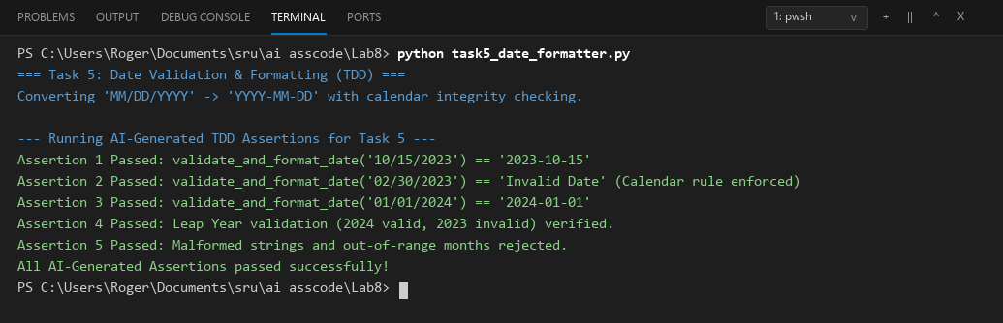
Comparison:
