AI ASSISTED CODING LAB-6
Name: Roger A Raju
Rollno: 2503a52370
Batch: 13
Task Description #1 (Privacy & Security in File Handling)
Promt: Use an AI generate a Python script that stores user data (name, email, password) in a file and a comparision table
Input:
Task-1(secured ) :
import getpass
import hashlib
import hmac
import json
import secrets
from pathlib import Path

DATA_FILE = Path(__file__).with_name("users_secured.json")
HASH_ITERATIONS = 100_000

def load_users():
if not DATA_FILE.exists():
return []
with DATA_FILE.open("r", encoding="utf-8") as file:
users = json.load(file)
if not isinstance(users, list):
raise ValueError("User data must be a JSON list.")
return users

def hash_password(password, salt=None):
salt = salt or secrets.token_bytes(16)
password_hash = hashlib.pbkdf2_hmac(
"sha256", password.encode("utf-8"), salt, HASH_ITERATIONS
)
return salt.hex(), password_hash.hex()

def verify_password(password, salt_hex, password_hash_hex):
salt = bytes.fromhex(salt_hex)
_, calculated_hash = hash_password(password, salt)
return hmac.compare_digest(calculated_hash, password_hash_hex)

def save_user(name, email, password):
users = load_users()
normalized_email = email.strip().lower()
if any(user.get("email") == normalized_email for user in users):
raise ValueError("A user with that email already exists.")

salt, password_hash = hash_password(password)
users.append(
{
"name": name.strip(),
"email": normalized_email,
"salt": salt,
"password_hash": password_hash,
}
)
with DATA_FILE.open("w", encoding="utf-8") as file:
json.dump(users, file, indent=2)

def main():
print("SECURED USER REGISTRATION")
name = input("Name: ").strip()
email = input("Email: ").strip()
password = getpass.getpass("Password: ")
if not name or not email or not password:
print("Name, email, and password are required.")
return

try:
save_user(name, email, password)
except (ValueError, json.JSONDecodeError) as error:
print(f"Could not save user: {error}")
return
print(f"User saved to {DATA_FILE}")

if __name__ == "__main__":
main()
output:
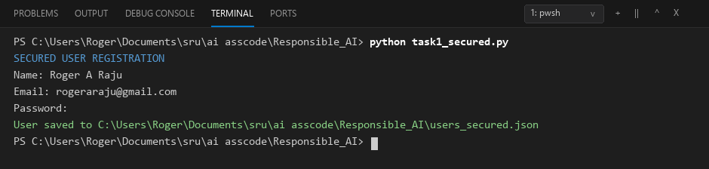
task-1(unsecured):
import json
from pathlib import Path

DATA_FILE = Path(__file__).with_name("users_unsecured.json")

def save_user(name, email, password):
"""Demonstration only: this stores the password in plain text."""
users = []
if DATA_FILE.exists():
with DATA_FILE.open("r", encoding="utf-8") as file:
users = json.load(file)

users.append(
{
"name": name,
"email": email,
"password": password,
}
)

with DATA_FILE.open("w", encoding="utf-8") as file:
json.dump(users, file, indent=2)

def main():
print("UNSECURED DEMONSTRATION - do not use in production")
name = input("Name: ")
email = input("Email: ")
password = input("Password: ")
save_user(name, email, password)
print(f"User saved to {DATA_FILE}")

if __name__ == "__main__":
main()
output:
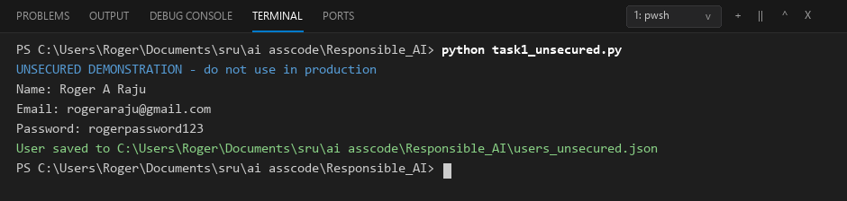
Comparison:
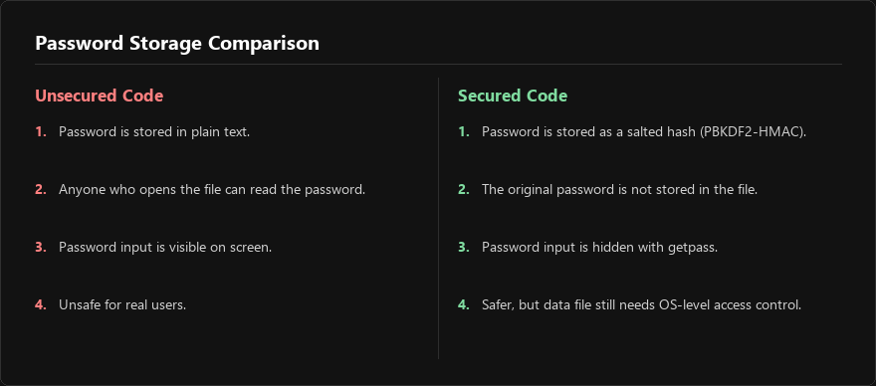
Task Description #2 – Fair Decision Logic
Prompt: generate a scholarship eligibility checker based on academic score, family income, and location. Examine whether the logic unfairly favors or disadvantages any group and their comparison between 2 codes
Task-2(fair):
Input:
APPROVAL_THRESHOLD = 70

def check_eligibility(academic_score, family_income, location):
"""Use academic score and financial need; location is audited, not scored."""
location = location.strip().lower()
if location not in {"urban", "rural"}:
raise ValueError("Location must be urban or rural.")
if not 0 <= academic_score <= 100 or family_income < 0:
raise ValueError("Enter a valid academic score and family income.")

academic_points = academic_score * 0.5
income_points = max(0, 40 - (family_income / 60_000) * 40)
total_score = academic_points + income_points

return {
"eligible": total_score >= APPROVAL_THRESHOLD,
"score": round(total_score, 2),
"location_used_for_decision": False,
}

def compare_locations(academic_score, family_income):
"""Show that equal applicants receive the same result in both locations."""
urban = check_eligibility(academic_score, family_income, "urban")
rural = check_eligibility(academic_score, family_income, "rural")
return {
"urban": urban,
"rural": rural,
"same_decision": urban["eligible"] == rural["eligible"],
}

def main():
academic_score = float(input("Academic score (0-100): "))
family_income = float(input("Family income: "))
location = input("Location (urban/rural): ")
result = check_eligibility(academic_score, family_income, location)
print("Eligible" if result["eligible"] else "Not eligible")
print(result)

if __name__ == "__main__":
main()
output:
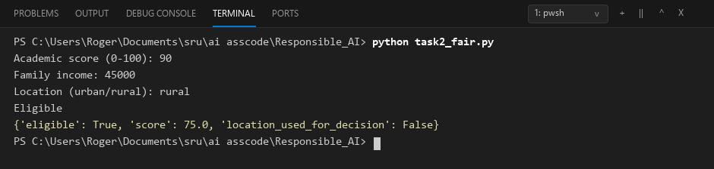
Task-2(unfair):
Input:
APPROVAL_THRESHOLD = 70
LOCATION_BONUS = {"urban": 0, "rural": 10}

def check_eligibility(academic_score, family_income, location):
location = location.strip().lower()
if location not in LOCATION_BONUS:
raise ValueError("Location must be urban or rural.")
if not 0 <= academic_score <= 100 or family_income < 0:
raise ValueError("Enter a valid academic score and family income.")

academic_points = academic_score * 0.5
income_points = max(0, 40 - (family_income / 60_000) * 40)
location_points = LOCATION_BONUS[location]
total_score = academic_points + income_points + location_points

return {
"eligible": total_score >= APPROVAL_THRESHOLD,
"score": round(total_score, 2),
"location_points": location_points,
}

def main():
academic_score = float(input("Academic score (0-100): "))
family_income = float(input("Family income: "))
location = input("Location (urban/rural): ")
result = check_eligibility(academic_score, family_income, location)
print("Eligible" if result["eligible"] else "Not eligible")
print(result)

if __name__ == "__main__":
main()
output:
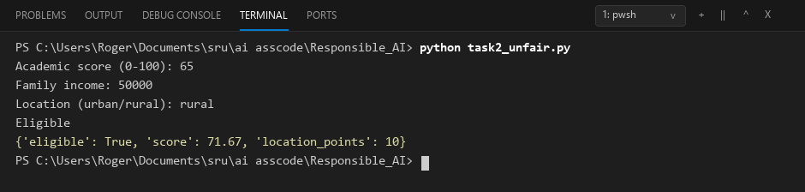
Comparison:
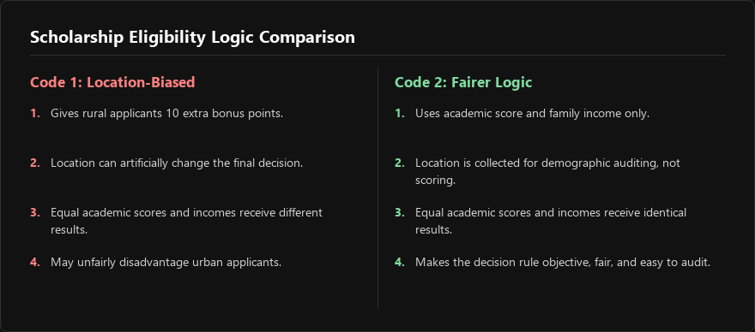
Task Description #3 (Transparency in AI-Based Admission System):
Promt: generate a Python program that predicts whether a student should be selected or rejected for admission based on factors such as entrance exam score, academic marks, and other relevant admission criteria and 2 codes and their comparison table
Task-3(explainable):
Input:
SELECTION_THRESHOLD = 70
WEIGHTS = {
"entrance exam": 0.50,
"academic marks": 0.30,
"interview": 0.20,
}

def admission_decision(entrance_score, academic_marks, interview_score):
scores = {
"entrance exam": entrance_score,
"academic marks": academic_marks,
"interview": interview_score,
}
contributions = {
factor: round(score * WEIGHTS[factor], 2)
for factor, score in scores.items()
}
total_score = round(sum(contributions.values()), 2)
selected = total_score >= SELECTION_THRESHOLD
strongest_factor = max(contributions, key=contributions.get)
weakest_factor = min(contributions, key=contributions.get)

if selected:
reason = (
f"Selected because the total score was {total_score}/100, "
f"above the threshold of {SELECTION_THRESHOLD}. "
f"The strongest factor was {strongest_factor} "
f"({contributions[strongest_factor]} points)."
)
else:
reason = (
f"Rejected because the total score was {total_score}/100, "
f"below the threshold of {SELECTION_THRESHOLD}. "
f"The lowest contributing factor was {weakest_factor} "
f"({contributions[weakest_factor]} points)."
)

return {
"decision": "Selected" if selected else "Rejected",
"total_score": total_score,
"threshold": SELECTION_THRESHOLD,
"contributions": contributions,
"reason": reason,
}

def main():
entrance_score = float(input("Entrance exam score (0-100): "))
academic_marks = float(input("Academic marks (0-100): "))
interview_score = float(input("Interview score (0-100): "))
result = admission_decision(entrance_score, academic_marks, interview_score)
print(result["decision"])
print(result["reason"])
print(f"Important factors: {result['contributions']}")

if __name__ == "__main__":
main()
output:
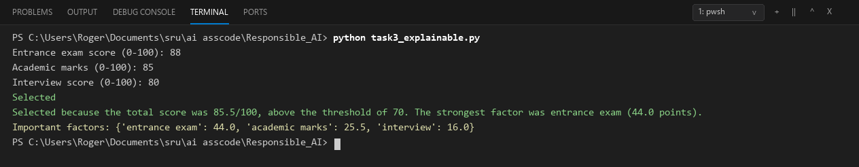
Task-3(no explaination):
input:
SELECTION_THRESHOLD = 70

def admission_decision(entrance_score, academic_marks, interview_score):
total_score = (
entrance_score * 0.50
+ academic_marks * 0.30
+ interview_score * 0.20
)
return "Selected" if total_score >= SELECTION_THRESHOLD else "Rejected"

def main():
entrance_score = float(input("Entrance exam score (0-100): "))
academic_marks = float(input("Academic marks (0-100): "))
interview_score = float(input("Interview score (0-100): "))
print(admission_decision(entrance_score, academic_marks, interview_score))

if __name__ == "__main__":
main()
output:
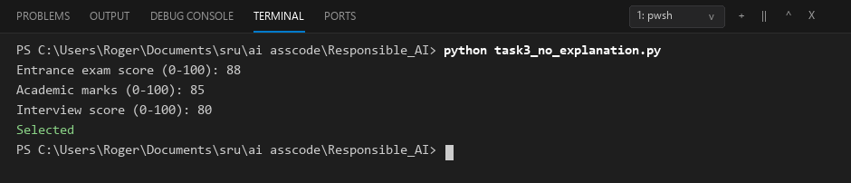
Comparison:
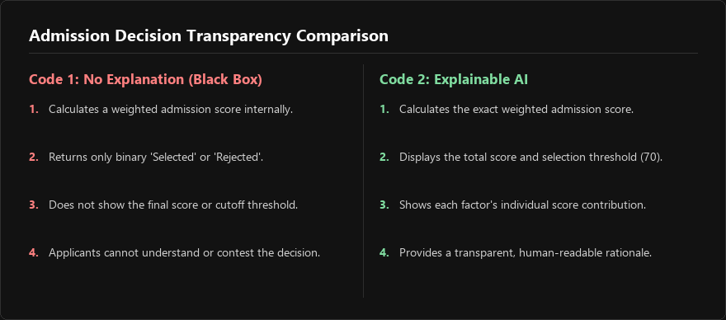
Task Description #4 – Ethical Scoring SystemTask:
Promt: Generate an employee performance evaluation system using inputs such as project completion rate, teamwork score, and attendance. Analyze the scoring logic for any unethical weighting or hidden bias and 2 codes and their comparison.
Task-4(ethical):
Input:
# Task 4 - Ethical Employee Performance Evaluation
EVALUATION_THRESHOLD = 70
WEIGHTS = {
"project completion": 0.45,
"teamwork": 0.35,
"attendance": 0.20,
}

def evaluate_employee_ethical(project_completion, teamwork, attendance):
"""
Ethical evaluation model:
- Balanced weighting: project completion (45%) and teamwork (35%) carry primary weight.
- Attendance is limited to 20% to avoid penalizing employees with approved leaves or medical needs.
- Full transparency: published weights and score contributions are returned.
"""
if not all(0 <= score <= 100 for score in (project_completion, teamwork, attendance)):
raise ValueError("All scores must be between 0 and 100.")

scores = {
"project completion": project_completion,
"teamwork": teamwork,
"attendance": attendance,
}

contributions = {
factor: round(score * WEIGHTS[factor], 2)
for factor, score in scores.items()
}

total_score = round(sum(contributions.values()), 2)
rating = "High" if total_score >= EVALUATION_THRESHOLD else "Needs improvement"

return {
"rating": rating,
"total_score": total_score,
"contributions": contributions,
"published_weights": WEIGHTS,
}

def main():
project_completion = float(input("Project completion rate (0-100): "))
teamwork = float(input("Teamwork score (0-100): "))
attendance = float(input("Attendance (0-100): "))
result = evaluate_employee_ethical(project_completion, teamwork, attendance)
print(f"Rating: {result['rating']}")
print(f"Total score: {result['total_score']}/100")
print(f"Contributions: {result['contributions']}")
print(f"Published weights: {result['published_weights']}")

if __name__ == "__main__":
main()
output:
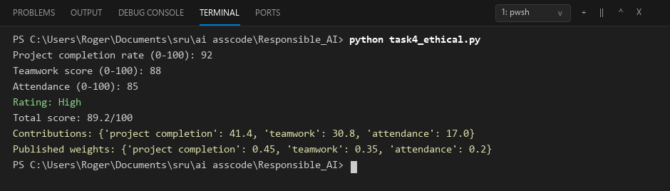
Task-4(unethical):
Input:
def evaluate_employee(project_completion, teamwork, attendance):
"""Demonstration of a potentially unfair evaluation model."""
if not all(0 <= score <= 100 for score in (project_completion, teamwork, attendance)):
raise ValueError("All scores must be between 0 and 100.")

# Attendance is overweighted and teamwork is undervalued without explanation.
total_score = (
project_completion * 0.30
+ teamwork * 0.10
+ attendance * 0.60
)
rating = "High" if total_score >= 70 else "Needs improvement"
return {"score": round(total_score, 2), "rating": rating}

def main():
project_completion = float(input("Project completion rate (0-100): "))
teamwork = float(input("Teamwork score (0-100): "))
attendance = float(input("Attendance (0-100): "))
print(evaluate_employee(project_completion, teamwork, attendance))

if __name__ == "__main__":
main()
output:
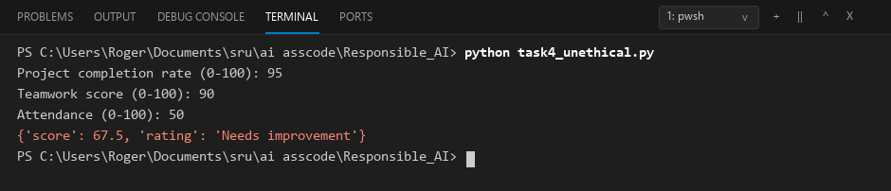
Comparison:
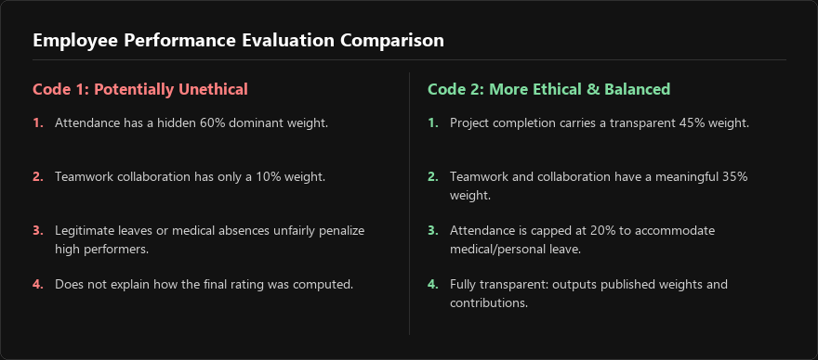
Task Description #5 – Accessibility and Inclusiveness
Promt: generate a user feedback form application. Review whether the language and options provided are inclusive and accessible to diverse users and 2 codes and there comparison
Task-5(accessible):
Input:
import json
from datetime import datetime, timezone
from pathlib import Path

FEEDBACK_FILE = Path(__file__).with_name("feedback_accessible.json")
VALID_RATINGS = {"1", "2", "3", "4", "5"}

def ask_rating():
while True:
answer = input("How would you rate your experience from 1 to 5? ").strip()
if answer in VALID_RATINGS:
return int(answer)
print("Please enter a whole number from 1 to 5.")

def ask_required(prompt):
while True:
answer = input(prompt).strip()
if answer:
return answer
print("This field is required, or type 'prefer not to say'.")

def collect_feedback():
print("User feedback form")
print("Use short answers if helpful. Optional questions may be left blank.")
return {
"name": input("Name (optional): ").strip() or None,
"contact": input("Email or other contact (optional): ").strip() or None,
"rating": ask_rating(),
"helpful": ask_required("What was helpful? "),
"improvement": ask_required("What could we improve? "),
"access_needs": input(
"Access needs or barriers (optional): "
).strip() or None,
"identity_details": input(
"Identity details (optional, or prefer not to say): "
).strip() or None,
"submitted_at": datetime.now(timezone.utc).isoformat(),
}

def main():
feedback = collect_feedback()
with FEEDBACK_FILE.open("w", encoding="utf-8") as file:
json.dump(feedback, file, indent=2)
print("Thank you. Your feedback was saved.")

if __name__ == "__main__":
main()
Output:
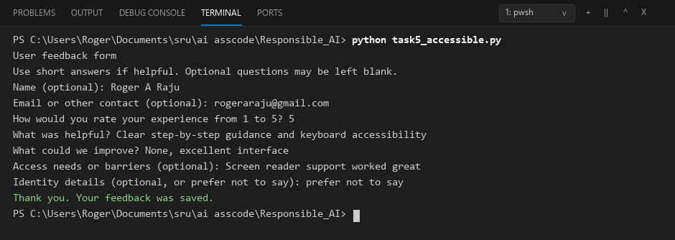
Task-5(basic):
Input:
import json
from pathlib import Path

FEEDBACK_FILE = Path(__file__).with_name("feedback_basic.json")

def main():
print("Customer Feedback")
name = input("Full name: ")
gender = input("Gender (Male/Female): ")
has_disability = input("Do you have a disability? (Yes/No): ")
rating = input("Rate us from 1 to 5: ")
comments = input("Additional comments: ")

feedback = {
"name": name,
"gender": gender,
"has_disability": has_disability,
"rating": rating,
"comments": comments,
}

with FEEDBACK_FILE.open("w", encoding="utf-8") as file:
json.dump(feedback, file, indent=2)
print("Feedback saved.")

if __name__ == "__main__":
main()
output:
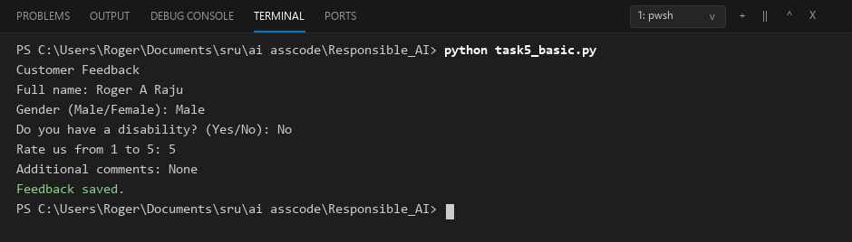
Comparison:
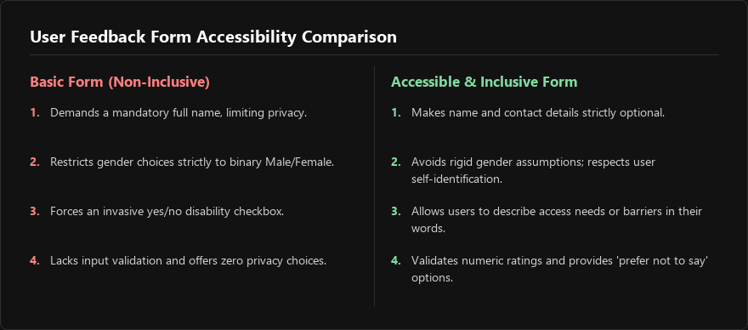
Task Description #6 (Fairness in Loan Approval System)
Promt:
Use an AI tool to generate a Python program that predicts whether a person should be approved or rejected for a loan based on information such as income, age, employment status, credit score, and loan amount and 2 codes and comparsion
Task-6(baised):
Input:
APPROVAL_THRESHOLD = 70

def loan_decision(income, age, employment_status, credit_score, loan_amount,
gender, religion, race):
"""Demonstration only: this rule uses unrelated sensitive attributes."""
if income <= 0 or loan_amount <= 0 or not 0 <= credit_score <= 850:
raise ValueError("Enter positive income/loan values and a credit score from 0 to 850.")

score = 0
score += min(income / 1000, 40)
score += min(credit_score / 10, 40)
score += 10 if employment_status == "full-time" else 0
score -= 20 if gender.lower() == "female" else 0
score -= 15 if religion.lower() == "minority" else 0
score -= 15 if race.lower() == "minority" else 0
score -= 10 if loan_amount > income * 3 else 0

return {
"decision": "Approved" if score >= APPROVAL_THRESHOLD else "Rejected",
"score": round(score, 2),
}

def main():
print("BIASED DEMONSTRATION - do not use for real lending")
income = float(input("Annual income: "))
age = int(input("Age: "))
employment_status = input("Employment status (full-time/other): ").strip().lower()
credit_score = float(input("Credit score (0-850): "))
loan_amount = float(input("Loan amount: "))
gender = input("Gender: ").strip()
religion = input("Religion: ").strip()
race = input("Race: ").strip()
print(loan_decision(income, age, employment_status, credit_score,
loan_amount, gender, religion, race))

if __name__ == "__main__":
main()
output:
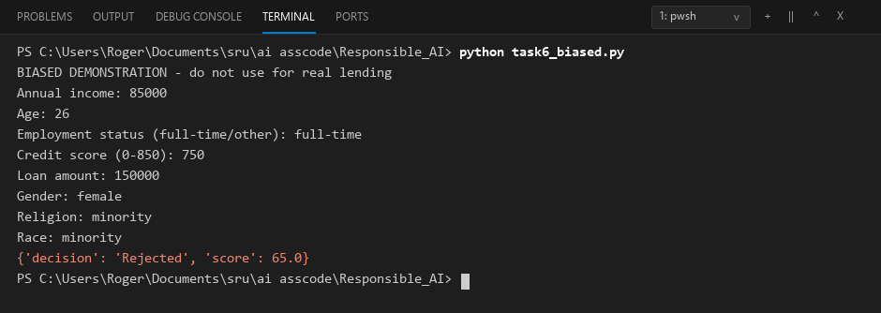
Task-6(fair):
Input:
APPROVAL_THRESHOLD = 70

def loan_decision(income, age, employment_status, credit_score, loan_amount):
"""Use relevant financial factors only; never use protected attributes."""
if income <= 0 or loan_amount <= 0:
raise ValueError("Income and loan amount must be positive.")
if not 18 <= age <= 100:
raise ValueError("Age must be between 18 and 100.")
if not 0 <= credit_score <= 850:
raise ValueError("Credit score must be between 0 and 850.")

employment_points = {
"full-time": 15,
"part-time": 8,
"self-employed": 10,
"unemployed": 0,
}

status = employment_status.strip().lower()
if status not in employment_points:
raise ValueError("Use full-time, part-time, self-employed, or unemployed.")

income_points = min(income / 1000, 35)
credit_points = (credit_score / 850) * 35
employment_score = employment_points[status]
affordability_points = 15 if loan_amount <= income * 2 else 0
total_score = income_points + credit_points + employment_score + affordability_points

return {
"decision": "Approved" if total_score >= APPROVAL_THRESHOLD else "Rejected",
"score": round(total_score, 2),
"factors": {
"income": round(income_points, 2),
"credit_score": round(credit_points, 2),
"employment_status": employment_score,
"loan_affordability": affordability_points,
},
"sensitive_attributes_used": False,
}

def main():
print("FAIRER LOAN APPROVAL DEMONSTRATION")
income = float(input("Annual income: "))
age = int(input("Age: "))
employment_status = input(
"Employment status (full-time/part-time/self-employed/unemployed): "
)
credit_score = float(input("Credit score (0-850): "))
loan_amount = float(input("Loan amount: "))
result = loan_decision(income, age, employment_status, credit_score, loan_amount)
print(result)

if __name__ == "__main__":
main()
output:
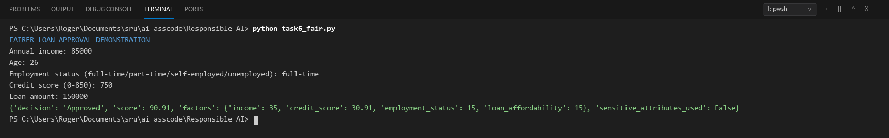
Comparison:
