FinPilot
Investment Portfolio & Goal Monitoring Platform
Architecture & design report
Item | Detail
Author | rogerantony-dev
Date | 25 September 2026
Repository | github.com/rogerantony-dev/finpilot
Stack | React 19 + Vite · Fastify 5 + Zod · Kysely · PostgreSQL 17 · Docker Compose · GitHub Actions
Run it | cp .env.example .env (set JWT_SECRET), then docker compose up --build → http://localhost:8088
Data | Synthetic data only, supplied CSVs loaded unmodified

Companion documents in the repository: README.md (setup and usage), DECISIONS.md (decision log D1–D12 with alternatives), docs/data-audit.md, docs/sql-tasks.md (queries and EXPLAIN walkthrough) and docs/diagrams/ (diagram sources).

1. Executive overview
Problem. A wealth-service team needs one place to see a customer’s consolidated investment position (accounts, holdings, activity, risk profile and goals) and an operations administrator needs to load daily CSV data safely: validated, idempotent, with every rejected row explained.
Scope delivered. Sign-in with VIEWER and ADMIN roles; customer search; customer overview with portfolio value, gain/loss, data freshness, asset-allocation chart and account cards; positions; server-side filtered and paginated transactions; goals with create/edit and consistency flags; administrator CSV import with row-level reasons and import history. A versioned REST API (/api/v1) with OpenAPI docs, PostgreSQL schema via migrations, a one-command Docker stack and a CI pipeline that tests the code and the running stack.
Major design decisions (full log with rejected alternatives in DECISIONS.md):
- TypeScript end-to-end in a pnpm monorepo; request/response contracts are Zod schemas in packages/shared, used for API validation, serialisation, the OpenAPI document and frontend types, so documentation cannot drift from code.
- PostgreSQL does the data work: constraints encode business rules; views hold the single definition of market value, P/L, allocation and goal status; the API never aggregates in application code and the browser never does valuation arithmetic.
- Plain SQL migrations (dbmate) + Kysely rather than an ORM, keeping constraints, views, partial indexes and EXPLAIN visible and reviewable.
- One import pipeline for the seed and the admin upload: stage → validate → merge in one transaction, idempotent by file SHA-256, rejects quarantined with reasons. The seed therefore proves the pipeline on the supplied data: transactions.csv loads 4,550 rows and rejects the 4 planted anomalies; holdings de-duplicates 3 exact duplicates.
- Same-origin deployment behind nginx with a JWT session in an httpOnly, SameSite=Strict cookie: no token in JavaScript, no CORS, API not exposed.
Evidence. 62 automated tests (53 API/integration against a real PostgreSQL, 9 web), a GitHub Actions pipeline with a Docker-stack smoke test, and a deliberately failing pull request (#1) showing the pipeline blocks broken code.

2. System context
Three people use the system: a wealth/service user (VIEWER) who looks up customers and maintains goals, an operations administrator (ADMIN) who imports daily files, and an engineering reviewer who inspects the API, database, logs and pipeline. Everything runs locally in Docker; the only external platform dependency is GitHub (repository, Actions CI, Dependabot). No external market data, identity provider or payment system is involved.
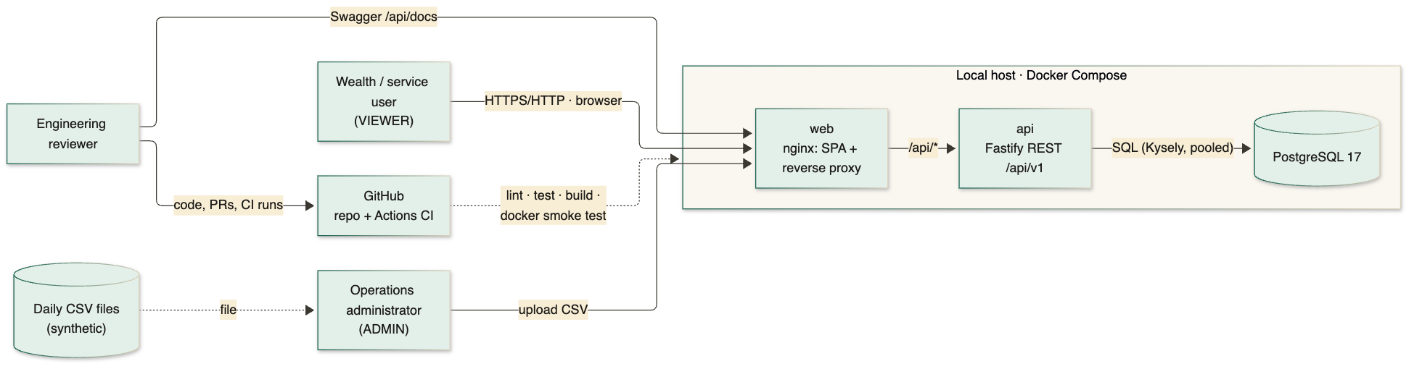
Figure 1 · System context

3. Component architecture
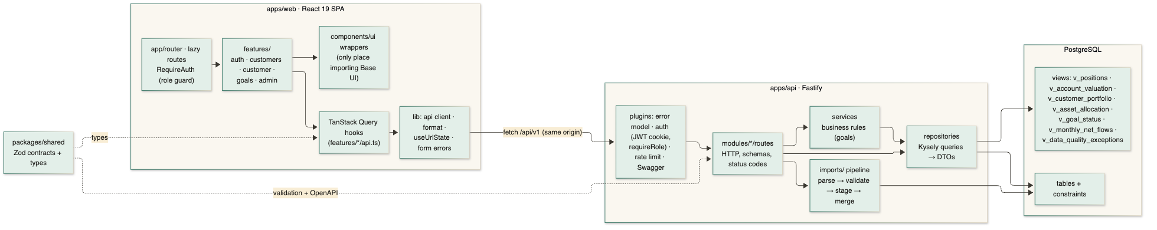
Figure 2 · Components and data-access boundary
Component | Responsibility
web · app/router | Routes; customer pages lazily loaded (chart library only on the overview); RequireAuth guards pages and the ADMIN-only import route.
web · features/* | Screens per area. Server state only through TanStack Query hooks in features/*/api.ts; no useEffect in the app. Filters, sort and page live in the URL.
web · components/ui | Wrappers around Base UI primitives (Select, Dialog, Form/Field, Meter, Progress, Toast) plus local primitives (Table, Card, Badge). An ESLint rule forbids importing Base UI anywhere else.
shared · packages/shared | Zod contracts and inferred types for every request and response.
api · plugins | Error model, JWT-cookie auth and requireRole, login rate limit, request IDs, log redaction, Swagger.
api · routes → services → repositories | Routes handle HTTP only; services hold business rules (goal dates, over-funding); repositories are the only data-access boundary: parameterised Kysely queries mapping snake_case rows to camelCase DTOs.
api · imports/ | Generic CSV pipeline driven by per-dataset definitions (columns, row schema, natural key, references).
PostgreSQL | Tables with constraints; reporting views used by repositories.

4. Data model (ERD)
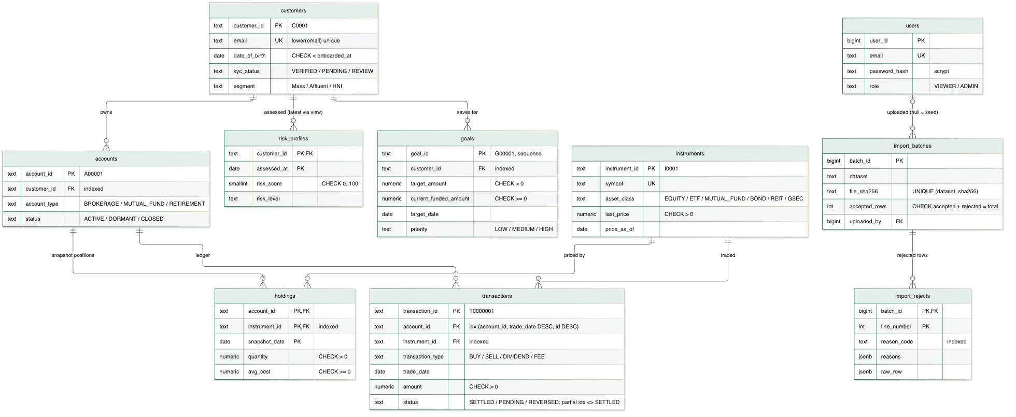
Figure 3 · Entity-relationship diagram (PK, FK, UK, key CHECK constraints and indexes)
Keys and types: natural keys from the data (C0001, A00001, T0000001) with format CHECKs; NUMERIC money/prices/quantities, never floats; DATE for dates; enums as TEXT + CHECK. Risk profiles keep history (latest via view); app-created goals take IDs from a sequence. Constraints as last line of defence: amount > 0, trade vs cash-event shape, date_of_birth < onboarded_at, sector only on equities, unique email, accepted + rejected = total, UNIQUE (dataset, file_sha256).
Indexes from query patterns only: transactions(account_id, trade_date DESC, transaction_id DESC) for the paginated ledger, a partial index on non-settled rows, and FK look-ups on accounts, goals, holdings, transactions. Views: v_positions (value = quantity × last price; P/L = rounded value − rounded cost, so totals add up), v_account_valuation, v_customer_portfolio, v_asset_allocation, v_goal_status, v_monthly_net_flows, v_data_quality_exceptions, v_latest_risk_profile.

5. API design
Method | Path (prefix /api/v1) | Purpose | Auth
GET | /health | Liveness + DB readiness (200 ok / 503 degraded), no secrets | public
POST | /auth/login · /auth/logout | Start (sets cookie) / end session | public
GET | /auth/me | Current user | session
GET | /customers | Search q (ID prefix, name, email, city), filters, sort, pagination | session
GET | /customers/{id} | Profile + latest risk profile (null if none) | session
GET | /customers/{id}/portfolio | Totals, accounts, allocation, positions, snapshot and price dates | session
GET | /customers/{id}/transactions | Filters: from/to, account, instrument, type, status; sort; pagination | session
GET · POST | /customers/{id}/goals | List with funded % and flags · create | session
PATCH | /goals/{goalId} | Edit changed fields | session
POST | /admin/imports/transactions | CSV import (text/csv body) | ADMIN
GET | /admin/imports · /admin/imports/{id}/rejects | Import history · rejected rows | ADMIN

- Contracts and docs: every route declares Zod schemas for params, query, body and responses; Swagger UI at /api/docs is generated from them, with real example responses for the portfolio and import endpoints.
- Validation: malformed input → 400 VALIDATION_ERROR with details[{field, message}]; well-formed but against a business rule → 422 UNPROCESSABLE (e.g. a goal date in the past).
- Error model: { error: { code, message, details?, requestId } } for every failure; codes UNAUTHENTICATED 401, FORBIDDEN 403, NOT_FOUND 404, RATE_LIMITED 429, INTERNAL_ERROR 500. Unexpected errors are logged with stack trace and returned generically.
- Pagination: page / pageSize (≤ 100) with totalItems and totalPages; every sort has a unique tie-breaker so pages never overlap. Customer sub-resources join through accounts.customer_id, so another customer’s accountId returns nothing.
- Conventions: JSON in camelCase; money and quantities as decimal strings; dates YYYY-MM-DD. Versioning by URL prefix; a breaking change would ship as /api/v2 alongside v1.
- Import semantics: 201 new batch, 200 ALREADY_IMPORTED for a file seen before (nothing changes), 422 for a wrong header; up to 200 rejects inline, the rest paginated.

6. Workflows

6.1 Login
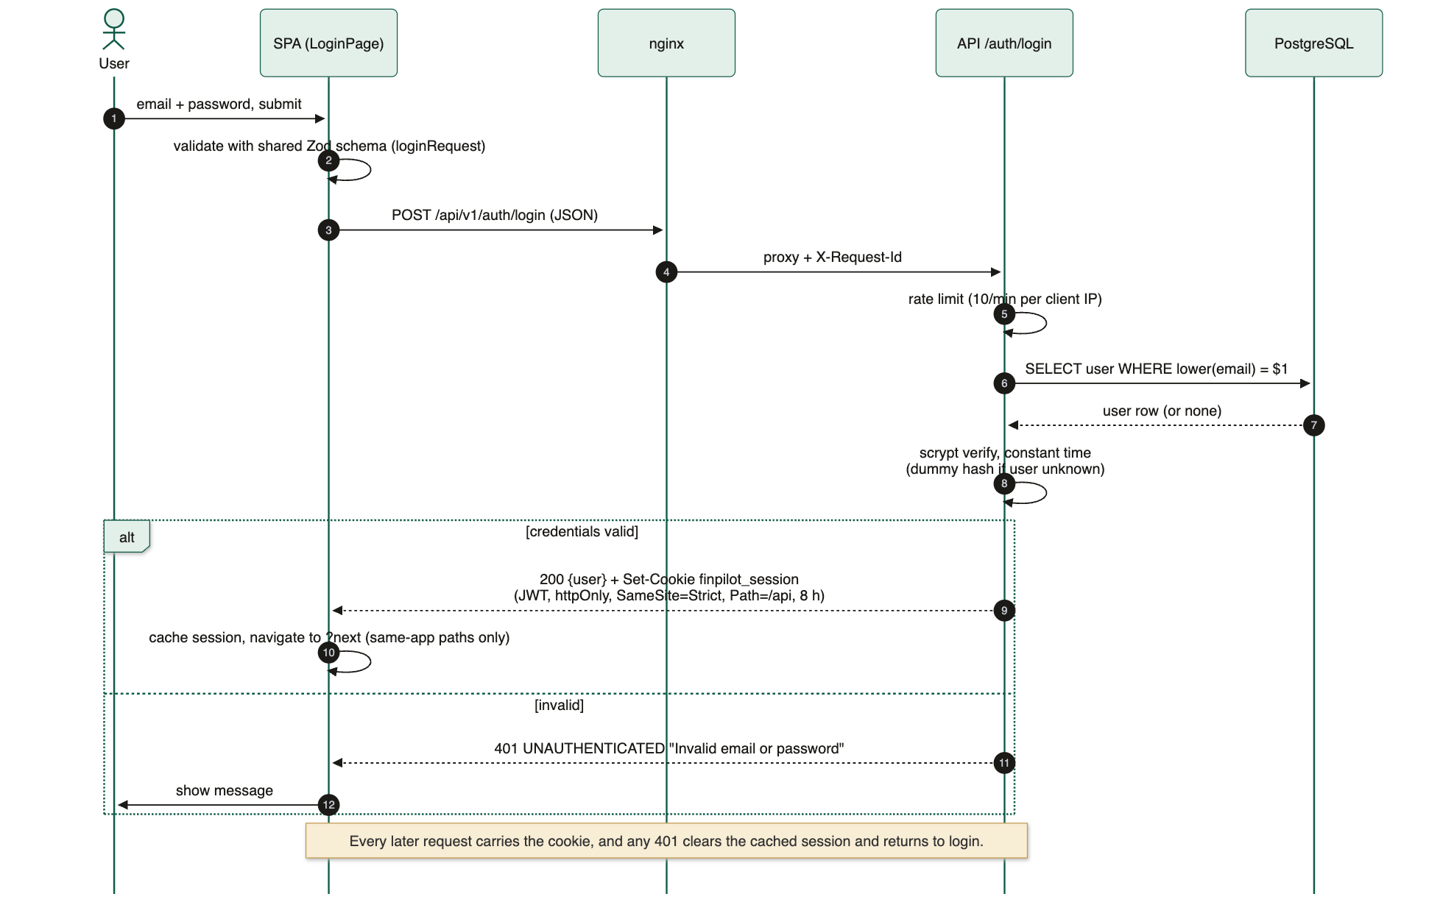
Figure 4 · Login and session establishment

6.2 Customer portfolio read
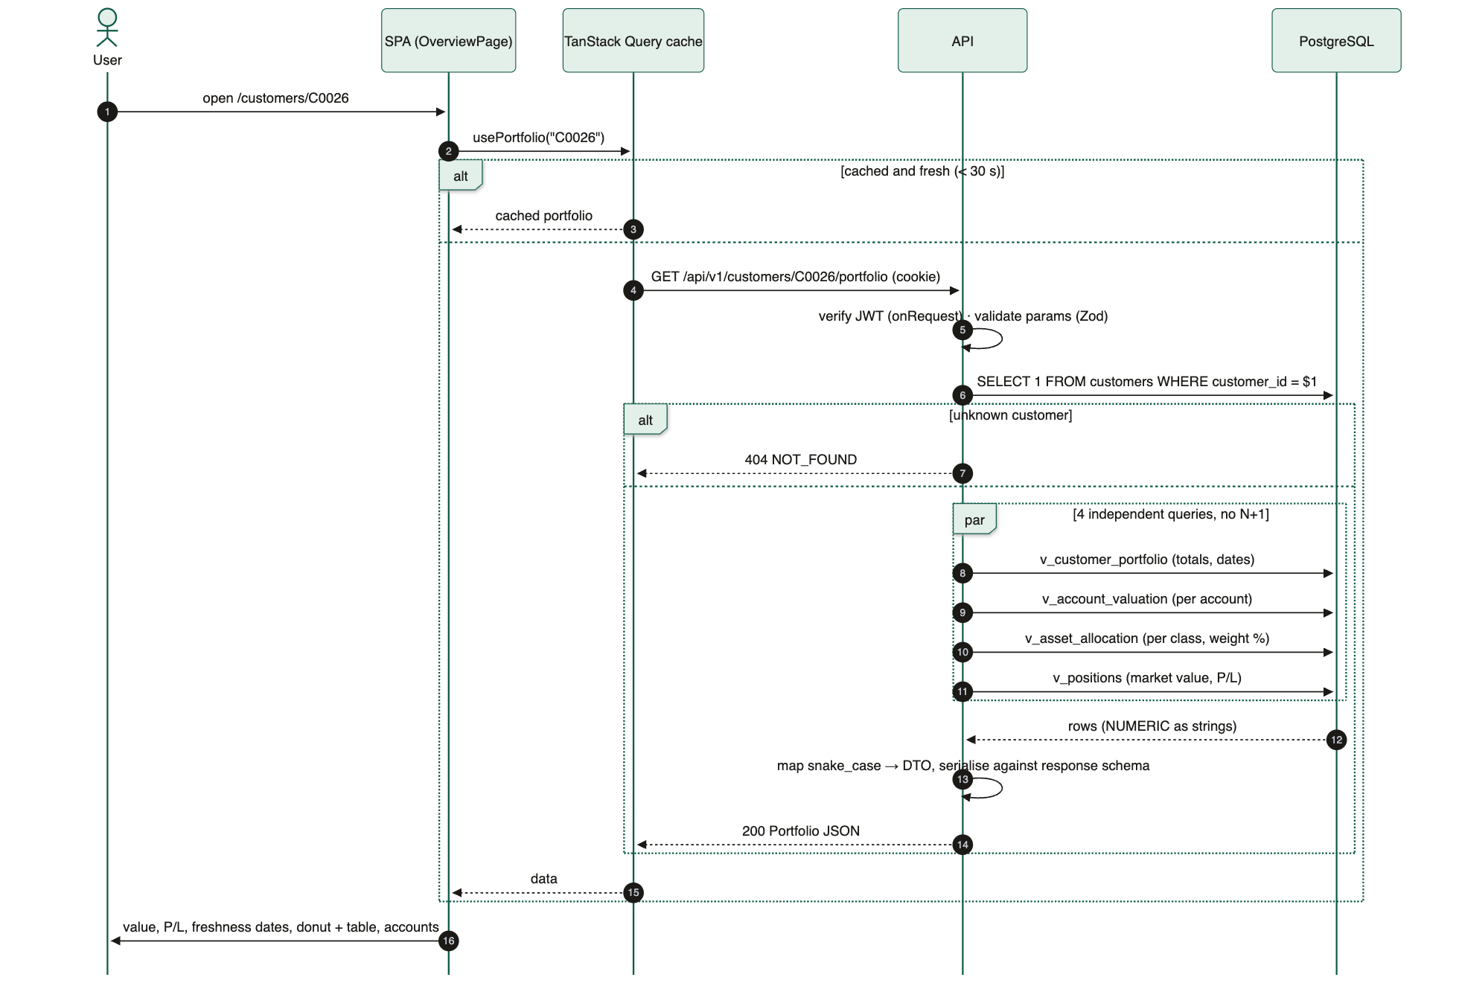
Figure 5 · Portfolio read: cache, auth, four view queries in parallel

6.3 Goal update
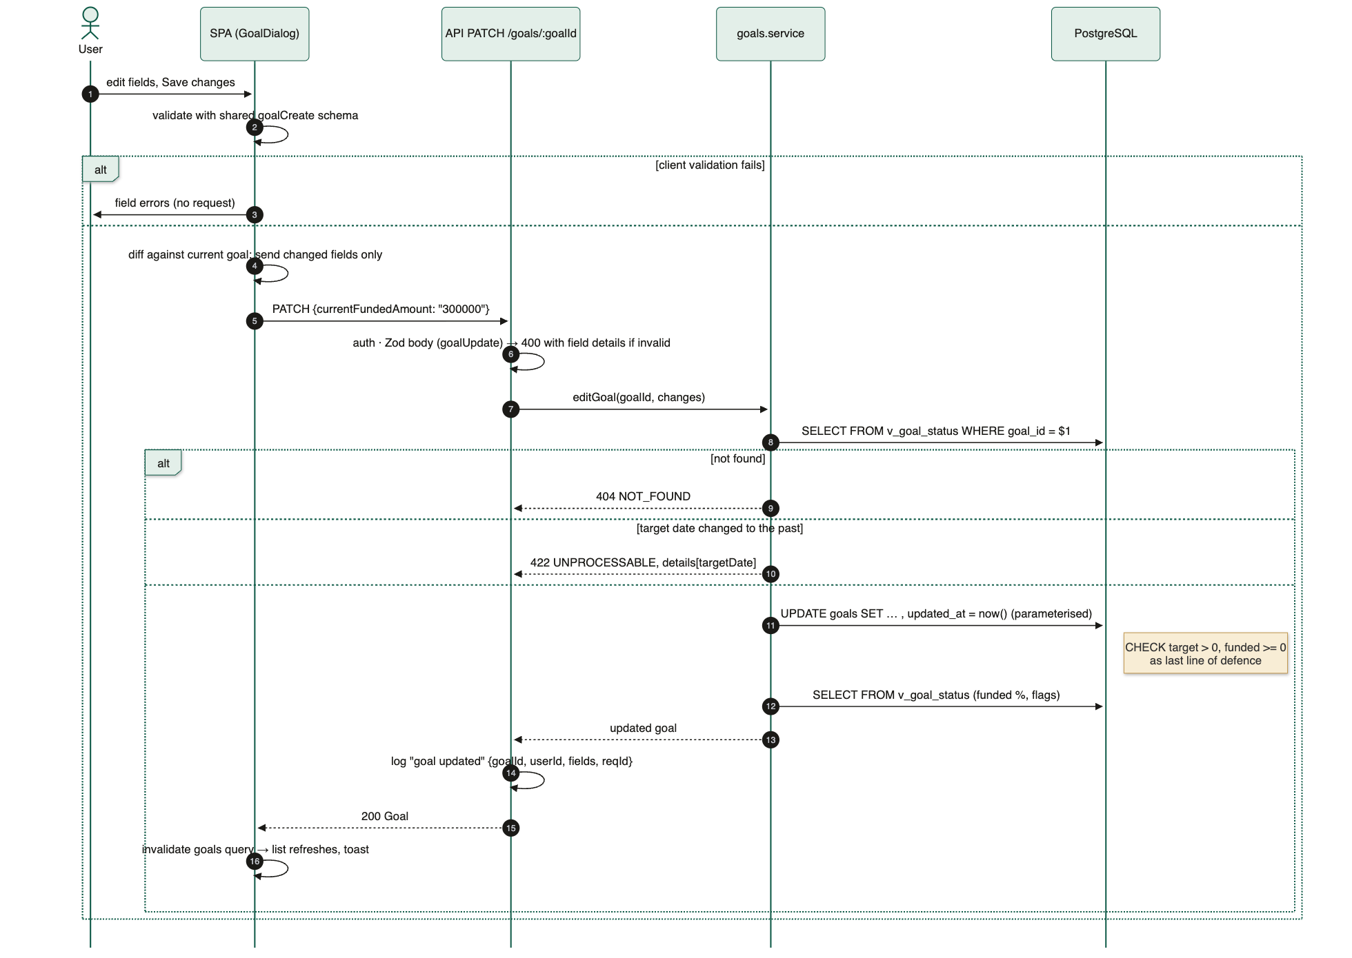
Figure 6 · Goal update: client validation, PATCH of changed fields, service rules, constraints

6.4 CSV import
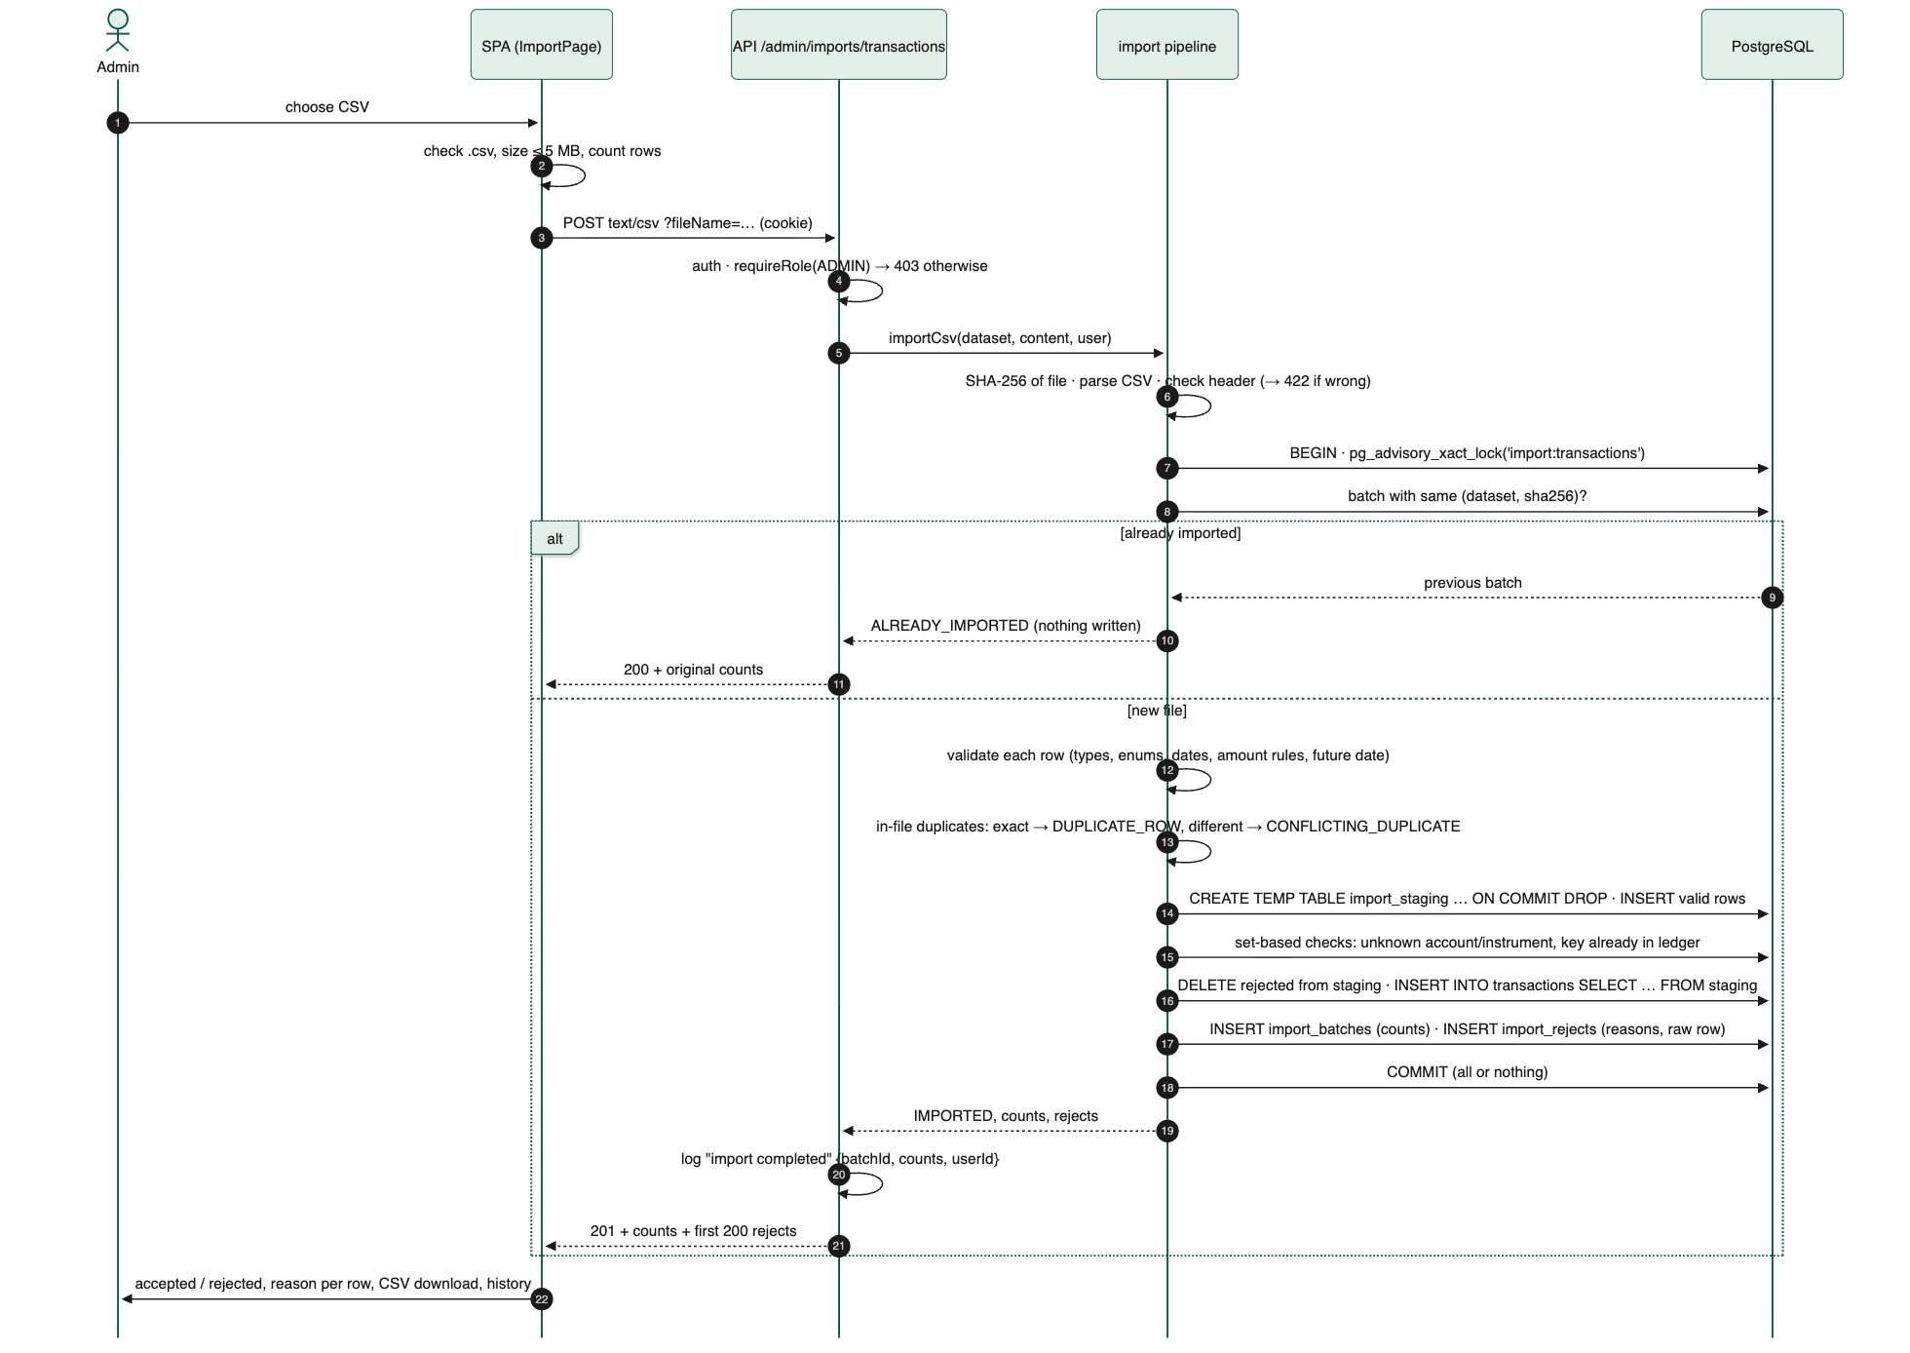
Figure 7 · CSV import: idempotency, staging, set-based checks, single-transaction merge

6.5 CI/CD
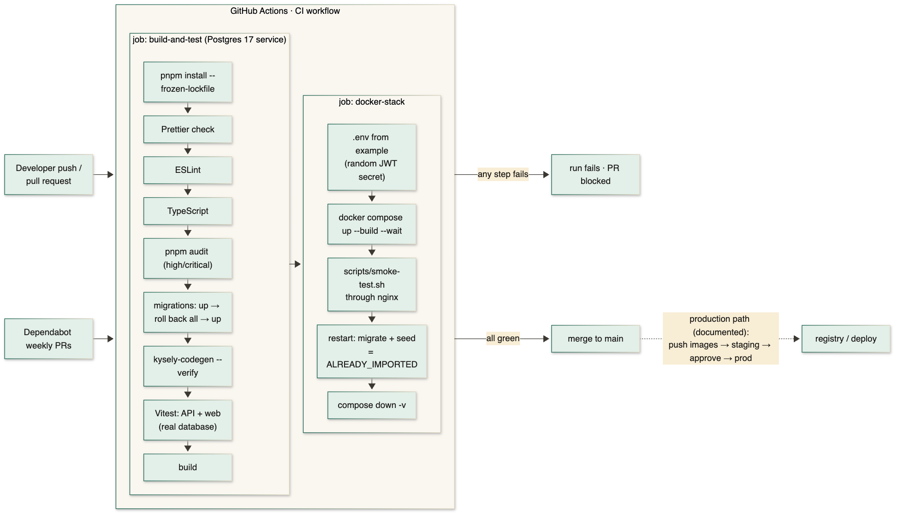
Figure 8 · CI/CD pipeline

7. Deployment topology
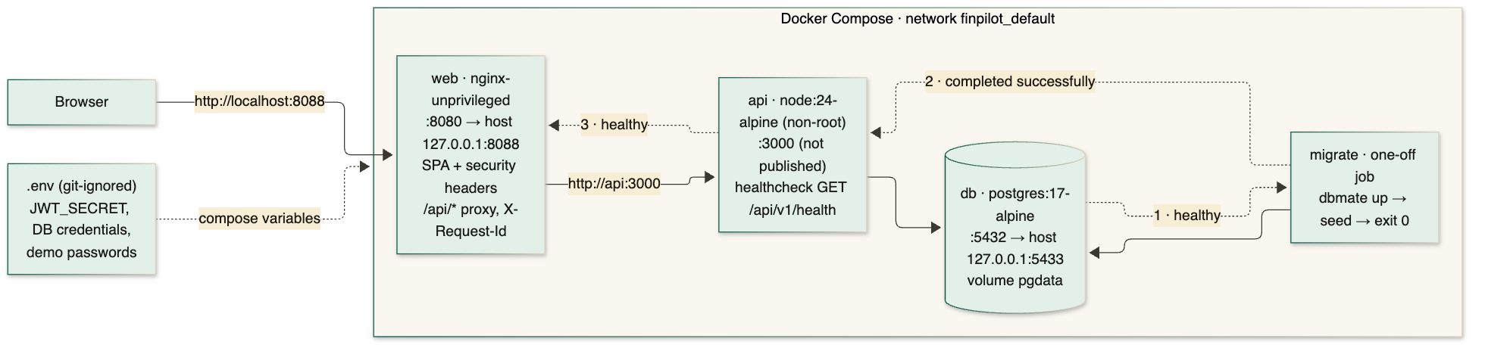
Figure 9 · Local deployment (Docker Compose)
Local. docker compose up --build builds two multi-stage, non-root images (API: compiled dist/, production dependencies, migrations, CSVs; web: static build on nginx-unprivileged). Start-up is ordered by health: PostgreSQL healthy → migrate (dbmate up, idempotent seed, exit 0) → API healthy → web. Only 127.0.0.1:8088 (web) and 127.0.0.1:5433 (PostgreSQL, for development) are published. Config comes from a git-ignored .env; Compose refuses to start without required secrets. Environments: development (pnpm dev with hot reload), CI (service container + Docker stack), and this Compose stack as production-like.
Local | Production mapping
nginx container | Managed load balancer / CDN terminating TLS (HSTS, COOKIE_SECURE=true); static assets on the CDN; domain via DNS + managed certificates.
api container | 2+ replicas on a container platform (ECS, Cloud Run or Kubernetes) with health checks and rolling deploys.
migrate job | One-off release step before rollout; expand → migrate → contract migrations so old and new versions coexist.
PostgreSQL container | Managed PostgreSQL (multi-AZ, automated backups, point-in-time recovery) behind PgBouncer/platform pooling.
.env file | Secret manager with rotation; separate DB roles (DDL for migrations, DML-only for the app).
docker compose logs | Central JSON log aggregation, metrics and alerts (5xx rate, latency, failed imports).

8. Security
Area | Controls
Authentication | Seeded demo users; scrypt password hashes with per-user salt, constant-time comparison, dummy hash for unknown emails (no user enumeration by timing or message); login rate limited to 10/min per client IP (proxy-aware).
Session | HS256 JWT (8 h) in an httpOnly, SameSite=Strict, Path=/api cookie, Secure when served over TLS; never readable by JavaScript or stored in localStorage. Trade-off: stateless, so role changes apply at expiry (logout clears the cookie immediately).
Authorisation | All /api/v1 routes except health and login require a session; admin routes enforce requireRole(ADMIN) on the server; the UI hides admin features as a convenience only.
Input validation | Zod on every params/query/body; CSV rows validated field by field; body limits (1 MB JSON, 5 MB CSV); redirect targets after login restricted to same-app paths.
SQL injection | Only parameterised Kysely queries; dynamic identifiers in the import pipeline come from fixed dataset definitions, never from input; LIKE wildcards in search are escaped.
CORS / CSRF | Same origin through nginx; CORS allows only WEB_ORIGIN; SameSite=Strict cookie; state-changing endpoints require JSON or text/csv bodies.
Browser hardening | CSP default-src 'self', frame-ancestors 'none', X-Frame-Options DENY, nosniff, Referrer-Policy, Permissions-Policy; API responses Cache-Control: no-store; pages restored from the back/forward cache are reloaded so data is not shown after sign-out.
Secrets | .env git-ignored, .env.example committed with placeholders; demo passwords from environment, not code; GitGuardian scan on pull requests; pnpm audit and Dependabot for dependencies.
Logs and PII | JSON logs redact Cookie, Authorization and Set-Cookie; no passwords or row contents logged; data is synthetic. Production: mask email/phone in logs, restrict DB access, encryption at rest by the managed database.

9. Reliability and operations
- Health checks: /health reports API status and database connectivity (200 ok / 503 degraded) and backs the container health checks that order start-up.
- Logging and correlation: structured JSON logs (pino); every request gets an ID, honoured from nginx’s X-Request-Id, returned in the x-request-id header and included in every error body, so a user-visible error maps to one log trail. Business events are logged explicitly: login success/failure, forbidden access, goal created/updated (user, fields), import completed (batch, counts, user).
- Timeouts: database connect timeout 5 s and statement timeout 10 s per pooled connection; nginx proxy read timeout 60 s; the frontend retries network and 5xx failures once, never 4xx.
- Failure behaviour: imports are all-or-nothing per file (one transaction), serialised per dataset by an advisory lock, and idempotent, so a retry after a crash is safe. A failed migration stops the start-up chain and dbmate rolls that migration back (each runs in a transaction); CI proves every migration also rolls back cleanly. Graceful shutdown drains in-flight requests and closes the pool.
- Monitoring (production): alerts on 5xx rate and latency percentiles, failed or high-reject imports, database connections and replication lag; dashboards by route.
- Backups: production relies on managed PostgreSQL automated backups with point-in-time recovery and periodic restore tests; locally pg_dump of the Compose volume. Migration rollback: pnpm db:rollback reverts one migration; in production prefer roll-forward fixes with expand/contract migrations.
- Connection pooling: one pg pool per API process (max 10); with several replicas, PgBouncer (transaction mode) or the platform pooler caps total connections.

10. Trade-offs and roadmap

Deliberate omissions
- Trading, payments, advice and real market data are out of scope by design; prices come from the supplied snapshot.
- No sign-up, password reset, MFA or SSO: demo users only. Stateless JWT without refresh tokens or a revocation list.
- Admin import covers transactions only in the UI; the pipeline already supports every dataset.
- Transactions are an activity ledger and do not reconcile to the holdings snapshot (the supplied data does not); positions come from the snapshot.
- No cloud deployment, TLS or reverse-proxy certificates locally; documented production mapping instead.

Expected scale limits
- Offset pagination and ILIKE search are fine for thousands of rows; for millions: keyset pagination on (trade_date, transaction_id) and a pg_trgm index for search.
- Views compute valuations on read (sub-millisecond at this size, see Appendix B); at scale, a materialised daily valuation table refreshed after each snapshot load.
- CSV import holds the file in memory (5 MB cap); larger files would stream into COPY staging.

Next production steps
Priority | Risk | Next step
Performance | Transaction search and pagination degrade with ledger growth | Keyset pagination, trigram index, materialised valuations; measure with EXPLAIN (ANALYZE, BUFFERS) in CI on a large fixture
Security | Stateless session cannot be revoked before expiry | Short-lived access token + rotating refresh token, or server-side sessions; MFA/SSO for staff
Reliability | Single API instance and local database | Two+ replicas, managed PostgreSQL with PITR, alerting on import failures and 5xx
Data | Snapshot and ledger do not reconcile | Reconciliation job and exception queue for operations

Appendix A · Data-quality anomalies and handling
File · row | Anomaly | Handling
transactions · T0000026 (line 4552) | Duplicate ID, byte-identical to line 27 | First kept, copy rejected DUPLICATE_ROW; differing copies would reject all (CONFLICTING_DUPLICATE)
transactions · T0004551 | Unknown instrument I9999 | Rejected UNKNOWN_REFERENCE
transactions · T0004552 | Negative FEE amount −75 | Rejected NEGATIVE_AMOUNT; not sign-flipped (could be a refund; guessing is unsafe)
transactions · T0004553 | Trade dated 2027-01-05 | Rejected FUTURE_DATE
holdings · 3 positions | Exact duplicate (account, instrument, date) | De-duplicated; PK prevents double-counted AUM
transactions · 1,069 rows | Trade before the account’s open date | Imported, reported in v_data_quality_exceptions (rejecting would drop ~23% of the ledger)
transactions · 114 rows | Activity on CLOSED accounts | Imported, reported as exceptions; accounts shown with status badges
goals · most rows | Name mentions a different goal type | Soft flag nameTypeMismatch

All rejected rows are stored in import_rejects with every reason and the original row. Raw CSVs are committed unmodified with SHA-256 checksums.

Appendix B · SQL and performance evidence
All SQL tasks in the brief run against the views (queries and results in docs/sql-tasks.md): top 10 customers by AUM (C0026 ₹19,53,574.61), allocation per customer and for the whole book (equity 83.75%), monthly BUY/SELL net flow for 12 months, top instruments by distinct holders, 12 HIGH-priority goals under 25% funded, and data-quality exceptions. The book total ₹5,27,54,963.55 was cross-checked against an independent calculation from the raw CSVs.
EXPLAIN (ANALYZE, BUFFERS) for the transactions screen (one customer, date range, newest first, 25 rows):
Limit (actual time=0.056..0.059 rows=25) Buffers: shared hit=19
-> Sort Sort Key: trade_date DESC, transaction_id DESC (quicksort 29kB)
-> Nested Loop
-> Seq Scan on accounts Filter: customer_id = 'C0026' (3 rows; 2 pages)
-> Index Scan using transactions_account_date_idx on transactions
Index Cond: account_id = accounts.account_id AND trade_date BETWEEN …
Execution Time: 0.094 ms

The composite index jumps to each of the customer’s accounts within the date range instead of scanning the 4,550-row ledger; 19 buffer hits, all from memory. The sequential scan on accounts is the planner’s correct choice for a two-page table; accounts_customer_id_idx takes over as it grows.

