<https://cdn.notonthehighstreet.com/system/product_images/images/001/193/860/original_chicken-knitted-tea-cosy.jpg>  
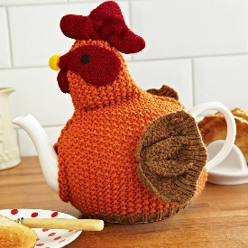

A tea cosy is a simple yet important piece of kit for any tea lover. Its main purpose is to keep your tea warm, but it can also add to the aesthetics of your tea-drinking experience and make a statement about your style and taste.

The function of a tea cosy is straightforward: it fits snugly over a teapot to insulate it and maintain the temperature of the tea. This is especially important if you’re hosting a tea party or taking time to enjoy a leisurely cup of tea, as it ensures that each cup you pour will be warm and comforting, no matter how long the pot has been sitting.

When it comes to the materials used to make tea cosies, the options are diverse. Some of the most common materials include wool, cotton, silk, and even crochet. Each material offers its own unique benefits: wool is warm and cozy, cotton is durable and easy to care for, silk adds a touch of luxury, and crochet can be customized to match any décor.

Aside from their functional benefits, tea cosies also play a role in creating a pleasing aesthetic for your tea table. Whether you’re hosting a tea party or simply enjoying a quiet cup at home, a beautifully designed tea cosy can add an extra touch of elegance to your tea service. With so many designs and styles to choose from, you’re sure to find one that fits your personal style and enhances the ambiance of your tea-drinking experience.

In conclusion, a tea cosy is a practical and stylish accessory that every tea lover should have. Not only does it help keep your tea warm, but it also adds to the overall aesthetic of your tea table, making it a must-have item for anyone who appreciates the finer things in life.

<https://www.pexels.com/photo/food-wood-dawn-coffee-9684326/>

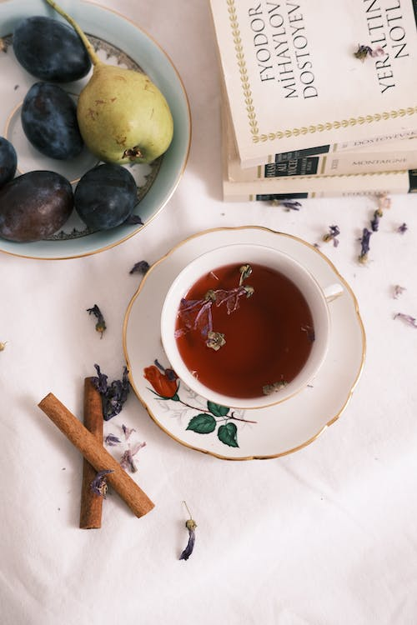

Making a proper cup of tea English style is a time-honored tradition that has been passed down through generations. It may seem simple, but there are a few key steps to follow to ensure a delicious cup of tea every time.

Step 1: Choose Your Tea

The first step in making a proper cup of tea is to choose your tea. English tea typically refers to black tea, and the most popular blends include Earl Grey, English Breakfast, and Darjeeling. Once you’ve selected your tea, measure out one teaspoon of loose tea leaves per cup of water, or one tea bag per cup.

Step 2: Boil the Water

Next, boil the water. It is important to use freshly drawn water, as the quality of the water can greatly impact the taste of the tea. Once the water has reached a rolling boil, remove it from heat.

Step 3: Warm the Teapot

To keep your tea hot for as long as possible, it is a good idea to warm the teapot first. Simply pour a little of the hot water into the teapot, swirl it around, and then pour it out.

Step 4: Steep the Tea

Add your tea leaves or tea bags to the teapot and pour in the hot water. Let the tea steep for three to five minutes, depending on your preferred strength. For a milder cup, steep for three minutes, and for a stronger cup, steep for five minutes.

Step 5: Serve the Tea

Once the tea has finished steeping, it is ready to be served. Pour the tea into cups, making sure to strain out any loose leaves. Traditionally, English tea is served with milk, so add a splash of milk to each cup, if desired.

Step 6: Enjoy Your Cup of Tea

Last but not least, sit back and enjoy your perfectly brewed cup of tea! Whether you’re sipping solo or sharing with friends, a proper cup of tea is the epitome of comfort and relaxation.

In conclusion, making a proper cup of tea English style is a simple and enjoyable process. By following these six easy steps, you’ll be able to enjoy a delicious cup of tea every time. Whether you’re a tea aficionado or simply enjoy a good cup of tea, this traditional method is sure to please.

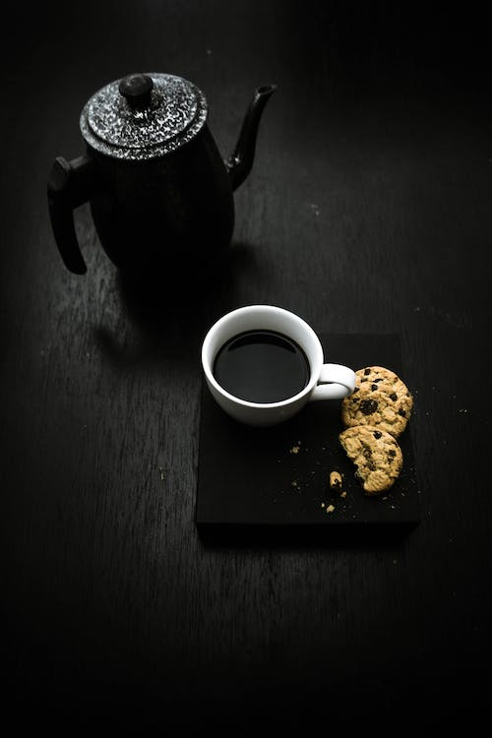

<https://www.pexels.com/photo/black-teapot-beside-teacup-2126268/>

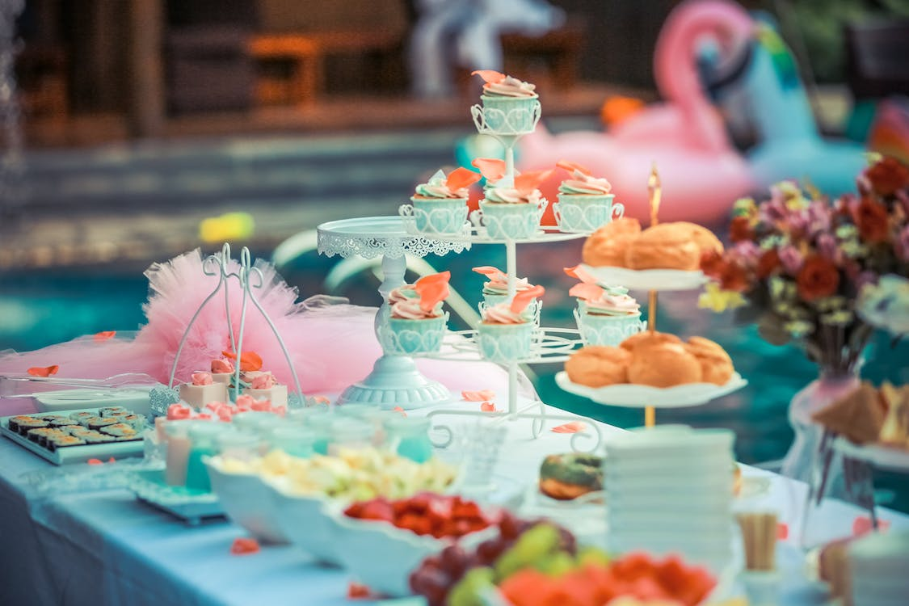  
<https://www.pexels.com/photo/cupcakes-display-on-cupcake-rack-587739/>



<https://www.pexels.com/photo/squirrels-on-concrete-surface-4116056/>

Hosting a tea party is a great way to bring friends and family together for a relaxed and elegant gathering. To complete the experience, it is important to choose the right snacks to serve. Here are some suggestions for delicious and sophisticated tea party snacks that are sure to impress your guests.

1. Finger Sandwiches: Finger sandwiches are a classic choice for tea parties. Fill your sandwiches with a variety of ingredients, such as cucumber, egg salad, smoked salmon, or ham and cheese. Cut the sandwiches into small, bite-sized portions for easy snacking.
2. Scones: Scones are a staple of English tea parties, and they’re perfect for spreading with butter, jam, or clotted cream. Serve a variety of flavors, such as plain, fruit-filled, or savory scones for a diverse selection.
3. Pastries: Pastries such as croissants, tarts, or éclairs are a delicious addition to any tea party. Choose a selection of sweet and savory options to satisfy a variety of tastes.
4. Tea Cakes: Tea cakes are a light and sweet snack that pair perfectly with a cup of tea. Serve a variety of flavors, such as lemon, poppy seed, or vanilla, for a diverse selection.
5. Shortbread Cookies: Shortbread cookies are a simple yet sophisticated snack that are perfect for a tea party. Serve plain or flavored shortbreads, such as rosemary or lavender, for a touch of elegance.
6. Fruit Skewers: Fresh fruit skewers are a healthy and refreshing snack that are perfect for a tea party. Choose a variety of seasonal fruit, such as berries, melon, or citrus, and serve with a dollop of whipped cream.
7. Tea Sandwiches: Tea sandwiches are a fun and unique snack that are perfect for a tea party. Fill your sandwiches with a variety of ingredients, such as smoked salmon, cream cheese, or cucumber, and cut them into small, bite-sized portions.

In conclusion, hosting a tea party is a wonderful way to bring people together and enjoy each other’s company. To complete the experience, choose a selection of delicious and sophisticated snacks that are sure to impress your guests. From finger sandwiches to tea cakes, the possibilities are endless.

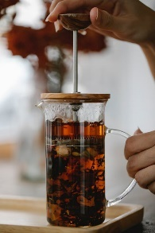

<https://www.pexels.com/photo/crop-unrecognizable-woman-holding-glass-french-press-teapot-with-tea-5946806/>

Teapots are often overlooked as just another kitchen appliance, but in reality, they are so much more. Not only do they serve a functional purpose, but they also add an element of style and charm to any tea-drinking experience. Here are just a few of the reasons why teapots are the coolest and why everyone should be using them.

1. Aesthetic Appeal: Teapots come in a variety of shapes, sizes, and designs, making them the perfect addition to any kitchen. From traditional ceramic teapots to modern glass and stainless-steel designs, there’s a teapot to fit every taste. Not only do they add to the décor of your kitchen, but they also make a statement when serving tea to guests.
2. Improved Tea Taste: Teapots allow for the proper steeping of tea leaves, which is crucial in ensuring the best possible taste. The temperature of the water, the size of the pot, and the length of steeping time all play a role in the final flavor of the tea. Using a teapot ensures that all of these factors are taken into account for a perfectly brewed cup of tea every time.
3. Convenient Serving: Teapots are designed for convenient and efficient serving. They come with a spout for easy pouring and a handle for comfortable gripping. With a teapot, you can easily pour a cup of tea for yourself or for a group of guests without any hassle.
4. A Timeless Tradition: Using a teapot is a timeless tradition that has been passed down through generations. Drinking tea from a teapot is a comforting and nostalgic experience that brings people together. Whether you’re sipping tea alone or sharing a pot with friends and family, using a teapot is a special and meaningful experience.
5. Easy to Clean: Unlike other kitchen appliances, teapots are easy to clean and maintain. Simply wash with soap and water, and let it air dry. For a deeper clean, you can remove the lid and give the inside a good scrub. With proper care, a teapot can last for many years and provide endless cups of tea.

In conclusion, teapots are not just a kitchen appliance, but a statement piece that adds style, convenience, and tradition to any tea-drinking experience. Whether you’re a tea aficionado or simply enjoy a good cup of tea, there’s a teapot out there for you. So why not ditch the traditional tea kettle and embrace the cool and timeless tradition of using a teapot today!

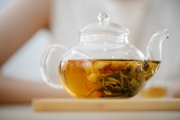

<https://www.pexels.com/photo/close-up-photo-of-clear-glass-teapot-with-herbal-tea-8330322/>

<https://www.pexels.com/photo/close-up-shot-of-keyboard-buttons-2882570/>

  
  
The HTTP 418 error, also known as the "I'm a teapot" error, is a quirky and entertaining part of the world of web development. But did you know that this error code has roots in the tradition of drinking tea and using teapots? In this blog post, we'll explore the connection between tea, teapots, and the HTTP 418 error.

The HTTP 418 error was first introduced as an April Fool's joke in 1998 by the Hyper Text Coffee Pot Control Protocol (HTCPCP) working group. The error message is meant to represent a teapot that is trying to serve coffee, but can only serve tea. This lighthearted joke was created to bring a touch of humor to the otherwise serious world of web development.

The connection between tea and teapots goes back centuries. Drinking tea has been a cherished tradition in many cultures, and teapots have been a staple of tea-drinking for just as long. Teapots are used to steep tea leaves and produce a flavorful and aromatic cup of tea. They come in a variety of shapes, sizes, and designs, and they can be made from materials such as ceramic, glass, or stainless steel.

So, what does the HTTP 418 error have to do with tea and teapots? In essence, the error message is a nod to the tradition of drinking tea and using teapots. By using a teapot to serve tea, we are acknowledging the timeless tradition of tea-drinking and bringing a touch of elegance and sophistication to our tea-drinking experience.

In the same way, the HTTP 418 error brings a touch of humor and lightheartedness to the world of web development. It serves as a reminder that even in the fast-paced and high-stress world of technology, there is still room for a little bit of fun and laughter.

In conclusion, the HTTP 418 error is a quirky and entertaining part of the world of web development, but it also has roots in the tradition of drinking tea and using teapots. Whether you're a web developer or a tea aficionado, it's important to remember the connection between tea, teapots, and the HTTP 418 error. So the next time you see the "I'm a teapot" error message, remember that it's a nod to the timeless tradition of tea-drinking and a reminder to take a moment to enjoy a cup of tea and a good laugh.



<https://www.pexels.com/photo/sliced-orange-fruit-in-clear-drinking-glass-3323682/>

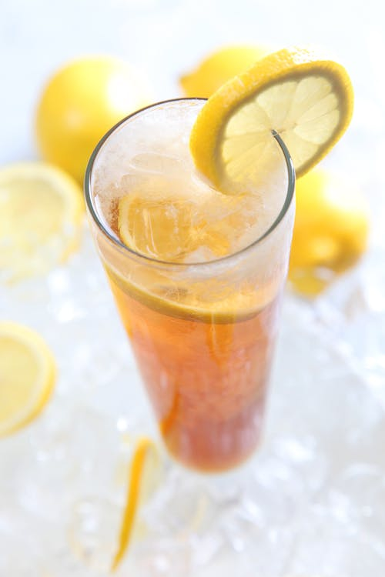

<https://www.pexels.com/photo/cold-drinks-served-on-clear-highball-glass-with-lemon-garnish-40594/>

Sun tea is a delicious and easy way to make iced tea without using any electricity or heat. It's a perfect option for a hot summer day when you want to enjoy a refreshing drink without having to turn on the stove or use the refrigerator. In this blog post, we'll explore the steps to making sun tea and why it's the perfect beverage for a sunny day.

Making sun tea is a simple process that requires only a few ingredients and a little bit of patience. Here's how to do it:

Ingredients:

* 6 tea bags (black tea is traditional, but you can use green or herbal tea as well)
* 6 cups of water
* 1 cup of sugar (or more or less to taste)
* 1 lemon, sliced (optional)
* Ice

Instructions:

1. Fill a clear glass jar with 6 cups of water and add the tea bags.
2. Place the jar in a sunny location, such as a windowsill or a patio table.
3. Allow the tea to steep in the sun for 4-6 hours. The sun's warmth will cause the water to evaporate and create a concentrated tea mixture.
4. Remove the tea bags and add the sugar, stirring until it dissolves.
5. Add the lemon slices, if desired.
6. Fill glasses with ice and pour the tea over the top.

Making sun tea is a simple and straightforward process, but the key to a really good sun tea is to start with high-quality tea leaves and to adjust the sugar to your liking. If you prefer a sweeter tea, add more sugar. If you prefer a less sweet tea, add less sugar. And if you're looking for a more sophisticated flavor, try adding fresh mint or ginger to the jar before steeping in the sun.

But why is sun tea the perfect beverage for a sunny day? There are several reasons:

1. It's natural: Sun tea is made using only the sun's warmth and a few simple ingredients. There's no need for electricity or heat, making it a great option for a sunny day.
2. It's refreshing: There's nothing like a cold glass of sun tea on a hot summer day. The combination of cold liquid and the natural flavors of tea are sure to refresh and rejuvenate you.
3. It's easy to make: Unlike other summer drinks, sun tea requires only a few simple ingredients and a little bit of patience. It's a quick and easy way to quench your thirst.
4. It's eco-friendly: By using the sun's warmth instead of electricity or heat, sun tea is an eco-friendly option for making iced tea.

In conclusion, sun tea is the perfect beverage for a sunny day for many reasons. Whether you're looking for a natural, refreshing, easy-to-make, or eco-friendly drink, sun tea has it all. So the next time you're looking for a cool drink on a hot day, try making sun tea. You won't regret it!

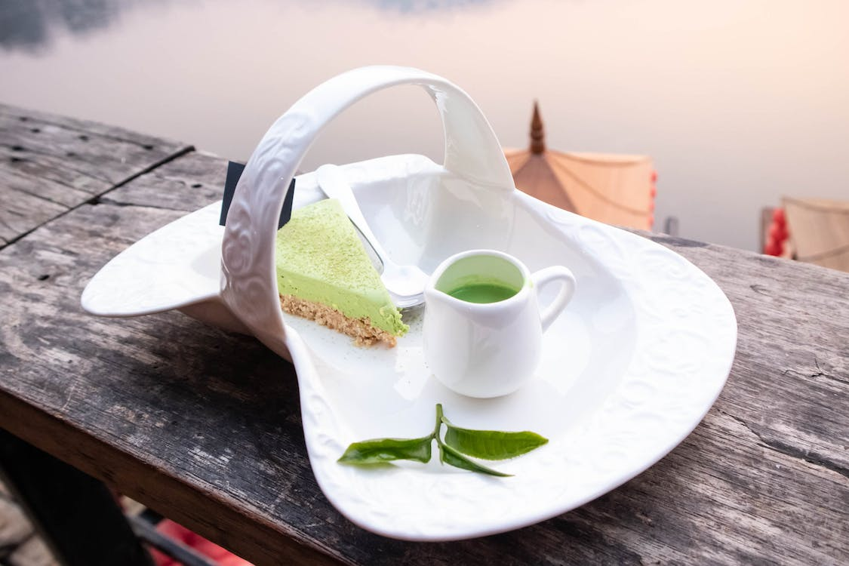

<https://www.pexels.com/photo/photo-of-match-cake-and-matcha-drink-on-a-porcelain-plate-8128636/>

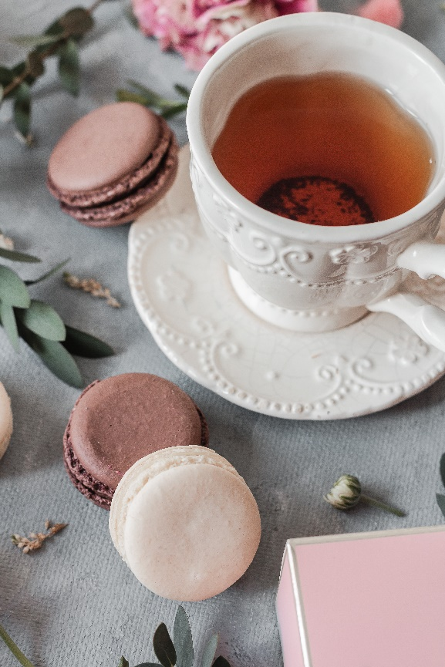

<https://www.pexels.com/photo/tea-cup-on-saucer-near-macaroons-on-surface-7296692/>

Baking with tea can be a fun and unique way to add flavor to your baked goods. Matcha and Earl Grey are two of the most popular teas to use in baking, and they can add a distinct and delicious flavor to your recipes. In this blog post, we'll explore the world of baking with tea, and we'll provide you with some delicious recipes for Matcha and Earl Grey baked goods.

Matcha: Matcha is a fine powder made from green tea leaves, and it has a unique flavor that is both grassy and slightly sweet. Matcha is a popular ingredient in Japanese tea ceremonies, but it has also found its way into the world of baking. When used in baking, matcha can add a vibrant green color and a delicate, earthy flavor to your recipes. Here are some of our favorite Matcha recipes:

* Matcha Cupcakes: These cupcakes are made with a fluffy and tender cake that is infused with matcha powder. Top them with a fluffy matcha frosting for a perfectly sweet and refreshing treat.
* Matcha Cookies: These chewy and crunchy cookies are a great way to enjoy matcha in a more portable form. They're easy to make and they're perfect for on-the-go snacking.
* Matcha Donuts: These donuts are made with a soft and tender dough that is infused with matcha powder. They're perfect for a special breakfast treat or for a sweet and indulgent dessert.

Earl Grey: Earl Grey is a black tea that is flavored with bergamot oil, and it has a unique and slightly citrusy flavor. When used in baking, Earl Grey can add a subtle and sophisticated flavor to your recipes. Here are some of our favorite Earl Grey recipes:

* Earl Grey Cupcakes: These cupcakes are made with a rich and tender cake that is infused with Earl Grey tea leaves. They're topped with a tangy and sweet lemon frosting for a perfect balance of flavors.
* Earl Grey Cookies: These soft and chewy cookies are a great way to enjoy Earl Grey in a more portable form. They're easy to make and they're perfect for on-the-go snacking.
* Earl Grey Loaf Cake: This loaf cake is made with a tender and fluffy cake that is infused with Earl Grey tea leaves. It's topped with a simple glaze for a perfectly sweet and sophisticated treat.

In conclusion, baking with tea can be a fun and unique way to add flavor to your baked goods. Whether you're looking to enjoy the unique flavor of Matcha or the sophisticated flavor of Earl Grey, there are plenty of recipes to choose from. So why not give it a try and add a touch of tea to your next baked creation!