Install Guide PHPUnit installation on windows

Download php installer for windows and execute it:

<http://windows.php.net/downloads/releases/php-5.3.27-nts-Win32-VC9-x86.msi>

Default installation path:

C:\PHP

mkdir workspace and clone moolde from github:

cd workspace

git clone <git://github.com/moodle/moodle.git>

Download pear:

<http://pear.php.net/go-pear.phar>

copy go-pear.phar into C:\PHP

open command line :

C:\PHP>pear channel-discover pear.phpunit.de

C:\PHP>pear install phpunit/PHPUnit

C:\PHP>pear install phpunit/PHPUnit_SkeletonGenerator

Open Netbeans

Tools🡪Options🡪PHP

Set path to PHP Unit Script and Skeleton Generator Script :

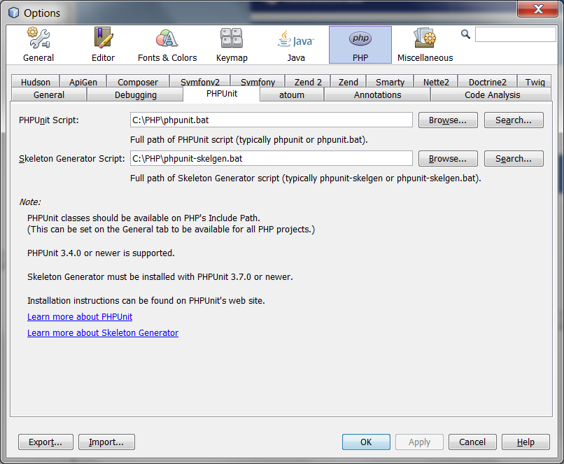

Right-click on the root folder in netbeans (PhpProjetc1 in the example) 🡪 Properties.

Change to Testing and activate PHPUnit.

Change to PHPUnit :

Activate « Use Bootstrap » and insert path to the bootstrap.php file:

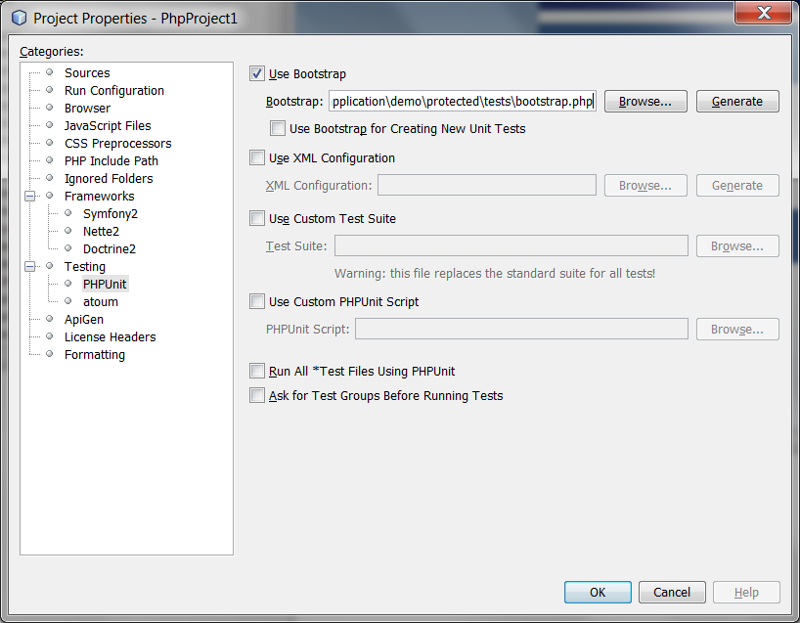

To execute tests set following properties:

Right-click on the root folder in netbeans (PhpProjetc1 in the example) 🡪 Properties.

Section „Source“ 🡪 Test Folder 🡪 set path to test folder:

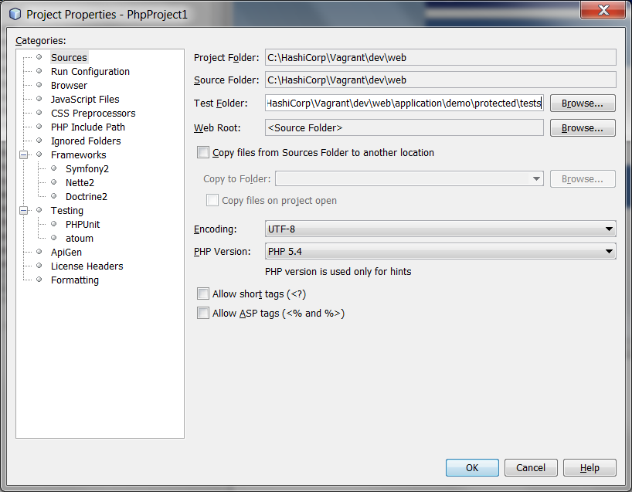

To run a test with PHPUnit:

Right-click on the *Test.php file 🡪 Run :

Test results :

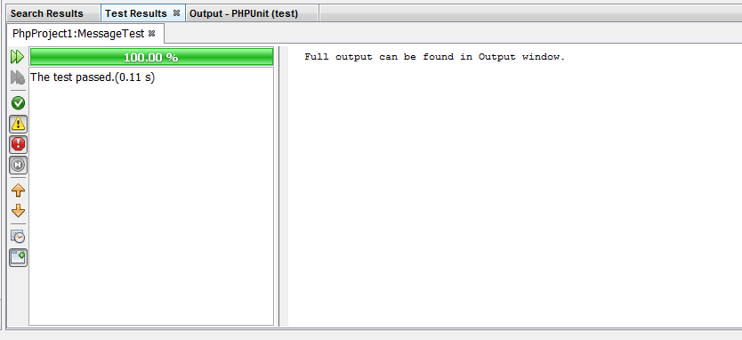

Output :

