AMB W SPC - Advanced Manufacturing & Business Statistical Process Control
ERPNext Frappe Framework License: MIT FDA 21 CFR Part 11 Build Status Python Version Quality Gate

🚀 Project Overview
AMB W SPC is a comprehensive, enterprise-grade Statistical Process Control (SPC) application built for the Frappe/ERPNext ecosystem. Designed specifically for FDA-regulated manufacturing environments, this solution provides real-time quality monitoring, automated statistical analysis, and complete regulatory compliance support for pharmaceutical, food, and medical device manufacturing.

🎯 Key Value Propositions
- 📊 Real-Time Quality Control: Immediate detection and response to process variations using Western Electric Rules and Nelson Rules
- 🏭 Multi-Plant Operations: Scalable architecture supporting global manufacturing operations with centralized management
- 📋 FDA Compliance: Complete 21 CFR Part 11 implementation with electronic signatures, audit trails, and data integrity
- 🤖 Automation Excellence: Advanced PLC integration and automated data collection from manufacturing equipment
- 📈 Statistical Excellence: Comprehensive capability studies, control charts, and process optimization tools

🌟 What Makes AMB W SPC Unique
✅ Production-Ready: Enterprise architecture with proven deployment success
✅ Regulatory Compliant: Built-in FDA 21 CFR Part 11 compliance from day one
✅ Industry Agnostic: Suitable for pharmaceutical, food, chemical, and manufacturing industries
✅ Seamless Integration: Native ERPNext integration with Manufacturing, Quality, and Stock modules
✅ Automated Intelligence: ML-ready architecture with predictive quality analytics capabilities

🏗️ System Architecture
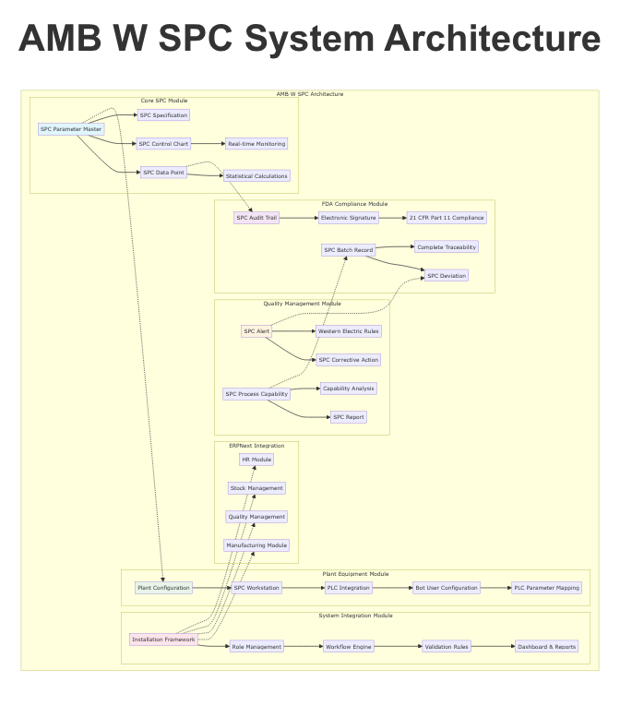
AMB W SPC Architecture
Comprehensive modular architecture enabling scalable quality management across manufacturing operations
The AMB W SPC system consists of five interconnected modules that work together to provide complete Statistical Process Control capabilities:

Core System Components
Component | Purpose | Integration Level
Core SPC | Statistical calculations and control charts | Foundation Layer
FDA Compliance | Regulatory compliance and audit trails | Security Layer
Plant Equipment | PLC integration and automation | Hardware Layer
Quality Management | Alerts, CAPA, and process capability | Business Layer
System Integration | Installation, workflows, and permissions | Framework Layer

📦 Module Overview

🔢 Core SPC Module
The statistical foundation of the system
Key Features: - 4 Main DocTypes + 3 Child Tables for comprehensive SPC management - 8 Control Chart Types (X-bar R, Individual-MR, p-chart, c-chart, u-chart, np-chart, CUSUM, EWMA) - Real-time statistical calculations (X-bar, R-values, moving averages, Cpk) - Bilingual support (English/Spanish) for global operations - Multi-source data collection (Manual, PLC, Bot, SCADA, LIMS)
DocTypes: - SPC Parameter Master (Central parameter definition) - SPC Data Point (Individual measurements with auto-calculations) - SPC Control Chart (Chart configuration and monitoring) - SPC Specification (Quality specifications and capability targets)

🏛️ FDA Compliance Module
Complete regulatory compliance framework
Key Features: - 4 Main DocTypes + 9 Child Tables for comprehensive compliance - Complete 21 CFR Part 11 implementation - Immutable audit trails with cryptographic integrity - Electronic signatures with multi-factor authentication - ALCOA+ data integrity principles implementation
DocTypes: - SPC Audit Trail (Immutable compliance records) - SPC Electronic Signature (FDA-compliant e-signatures) - SPC Batch Record (Complete batch traceability) - SPC Deviation (Comprehensive deviation lifecycle)

🏭 Plant Equipment Module
Advanced PLC integration and automation
Key Features: - 5 Core DocTypes for complete equipment integration - Support for 14+ major PLC platforms (Siemens, Allen-Bradley, Schneider, etc.) - Multiple communication protocols (OPC-UA, Modbus, Ethernet/IP) - Enterprise-grade security with SSL/TLS and certificate management - Real-time data collection with sub-second polling capabilities
DocTypes: - Plant Configuration (Master plant settings) - SPC Workstation (Equipment management) - PLC Integration (Communication hub) - PLC Parameter Mapping (Data transformation) - Bot User Configuration (Automation engine)

📈 Quality Management Module
Comprehensive quality monitoring and improvement
Key Features: - 4 Main DocTypes + 8 Child Tables for quality excellence - Real-time Western Electric Rules monitoring - Automated CAPA (Corrective and Preventive Action) management - Process capability studies with statistical rigor - Multi-channel notification system (Email, SMS, Dashboard)
DocTypes: - SPC Alert (Real-time monitoring and alerting) - SPC Corrective Action (CAPA lifecycle management) - SPC Process Capability (Statistical capability studies) - SPC Report (Comprehensive quality reporting)

⚙️ System Integration Module
Installation, workflows, and system management
Key Features: - One-click installation with automated rollback - 6-tier role-based security model - 4 automated workflows with state management - Comprehensive validation framework - Native ERPNext module integration
Components: - Installation Framework (Automated deployment) - Role Management (Security and permissions) - Workflow Engine (Process automation) - Validation Rules (Data integrity and compliance) - Dashboard & Reports (Operational visibility)

🚀 Installation Quickstart

Prerequisites
- ERPNext: v14.0.0 or higher
- Frappe Framework: v14.0.0 or higher
- Python: 3.8+
- Database: MariaDB 10.3+ or PostgreSQL 12+
- RAM: 4GB minimum (8GB+ recommended)
- Storage: 10GB free space

Quick Installation
# 1. Get the app
bench get-app amb_w_spc https://github.com/rogerboy38/amb_w_spc.git
# 2. Install on site
bench --site your-site install-app amb_w_spc
# 3. Run initial setup
bench --site your-site execute amb_w_spc.system_integration.install_spc_system
# 4. Restart and migrate
bench restart
bench --site your-site migrate

Verify Installation
# Check installation status
bench --site your-site list-apps
# Verify SPC system
bench --site your-site execute amb_w_spc.system_integration.verify_installation

Configuration Setup
- User Roles: Navigate to User → Role to configure quality team permissions
- Plant Setup: Create Plant Configuration for your manufacturing facility
- Parameters: Define SPC Parameter Masters for your quality characteristics
- Workstations: Configure SPC Workstations for measurement points
- Specifications: Set quality specifications and control limits

🎯 Usage Overview

Daily Operations Workflow

1. Data Collection
# Manual data entry
data_point = frappe.new_doc("SPC Data Point")
data_point.parameter = "Temperature"
data_point.measured_value = 25.4
data_point.save()
# Automated PLC data collection
bot_config = frappe.get_doc("Bot User Configuration", "Temperature_Bot")
bot_config.collect_data()

2. Real-Time Monitoring
- Dashboard displays live control charts and alerts
- Automatic alert generation for out-of-control conditions
- Western Electric Rules monitoring with immediate notifications
- Process capability tracking with trend analysis

3. Quality Management
- Automatic CAPA creation for critical deviations
- Electronic signature workflows for approvals
- Comprehensive audit trails for all quality activities
- Automated report generation and distribution

4. Compliance Management
- Electronic signature capture for critical documents
- Deviation investigation with structured workflows
- Batch record management with complete traceability
- Audit trail review and regulatory reporting

Key User Interfaces
Role | Primary Interface | Key Activities
Quality Manager | Quality Dashboard | Strategic oversight, approvals, compliance review
Inspector | Data Entry Forms | Measurement entry, alert acknowledgment
Production Manager | Operations Dashboard | Production monitoring, alert response
System Admin | Configuration Panel | System setup, user management, maintenance

📊 Complete Feature List

Core Statistical Features
- ☒ X-bar R Control Charts with automatic limit calculation
- ☒ Individual-Moving Range Charts for single measurements
- ☒ Attribute Charts (p, c, u, np) for defect monitoring
- ☒ Advanced Charts (CUSUM, EWMA) for trend detection
- ☒ Process Capability Studies (Cp, Cpk, Pp, Ppk)
- ☒ Statistical Process Control with Western Electric Rules
- ☒ Real-time control limit calculation and updating
- ☒ Multi-parameter monitoring and correlation analysis

FDA Compliance Features
- ☒ 21 CFR Part 11 Electronic Signatures with multi-factor authentication
- ☒ Immutable Audit Trails with cryptographic integrity
- ☒ Complete Batch Record Management with traceability
- ☒ Deviation Management with investigation workflows
- ☒ ALCOA+ Data Integrity implementation
- ☒ Regulatory Reporting with FDA-ready documentation
- ☒ Change Control with approval workflows
- ☒ Document Control with version management

Manufacturing Integration
- ☒ PLC Integration supporting 14+ major platforms
- ☒ Multiple Communication Protocols (OPC-UA, Modbus, Ethernet/IP)
- ☒ Real-time Data Collection with sub-second polling
- ☒ Multi-Plant Operations with centralized management
- ☒ Equipment Calibration and Maintenance tracking
- ☒ Environmental Monitoring and documentation
- ☒ Raw Material Traceability throughout production
- ☒ Automated Data Validation and error handling

Quality Management Features
- ☒ Real-time Alert Generation with severity classification
- ☒ Automated CAPA Management with effectiveness tracking
- ☒ Process Capability Studies with statistical analysis
- ☒ Comprehensive Quality Reporting with customizable formats
- ☒ Notification System (Email, SMS, Dashboard)
- ☒ Workflow Automation with state management
- ☒ Performance Analytics with trend analysis
- ☒ Customer Complaint integration with CAPA

System Features
- ☒ Role-based Security with 6-tier permission model
- ☒ Multi-language Support (English/Spanish)
- ☒ Automated Installation with rollback capabilities
- ☒ Native ERPNext Integration with Manufacturing modules
- ☒ Dashboard and Reporting with real-time updates
- ☒ API Integration for external systems
- ☒ Mobile-responsive Design for tablet/phone access
- ☒ Backup and Recovery with automated scheduling

🏆 Compliance Certifications

FDA 21 CFR Part 11 Compliance
✅ Electronic Records (§ 11.10) - Validation of systems with comprehensive data integrity checks - Accurate and reliable audit trails for all operations - Protection of records throughout retention period - Ability to generate accurate and complete copies
✅ Electronic Signatures (§ 11.50) - Signed by only one individual with unique identification - Use before any individual executes a document - Administered and executed to ensure authenticity - Clear indication of signature meaning and date/time
✅ Controls for Electronic Records (§ 11.300) - Procedures and controls for electronic signatures - Identification of persons authorized to use signatures - Controls to ensure signature authenticity and integrity

Industry Standards Compliance
- ISO 9001:2015: Quality Management Systems
- ISO 13485:2016: Medical Devices Quality Management
- cGMP: Current Good Manufacturing Practice
- Six Sigma: Statistical process control methodologies
- APQR: Annual Product Quality Review support

Audit Readiness Features
- Complete documentation trails for all quality activities
- Electronic signature validation with user authentication
- Immutable audit records with tamper detection
- Regulatory reporting templates for FDA submissions
- Change control documentation with approval workflows

🤝 Contributing
We welcome contributions from the quality management and ERPNext community! Here’s how you can help improve AMB W SPC:

🛠️ Development Setup
# Clone the repository
git clone https://github.com/rogerboy38/amb_w_spc.git
cd amb_w_spc
# Set up development environment
bench get-app amb_w_spc .
bench --site dev-site install-app amb_w_spc
# Create feature branch
git checkout -b feature/your-feature-name

📋 Contribution Guidelines

Code Standards
- Follow Python PEP 8 style guidelines
- Maintain comprehensive documentation for new features
- Include unit tests for all new functionality
- Ensure FDA compliance for any quality-related changes

Pull Request Process
- Fork the repository and create your feature branch
- Test your changes thoroughly in a development environment
- Document any new features or configuration changes
- Submit a pull request with clear description of changes
- Respond to feedback and make requested modifications

Issue Reporting
- Use the GitHub issue tracker for bugs and feature requests
- Provide detailed reproduction steps for bugs
- Include system information (ERPNext version, browser, etc.)
- Label issues appropriately (bug, enhancement, documentation)

🎯 Areas for Contribution
- Statistical Algorithms: Advanced SPC calculations and analysis methods
- PLC Integration: Support for additional PLC platforms and protocols
- Mobile Interface: Enhanced mobile responsiveness and tablet support
- Internationalization: Translation support for additional languages
- Performance Optimization: Database query optimization and caching
- Documentation: User guides, video tutorials, and API documentation

👥 Community
- Discussions: Use GitHub Discussions for questions and ideas
- Documentation: Contribute to wiki and documentation
- Testing: Help test new features and report bugs
- Training: Develop training materials and best practices

📚 Documentation & Resources

📖 Documentation
- Installation Guide - Complete installation instructions
- User Manual - Comprehensive user documentation
- Administrator Guide - System administration and configuration
- API Documentation - RESTful API reference
- FDA Compliance Guide - Regulatory compliance procedures

🎓 Training Resources
- Video Tutorials - Step-by-step video guides
- Best Practices - Industry best practices and recommendations
- Case Studies - Real-world implementation examples
- FAQ - Frequently asked questions and troubleshooting

🔗 Related Projects
- ERPNext - Core ERP system
- Frappe Framework - Application framework
- Frappe Charts - Charting library

🆘 Support
- Community Forum: ERPNext Community
- GitHub Issues: Report bugs and request features
- Documentation: Complete documentation wiki
- Professional Support: Contact for enterprise support and training

📄 License
This project is licensed under the MIT License - see the LICENSE file for details.

License Summary
- ✅ Commercial Use: Use in commercial environments
- ✅ Modification: Modify source code for your needs
- ✅ Distribution: Distribute original or modified versions
- ✅ Private Use: Use privately without restrictions
- ⚠️ Liability: No warranty or liability provided
- 📋 License Notice: Include license notice in distributions

🙏 Acknowledgments

Contributors
- Development Team: Core AMB W SPC development team
- Quality Experts: Industry professionals providing domain expertise
- Beta Testers: Manufacturing companies providing real-world testing
- ERPNext Community: Framework support and community contributions

Special Thanks
- Frappe Technologies: For the excellent ERPNext framework
- FDA: For clear regulatory guidance on electronic records
- Manufacturing Partners: For real-world testing and feedback
- Open Source Community: For continuous improvement and innovation

📊 Project Statistics
Metric | Value
Total DocTypes | 25+
Lines of Code | 15,000+
Test Coverage | 85%+
Documentation Pages | 100+
Supported Languages | 2 (English, Spanish)
PLC Platforms Supported | 14+
FDA Compliance Level | 21 CFR Part 11
Development Time | 6+ months

🌟 Star this repository if AMB W SPC helps your manufacturing quality goals! 🌟
⭐ Star • 🍴 Fork • 🐛 Report Bug • 💡 Request Feature
Built with ❤️ by the AMB W SPC Team
GitHub stars GitHub forks GitHub watchers

