**Homework logic for assignment one**

**Roger Benjume CSCD 300, SPRING 2022**

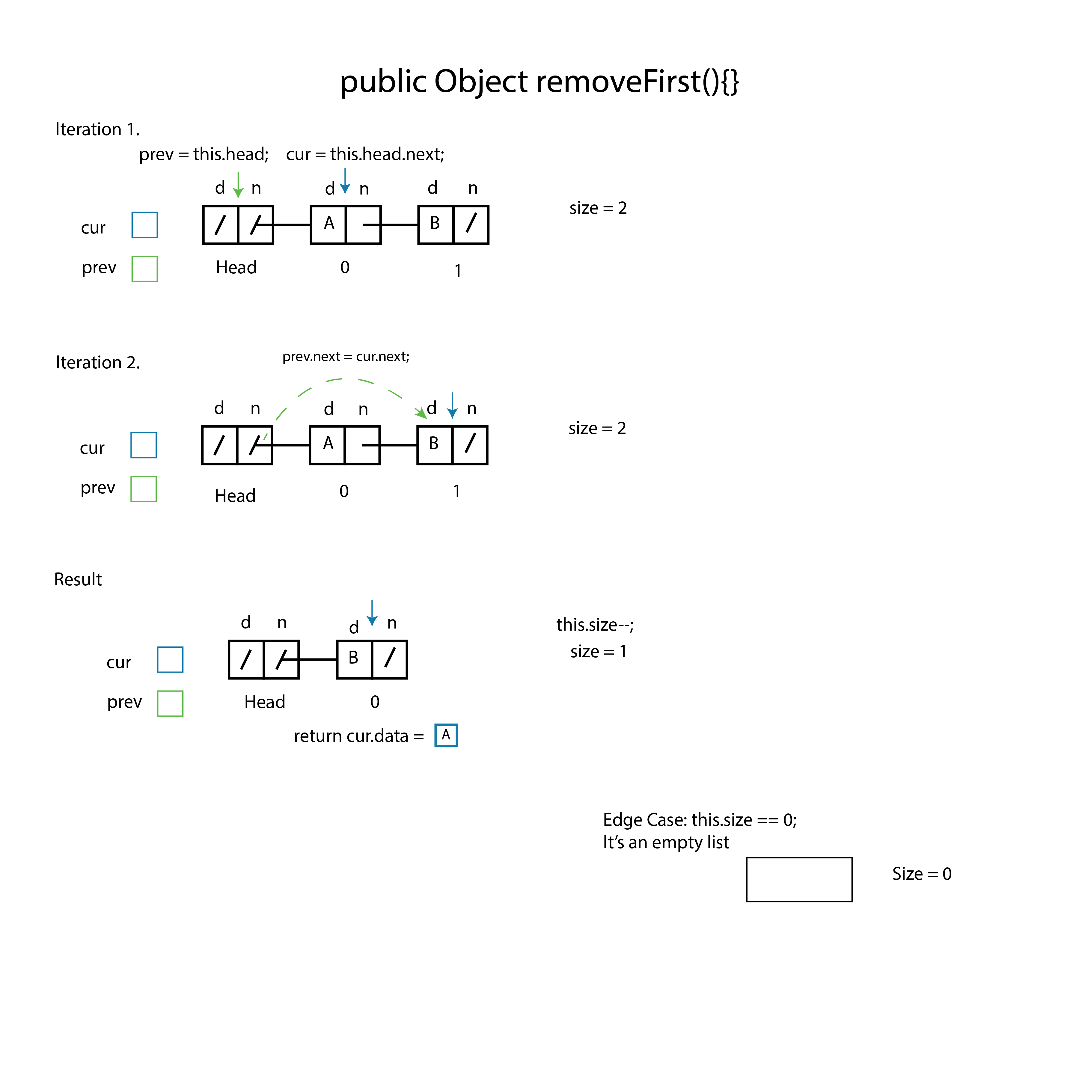

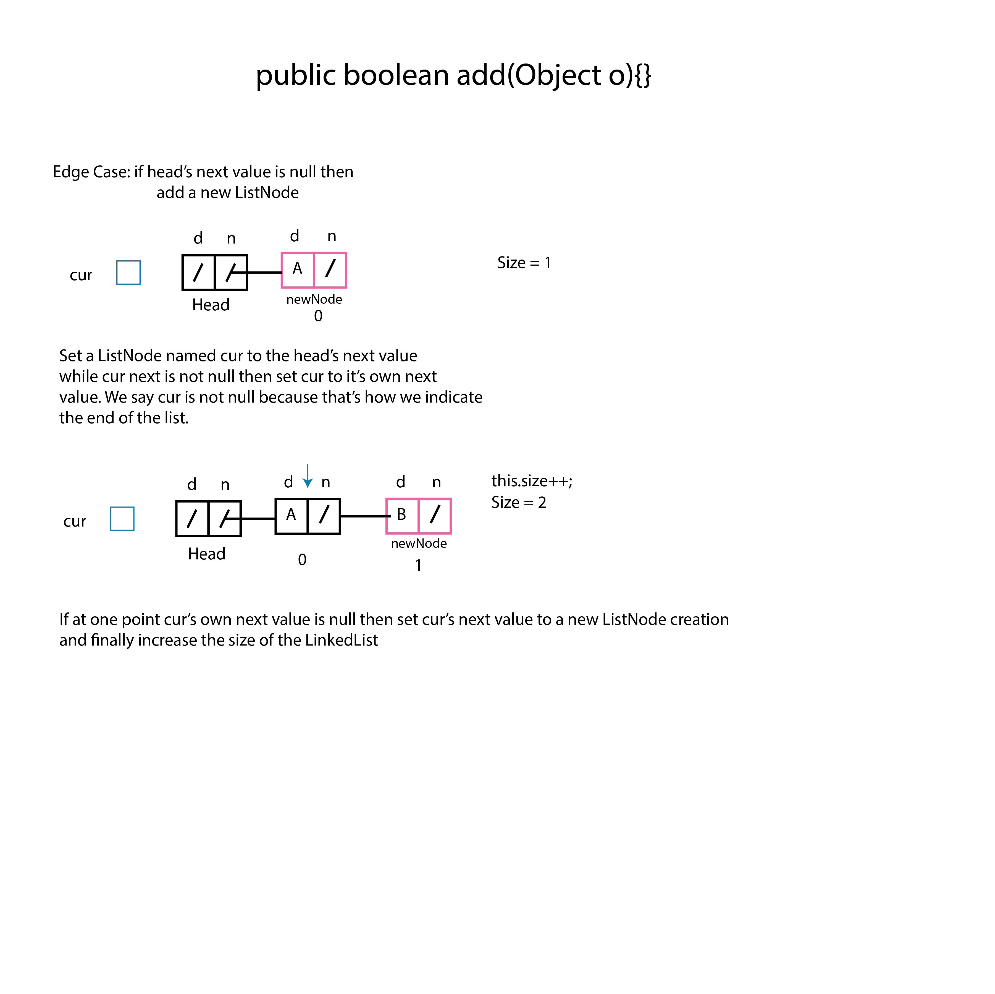

In this case we have a while loop that evaluates when cur’s next value is not null. We say this because if cur were to be null then we have reached the end of the list.

Usually for add operations we use cur.next != null.

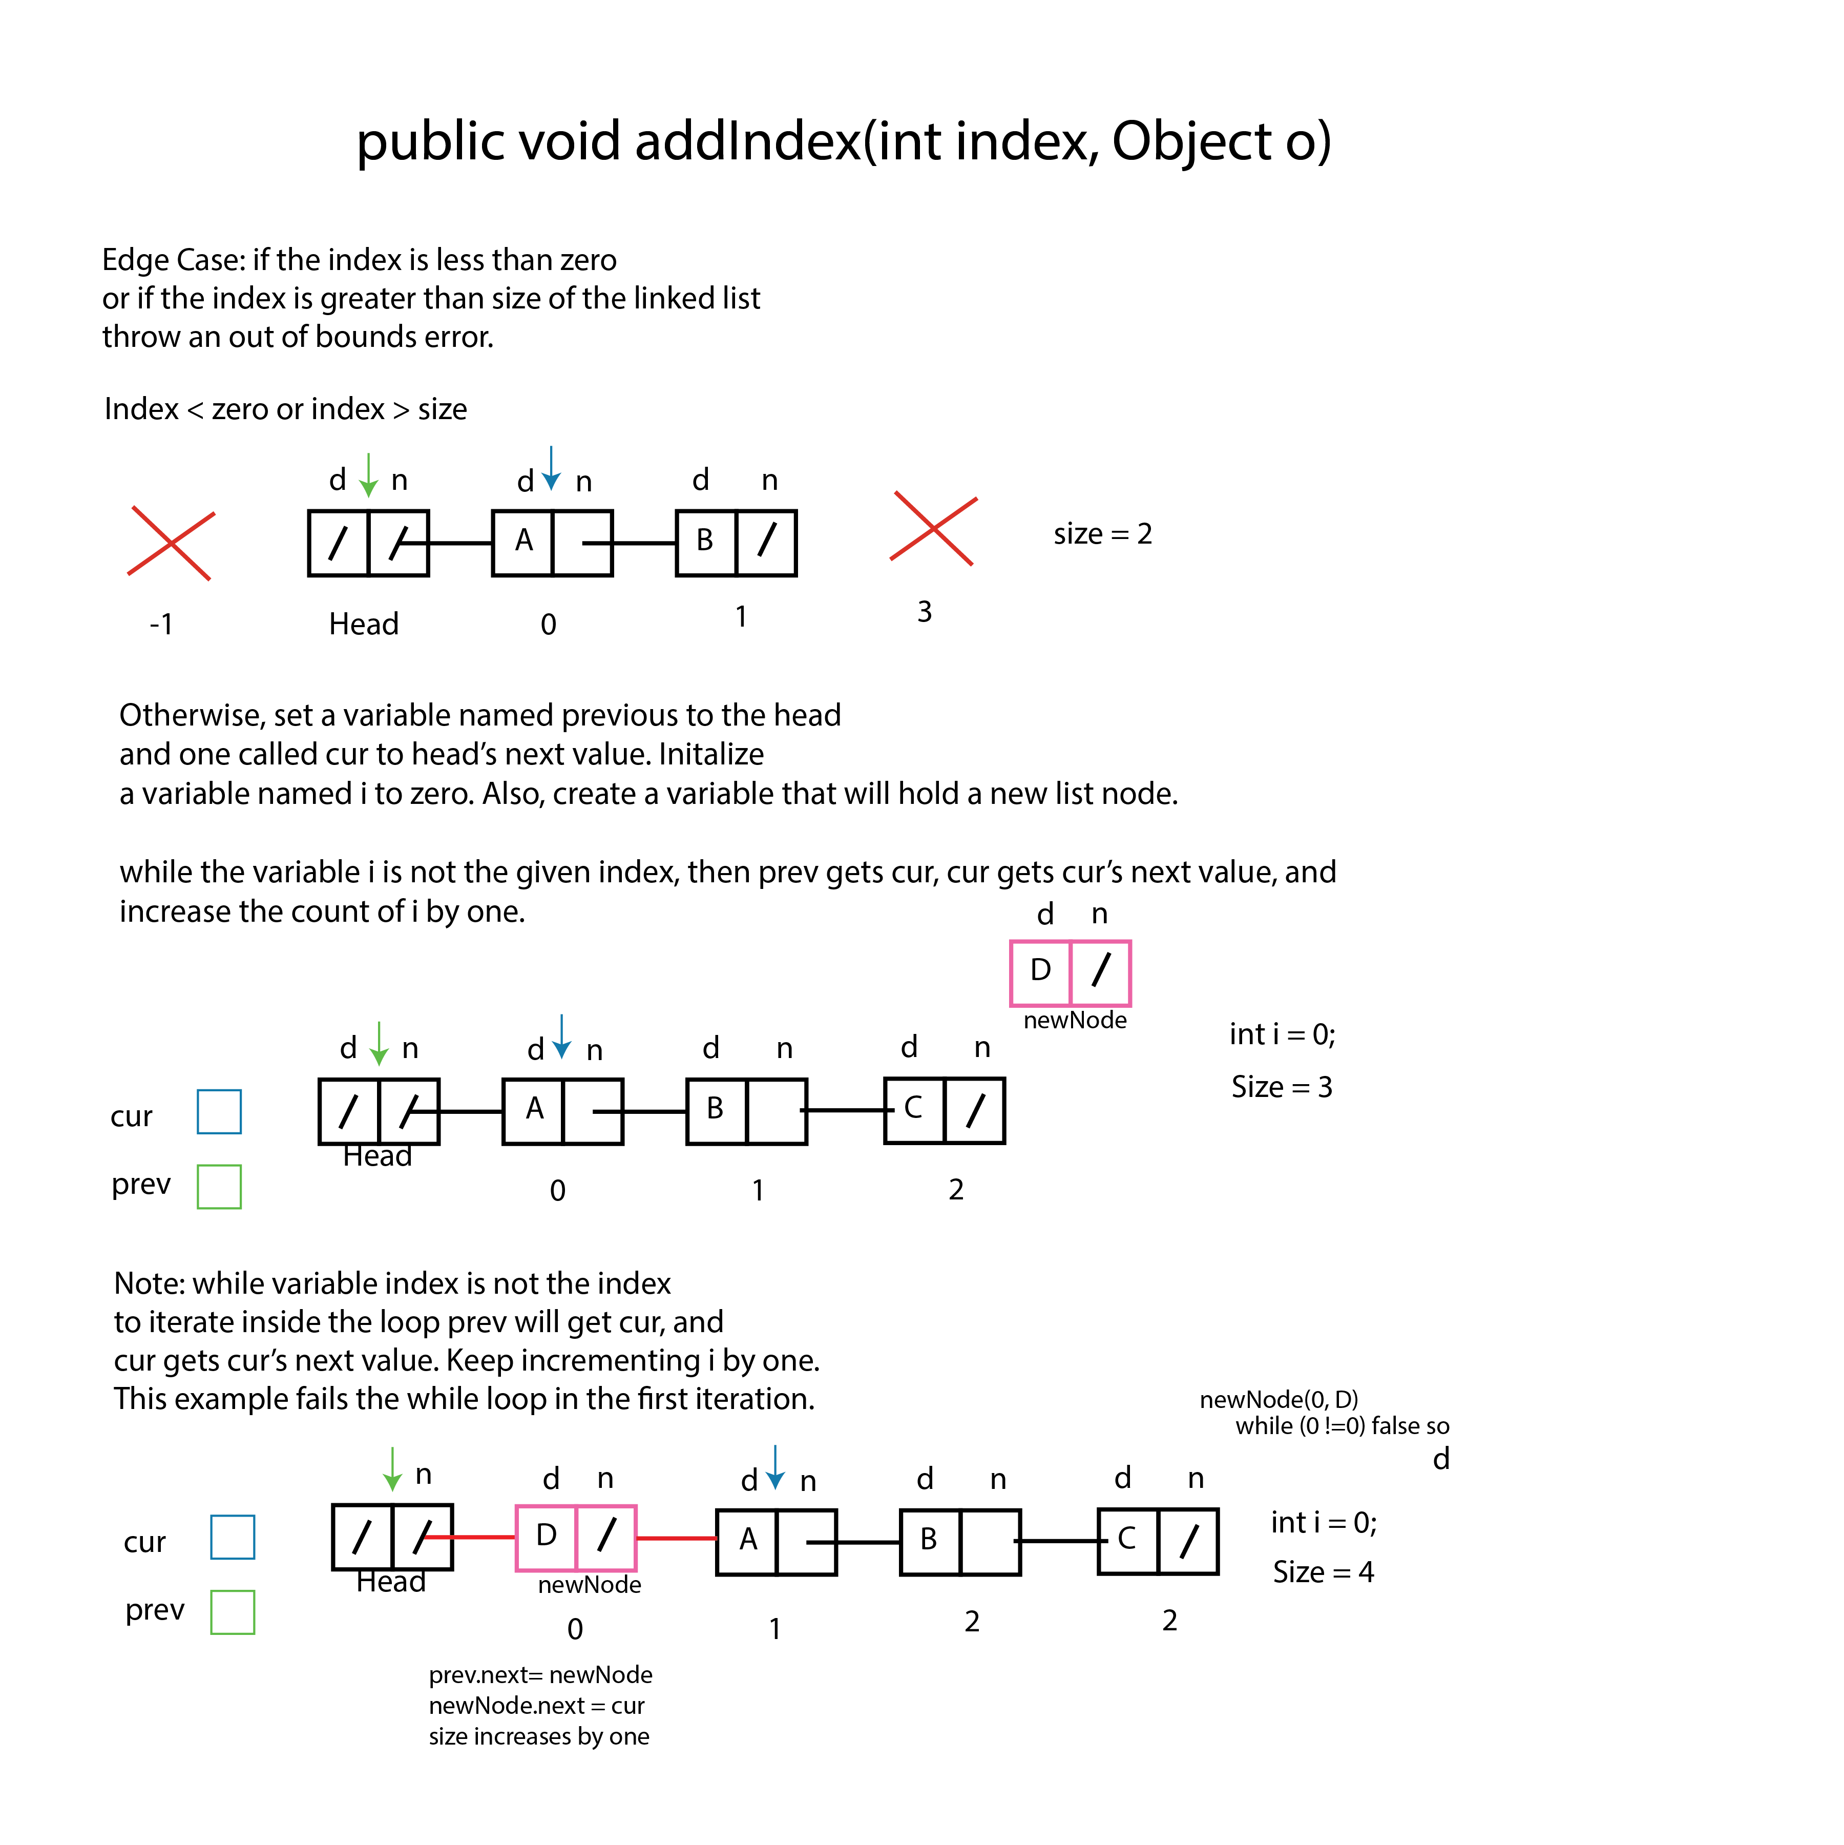

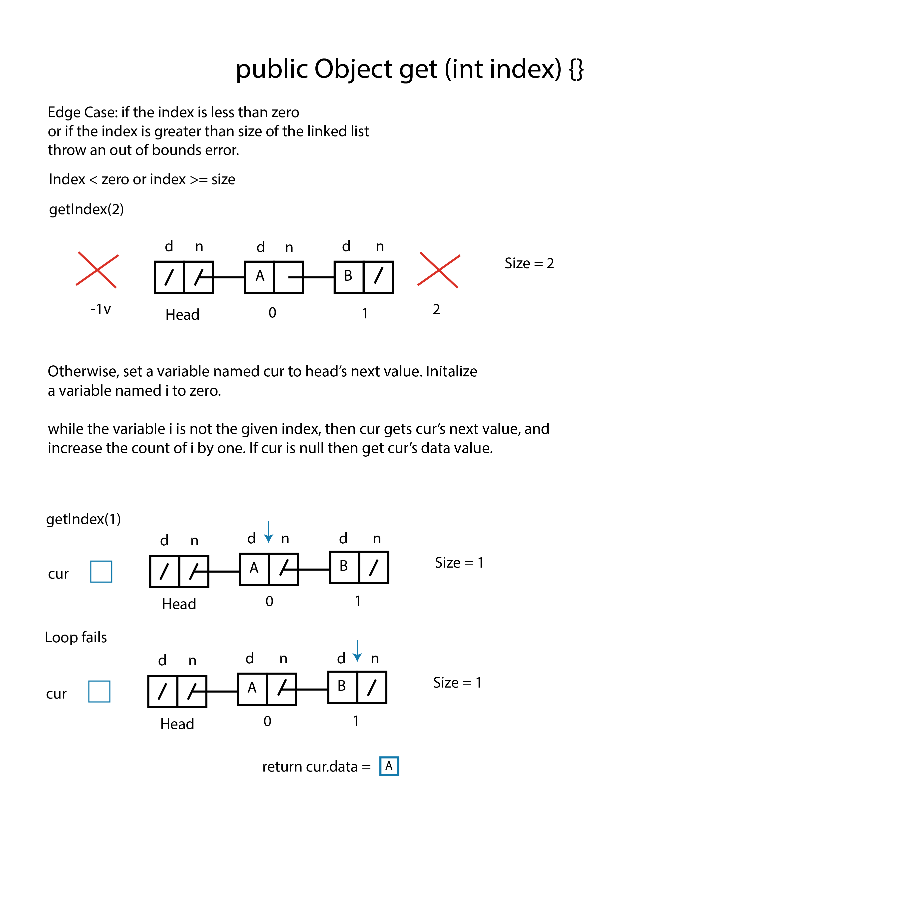

In this case we will have a while loop. This while loop will run until a variable n

Is less than the given index. Also, we only have to use one variable such as cur because we are just getting a value. This is true because we are not removing or adding nodes to the list.

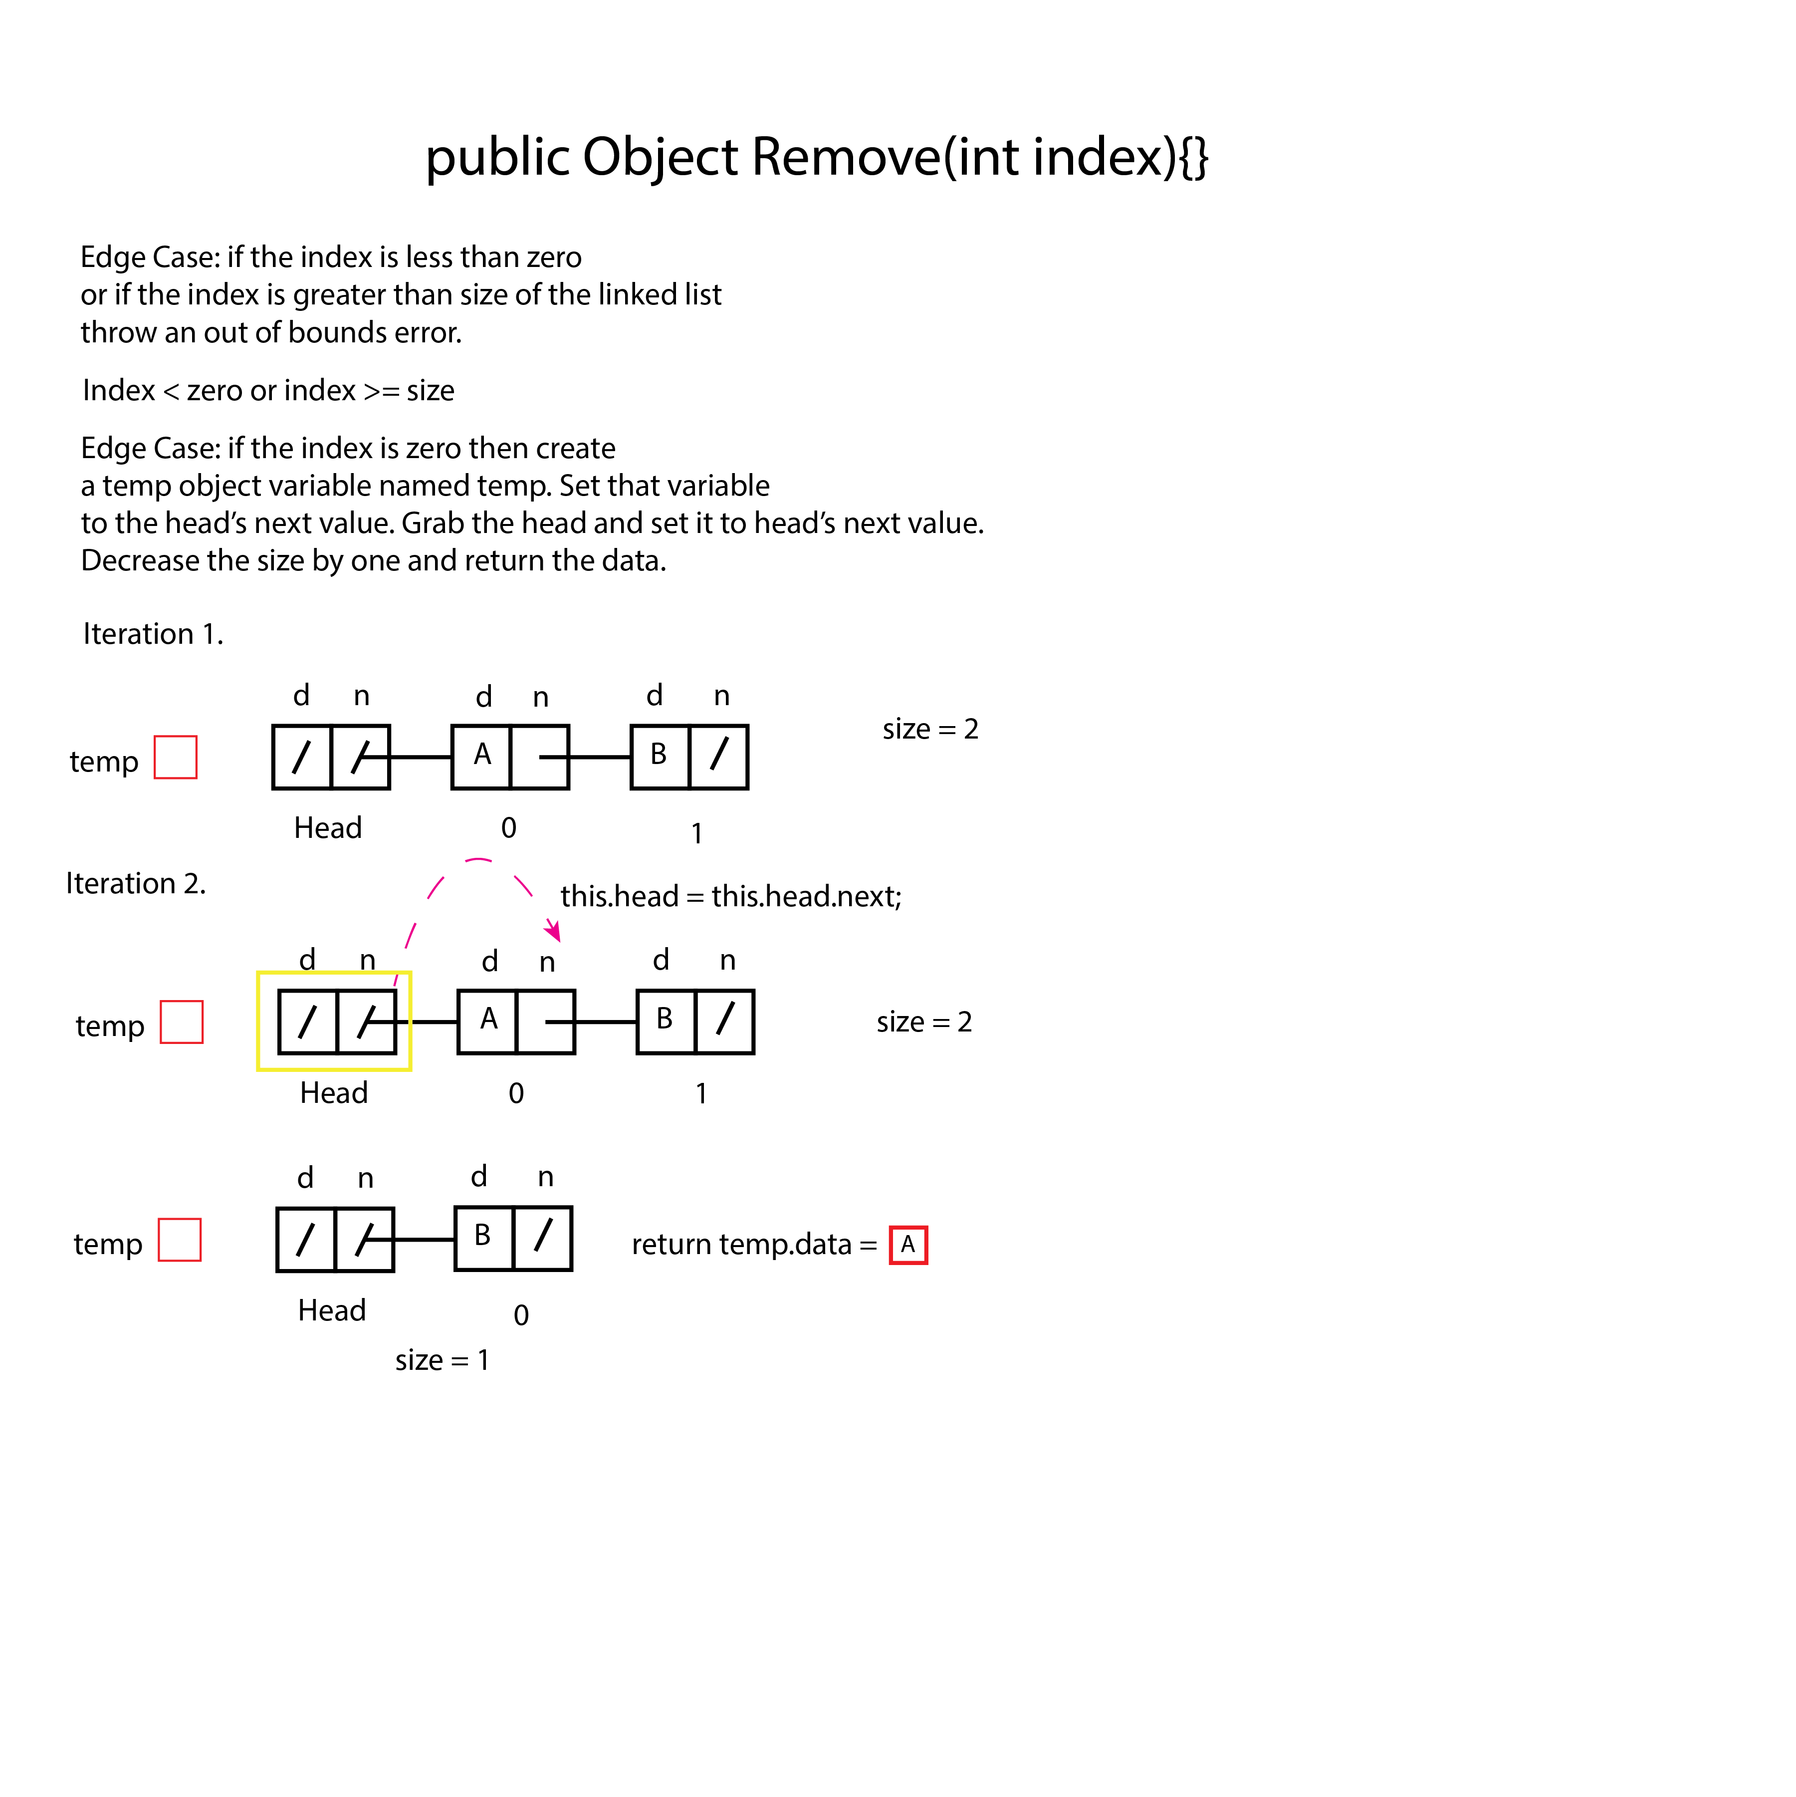

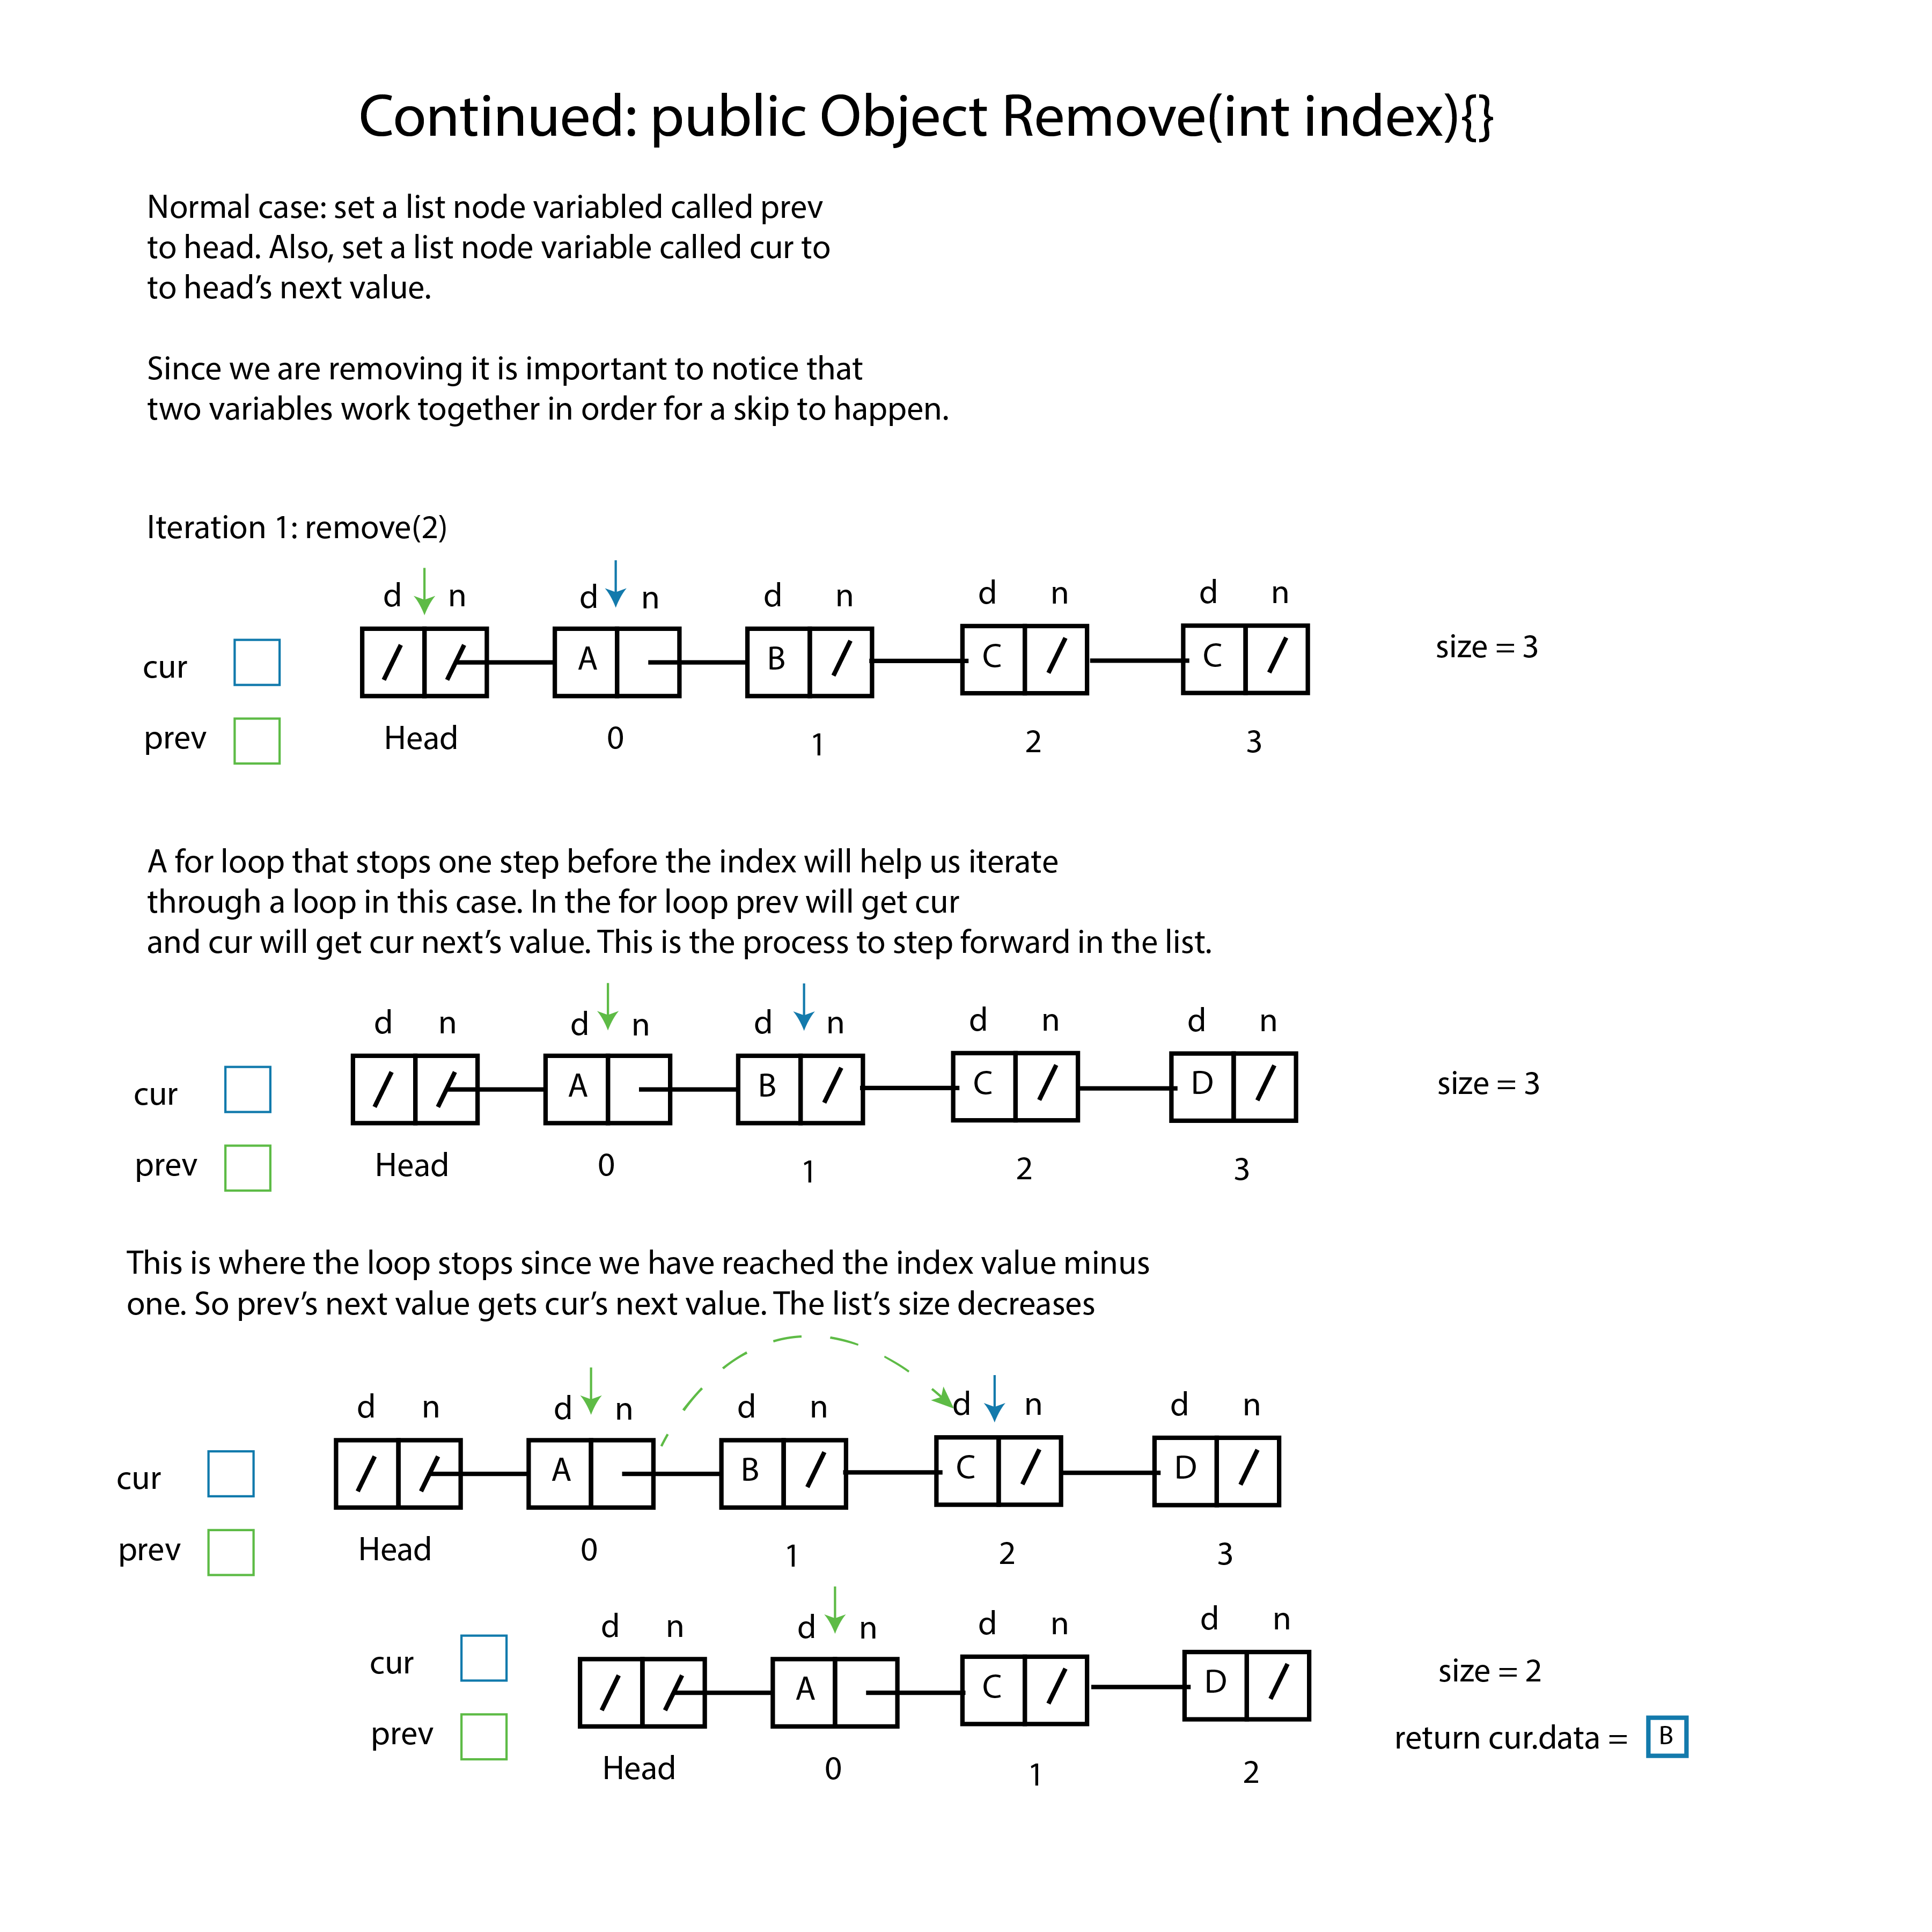

Here we use a different approach. This method will use a for loop, and alternatively a while loop can be used. Since this a for loop example, the for loop

will go through the whole list. Also, we must use to refrence variable since we are removing from the list. Having these two variables allows to perform the walk, and one variable such as prev will stay one step behind.

It is important to consider that if a desired value to be removed is found

Cur will get cur.next and this will leave prev in it’s original position. T

