**Movements to use in electronic scoring**

**3 tables:** use anything scheduled for 3 tables

**4 tables:**

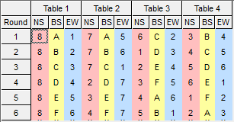24 boards, ¾ Howell, 8 stationary

24 boards, ¾ Howell, 3 stationary

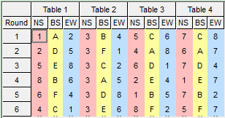

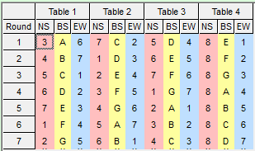28 boards, Howell EBU p33, 8 stationary

28 boards, Howell BB 8 stationary

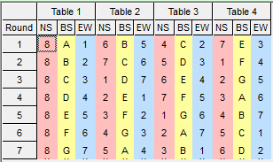

**5 tables:**

27 boards, Howell EBU p35, 10 stationary

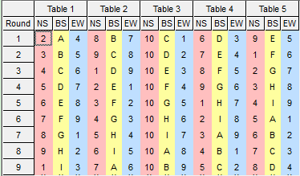

27 boards, Howell Fleming, 10 stationary

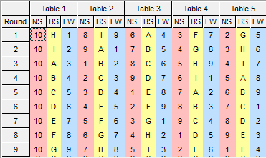

**6 tables:**

24 boards, ¾ Howell, 12+11+10 stationary

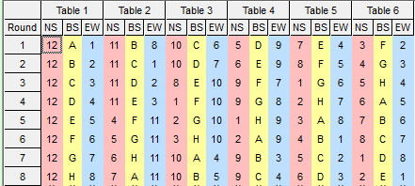

27 boards, ¾ Howell, EBU p38, 11+10 stationary

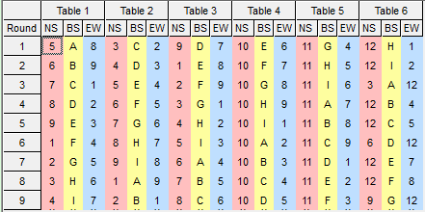

27 boards, ¾ Howell EBU Farrington, 12+11 stationary

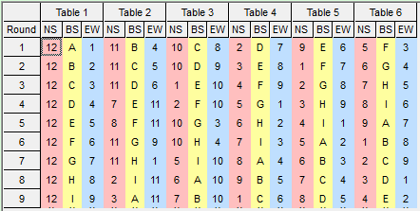

**7 tables:**

24 boards, ¾ Howell EBU p46, 13+14 stationary

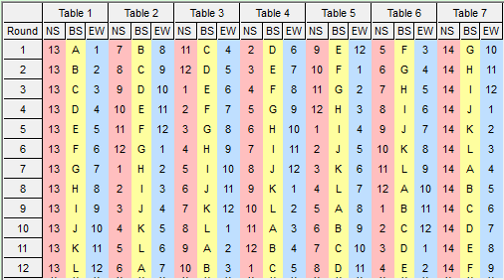

26 boards, Howell EBU p48, 14 stationary

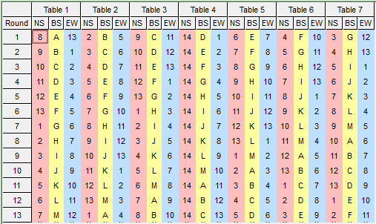

**8 tables:**

24 boards, Double weave Mitchell, NS stationary

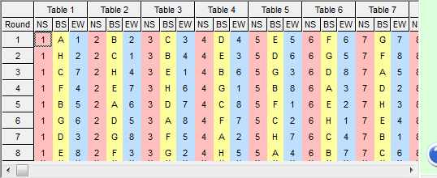

24 boards, Howell, 16 stationary

