LIDAR plot

Roger Downing

7 October 2015

# Investigation of sample LIDAR data

Sample data is provided as a 775 megabyte zip file, which contains:

1. Directory of generated wake field images
2. Video composed of wake field images in series
3. LIDAR hardware installation documentation
4. Text file of LIDAR operating temperatures and input values, recorded every 2.5 minutes
5. 24 directories, '00' to '23', each holding 95 '.scn' files

The 24 directories each represent one hour of the day of August 23rd, 2014. Each '.scn' file is a single LIDAR scan from that hour and lasting roughly 30 seconds.

## Filename:\tC:\Lidar\Data\2014\201408\20140823\00\2138233_23081400_25.scn\t  
## Campaign code:\taltenbruch2 nacelle t1 a2 dg 0406 1357\t\t\t\t\t\t  
## Campaign number:\t304\t\t\t\t\t\t  
## Rays in scan:\t21\t\t\t\t\t\t  
## Start time: \t00:01:03\t\t\t\t\t\t  
## Range gate\tDoppler\tIntensity\tRay time\tAz\tEl\tPitch\tRoll  
## 0\t38.618607\t0.919469\t00:01:03\t150\t0\t1.538\t-0.525  
## 1\t-39.102631\t0.967835\t00:01:03\t150\t0\t1.538\t-0.525  
## 2\t3.780688\t1.016727\t00:01:03\t150\t0\t1.538\t-0.525  
## 3\t2.595855\t1.020028\t00:01:03\t150\t0\t1.538\t-0.525

The file appears to be a tab-separated variable file with headers and 5 lines of preamble.

# Read in a file of LIDAR data as a CSV file with tab separators, skipping the first 5 lines and using column headers  
lidar <- read.csv( lidar.filename, skip=5, header=TRUE, sep="\t" )  
  
summary( lidar )

## Range.gate Doppler Intensity Ray.time   
## Min. : 0.00 Min. :-39.599 Min. :0.8876 00:01:03: 16   
## 1st Qu.: 3.75 1st Qu.: 3.685 1st Qu.:1.0359 00:01:05: 16   
## Median : 7.50 Median : 4.908 Median :1.0606 00:01:06: 16   
## Mean : 7.50 Mean : 6.885 Mean :1.0544 00:01:08: 16   
## 3rd Qu.:11.25 3rd Qu.: 6.767 3rd Qu.:1.0844 00:01:09: 16   
## Max. :15.00 Max. : 38.619 Max. :1.1209 00:01:10: 16   
## (Other) :240   
## Az El Pitch Roll   
## Min. :150 Min. :0 Min. :-0.7060 Min. :-3.9930   
## 1st Qu.:174 1st Qu.:0 1st Qu.: 0.0080 1st Qu.:-1.0350   
## Median :180 Median :0 Median : 0.4160 Median :-0.3210   
## Mean :180 Mean :0 Mean : 0.5083 Mean :-0.4327   
## 3rd Qu.:186 3rd Qu.:0 3rd Qu.: 1.2320 3rd Qu.: 0.6990   
## Max. :210 Max. :0 Max. : 1.6400 Max. : 3.4540   
##

The range of Doppler values appears unusual: 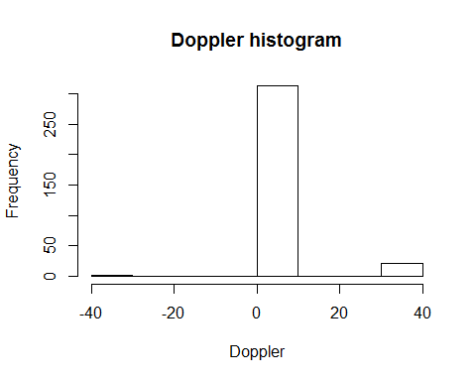

Looks like there are spurious outliers which should be ignored. The 'Range.gate' values do not appear to be actual ranges, but rather refer to a portion of a range. A web search determines that the range gate for a Galion 4000 LIDAR system is 30 metres. Looking at the included imagery of wake fields, it seems that although the range gates start at zero, the first measurement range is from 45 metres, so:

# Calculate actual ranges by multiplying the range gate by 30 (metres) and then adding 15 for the midpoint  
lidar$Range = ( lidar$Range.gate + 1 ) * 30 + 15

Provided azimuth is in degrees, but the R trig functions use radians:

# Convert azimuth angle to radians  
lidar$Az = lidar$Az * pi / 180  
  
# Change polar to cartesian coordinates  
lidar$x = lidar$Range * sin( lidar$Az )  
lidar$y = lidar$Range * cos( lidar$Az )  
  
# Plot our point distribution for sanity-checking  
plot( lidar$x, lidar$y )

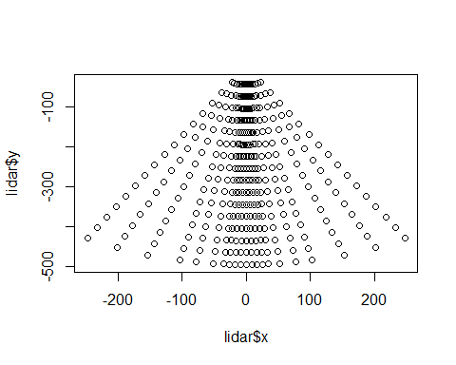

Now that we have the data plotting onto a grid, we can perform bilinear 2d interpolation of the values. Bilinear was chosen as a simple but effective way of interpolating on a plane, but it may not necessarily be the right choice. Someone more versed in fluid dynamics could advise.

## Loading required package: sp  
##   
## Attaching package: 'raster'  
##   
## The following objects are masked from 'package:descr':  
##   
## crosstab, freq

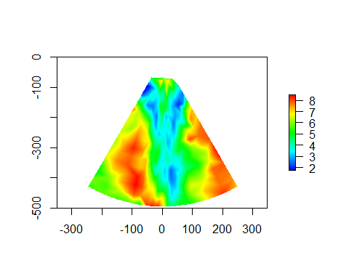

A side-by-side comparison of this image with the corresponding provided image shows great similarity but significant difference. An investigation into suitable interpolation is required to make sure that the chosen method is appropriate.

## Horizontal wind speed plotting

Measurement of the wake wind speed deficit is a useful parameter: 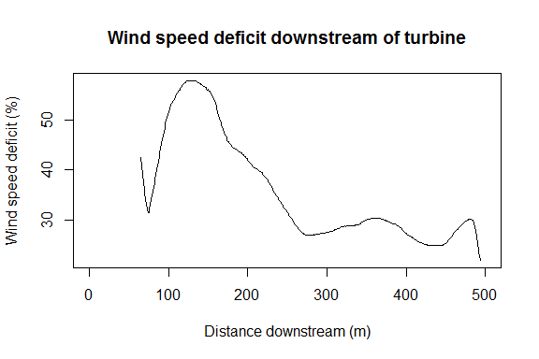

## Wake Identification

Can we determine the region of the image over which the wake stretches? We should find the centre-line, and then calculate the full width half-maximum as a way of estimating the lateral extent of the wake. Plot an example cross-section: 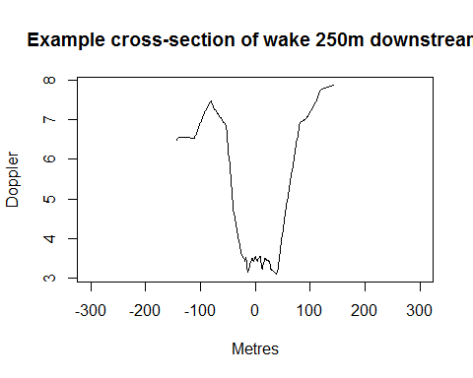

Smooth the data before we try to extract the minimum value: 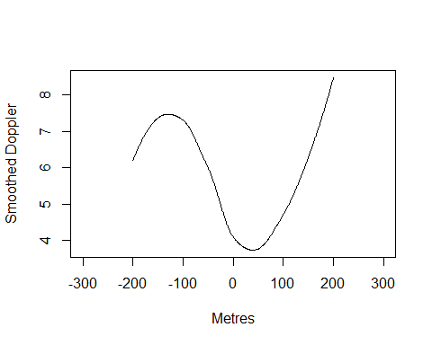

Now, redraw the image with the centre-line added: 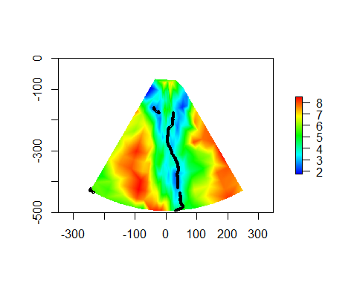

The tail end of the wake could be used as a coarse estimation of incident wind direction: 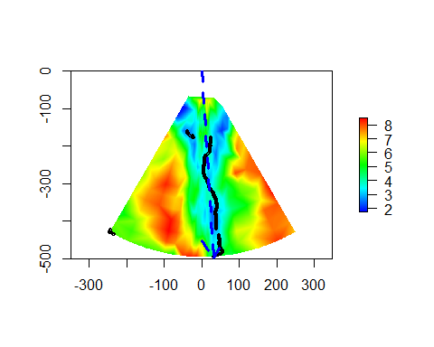

The angle of incidence can then be estimated at 3.66 degrees counter-clockwise to the turbine heading.