ROGER GONZALBO i GASPAR

Hilos – Parte 2

Contenido
Visibility Atomicity Demo: 2
ThreadPoolDemo: 2
CallableFutureDemo: 4
CompletableFutureDemo: 5
RaceCoordinationDemo: 6
DeadLockDemo 7
ForkJoinSumDemo: 8
ConcurrentListDemo: 9
VirtualThreadsDemo: 10

Visibility Atomicity Demo:
Explanation:
Code Overview: This program demonstrates the difference between a standard int counter and an Atomic Integer. Without synchronization, a standard counter suffers from race conditions (lost updates) because the increment operation is not atomic.
Test Configuration: To test the thread safety limits, I performed a heavy stress test. I modified the loop iterations from 100,000 to 100,000,000 per thread. This massive workload guarantees a high collision rate when accessing the shared variable.
Observation & Conclusion: As shown in the screenshot, the Atomic Integer handled the load perfectly, reaching exactly 200,000,000. In contrast, the standard int counter failed significantly reaching only ~177 million, confirming that over 20 million increments were lost due to race conditions.
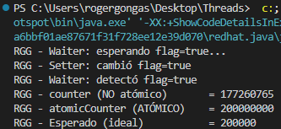
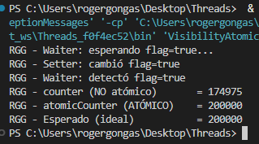
Original code: Modified code:

ThreadPoolDemo:
Code Overview: This exercise illustrates the use of Executor Service with a FixedThreadPool. Creating a new thread for every short-lived task is expensive for the operating system. A thread pool solves this by reusing a fixed set of worker threads to execute tasks from a queue. This improves performance and prevents resource exhaustion.
Test Configuration: I modified the code to initialize the pool with only 1 thread instead of 3 (newFixedThreadPool(1)). My goal was to see how the executor handles tasks when no parallel workers are available, forcing a sequential execution.
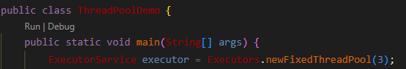
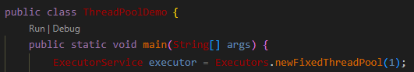
Observation & Conclusion: The output confirms that the tasks were executed sequentially, one after another, by the same thread (pool-1-thread-1). This proves that the Executor Service queues the submitted tasks and processes them based on the available pool size, effectively throttling the efficiency.
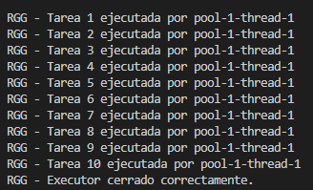
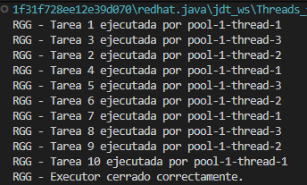

CallableFutureDemo:
Code Overview: This code introduces Callable<T> and Future<T>. While a Runnable cannot return a value, a Callable can return a result or throw a checked exception. When we submit a Callable to the executor, we immediately receive a Future object acting as a placeholder. We use future.get() to retrieve the result once the computation is complete.
Test Configuration: I customized the task output with my initials and increased the number of tasks submitted to the pool from 5 to 15. This allows us to see how the fixed thread pool handles a larger queue of tasks that return values.
Observation & Conclusion: The screenshot shows that the executor managed the 15 tasks using the limited pool threads. The main thread then successfully collected all 15 results using future.get(), blocking, when necessary, until each result was ready, to finally compute the maximum value.

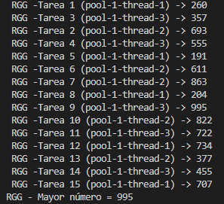
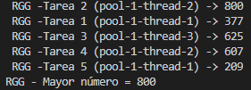
Código original: Código modificado:

CompletableFutureDemo:

Code Overview: This demo showcases asynchronous programming using CompletableFuture. We simulate a non-blocking data pipeline with three stages: downloading data, processing it, and displaying the result. Methods like supplyAsync and thenApply allow chaining these operations without blocking the main thread.
Test Configuration: I personalized the log messages with my initials and modified the simulated data source. In the descargarDatosAsync method, I changed the return string to "RGG_DATA: A, B, C". This tests if the pipeline correctly passes and transforms the modified data through all asynchronous stages.
Observation & Conclusion: The execution confirms that the data flowed correctly through the pipeline. My custom string was successfully downloaded, processed (converted to uppercase), and displayed by the final task, proving the chain works as expected.

Resultado original:
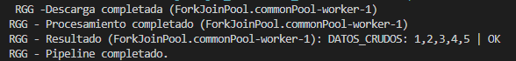

Resultado modificado:
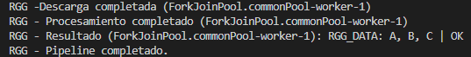

RaceCoordinationDemo:

Code Overview: This program simulates a race to demonstrate advanced thread coordination. It uses a CyclicBarrier to ensure all runner threads wait until everyone is ready before starting (simulating the starting gun). It then uses a CountDownLatch to make the main "Judge" thread wait until the counter reaches zero, indicating all runners have finished.
Test Configuration: I customized the output with my initials and increased the number of runners (int runners) from 5 to 8. This requires the CyclicBarrier to wait for 8 parties before tripping, and the CountDownLatch to receive 8 signals before releasing the Judge.
Observation & Conclusion: The output shows that "PISTOLAZO" (the barrier release) only appeared after all 8 runners printed their "Ready" message. Finally, the Judge only declared the race after the last runner finished, confirming both synchronization aids worked correctly with the larger group.
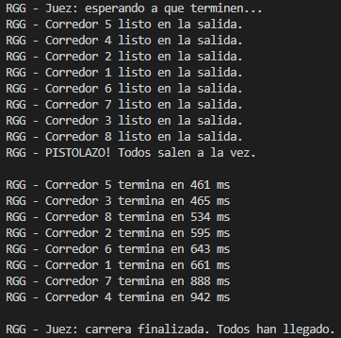
Resultado original: Resultado modificado:
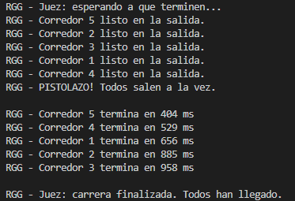

DeadLockDemo:
Code Overview: This code demonstrates a classic Deadlock scenario, where two threads wait indefinitely for each other to release a lock (Circular Wait). The exercise includes a fix based on "Global Lock Ordering". By ensuring all threads acquire locks in the same order (always Lock A, then Lock B), the cycle is broken.
Test Configuration: I commented out the deadlock-prone section (Part 1) to verify the fix in Part 2. I added my initials to the critical section logs and increased the sleep time to 500ms inside lockGlobalOrder. This tests if the threads can successfully acquire the locks sequentially without freezing.
Observation & Conclusion: Unlike the first version of the code which hangs indefinitely, this version completed successfully. Thread C1 acquired Lock A and B, finished, and only then could Thread C2 proceed. The global ordering strategy successfully prevented the deadlock, allowing the program to exit cleanly.
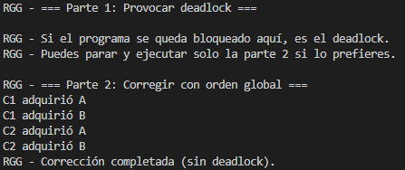
Código original:

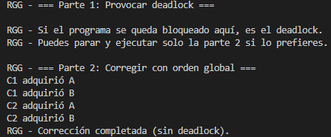
Código modificado:

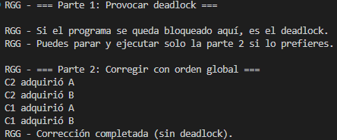
Codigo modificando el sleep también:

ForkJoinSumDemo:
Code Overview: This exercise uses the Java Fork/Join framework, designed for recursive "Divide and Conquer" algorithms. It uses a ForkJoinPool to distribute tasks across available processor cores. The problem (summing a large array) is recursively split into smaller sub-tasks until a specific size threshold is reached. Threads that finish early can "steal" work from others (work-stealing algorithm).
Test Configuration: To stress-test the framework, I significantly reduced the threshold variable from 200,000 to 1,000. This forces the algorithm to split the array into many more tiny fragments, creating a much larger number of RecursiveTask instances than usual. I also added my initials to the final output.
Observation & Conclusion: Even with the massive increase in task fragmentation, the screenshot confirms that the parallel sum result matched the sequential sum perfectly. This demonstrates the robustness of the framework in managing thousands of small tasks and combining their results correctly without data loss.

Código original:
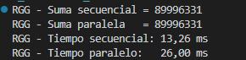
Código modificado:
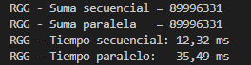

ConcurrentListDemo:

Code Overview: This code highlights the danger of using non-thread-safe collections like ArrayList in a multi-threaded environment. It compares it with CopyOnWriteArrayList. The latter achieves thread safety by creating a fresh copy of the underlying array every time a mutation (add/set) occurs, preventing corruption during iteration or concurrent access.
Test Configuration: I increased the contention by doubling the number of threads from 10 to 20. With 20 threads writing concurrently (Total expected size: 200,000), the standard ArrayList is almost guaranteed to fail due to race conditions.
Observation & Conclusion: The ArrayList failed to report the correct size (Expected: 200,000 vs Actual: 45,945), indicating severe data loss. In contrast, the CopyOnWriteArrayList reported exactly 200,000 elements, proving it handled the concurrent writes safely despite the high load.

Codigo original:
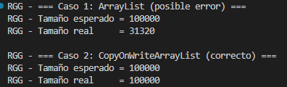
Codigo modificado:
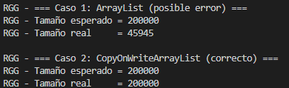

VirtualThreadsDemo:
Code Overview This demo compares traditional Platform Threads (which map 1:1 to OS threads) against the new Virtual Threads (managed by the JVM). Platform threads are heavy on memory and limited in number. Virtual threads are extremely lightweight, allowing us to spawn millions of them, which is ideal for high-throughput I/O applications.
Test Configuration I customized the output with my initials and significantly increased the workload from 10,000 to 100,000 concurrent tasks. This stress test compares how efficiently the traditional thread pool (limited to 200 threads) handles a massive queue versus the Virtual Thread executor, which creates a new lightweight thread for every single task.
Observation & Conclusion The output shows that the Virtual Threads executor handled the 100,000 tasks efficiently. While the Platform Threads eventually finished (using a pool to avoid crashing), the Virtual Threads demonstrated their capability to handle massive concurrency without the overhead associated with OS threads.

Código Original:
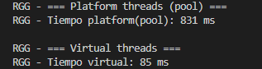

Código modificado:
