M3 Medium Range Radio (Version 10) Documentation

(MRRv10)

Revision 2.0

Zhiyoong Foo [1], SeokHyeon Jeong[2] and Li-Xuan Chuo[3]

Michigan Integrated Circuits Laboratory, University of Michigan, Ann Arbor

Last Updated: August 28, 2019

Contents

I. Revision History 3

A. MRRv7 3

B. MRRv8 3

C. MRRv9 3

D. MRRv10 3

II. Layer Description 4

III. MBUS Register File 7

A. Register File Mapping 7

B. Register Descriptions 9

IV. TRX Radio 21

A. Power Domains 21

B. Interrupt Considerations 21

C. Power Draw / Current Draw / Energy Consumption 21

D. Operation 21

E. Block Diagrams 23

V. On-chip Clock Generator 25

A. Power Domains 25

B. Power Draw / Current Draw / Energy Consumption 25

C. Operation 25

VI. LDO 28

A. Power Domains 28

B. Operation 28

C. Post-PEX Simulation Results 30

D. Measurement Results 44

VII. Appendix 45

A. Power Oscillator Frequency Range 45

B. On-Chip Clock Generator Frequency Range 47

# Revision History

## MRRv7

* Power oscillator's transistor size increased

Version A : 2µm to 8µm   
Version B : 2µm to 16 µm

## MRRv8

* Chip width increased for sideway step back
* Double size ANT pads
* MBUS change
* Has Version A only

## MRRv9

* ANTP and ANTN Pad (100µm -> 50µm) (M1~M6 -> M3~M6)
* Has Version A and C

Version C : 5µm transistor size in the power oscillator

## MRRv10

* Added Voltage Clamp to fix chirp/settling
* Fixed floating S/D in the Power Oscillator tuning cap
* Increased division ratio in the RF Counter
* Has Version A, B and C

# Layer Description

The Medium Range Radio (MRRv10) (Figure II‑i & Figure II‑ii) contains TRX Radio, on-chip clock gen, and Linear Regulator.

* Designed in TSMC180 tsmc18rf
* Tapedout on May 6th 2019
* Top-Level layout is located at:  
  /afs/eecs.umich.edu/vlsida/projects/ m3_hdk/virtuoso/TSMC180/MRRv10A/layout

/afs/eecs.umich.edu/vlsida/projects/ m3_hdk/virtuoso/TSMC180/MRRv10B/layout

/afs/eecs.umich.edu/vlsida/projects/ m3_hdk/virtuoso/TSMC180/MRRv10C/layout

* Top-Level LVS CDL is located at:  
  /afs/eecs.umich.edu/vlsida/projects/ m3_hdk/layer/MRR/MRRv10A/cdl/MRRv10A.cdl

/afs/eecs.umich.edu/vlsida/projects/ m3_hdk/layer/MRR/MRRv10B/cdl/MRRv10B.cdl

/afs/eecs.umich.edu/vlsida/projects/ m3_hdk/layer/MRR/MRRv10C/cdl/MRRv10C.cdl

* Top-Level Finesim CDL is located at:  
  /afs/eecs.umich.edu/vlsida/projects/ m3_hdk/layer/MRR/MRRv10A/ckt/MRRv10A.ckt

/afs/eecs.umich.edu/vlsida/projects/ m3_hdk/layer/MRR/MRRv10B/ckt/MRRv10B.ckt

/afs/eecs.umich.edu/vlsida/projects/ m3_hdk/layer/MRR/MRRv10C/ckt/MRRv10C.ckt

* MBUS Long Address is 20’h23004



Figure ‑ Medium Range Radio Layer (Version 10) (MRRv10) (1050um X 1630um)



Figure ‑ MRRv10 Wirebonding Diagram (MBUS only)

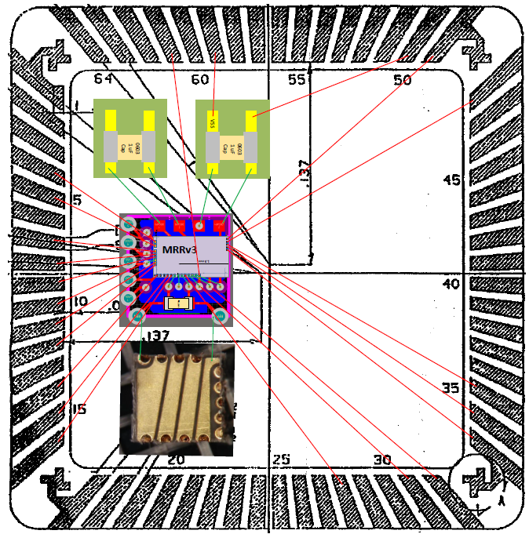

Figure II-iii MRR Wirebonding diagram w/ antenna example

# MBUS Register File

## Register File Mapping

Please see Table III‑1.

|  |  |  |  |  |
| --- | --- | --- | --- | --- |
| Address | Register Name | W/R | Size & Reset | Bit Field |
| 0x00 | MRR_TRX_DIV_RESETN | W/R | 1’h0 | [22] |
| MRR_TRX_DIV_EN | W/R | 1’h0 | [21] |
| MRR_TRX_CAP_ANTP_TUNE_COARSE | W/R | 10’h000 | [16:7] |
| MRR_CL_CTRL | W/R | 6’h08 | [6:1] |
| MRR_CL_EN | W/R | 1’h0 | [0] |
| 0x01 | MRR_TRX_CAP_ANTP_TUNE_FINE | W/R | 6’h00 | [21:16] |
| MRR_TRX_CAP_ANTN_TUNE_FINE | W/R | 6’h00 | [15:10] |
| MRR_TRX_CAP_ANTN_TUNE_COARSE | W/R | 10’h000 | [9:0] |
| 0x02 | MRR_TX_PULSE_FINE_TUNE | W/R | 4’h7 | [18:15] |
| MRR_TX_PULSE_FINE | W/R | 1’h0 | [14] |
| MRR_TX_EN_OW | W/R | 1’h0 | [13] |
| MRR_TX_BIAS_TUNE | W/R | 13’h1FFF | [12:0] |
| 0x03 | MRR_RX_AMP_OW_EN | W/R | 1’h0 | [21] |
| MRR_TRX_ISOLATEN | W/R | 1’h0 | [20] |
| MRR_CAP_P_OW | W/R | 1’h0 | [19] |
| MRR_CAP_S_OW | W/R | 1’h0 | [18] |
| MRR_RX_SAMPLE_CAP | W/R | 3’h0 | [17:15] |
| MRR_TRX_MODE_EN | W/R | 1’h0 | [14] |
| MRR_RX_EN_OW | W/R | 1’h0 | [13] |
| MRR_RX_BIAS_TUNE | W/R | 13’h0801 | [12:0] |
| 0x04 | LDO_ VREF_I_AMP | W/R | 4’h0 | [19:16] |
| LDO_ SEL_VOUT | W/R | 3’h4 | [15:13] |
| LDO_EN_VREF | W/R | 1’h0 | [12] |
| LDO_EN_IREF | W/R | 1’h0 | [11] |
| LDO_EN_LDO | W/R | 1’h0 | [10] |
| RO_EN_MONITOR | W/R | 1’h0 | [9] |
| RO_SEL_DIV | W/R | 2’h0 | [8:7] |
| RO_SEL_EXT_CLK | W/R | 1’h0 | [6] |
| RO_EN_CLK | W/R | 1’h0 | [5] |
| RO_ISOLATE_CLK | W/R | 1’h1 | [4] |
| RO_RESET | W/R | 1’h1 | [3] |
| RO_EN_RO_LDO | W/R | 1’h0 | [2] |
| RO_EN_RO_V1P2_PRE | W/R | 1’h0 | [1] |
| RO_EN_RO_V1P2 | W/R | 1’h0 | [0] |
| 0x05 | RO_R_REF | W/R | 4’h8 | [23:20] |
| RO_I_BUF | W/R | 4’h0 | [19:16] |
| RO_I_BUF2 | W/R | 4’h0 | [15:12] |
| RO_I_CMP | W/R | 4’h1 | [11:8] |
| RO_I_MIRROR | W/R | 2’h1 | [7:6] |
| RO_I_MIRROR2 | W/R | 2’h1 | [5:4] |
| RO_I_MIRRb | W/R | 4’hD | [3:0 |
| 0x06 | RO_PDIFF | W/R | 15’h1000 | [14:0] |
| 0x07 | RO_MIM | W/R | 7’h10 | [13:7] |
| RO_MOM | W/R | 7’h10 | [6:0] |
| 0x08 | RO_POLY | W/R | 24’h400000 | [23:0] |
| 0x09 | MRR_RAD_FSM_TX_DATA_0 | W/R | 24’h000000 | [23:0] |
| 0x0A | MRR_RAD_FSM_TX_DATA_1 | W/R | 24’h000000 | [23:0] |
| 0x0B | MRR_RAD_FSM_TX_DATA_2 | W/R | 24’h000000 | [23:0] |
| 0x0C | MRR_RAD_FSM_TX_DATA_3 | W/R | 24’h000000 | [23:0] |
| 0x0D | MRR_RAD_FSM_TX_DATA_4 | W/R | 24’h000000 | [23:0] |
| 0x0E | MRR_RAD_FSM_TX_DATA_5 | W/R | 24’h000000 | [23:0] |
| 0x0F | MRR_RAD_FSM_TX_DATA_6 | W/R | 24’h000000 | [23:0] |
| 0x10 | MRR_RAD_FSM_TX_DATA_7 | W/R | 24’h000000 | [23:0] |
| 0x11 | MRR_RAD_FSM_TX_D_LEN | W/R | 8’hC0 | [15:8] |
| MRR_RAD_FSM_TX_H_LEN | W/R | 5’h0 | [7:3] |
| MRR_RAD_FSM_EN | W/R | 1’h0 | [2] |
| MRR_RAD_FSM_RSTN | W/R | 1’h0 | [1] |
| MRR_RAD_FSM_SLEEP | W/R | 1’h0 | [0] |
| 0x12 | MRR_RAD_FSM_ TX_PR_LEN | W/R | 3’h0 | [22:20] |
| MRR_RAD_FSM_ TX_PS_LEN | W/R | 10’h031 | [19:10] |
| MRR_RAD_FSM_TX_LW_LEN | W/R | 10’h018 | [9:0 |
| 0x13 | MRR_RAD_FSM_TX_MODE | W/R | 3’h3 | [23:21] |
| MRR_RAD_FSM_SEED | W/R | 6’h01 | [20:15] |
| MRR_RAD_FSM_TX_C_LEN | W/R | 15’h064 | [14:0] |
| 0x14 | MRR_RAD_FSM_RX_SAMPLE_LEN | W/R | 3’h0 | [23:21] |
| MRR_RAD_FSM_RX_POWERON_LEN | W/R | 2’h0 | [20:19] |
| MRR_RAD_FSM_TX_POWERON_LEN | W/R | 3’h0 | [18:16] |
| MRR_RAD_FSM_GUARD_LEN | W/R | 14’h0 | [15:2] |
| MRR_RAD_FSM_TX_CNST_LEN | W/R | 2’h0 | [1:0] |
| 0x15 | MRR_RAD_FSM_TX_HDR_CNST | W/R | 4’h8 | [23:20] |
| MRR_EN_DIG_MONITOR | W/R | 1’h0 | [19] |
| MRR_RAD_FSM_RX_DATA_BITS | W/R | 7’h20 | [18:12] |
| MRR_RAD_FSM_RX_HDR_TH | W/R | 6’h08 | [11:6] |
| MRR_RAD_FSM_RX_HDR_BITS | W/R | 6’h08 | [5:0] |
| 0x16 | MRR_RAD_FSM_CONT_PULSE_MODEb | W/R | 1’h1 | [12] |
| MRR_DIG_MONITOR_SEL3 | W/R | 4’h0 | [11:8] |
| MRR_DIG_MONITOR_SEL2 | W/R | 4’h0 | [7:4] |
| MRR_DIG_MONITOR_SEL1 | W/R | 4’h0 | [3:0] |
| 0x17 | MRR_RAD_FSM_SYNC_SUC | R | 1’h0 | [11] |
| MRR_RAD_FSM_LFSR | R | 6’h00 | [10:5] |
| MRR_RAD_FSM_STATE | R | 5’h00 | [4:0] |
| 0x18 | MRR_RAD_FSM_RX_HDR_0 | R | 24’hX | [23:0] |
| 0x19 | MRR_RAD_FSM_RX_HDR_1 | R | 24’hX | [23:0] |
| 0x1A | MRR_RAD_FSM_RX_DATA_0 | R | 24’hX | [23:0] |
| 0x1B | MRR_RAD_FSM_RX_DATA_1 | R | 24’hX | [23:0] |
| 0x1C | MRR_RAD_FSM_RX_DATA_2 | R | 24’hX | [23:0] |
| 0x1D | MRR_RAD_FSM_RX_DATA_3 | R | 24’hX | [23:0] |
| 0x1E | MRR_RAD_FSM_IRQ_REPLY_PACKET | W/R | 24’h001002 | [23:0] |
| 0x1F | IRQ packet to PRC  WAKEUP_ON_PEND_REQ | W/R | 1’h0 | [5] |
| FIX ME  LC_CLK_LOAD | W/R | 1’h0 | [4] |
| LC_CLK_DIV | W/R | 2’h3 | [3:2] |
| LC_CLK_RING | W/R | 2’h3 | [1:0] |
| 0x20 | MRR_TRX_CNT_OUT | R | 24’hX | [23:0] |
| 0x21 | MRR_TRX_RC_IRQ_EN | W/R | 1’h0 | [14] |
| MRR_TRX_SEL_VCLAMP_SLP | W/R | 2’h0 | [13:12] |
| MRR_TRX_EN_SLP_VCLAMP | W/R | 1’h0 | [11] |
| MRR_TRX_ENb_CONT_RC | W/R | 1’h1 | [10] |
| MRR_TRX_SEL_VCLAMP | W/R | 6’h11 | [9:4] |
| MRR_TRX_RESETn_RC_CNT | W/R | 1’h0 | [3] |
| MRR_TRX_ISOLn_COMP | W/R | 1’h0 | [2] |
| MRR_TRX_ENb_COMP | W/R | 1’h1 | [1] |
| MRR_TRX_EN_DIV | W/R | 1’h0 | [0] |
| 0x22 | MRR_TRX_RC_CNT | R | 24’hX | [23:0] |
| 0x23 | MRR_TRX_RC_IRQ_REPLY_PACKET | W/R | 24’h001003 | [23:0] |

Table ‑ Register File Mapping

## Register Descriptions

##### MRR_TRX_DIV_RESETN

Resets CFO counter.

##### MRR_TRX_DIV_EN

Controls CFO clock gating which is fed into a divider.

##### MRR_TRX_CAP_ANTP_TUNE_COARSE

Controls CFO frequency by adjusting capacitance. Thermometer code with 100fF step size. Increasing this value will increase capacitance and thus decrease frequency. It has been designed to cover ~100MHz range. Note that ideally (assuming no mismatch) MRR_TRX_CAP_ANTN_TUNE_COARSE should have same value as MRR_TRX_CAP_ANTP_TUNE_COARSE to be symmetric. Also note that tuning range varies with center frequency. At lower center frequency, tuning range will be narrower while at high center frequency, tuning range will be wider. Following table shows simulated (after PEX) CFO for each code. See Table VII‑1/Table VII‑2 for expected CFO frequency with different configurations.

|  |  |
| --- | --- |
| MRR_TRX_CAP_ANTP_TUNE_COARSE | Capacitance (fF) |
| 10’h000 | 0 |
| 10’h001 | 100 |
| 10’h003 | 200 |
| 10‘h007 | 300 |
| 10’h00F | 400 |
| 10’h01F | 500 |
| 10’h03F | 600 |
| 10’h07F | 700 |
| 10’h0FF | 800 |
| 10’h1FF | 900 |
| 10’h3FF | 1000 |

Table III‑2 Code vs Capacitance Values

##### MRR_CL_CTRL

Controls current limiter strength. Refer to following table for details. Detailed circuit is shown in “Figure IV-vi MRR Current Limiter.”

|  |  |  |  |
| --- | --- | --- | --- |
| MRR_CL_CTRL | Switch (Ω) | Resistor(Ω) | Total(Ω) |
| 0 | 26.5 | 0.0 | 26.5 |
| 1 | 26.5 | 112.1 | 138.7 |
| 2 | 133.0 | 1.09k | 1.22k |
| 3 | 672.6 | 10.85k | 11.52k |
| 4 | 3.7k | 106.7k | 110.4k |
| 5 | 35.6k | 1.14M | 1.18M |

Table III‑3 Current limiter strength vs code (simulated)

##### MRR_CL_EN

Enables current limiter (i.e. supplies current). Note that with addition of voltage limiter (in v10), current limiter can be controlled by the voltage limiter. Please refer to following table for right configuration.

|  |  |  |  |
| --- | --- | --- | --- |
| MRR_CL_EN | MRR_TRX_ISOLn_COMP | MRR_TRX_ENb_CONT_RC | Current Limiter Configuration |
| 1’h0 | 1’hx | 1’hx | Always OFF |
| 1’h1 | 1’h0 | 1’hx | Always ON |
| 1’h1 | 1’h1 | 1’h0 | Controlled by Voltage clamp  Can be ON during TX |
| 1’h1 | 1’h1 | 1’h1 | Controlled by Voltage clamp  OFF during TX |

Table III‑4 Current limiter configurations

##### MRR_TRX_CAP_ANTP_TUNE_FINE

Controls CFO frequency by adjusting capacitance. Binary code with 5fF step size. Increasing this value will increase capacitance and thus decrease frequency. It has been designed to cover ~20MHz range. Note that ideally (assuming no mismatch) MRR_TRX_CAP_ANTP_TUNE_FINE should have same value as MRR_TRX_CAP_ANTN_TUNE_FINE to be symmetric. Also note that tuning range varies with center frequency. At lower center frequency, tuning range will be narrower while at high center frequency, tuning range will be wider. See Table VII‑1/Table VII‑2 for expected CFO frequency with different configurations.

##### MRR_TRX_CAP_ANTN_TUNE_FINE

Controls CFO frequency by adjusting capacitance. Binary code with 5fF step size. Refer to MRR_TRX_CAP_ANTP_TUNE_FINE for details. See Table VII‑1/Table VII‑2 for expected CFO frequency with different configurations.

##### MRR_TRX_CAP_ANTN_TUNE_COARSE

Controls CFO frequency by adjusting capacitance. Thermometer code with 100fF step size. Refer to MRR_TRX_CAP_ANTP_TUNE_COARSE for details. See Table VII‑1/Table VII‑2 for expected CFO frequency with different configurations.

##### MRR_TX_PULSE_FINE_TUNE (Reserved for other use)

Controls pulse width in TX mode. Effective only when MRR_TX_PULSE_FINE = 1’h1.

##### MRR_TX_PULSE_FINE (Reserved for other use)

Selects pulse control method in TX mode.

* 1’h0 : Pulse width set by FSM. Minimum pulse width is limited by FSM clock speed. Pulse width can be controlled at the integer multiple of the min value. <- need to check
* 1’h1: Pulse width set by internal pulse generator. Allows fine control using MRR_TX_PULSE_FINE_TUNE.

##### MRR_TX_EN_OW

Overwrite signal for TX mode. Always transmitting when enabled (i.e. Power oscillator runs continuously).

##### MRR_TX_BIAS_TUNE

Controls bias current of the Power Oscillator in TX mode. Thermometer code. Increasing this value will increase current consumption. See following table for the current consumption.

|  |  |  |
| --- | --- | --- |
| MRR_TX_BIAS_TUNE | Current Consumption (µA) | |
| **Minimum cap**  MRR_TRX_CAP_ANTP_TUNE_COARSE = 10’h0  MRR_TRX_CAP_ANTN_TUNE_COARSE=10’h0  MRR_TRX_CAP_ANTP_TUNE_FINE=6’h0  MRR_TRX_CAP_ANTN_TUNE_FINE =6’h0 | **Maximum Cap**  MRR_TRX_CAP_ANTP_TUNE_COARSE = 10’h3FF  MRR_TRX_CAP_ANTN_TUNE_COARSE=10’h3FF  MRR_TRX_CAP_ANTP_TUNE_FINE=6’h3F  MRR_TRX_CAP_ANTN_TUNE_FINE =6’h3F |
| 13’h0001 | 41.6 | 41.5 |
| 13’h0003 | 75.7 | 75.5 |
| 13’h0007 | 109.7 | 109.8 |
| 13’h000F | 143.2 | 143.3 |
| 13’h001F | 274.2 | 275.6 |
| 13’h003F | 398.6 | 402.0 |
| 13’h007F | 485.0 | 507.3 |
| 13’h00FF | 535.0 | 570.5 |
| 13’h01FF | 572.6 | 613.7 |
| 13’h03FF | 604.0 | 648.0 |
| 13’h07FF | 631.9 | 677.3 |
| 13’h0FFF | 656.2 | 703.4 |
| 13’h1FFF | 678.5 | 726.2 |

Table III‑5 Code vs Current Consumption in the Power Oscillator (after PEX)

##### MRR_RX_AMP_OW_EN (Reserved for debug)

Enables voltage overwriting for controlling RX amplifier current. Overwrite voltage can be provided by from pads (either RX_AMP_PW or RX_AMP_PMOS, i.e. two pads on the bottom right).

##### MRR_TRX_ISOLATEN

Isolate signal.

##### MRR_CAP_P_OW

Overwrite signal for decap configuration. Enabling this signal (=1’h1) will always put external decaps in parallel. See “Figure IV-i TRX Radio front-end of MRR” for configuration details.

##### MRR_CAP_S_OW

Overwrite signal for decap configuration. Enabling this signal (=1’h1) will always put external decaps in series. See “Figure IV-i TRX Radio front-end of MRR” for configuration details.

##### MRR_RX_SAMPLE_CAP

Controls sampling capacitance in RX mode. Thermometer code. Increasing this value will increase sampling capacitance which will help to reduce noise. See following table for capacitance values.

|  |  |
| --- | --- |
| MRR_RX_SAMPLE_CAP | Sampling Capacitance (pF) |
| 3’h0 | 0.5 |
| 3’h1 | 1 (Default) |
| 3’h3 | 1.5 |
| 3’h7 | 2 |

Table III‑6 Code vs Sampling Capacitance (pF)

##### MRR_TRX_MODE_EN

Enables RX. See “Figure IV-i TRX Radio front-end of MRR” for configuration details.

##### MRR_RX_EN_OW (Reserved for debug)

Overwrite signal for RX mode. Always receiving when enabled (i.e. Power oscillator runs continuously). Effective only when MRR_TRX_MODE_EN = 1’h1.

##### MRR_RX_BIAS_TUNE

Controls bias current of the Power Oscillator in RX mode. Thermometer code. Increasing this value will increase bias current.

##### LDO_ VREF_I_AMP

Controls bias current of body buffers used in the voltage reference.

##### LDO_ SEL_VOUT

Controls output voltage level of the LDO.

##### LDO_EN_VREF

Enables voltage reference.

##### LDO_EN_IREF

Enables current reference.

##### LDO_EN_LDO

Controls power gate of the LDO (from VBAT).

##### RO_EN_MONITOR

Enables monitoring of output frequency of on-chip clock gen through pad (CLK MON, second pad in the top left corner)

##### RO_SEL_DIV

Selects division ratio of the on-chip clock gen. See below table for details. Also, refer to Table VII‑3 for details on clock frequency values.

|  |  |  |
| --- | --- | --- |
| RO_SEL_DIV | Division ratio | Clock frequency (kHz) |
| 0 | 1 | 240 |
| 1 | 2 | 120 |
| 2 | 4 | 60 |
| 3 | 8 | 30 |

Table III‑7 Code vs Division ratio based on simulation results (TT after PEX)

##### RO_SEL_EXT_CLK

Selects clock source for the RADIO FSM.

* 1’h0 : on-chip clock gen
* 1’h1 : External clock (EXT CLK, first pad in the top left corner)

##### RO_EN_CLK

Enables Radio FSM clock.

##### RO_ISOLATE_CLK

Isolates clock output.

##### RO_RESET

Resets on-chip clock.

##### RO_EN_RO_LDO

Resets on-chip clock.

##### RO_EN_RO_V1P2_PRE

Resets on-chip clock.

##### RO_EN_RO_V1P2

Resets on-chip clock.

##### RO_R_REF

Controls resistance of the current source.

##### RO_I_BUF

Adjust the buffer bias current (Current REF).

##### RO_I_BUF2

Adjusts the buffer bias current (Composite resistor).

##### RO_I_CMP

Adjusts the comparator bias current. Increasing bit increases comparator speed and thus improves temperature coefficient (TC) of the reference clock (CLKREF) at the cost of higher power consumption. TC improves until comparator delay becomes negligible to the overall period.

##### RO_I_MIRROR

Adjusts main current.

##### RO_I_MIRROR2

Adjusts current level of the bias voltage generator used in the wide-swing current mirror.

##### RO_I_MIRRb

Adjusts bias voltages in the main current mirror.

##### RO_PDIFF

Adjusts P+ diffusion resistor size. Increasing the value (decreasing the resistance) will make period more CTAT.

##### RO_MIM

Adjusts MIM cap size. Increasing the value decreases clock frequency. See Table VII‑3 for details.

##### RO_MOM

Adjusts MOM cap size. Increasing the value decreases clock frequency. See Table VII‑3 for details.

##### RO_POLY

Adjust P+ poly resistor size. Increasing the value (decreasing the resistance) will make period more PTAT.

##### MRR_RAD_FSM_TX_DATA_0

TX Data buffer (Bits: 0-23)

##### MRR_RAD_FSM_TX_DATA_1

TX Data buffer (Bits: 24-47)

##### MRR_RAD_FSM_TX_DATA_2

TX Data buffer (Bits: 48-71)

##### MRR_RAD_FSM_TX_DATA_3

TX Data buffer (Bits: 72-95)

##### MRR_RAD_FSM_TX_DATA_4

TX Data buffer (Bits: 96-119)

##### MRR_RAD_FSM_TX_DATA_5

TX Data buffer (Bits: 120-143)

##### MRR_RAD_FSM_TX_DATA_6

TX Data buffer (Bits: 144-167)

##### MRR_RAD_FSM_TX_DATA_7

TX Data buffer (Bits: 168-191)

##### MRR_RAD_FSM_TX_D_LEN

Set the number of transmitted bits

##### MRR_RAD_FSM_TX_H_LEN (Reserved)

Set the number of transmitted header bits (not used typically)

##### MRR_RAD_FSM_EN

Start the radio FSM

##### MRR_RAD_FSM_RSTN

Reset the radio FSM

##### MRR_RAD_FSM_SLEEP

Power gated the FSM

##### MRR_RAD_FSM_ TX_PR_LEN

Set pulse repetition rate. See “Figure IV-iii MRR TX Pulse Configuration” for detailed explanation.

##### MRR_RAD_FSM_ TX_PS_LEN

Set pulse spacing (ex: conventional 2PPM 🡪 PS_LEN=PW_LEN). See “Figure IV-iii MRR TX Pulse Configuration” for detailed explanation.

##### MRR_RAD_FSM_TX_PW_LEN

Set pulse width. See “Figure IV-iii MRR TX Pulse Configuration” for detailed explanation.

##### MRR_RAD_FSM_TX_MODE (Reserved for other use, use code rate = 1 for default setting)

TX convolutional coding -- code rate **0**:4 **1**:3 **2**:2 **3**:1(baseline) **4**:1/2 **5**:1/3 **6**:1/4

When code rate (M) is greater than 1, TX will use 2M PPM modulation for enhanced data rate

##### MRR_RAD_FSM_SEED (Reserved)

Set seed for TX header LFSR (not used typically)

##### MRR_RAD_FSM_TX_C_LEN

Decap recharging time respect to PW_LEN (ex: C_LEN=32 if (PW_LEN+1):C_LEN=1:32). See “Figure IV-iii MRR TX Pulse Configuration” for detailed explanation.

##### MRR_RAD_FSM_RX_SAMPLE_LEN

Set RX sample cap time (integration time, i.e. RX data rate). See “Figure IV-iv MRR RX Timing” and “Figure IV-v MRR RX Sampling Circuits Details.”

##### MRR_RAD_FSM_RX_POWERON_LEN

Set RX power on time. See “Figure IV-ii MRR Packet Timing Register Controls” for detailed explanation.

##### MRR_RAD_FSM_TX_POWERON_LEN

Set TX power on time. See “Figure IV-ii MRR Packet Timing Register Controls” for detailed explanation.

##### MRR_RAD_FSM_GUARD_LEN

Set TX power on time. See “Figure IV-ii MRR Packet Timing Register Controls” for detailed explanation.

##### MRR_RAD_FSM_TX_CNST_LEN (Reserved)

TX convolutional code constraint length (https://en.wikipedia.org/wiki/Convolutional_code)

##### MRR_RAD_FSM_TX_HDR_CNST (Reserved)

TX LFSR shift due to different pulse width setting (not used typically)

##### MRR_EN_DIG_MONITOR (Reserved for debug)

Enable digital monitor pad output

##### MRR_RAD_FSM_RX_DATA_BITS

Set the number of RX bits

##### MRR_RAD_FSM_RX_HDR_TH (Reserved, default should be 0)

RX PN-code check threshold, 0 🡪 don’t check

##### MRR_RAD_FSM_RX_HDR_BITS (Reserved for debug)

Set the number of RX header bits

##### MRR_RAD_FSM_CONT_PULSE_MODEb

FIX ME

##### MRR_DIG_MONITOR_SEL3 (Reserved for debug)

Selection of different FSM control signal monitoring

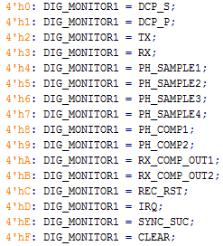

##### MRR_DIG_MONITOR_SEL2 (Reserved for debug)

Selection of different FSM control signal monitoring

##### MRR_DIG_MONITOR_SEL1 (Reserved for debug)

Selection of different FSM control signal monitoring

##### MRR_RAD_FSM_SYNC_SUC (Reserved for debug)

Indicator of FSM RX sync success (Read-only)

##### MRR_RAD_FSM_LFSR (Reserved for debug)

FSM LFSR value (Read-only)

##### MRR_RAD_FSM_STATE (Reserved for debug)

FSM state (Read-only)

##### MRR_RAD_FSM_RX_HDR_0 (Reserved for debug)

RX header bits

##### MRR_RAD_FSM_RX_HDR_1 (Reserved for debug)

RX header bits

##### MRR_RAD_FSM_RX_DATA_0

RX data

##### MRR_RAD_FSM_RX_DATA_1

RX data

##### MRR_RAD_FSM_RX_DATA_2

RX data

##### MRR_RAD_FSM_RX_DATA_3

RX data

##### MRR_RAD_FSM_IRQ_REPLY_PACKET

Set the correct MBus IRQ packet configuration to PRC

##### WAKEUP_ON_PEND_REQ

FIX ME

##### LC_CLK_LOAD

FIX ME

##### LC_CLK_DIV

Layer Controller’s Clock Divider. See Table III‑8. Used in conjunction with LC_CLK_RING.

|  |  |
| --- | --- |
| Value | Clock Division |
| 2’h0 | 8 |
| 2’h1 | 4 |
| 2’h2 | 2 |
| 2’h3 | 0 |

Table ‑ LC_CLK_DIV Register

##### LC_CLK_RING

Layer Controller’s Ring Oscillator’s Speed. See Table III‑9 & Table III‑10 for post-pex simulation results. Use in conjunction with LC_CLK_DIV.

|  |
| --- |
| 27°C  LC_CLK_DIV: 2’h3 |
| V0P6 (V) | 0.45 | 0.50 | 0.55 | 0.60 | 0.65 | 0.70 |
| V1P2 (V) | 0.90 | 1.00 | 1.10 | 1.20 | 0.30 | 1.40 |
| LC_CLK_RING: 2’h3 |
| Frequency (KHz) | 38.6 | 64.7 | 95.4 | 129 | 166 | 204 |
| V0P6 Power (nW) | 7.64 | 17.2 | 33.3 | 58.0 | 93.2 | 141 |
| V1P2 Power (nW) | 3.78 | 6.62 | 12.0 | 19.6 | 29.7 | 43.0 |
| V0P6 Leakage (pW) | 94.0 | 107 | 121 | 135 | 150 | 166 |
| V1P2 Leakage (pW) | ≈0 | ≈0 | ≈0 | ≈0 | ≈0 | ≈0 |
| LC_CLK_RING: 2’h2 |
| Frequency (KHz) | 31.8 | 53.3 | 78.6 | 107 | 137 | 169 |
| V0P6 Power (nW) | 6.30 | 14.2 | 27.5 | 47.8 | 76.8 | 116 |
| V1P2 Power (nW) | 2.60 | 5.60 | 9.90 | 16.0 | 24.4 | 35.5 |
| V0P6 Leakage (pW) | 96.8 | 110 | 125 | 140 | 154 | 171 |
| V1P2 Leakage (pW) | ≈0 | ≈0 | ≈0 | ≈0 | ≈0 | ≈0 |
| LC_CLK_RING: 2’h1 |
| Frequency (KHz) | 27.1 | 45.4 | 67.0 | 90.8 | 116 | 144 |
| V0P6 Power (nW) | 5.4 | 12.1 | 23.5 | 40.8 | 65.6 | 99.2 |
| V1P2 Power (nW) | 2.4 | 4.7 | 8.6 | 13.6 | 20.9 | 30.3 |
| V0P6 Leakage (pW) | 96.8 | 110 | 125 | 140 | 155 | 171 |
| V1P2 Leakage (pW) | ≈0 | ≈0 | ≈0 | ≈0 | ≈0 | ≈0 |
| LC_CLK_RING: 2’h0 |
| Frequency (KHz) | 24.1 | 40.4 | 59.7 | 80.9 | 104 | 128 |
| V0P6 Power (nW) | 4.9 | 10.8 | 20.9 | 36.3 | 58.4 | 88.4 |
| V1P2 Power (nW) | 2.0 | 4.2 | 7.5 | 12.1 | 18.7 | 27.0 |
| V0P6 Leakage (pW) | 99.4 | 114 | 129 | 144 | 159 | 177 |
| V1P2 Leakage (pW) | ≈0 | ≈0 | ≈0 | ≈0 | ≈0 | ≈0 |

Table ‑ LC_CLK_RING Register Post-Pex Results (27°C) (TT)[4]

|  |
| --- |
| 40°C  LC_CLK_DIV: 2’h3 |
| V0P6 (V) | 0.45 | 0.50 | 0.55 | 0.60 | 0.65 | 0.70 |
| V1P2 (V) | 0.90 | 1.00 | 1.10 | 1.20 | 0.30 | 1.40 |
| LC_CLK_RING: 2’h3 |
| Frequency (KHz) | 43.4 | 70.0 | 100 | 134 | 170 | 207 |
| V0P6 Power (nW) | 8.9 | 19.2 | 36.2 | 61.6 | 97.5 | 145 |
| V1P2 Power (nW) | 3.7 | 7.3 | 12.7 | 20.4 | 30.7 | 43.9 |
| V0P6 Leakage (pW) | 189 | 216 | 244 | 273 | 303 | 335 |
| V1P2 Leakage (pW) | ≈0 | ≈0 | ≈0 | ≈0 | ≈0 | ≈0 |
| LC_CLK_RING: 2’h2 |
| Frequency (KHz) | 35.7 | 57.6 | 83.0 | 111 | 140 | 171 |
| V0P6 Power (nW) | 7.4 | 15.9 | 29.9 | 50.9 | 80.4 | 120 |
| V1P2 Power (nW) | 3.0 | 6.0 | 10.6 | 16.8 | 25.3 | 36.2 |
| V0P6 Leakage (pW) | 196 | 223 | 252 | 282 | 313 | 346 |
| V1P2 Leakage (pW) | ≈0 | ≈0 | ≈0 | ≈0 | ≈0 | ≈0 |
| LC_CLK_RING: 2’h1 |
| Frequency (KHz) | 30.4 | 49.1 | 70.8 | 94.3 | 119 | 145 |
| V0P6 Power (nW) | 6.4 | 13.6 | 25.5 | 44.5 | 68.7 | 103 |
| V1P2 Power (nW) | 2.5 | 5.2 | 8.9 | 14.4 | 21.7 | 31.1 |
| V0P6 Leakage (pW) | 195 | 220 | 252 | 282 | 313 | 346 |
| V1P2 Leakage (pW) | ≈0 | ≈0 | ≈0 | ≈0 | ≈0 | ≈0 |
| LC_CLK_RING: 2’h0 |
| Frequency (KHz) | 27.1 | 43.7 | 63.0 | 83.9 | 106 | 129 |
| V0P6 Power (nW) | 5.7 | 12.1 | 22.8 | 38.7 | 61.2 | 91.3 |
| V1P2 Power (nW) | 2.4 | 4.6 | 8.1 | 12.8 | 19.3 | 27.7 |
| V0P6 Leakage (pW) | 202 | 230 | 260 | 291 | 323 | 357 |
| V1P2 Leakage (pW) | ≈0 | ≈0 | ≈0 | ≈0 | ≈0 | ≈0 |

Table ‑ LC_CLK_RING Register Post-Pex Results (40°C) (TT)[5]

##### MRR_TRX_CNT_OUT

Count for CFO. Counter gets CFO/128 as an input.

##### MRR_TRX_RC_IRQ_EN

Enables RC_IRQ. This is a mask signal for RC_IRQ

##### MRR_TRX_SEL_VCLAMP_SLP

Adjusts clamped voltage of a sleep mode voltage clamp. See Figure III‑i for voltage levels.



Figure ‑ Clamped voltage vs temperature w.r.t different VBAT and MRR_TRX_SEL_VCLAMP. Simulated at TT corner with 15nA decap leakage.

##### MRR_TRX_EN_SLP_VCLAMP

Enables sleep mode voltage clamp

##### MRR_TRX_ENb_CONT_RC

Enables or disables voltage clamp during TX. See Table III‑4 for detailed configurations.

##### MRR_TRX_SEL_VCLAMP

Adjusts clamped voltage level. Clamped voltage level can be calculated as follows.

Clamped Voltage (V) = VREF/0.69 × (MRR_TRX_SEL_VCLAMP × 0.05 + 2.7)

VREF level can be found in Table III‑11.

|  |  |  |  |  |  |
| --- | --- | --- | --- | --- | --- |
|  | TT | FF | SS | SF | FS |
| VREF (V) | 0.690 | 0.768 | 0.614 | 0.563 | 0.820 |

Table ‑ Simulated VREF values across corners.

If this value is set too high, VRAD won’t be able to recharge within time, i.e. does not reach plateau. If this value is too low, TX distance will degrade due to low VRAD. Proper value can be found by monitoring MRR_TRX_RC_CNT.

##### MRR_TRX_RESETn_RC_CNT

Reset signal for recharge counter. See Table III‑4 for detailed configurations.

##### MRR_TRX_ISOLn_COMP

Isolates voltage clamp output.

##### MRR_TRX_ENb_COMP

Power gate signal for a comparator used in the voltage clamp.

##### MRR_TRX_EN_DIV

Power gate signal for divider used in the voltage clamp

##### MRR_TRX_RC_CNT

Represents number of successful recharge event. Count per pulse is binary, i.e. either 0 (VRAD did not reach target voltage) or 1 (VRAD reached target voltage and clamped). When MRR_TRX_SEL_VCLAMP is set too high, count value will be 0 while when it is set too low, count will be same as number of pulses in the packet. Therefore, ideal MRR_TRX_SEL_VCLAMP can be found by decreasing its value from maximum while monitoring the count. As MRR_TRX_SEL_VCLAMP decrease, MRR_TRX_RC_CNT will start to increase and then saturate. MRR_TRX_SEL_VCLAMP value at that knee corresponds to an ideal value.

##### MRR_TRX_RC_IRQ_REPLY_PACKET

FIX ME

# TRX Radio

This is a TRX Radio designed by Li-Xuan Chuo. Figure IV‑i shows the block diagram of the TRX front-end of MRR. The transmitter and receiver are co-designed with the loop antenna. The carrier frequency is set by the antenna impedance and off-chip/on-chip capacitor.

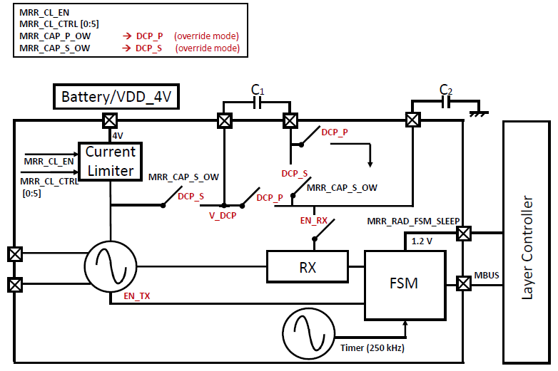

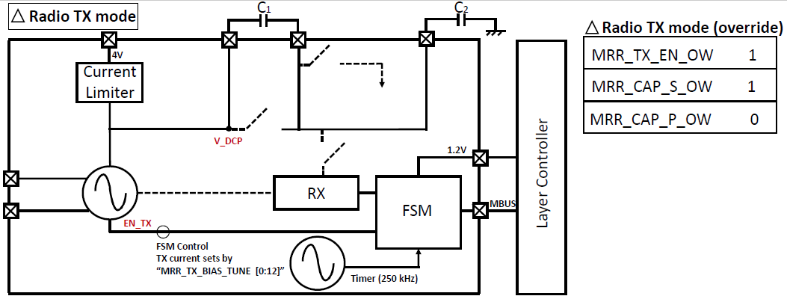

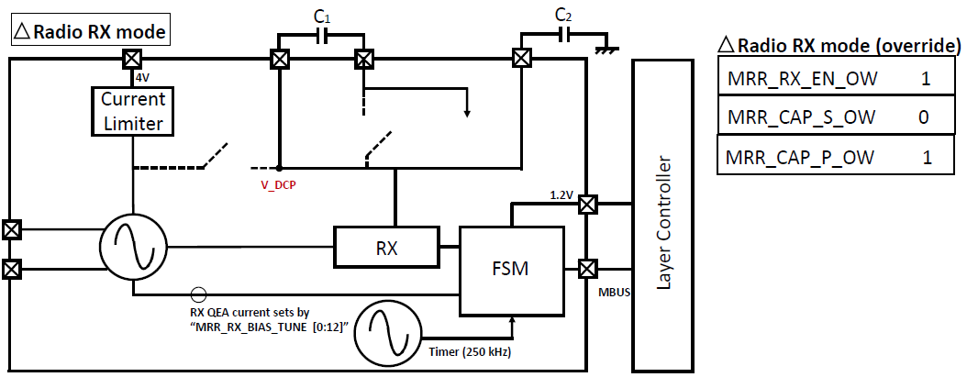

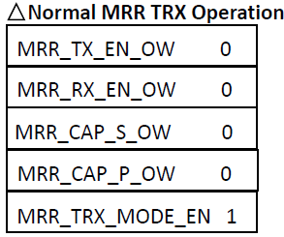

Figure IV‑i TRX Radio front-end of MRR

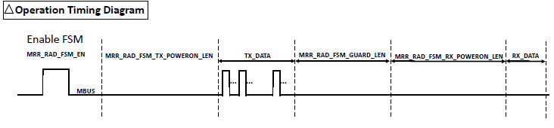

Figure IV-ii MRR Packet Timing Register Controls

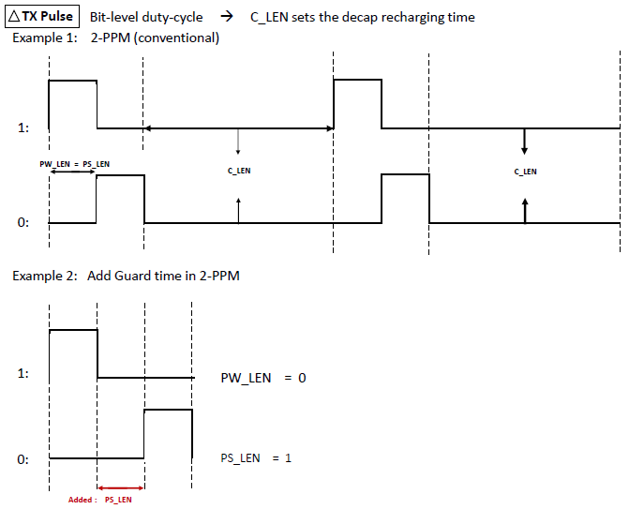

Figure IV-iii MRR TX Pulse Configuration

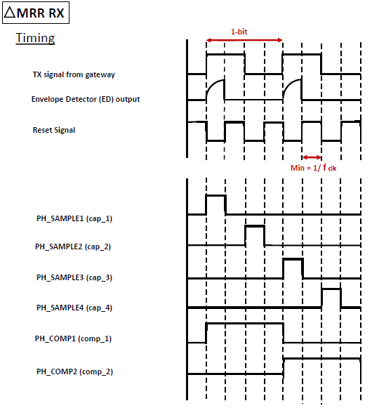

Figure IV-iv MRR RX Timing

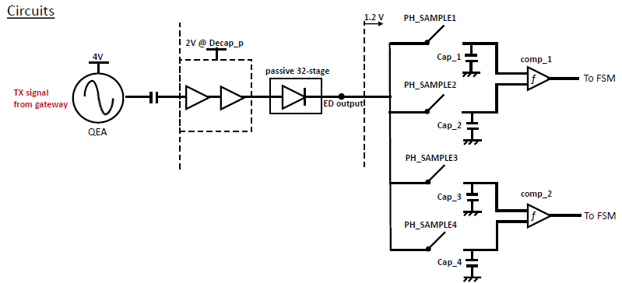

Figure IV-v MRR RX Sampling Circuits Details

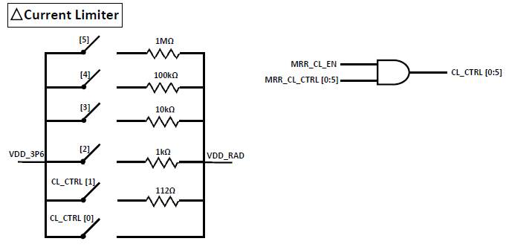

Figure IV-vi MRR Current Limiter

## Power Domains

The radio portion mainly works out of off-chip decaps. Those decaps need to be recharged periodically by a 4V-battery (through current limiter) or by PMU VDD_3P6. The radio is at 4V in TX mode and at 2V in RX mode. The radio block has a switching structure to generate 2V from decaps. It is always TX first then RX. The FSM portion works at 1.2V which is generated by PMU.

## Interrupt Considerations

TRX radio will send out an interrupt signal when it finishes the received operation, followed by the demodulated signal.

## Power Draw / Current Draw / Energy Consumption

|  |  |  |
| --- | --- | --- |
| Mode | V3P6  (3.6V) | V1P2  (1.2V) |
| Active |  |  |
| Standby |  |  |

Table ‑ TEMP_SENSOR Current Draw

## Operation

* **Initial TRX radio settings**
* Need to first setup the register correctly (TRX data bits, data rate, decap recharge time, etc.)
* Need to enable the current limiter
* Normal operation is to set the current limiter in a tiny current mode and trickle charge decaps (in series, by setting MRR_CAP_S_OW = 1) in the beginning. Before starting the FSM, the MRR_CAP_S_OW register should be set to 0.
* Decaps need to be periodically configured in parallel to equalize the floating node voltage.

(MRR_CAP_P_OW = 1, MRR_CAP_S_OW = 0)

* **Q-Enhanced Amplifier (QEA) setting for the receiver**
* TRX RX uses a QEA as the front-end first stage RF amplifier, the bias current setting should base on the LC tank (antenna/cap) Q value. This is a one-time calibration value for the same system. Use MRR_RX_BIAS_TUNE register to sweep the current from VBAT and monitor the envelope detector output to make sure the power oscillator does not oscillate (no DC shift at ED output). Usually the bias current value is 10’s of µA for a Q of 150-200 antenna.
* **FSM Start sequence**

Before starting the FSM, make sure the on-chip timer already has a stable frequency. FSM will send out **ALL** the data in the TX_DATA register specified by # of data to send in the configuration register.

* Power on the FSM
* Unreset the FSM
* Set ISOLATEN to high to give state machine control
* Enable the FSM

Following is the TX sequence in C code:

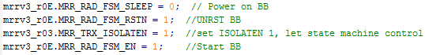

* **MRR TRX radio always does TX 🡪 RX (default operation)**
* Can be modified to TX only in setting MRR_TRX_MODE_EN register
* **The RX power domain is 2V, which is coming from the internal DC-DC converter (DCP_S, DCP_P) and decaps**
* **The Full MRR TX 🡪 RX operation timing with the gateway can be found below.**

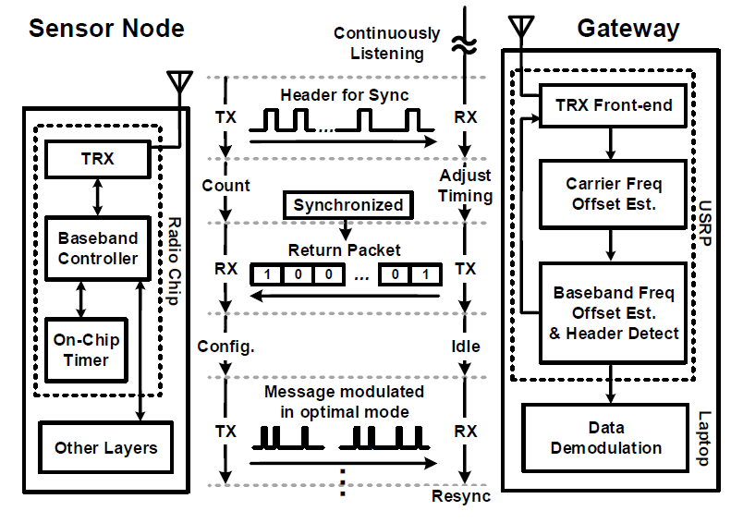

## Block Diagrams

1. Power Oscillator/Q-enhanced Amplifier  
   

Figure IV‑ii Power Oscillator block diagram

Power oscillator/ Q-enhanced Amplifier is based on a back-to-back inverter with tunable cap array on each node (ANTP and ANTN). Its current level is controlled by adjusting the footer configuration with MRR_TX_BIAS_TUNE (for TX) or MRR_RX_BIAS_TUNE (for RX). Tunable cap array are controlled with MRR_TRX_CAP_ANTP_TUNE_COARSE, MRR_TRX_CAP_ANTN_TUNE_COARSE, MRR_TRX_CAP_ANTP_TUNE_FINE, and MRR_TRX_CAP_ANTN_TUNE_FINE. Refer to Table VII‑1/Table VII‑2 for expected CFO frequency with different configurations. Note that switches in the cap array connect capacitor to VRAD when they are OFF. This provides high impedance connection to VRAD and prevents floating nodes which causes the settling issue.

1. Voltage Clamp



Figure IV‑iiiiii Voltage Clamp Block Diagram

Voltage clamp presets VRAD voltage before TX to prevent settling issue due to finite PMU strength. Voltage clamp has 2 modes, sleep and active mode. During sleep mode, voltage clamp uses divided V3P6 to charge/hold VRAD to a fixed voltage. To enable sleep mode, MRR_TRX_EN_SLP_VCLAMP should be set high and target voltage level can be controlled with MRR_TRX_SEL_VCLAMP_SLP (Detailed voltage level can be found in the register description). During active mode, voltage clamps controls current limiter (CL) to charge VRAD by turning it ON and clamps VRAD when it reaches target voltage by turning it off. To enable active mode, the clamp should be un-power gated (MRR_TRX_ENb_COMP & MRR_TRX_EN_DIV) and un-isolated (MRR_TRX_ISOLn_COMP). Active mode voltage clamp level can be controlled by MRR_TRX_SEL_VCLAMP. Note that active voltage clamp operation can either enabled or disabled during TX by controlling MRR_TRX_ENb_CONT_RC. Disabling active voltage clamp during TX is preferred as enabling CL introduces spike on VRAD which affects CFO. Active mode voltage clamp output (Recharge) can be monitored through MRR_TRX_RC_CNT to figure out optimal MRR_TRX_SEL_VCLAMP. Refer to register description of MRR_TRX_RC_CNT for finding optimal MRR_TRX_SEL_VCLAMP.

# On-chip Clock Generator

This is an on-chip clock generator designed by Seokhyeon Jeong. The clock generator has been mainly designed to be used as a TRX Radio FSM clock. It has been designed for -30°C to 130°C temperature range with 240kHz output frequency.

Figure V‑i shows the block diagram of the on-chip clock generator.



Figure V‑i Timer Block Diagram

## Power Domains

Clock genenerator has been designed to operate from a supply voltage ranging from 1.0V to 1.4V. It can choose to operate either from VDD_1P2 generated from PMU for VDD_LDO generated from LDO. See Section VI for details regarding the block itself. As LDO provides regulated output voltage, running off of LDO provides better supply sensitivity compared to PMU VDD_1P2.

* VDD_1P2 (from PMU)
* VDD_LDO (from LDO)

## Power Draw / Current Draw / Energy Consumption

|  |  |
| --- | --- |
| Mode | V1P2  (1.2V) |
| Active | 1μA |
| Standby |  |

Table V‑1 On-chip Clock gen Current Draw

## Operation

* **Startup sequence** 
  + **Using PMU V1P2 as a power source**

1. Un-powergate clock gen

RO_EN_RO_V1P2-> 1’h1

*Include following step before step #1 if startup current is too high.

RO_EN_RO_V1P2_PRE **-**> 1’h1

1. Release isolation

RO_ISOLATE_CLK -> 1’h0

RO_EN_CLK -> 1’h1

1. Start Clock

RO_RESET **-**> 1’h0

* + **Using LDO as a power source**

1. Un-powergate voltage reference in LDO. Voltage reference consumes only tens of pA so it requires some stabilization time (~30ms)  
   MRR_TRX_CAP_ANTP_TUNE_COARSE -> 1’h1
2. Un-powergate the current reference and the main amplifier in LDO  
   MRR_CL_CTRL -> 1’h1  
   MRR_CL_EN -> 1’h1
3. Un-powergate clock gen

RO_EN_RO_LDO-> 1’h1

1. Release isolation

RO_ISOLATE_CLK -> 1’h0

RO_EN_CLK -> 1’h1

1. Start Clock

RO_RESET **-**> 1’h0

* **Temperature Coefficient (TC)**

Temperature coefficient of the output frequency can be tuned with following parameters. Refer to their description for usage.

RO_POLY

RO_PDIFF

* **Frequency Tuning**

Output frequency can be tuned by adjusting RO_MIM or RO_MOM. It is recommended to adjust them simultaneously (i.e. RO_MOM=RO_MIM) as they affect temperature coefficient. This will give 5kHz tuning step while tuning them individually will give 2.5kHz step. See Table VII‑3 for tuning range. Note that although RO_POLY/ RO_PDIFF can adjust frequency, it is not recommended as they will affect temperature coefficient.

# LDO

This is a Linear Regulator used to regulate VDD of On-chip clock generator, originally designed by Inhee Lee. See Figure VI‑i & Figure VI‑ii.

## Power Domains

* VDD_3P6
* VDD_1P2
* On-chip clock generator’s VDD

## Operation

* Select desired output voltage via LDO_ SEL_VOUT

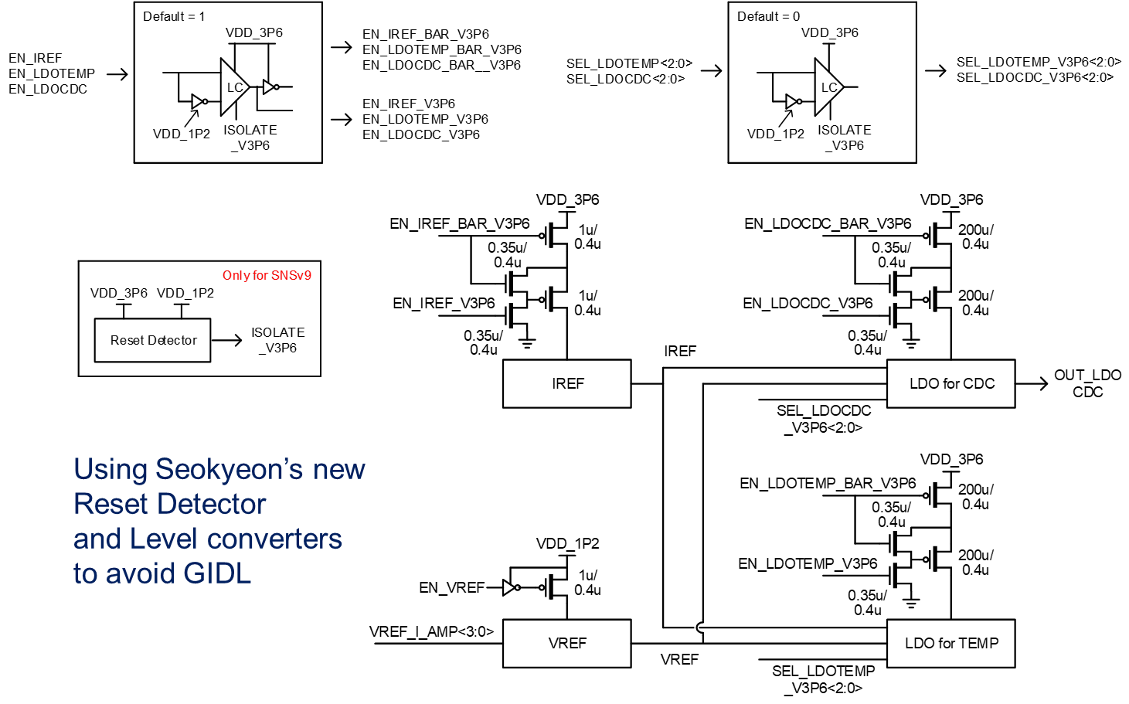

Figure ‑ LDO_TOP Block Diagram

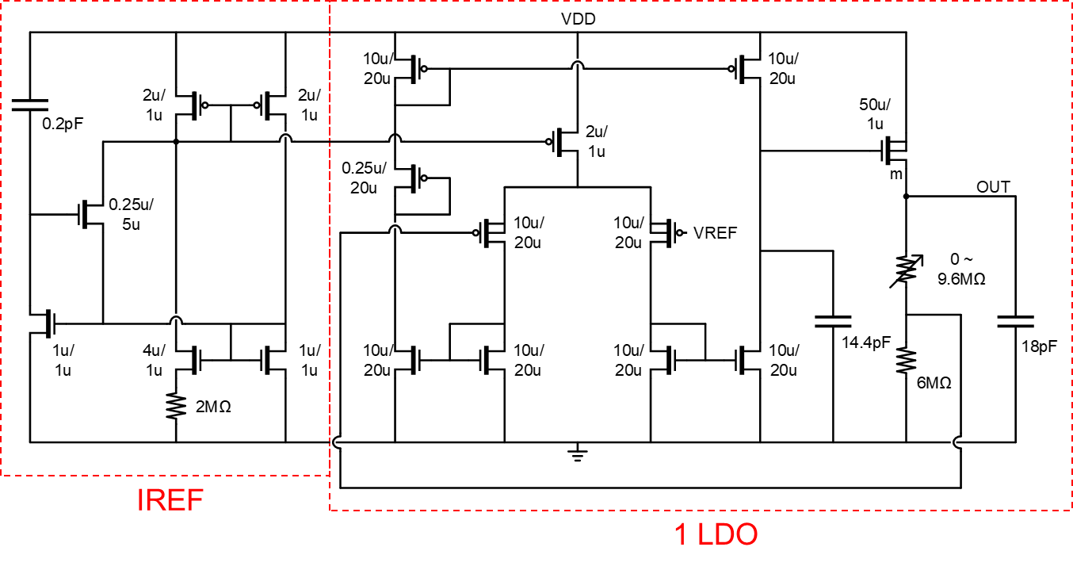

Figure ‑ IREF+1 LDO

## Post-PEX Simulation Results

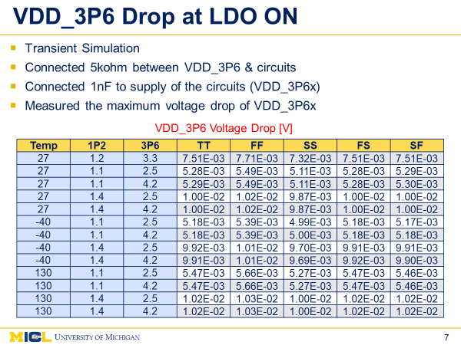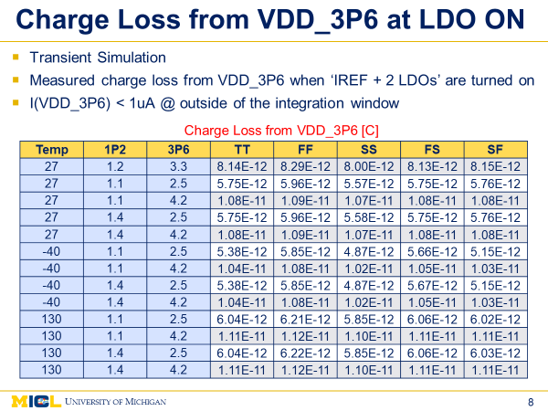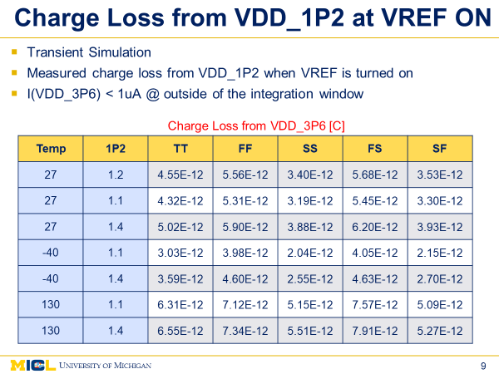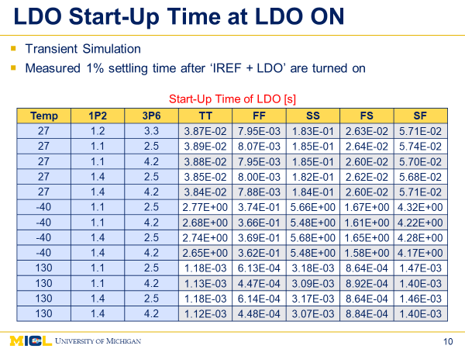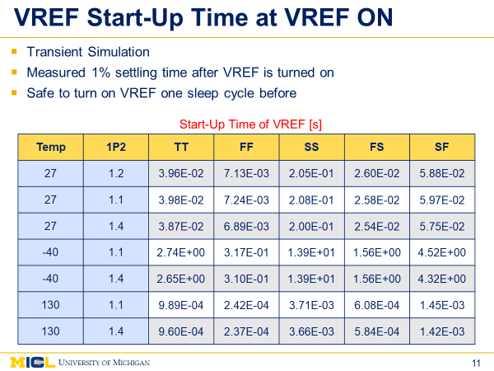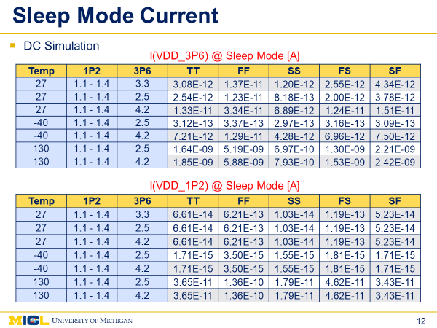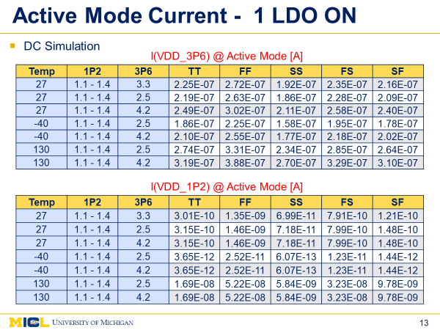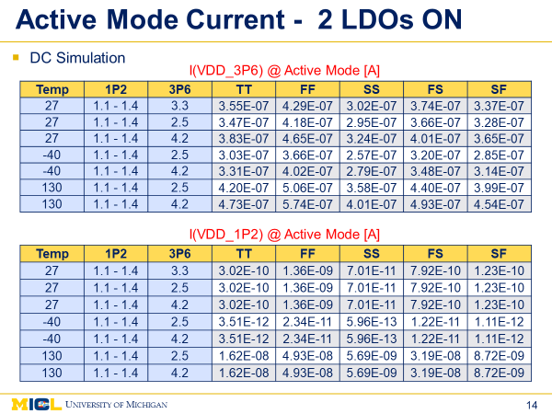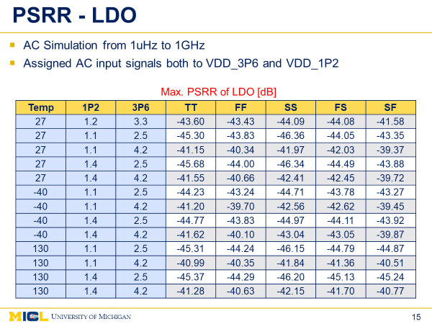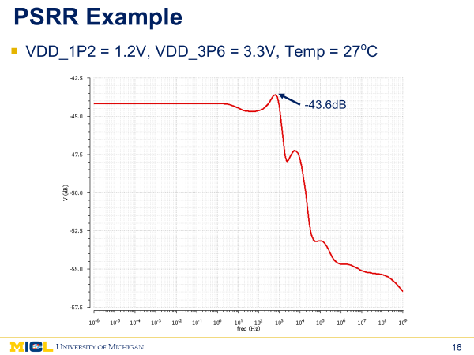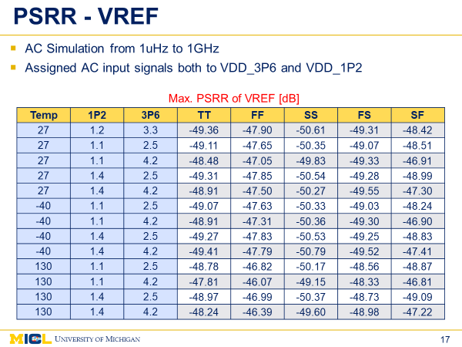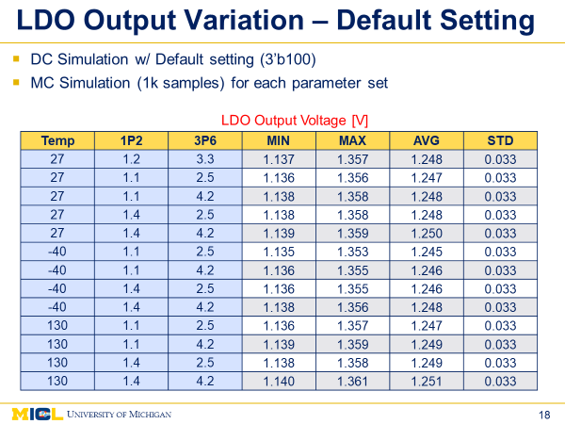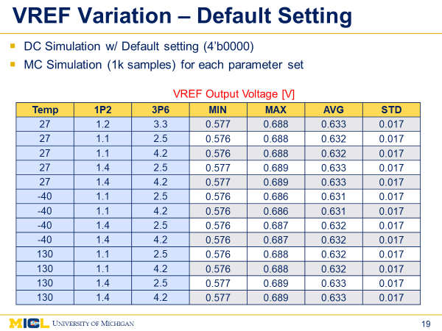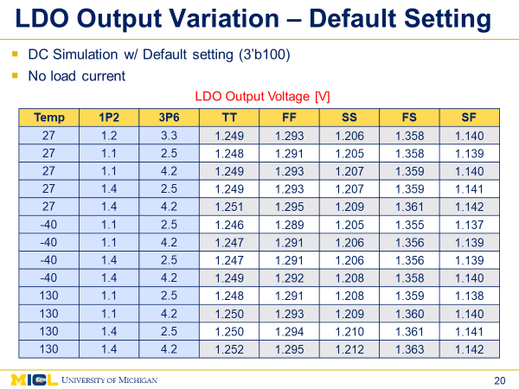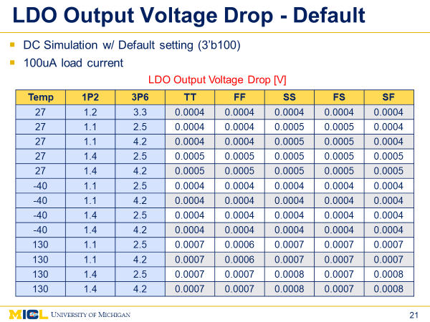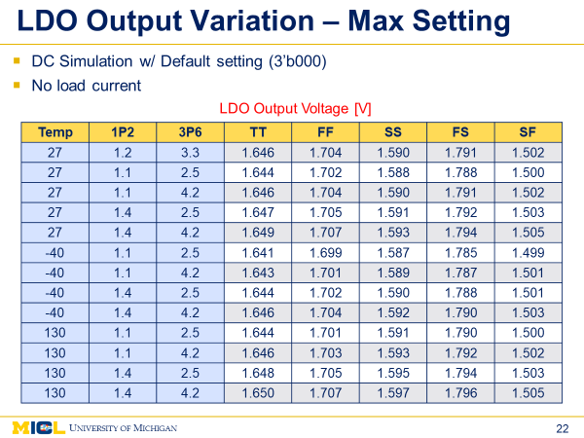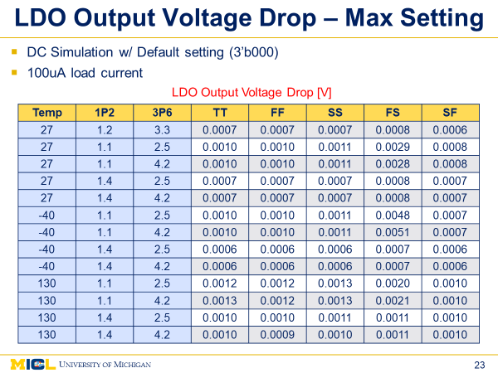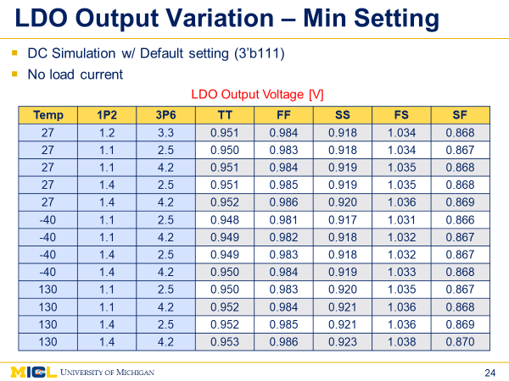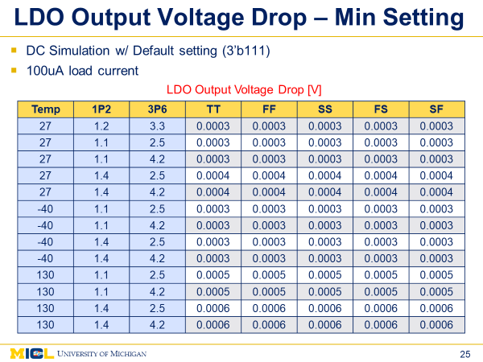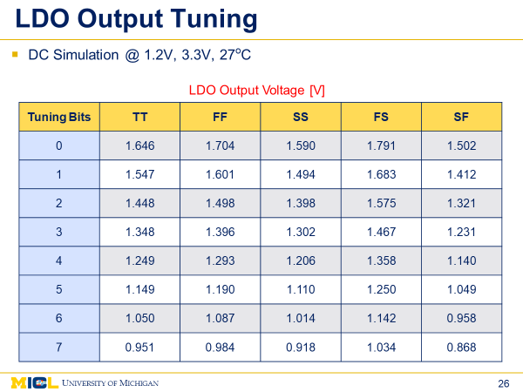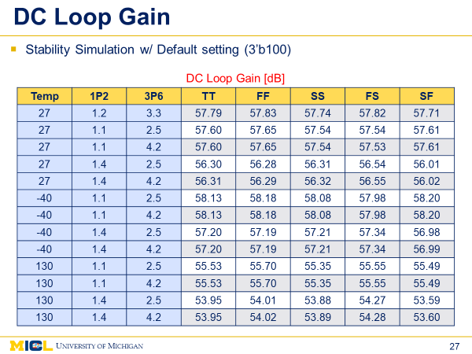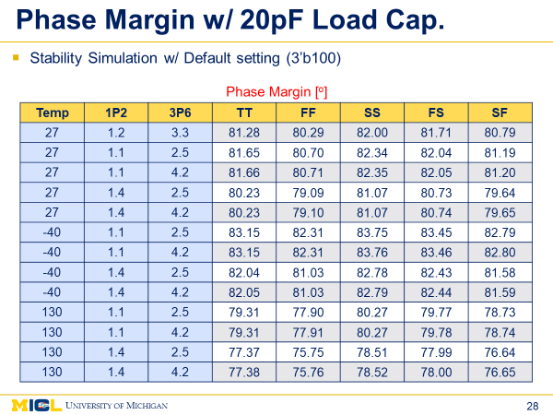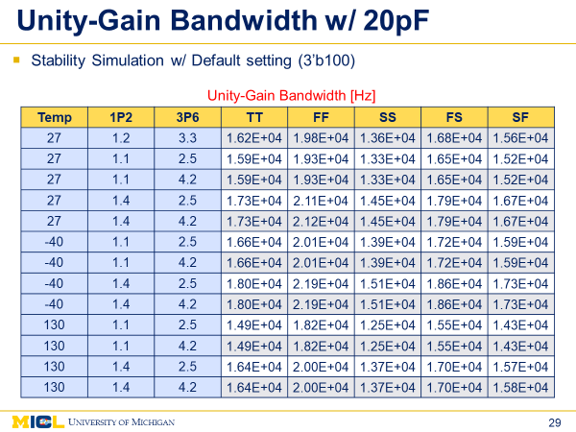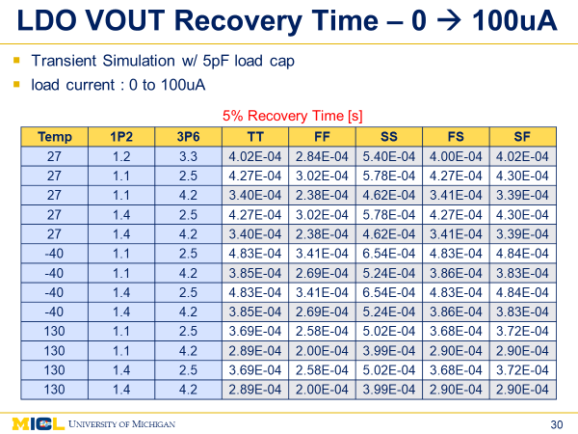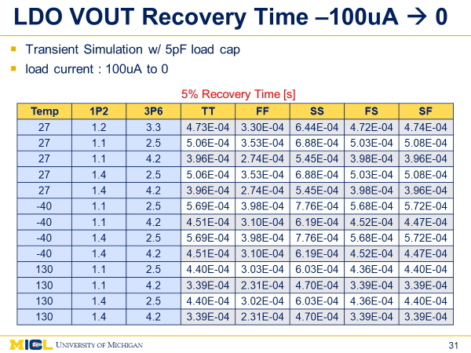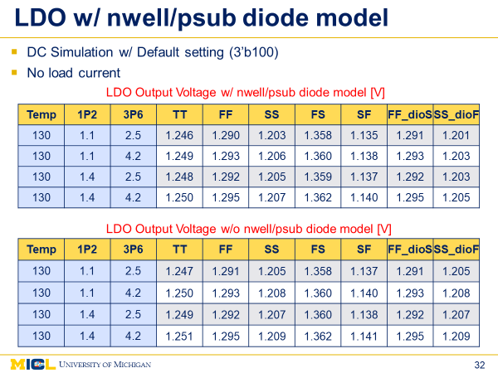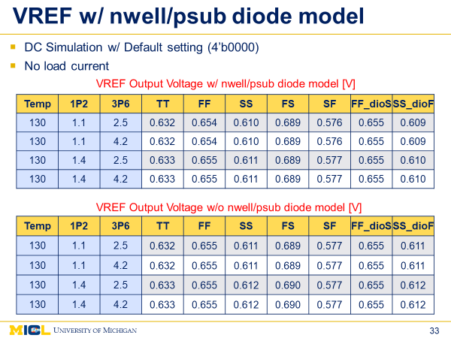

## Measurement Results

# Appendix

## Power Oscillator Frequency Range

Following tables show simulated power oscillator frequency depending on different tuning values as well as the external antenna cap. Simulation includes parasitic extraction and uses extracted antenna model (AHv4.1_rev1) from HFSS.

As mentioned before, frequency tuning can be done by adjusting MRR_TRX_CAP_ANTP_TUNE_COARSE / MRR_TRX_CAP_ANTN_TUNE_COARSE and MRR_TRX_CAP_ANTP_TUNE_FINE / MRR_TRX_CAP_ANTN_TUNE_FINE. In the table, coarse tuning values are shown in column and fine tuning values are shown in row.

|  |  |  |  |  |  |  |  |  |  |  |  |
| --- | --- | --- | --- | --- | --- | --- | --- | --- | --- | --- | --- |
|  | Power Oscillator Frequency (MHz) | | | | | | | | | | |
| **0** | **1** | **2** | **3** | **4** | **5** | **6** | **7** | **8** | **9** | **10** |
| 0 | 944.93 | 934.33 | 923.71 | 913.60 | 903.96 | 894.38 | 885.29 | 876.40 | 867.68 | 859.40 | 851.17 |
| 1 | 944.61 | 933.87 | 923.62 | 913.39 | 903.67 | 894.18 | 885.01 | 876.07 | 867.55 | 859.18 | 850.46 |
| 2 | 944.34 | 933.53 | 923.08 | 912.93 | 903.32 | 893.78 | 884.64 | 875.71 | 867.27 | 858.83 | 850.70 |
| 3 | 944.14 | 933.46 | 923.10 | 912.72 | 903.10 | 893.65 | 884.50 | 875.74 | 867.09 | 858.57 | 850.47 |
| 4 | 943.23 | 932.50 | 922.08 | 912.10 | 902.42 | 892.88 | 883.83 | 875.08 | 866.46 | 858.07 | 849.94 |
| 5 | 942.89 | 932.17 | 921.83 | 911.93 | 902.19 | 892.76 | 883.60 | 874.70 | 866.17 | 857.78 | 849.76 |
| 6 | 942.53 | 932.01 | 921.64 | 911.57 | 901.93 | 892.53 | 883.32 | 874.38 | 866.04 | 857.61 | 849.50 |
| 7 | 942.19 | 931.64 | 921.26 | 911.19 | 901.57 | 892.14 | 883.27 | 874.18 | 865.61 | 857.30 | 849.55 |
| 8 | 941.26 | 930.57 | 920.23 | 910.36 | 900.58 | 891.23 | 882.21 | 873.44 | 864.79 | 856.57 | 848.45 |
| 9 | 940.97 | 930.35 | 920.21 | 910.10 | 900.33 | 890.98 | 882.03 | 873.14 | 864.52 | 856.38 | 848.29 |
| 10 | 940.53 | 929.91 | 919.61 | 909.56 | 900.03 | 890.59 | 881.61 | 872.82 | 864.30 | 856.02 | 847.93 |
| 11 | 940.24 | 929.65 | 919.48 | 909.50 | 899.73 | 890.45 | 881.36 | 872.53 | 864.04 | 855.81 | 847.84 |
| 12 | 939.45 | 929.08 | 918.71 | 908.79 | 899.18 | 889.77 | 880.84 | 871.95 | 863.66 | 855.15 | 847.18 |
| 13 | 939.17 | 928.61 | 918.41 | 908.53 | 898.87 | 889.53 | 880.65 | 871.81 | 863.35 | 855.02 | 847.08 |
| 14 | 938.73 | 928.22 | 918.01 | 908.07 | 898.45 | 889.14 | 880.24 | 871.38 | 862.99 | 854.84 | 846.84 |
| 15 | 938.56 | 928.15 | 919.15 | 907.90 | 898.30 | 889.21 | 880.00 | 871.33 | - | 854.72 | 846.51 |
| 16 | 937.10 | 926.58 | 916.39 | 906.54 | 896.89 | 887.75 | 878.76 | 870.08 | 861.56 | 853.47 | 845.50 |
| 17 | 936.81 | 926.50 | 916.10 | 906.25 | 896.82 | 887.48 | 878.45 | 869.77 | 861.41 | 853.24 | 845.28 |
| 18 | 936.55 | 925.93 | 915.83 | 905.93 | 896.33 | 887.26 | 878.23 | 869.63 | 861.16 | 852.94 | 844.98 |
| 19 | 936.06 | 925.58 | 915.52 | 905.60 | 896.11 | 886.95 | 877.98 | 869.24 | - | 852.67 | 844.80 |
| 20 | 935.36 | 924.85 | 914.81 | 904.92 | 895.41 | 886.32 | 877.31 | 868.64 | 860.35 | 852.16 | 844.19 |
| 21 | 935.22 | 924.86 | 914.59 | 904.71 | 895.23 | 886.01 | - | 868.53 | 860.12 | 851.93 | 844.09 |
| 22 | 934.80 | 924.29 | 914.14 | 904.38 | 894.88 | 885.66 | 876.74 | 868.13 | 859.75 | 851.69 | 843.73 |
| 23 | 934.38 | 924.19 | 913.94 | 904.16 | 894.65 | 885.52 | 876.64 | - | 859.51 | 851.40 | 843.70 |
| 24 | 933.77 | 923.23 | 913.39 | 903.26 | 893.99 | 884.84 | 875.94 | 867.28 | 858.79 | 850.80 | 843.05 |
| 25 | 933.39 | 922.96 | 912.81 | 903.13 | 893.86 | 884.54 | 875.70 | 867.09 | 858.74 | 850.57 | 842.71 |
| 26 | 932.93 | 922.63 | 912.57 | 902.74 | 893.34 | 884.20 | 875.24 | 866.75 | 858.35 | 850.21 | 842.37 |
| 27 | 932.65 | 922.29 | 912.30 | 902.45 | 893.20 | - | 875.05 | 866.55 | 858.12 | 850.11 | 842.18 |
| 28 | 931.98 | 921.61 | 911.66 | 901.88 | 892.47 | 883.28 | 874.50 | 865.86 | 857.49 | 849.49 | 841.68 |
| 29 | 931.65 | 943.80 | 911.31 | 901.62 | 892.17 | 883.12 | 874.25 | 865.68 | 857.36 | 849.30 | 841.43 |
| 30 | 931.38 | 921.04 | 910.87 | 901.23 | 891.95 | 882.85 | 873.69 | 865.45 | 857.04 | 849.23 | 841.16 |
| 31 | 930.98 | 920.72 | 910.66 | - | 891.61 | 882.59 | 873.70 | - | 856.80 | 848.79 | 841.07 |
| 32 | 929.93 | 919.62 | 943.86 | 900.03 | 890.68 | 881.64 | 872.83 | 864.32 | 856.02 | 847.96 | 840.17 |
| 33 | 929.68 | 919.43 | 909.57 | 899.80 | 890.50 | 881.80 | - | 864.09 | 855.87 | 847.85 | 840.04 |
| 34 | 929.37 | 919.02 | 909.09 | 899.39 | 890.11 | 881.17 | 872.29 | 863.79 | 855.59 | 847.52 | 839.68 |
| 35 | 929.22 | 918.78 | 908.79 | 899.19 | 889.97 | 880.82 | 872.08 | 863.57 | 855.34 | 847.35 | 839.54 |
| 36 | 928.30 | 918.03 | 908.19 | 898.49 | 889.22 | 880.26 | 871.51 | 863.03 | 854.73 | 846.81 | 838.95 |
| 37 | 927.98 | 917.76 | 907.93 | 898.36 | 889.10 | 880.11 | 871.42 | 862.81 | 854.60 | 846.53 | 838.79 |
| 38 | 927.68 | 917.42 | 907.50 | 897.92 | 888.70 | 879.70 | 870.95 | 862.60 | 854.25 | 846.21 | 838.54 |
| 39 | 927.42 | 917.14 | - | - | 888.48 | 879.53 | 870.75 | 862.26 | 854.15 | 846.09 | 838.34 |
| 40 | 926.51 | 916.33 | 906.43 | 896.97 | 887.63 | 878.71 | 870.05 | 861.61 | 853.49 | 845.40 | 837.72 |
| 41 | 926.30 | 916.12 | 906.25 | 896.74 | 887.44 | 878.57 | 869.95 | - | 853.22 | 845.22 | 837.55 |
| 42 | 925.88 | 915.81 | 905.90 | 896.41 | 887.15 | 878.16 | 869.51 | 861.04 | 852.80 | 844.97 | 837.29 |
| 43 | 925.69 | 915.54 | 905.69 | 896.10 | 886.88 | 877.98 | 869.25 | 860.85 | 852.63 | 945.12 | 837.04 |
| 44 | 925.07 | 914.89 | 904.99 | 895.54 | 886.21 | 877.38 | 868.63 | 860.25 | 852.06 | 844.28 | 836.47 |
| 45 | 924.73 | 914.54 | 904.69 | 895.23 | 886.14 | 877.15 | 868.41 | 860.08 | - | 843.98 | 836.26 |
| 46 | 924.29 | 914.12 | 904.40 | 894.99 | 885.77 | 876.83 | 868.09 | 859.74 | 851.59 | 843.77 | 835.96 |
| 47 | 924.14 | 913.96 | 904.12 | 894.75 | 885.54 | 876.62 | 867.92 | - | 851.41 | - | 835.86 |

Table VII‑1 Simulated CFO (MHz) with 700fF ANT cap (after PEX) with different MRR_TRX_CAP_ANTP_TUNE_COARSE / MRR_TRX_CAP_ANTN_TUNE_COARSE (column) and MRR_TRX_CAP_ANTP_TUNE_FINE/MRR_TRX_CAP_ANTN_TUNE_FINE (row) configurations

|  |  |  |  |  |  |  |  |  |  |  |  |
| --- | --- | --- | --- | --- | --- | --- | --- | --- | --- | --- | --- |
|  | Power Oscillator Frequency (MHz) | | | | | | | | | | |
| **0** | **1** | **2** | **3** | **4** | **5** | **6** | **7** | **8** | **9** | **10** |
| 0 | 913.25 | 903.38 | 894.06 | 884.81 | 876.00 | 867.36 | 858.97 | 850.80 | 842.88 | 835.32 | 827.78 |
| 1 | 912.95 | 903.17 | 893.81 | 884.65 | 875.79 | 867.12 | 858.93 | 850.68 | 842.81 | 835.05 | 827.01 |
| 2 | 912.52 | 902.77 | 893.46 | 884.20 | 875.42 | 866.76 | 858.45 | 850.32 | 842.40 | 834.77 | 827.36 |
| 3 | 912.41 | 902.53 | 893.39 | 883.99 | 875.24 | 866.77 | 858.33 | 850.26 | 842.31 | 834.60 | 827.10 |
| 4 | 911.58 | 901.95 | 892.57 | 883.45 | 874.66 | 865.95 | 857.66 | 849.54 | 841.71 | 834.02 | 826.59 |
| 5 | 911.41 | 901.65 | 892.30 | 883.23 | 874.43 | 865.82 | 857.51 | 849.38 | 841.54 | 833.85 | 826.40 |
| 6 | 910.93 | 901.40 | 892.04 | 883.04 | 874.23 | 865.61 | 857.31 | 849.12 | 841.31 | 833.69 | 826.15 |
| 7 | 910.75 | 901.11 | 891.90 | 882.68 | 873.89 | 865.31 | 857.05 | 848.87 | 841.00 | 833.42 | 826.25 |
| 8 | 909.80 | 900.18 | 890.84 | 881.78 | 872.99 | 864.40 | 856.13 | 848.06 | 840.30 | 832.70 | 825.27 |
| 9 | 909.51 | 900.11 | 890.79 | 881.61 | 872.71 | 864.23 | 856.07 | 847.89 | 840.03 | 832.63 | 825.06 |
| 10 | 909.18 | 899.55 | 890.35 | 881.14 | 872.45 | 863.92 | 855.63 | 847.60 | 839.75 | 832.22 | 824.81 |
| 11 | 909.02 | 899.38 | 890.15 | 881.07 | 872.17 | 863.70 | 855.50 | 847.57 | 839.58 | 832.05 | 824.62 |
| 12 | 908.21 | 898.82 | 889.41 | 880.39 | 871.80 | 863.12 | 855.02 | 846.86 | 839.17 | 831.45 | 824.08 |
| 13 | 908.07 | 898.37 | 889.16 | 880.11 | 871.43 | 862.86 | 854.70 | 846.68 | 838.91 | 831.33 | 823.92 |
| 14 | 907.69 | 898.17 | 888.82 | 879.76 | 871.08 | 862.54 | 854.37 | 846.41 | 838.62 | 831.01 | 823.78 |
| 15 | 907.52 | 897.86 | 889.81 | 879.66 | 870.87 | 862.57 | 854.20 | 846.33 | - | 831.06 | 823.46 |
| 16 | 906.04 | 896.54 | 887.27 | 878.37 | 869.60 | 861.17 | 852.99 | 845.15 | 837.34 | 829.81 | 822.47 |
| 17 | 905.88 | 896.47 | 887.08 | 878.12 | 869.45 | 861.01 | 852.86 | 844.84 | 837.09 | 829.58 | 822.29 |
| 18 | 905.54 | 895.98 | 886.82 | 877.85 | 869.06 | 860.86 | 852.65 | 844.74 | 836.87 | 829.39 | 822.05 |
| 19 | 905.20 | 895.69 | 886.46 | 877.52 | 868.91 | 860.54 | 852.39 | 844.37 | 912.66 | 829.18 | 821.81 |
| 20 | 904.56 | 895.09 | 885.89 | 876.95 | 868.28 | 859.92 | 851.82 | 843.83 | 836.08 | 828.58 | 821.32 |
| 21 | 904.32 | 894.90 | 885.65 | 876.73 | 868.07 | 859.67 | - | 843.70 | 835.92 | 828.54 | 821.26 |
| 22 | 903.95 | 894.52 | 885.26 | 876.35 | 867.82 | 859.38 | 851.27 | 843.40 | 835.62 | 828.23 | 820.91 |
| 23 | 903.77 | 894.41 | 885.07 | 876.16 | 867.57 | 859.20 | 851.06 | - | 835.44 | 827.96 | 820.75 |
| 24 | 902.96 | 893.45 | 884.29 | 875.47 | 866.89 | 858.64 | 850.48 | 842.54 | 834.98 | 827.49 | 820.24 |
| 25 | 902.71 | 893.24 | 884.09 | 875.27 | 866.80 | 858.43 | 850.19 | 842.29 | 834.63 | 827.16 | 819.95 |
| 26 | 902.36 | 893.01 | 883.79 | 874.93 | 866.37 | 857.96 | 849.84 | 841.99 | 834.41 | 826.93 | 819.67 |
| 27 | 902.11 | 892.63 | 883.64 | 874.71 | 866.22 | 912.74 | 849.65 | 841.85 | 834.17 | 826.88 | 819.49 |
| 28 | 901.37 | 892.10 | 882.97 | 874.04 | 865.59 | 857.25 | 849.08 | 841.23 | 833.62 | 826.24 | 818.95 |
| 29 | 901.24 | 912.23 | 882.69 | 873.84 | 865.34 | 857.07 | 848.94 | 841.05 | 833.49 | 826.06 | 818.83 |
| 30 | 900.96 | 891.66 | 882.37 | 873.52 | 865.04 | 856.86 | 848.33 | 840.82 | 833.20 | 825.90 | 818.53 |
| 31 | 900.65 | 891.28 | 882.21 | - | 864.78 | 856.53 | 848.42 | 912.51 | 832.99 | 825.54 | 818.35 |
| 32 | 899.77 | 890.24 | - | 872.41 | 863.92 | 855.68 | 847.61 | 839.79 | 832.20 | 824.90 | 817.68 |
| 33 | 899.38 | 890.06 | 881.11 | 872.33 | 863.74 | 855.78 | 912.76 | 839.61 | 832.09 | 824.65 | 817.46 |
| 34 | 899.17 | 889.80 | 880.70 | 871.88 | 863.48 | 855.18 | 847.20 | 839.30 | 831.80 | 824.35 | 817.22 |
| 35 | 898.85 | 889.52 | 880.43 | 871.71 | 863.25 | 854.94 | 846.98 | 839.12 | 831.59 | 824.25 | 817.05 |
| 36 | 898.21 | 888.89 | 879.82 | 871.12 | 862.64 | 854.48 | 846.38 | 838.63 | 831.05 | 823.68 | 816.53 |
| 37 | 897.91 | 888.62 | 879.58 | 870.97 | 862.48 | 854.35 | 846.17 | 838.44 | 830.85 | 823.50 | 816.37 |
| 38 | 897.52 | 888.25 | 879.33 | 870.55 | 862.12 | 853.90 | 845.89 | 838.13 | 830.65 | 823.31 | 816.16 |
| 39 | 897.39 | 888.08 | - | 870.33 | 861.93 | 853.77 | 845.68 | 837.96 | 830.40 | 823.02 | 815.94 |
| 40 | 896.48 | 887.30 | 878.34 | 869.70 | 861.18 | 852.99 | 845.10 | 837.29 | 829.75 | 822.49 | 815.30 |
| 41 | 896.44 | 887.06 | 878.14 | 869.42 | 861.00 | 852.87 | 844.90 | - | 829.60 | 822.36 | 815.14 |
| 42 | 896.01 | 886.70 | 877.83 | 869.17 | 860.68 | 852.57 | 844.54 | 836.78 | 829.27 | 822.03 | 814.88 |
| 43 | 895.75 | 886.55 | 877.59 | 868.87 | 860.52 | 852.34 | 844.32 | 836.67 | 829.13 | - | 814.74 |
| 44 | 895.21 | 885.96 | 876.96 | 868.34 | 859.93 | 851.79 | 843.82 | 836.12 | 828.61 | 821.30 | 814.21 |
| 45 | 894.80 | 885.66 | 876.73 | 868.06 | 859.77 | 851.50 | 843.72 | 835.91 | - | 821.13 | 814.09 |
| 46 | 894.45 | 885.33 | 876.38 | 867.82 | 859.48 | 851.25 | 843.39 | 835.63 | 828.19 | 820.87 | 813.74 |
| 47 | 894.35 | 885.05 | 876.18 | 867.61 | 859.37 | 851.02 | 843.14 | - | 827.92 | - | 813.61 |

Table VII‑2 Simulated CFO (MHz) with 800fF ANT cap (after PEX) with different MRR_TRX_CAP_ANTP_TUNE_COARSE / MRR_TRX_CAP_ANTN_TUNE_COARSE (column) and MRR_TRX_CAP_ANTP_TUNE_FINE/MRR_TRX_CAP_ANTN_TUNE_FINE (row) configurations

## On-Chip Clock Generator Frequency Range

Following tables show simulated on-chip clock generator frequency depending on different tuning values (RO_MIM and RO_MOM). Simulation includes parasitic extraction.

|  |  |  |  |  |  |  |  |
| --- | --- | --- | --- | --- | --- | --- | --- |
| RO_MIM  /RO_MOM | Clock Freq.(kHz) | RO_MIM  /RO_MOM | Clock Freq.(kHz) | RO_MIM  /RO_MOM | Clock Freq.(kHz) | RO_MIM  /RO_MOM | Clock Freq.(kHz) |
| 0 | 339.2 | **32** | 276.6 | **64** | 233.8 | **96** | 202.5 |
| 1 | 334.6 | **33** | 273.6 | **65** | 231.7 | **97** | 200.9 |
| 2 | 329.3 | **34** | 270.0 | **66** | 229.1 | **98** | 198.9 |
| 3 | 325.9 | **35** | 267.8 | **67** | 227.5 | **99** | 197.7 |
| 4 | 321.0 | **36** | 264.4 | **68** | 225.1 | **100** | 195.9 |
| 5 | 316.9 | **37** | 261.7 | **69** | 223.1 | **101** | 194.4 |
| 6 | 312.9 | **38** | 259.0 | **70** | 221.1 | **102** | 192.9 |
| 7 | 309.9 | **39** | 256.9 | **71** | 219.6 | **103** | 191.8 |
| 8 | 304.8 | **40** | 253.4 | **72** | 217.0 | **104** | 189.8 |
| 9 | 301.1 | **41** | 250.8 | **73** | 215.1 | **105** | 188.3 |
| 10 | 296.8 | **42** | 247.8 | **74** | 213.0 | **106** | 186.7 |
| 11 | 294.1 | **43** | 246.0 | **75** | 211.6 | **107** | 185.6 |
| 12 | 290.1 | **44** | 243.2 | **76** | 209.5 | **108** | 184.0 |
| 13 | 286.8 | **45** | 240.9 | **77** | 207.8 | **109** | 182.7 |
| 14 | 283.6 | **46** | 238.6 | **78** | 206.1 | **110** | 181.4 |
| 15 | 281.1 | **47** | 236.9 | **79** | 204.8 | **111** | 180.4 |
| 16 | 276.6 | **48** | 233.8 | **80** | 202.4 | **112** | 178.6 |
| 17 | 273.6 | **49** | 231.6 | **81** | 200.8 | **113** | 177.3 |
| 18 | 270.0 | **50** | 229.0 | **82** | 198.9 | **114** | 175.8 |
| 19 | 267.8 | **51** | 227.4 | **83** | 197.6 | **115** | 174.9 |
| 20 | 264.4 | **52** | 225.0 | **84** | 195.8 | **116** | 173.4 |
| 21 | 261.7 | **53** | 223.0 | **85** | 194.3 | **117** | 172.3 |
| 22 | 259.0 | **54** | 221.0 | **86** | 192.8 | **118** | 171.1 |
| 23 | 256.9 | **55** | 219.6 | **87** | 191.7 | **119** | 170.2 |
| 24 | 253.5 | **56** | 217.1 | **88** | 189.8 | **120** | 168.7 |
| 25 | 250.9 | **57** | 215.2 | **89** | 188.4 | **121** | 167.6 |
| 26 | 248.0 | **58** | 213.0 | **90** | 186.7 | **122** | 166.2 |
| 27 | 246.1 | **59** | 211.6 | **91** | 185.6 | **123** | 165.4 |
| 28 | 243.3 | **60** | 209.5 | **92** | 184.0 | **124** | 164.1 |
| 29 | 241.0 | **61** | 207.8 | **93** | 182.7 | **125** | 163.1 |
| 30 | 238.7 | **62** | 206.1 | **94** | 181.4 | **126** | 162.0 |
| 31 | 237.0 | **63** | 204.8 | **95** | 180.4 | **127** | 161.2 |

Table VII‑3 Simulated SFO (kHz) with different RO_MIM/RO_MOM configurations

1. zhiyoong@umich.edu
2. seojeong@umich.edu
3. lxchuo@umich.edu
4. Leakage Power does not include power-gating
5. Leakage Power does not include power-gating