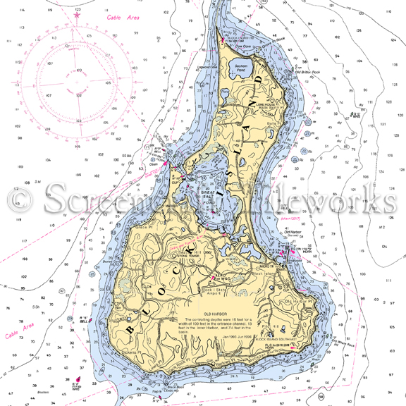

SHIP 84

BLOCK ISLAND

2019

Boarding Manual

|  |
| --- |
|  |
| July 7-14 2019  For Register Scouts  Coed Ages 14 – 21  Capacity: 6 scouts  Fee: $470.00  Registration Deadline:  May 31, 2019 |
| Sea Scout Ship 84  Contact:  Skipper Erol Eyikan eroleyikan@hotmail.com |

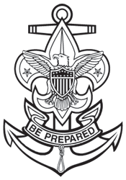

# Ship 84 Block Island 2019

## Our Mission

Ship 84 is a co-ed, non-profit Sea Scout group located in Fairfield CT.

Our mission is to create youth leadership and personal development opportunities for 14 to 21 year-olds while teaching seamanship and safe boating skills through challenging and fun-filled programs at sea.

## Skipper’s Letter to the Parents

Since 1932, Ship 84 has been a wonderful learning ground for our kids on their way to become future leaders: testing their skills, building their self-confidence, and challenging them both intellectually and physically while creating fun memories.

Taking a 40 foot boat under sail to Block Island and back is no simple task for the average middle or high schooler. Apart from the seamanship skills, it requires self-confidence and teamwork. At its core, developing their self-confidence and learning how to be a team is the essence of the long cruise that they are about to embark on.

I welcome your scouts to this week-long adventure. This may not be the biggest adventure they will have in their lives, but for many of them, this will be the one most remembered.

Sincerely

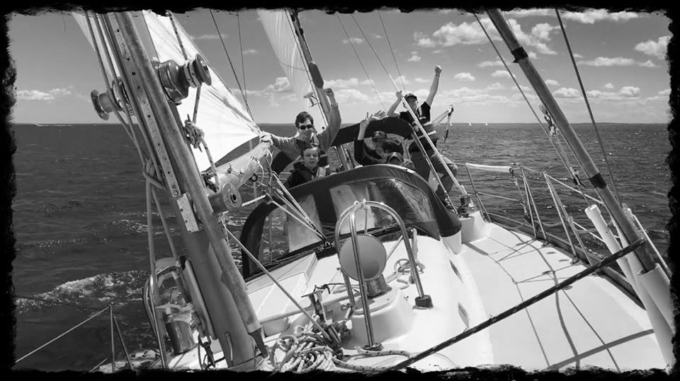

The Resolution under sail…

Erol Eyikan

Skipper Ship 84

## Event Summary

The Block Island long cruise is a week-long adventure. This is where the scouts put all of their seamanship and leadership skills to use. Starting from Southport harbor, we head east towards Block Island visiting a different port of call each night.

One of the favorite stops is the Branford Marina, where we have access to a swimming pool and a gazeebo with a grill, not to mention great views of the harbor.

Another highlight is our visit to the US Coast Guard Academy where we can get a quick tour of the academy, tour the on-site museum and visit the exchange store for some souvenirs. And of course they always have interesting boats out there for us to see. If we are lucky we get to see a nuclear submarine or two traveling up or down the New London channel.

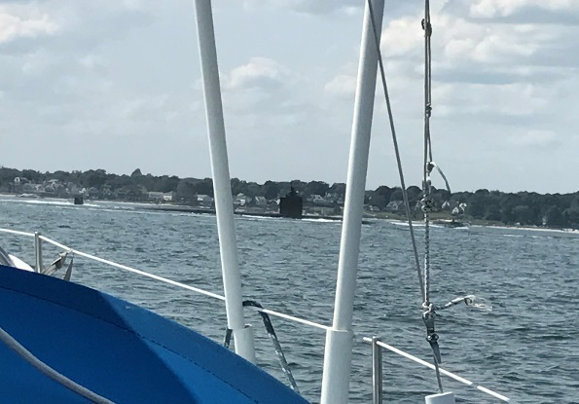

A nuclear submarine on our starboard bow during our 2018 trip

This year we are also adding a stop at the Mystic Seaport. We will be able to dock at extremely historical docks and visit the museum from a whole new perspective.

The ultimate destination of the trip is our lay day at Block Island. We leave our boat at a mooring and spend the day at the beach and around town. We make sure we schedule a visit to the ice cream shop, another favorite for the scouts.

Food is one of the best parts of the trip. All Meals are planned in advance and are prepared on board our boat by the scouts. If we are underway, we do not cook, we just prepare cold cut sandwiches or something similar. We bring plenty of food and snacks so that no one goes to bed hungry.

Here is our itinerary.

Day 1 Sunday: Southport to Branford – 5hrs

Day 2: Branford to Mystic Seaport – 10hrs

Day 3: Lay day at Mystic Seaport

Day 4: Mystic Seaport to Block Island – 6hrs

Day 5: Lay day at Block Island

Day 6: Block Island to New London (US Coast Guard Academy) – 5hrs

Day 7: New London to Milford – 8hrs

Day 8: Milford to Southport – 2hrs

Note that the itinerary is subject to change based on marina and slip availability, weather conditions, crew health reasons, boat maintenance reasons or any other reason based on the skipper’s judgement.

## Main Ports of Call

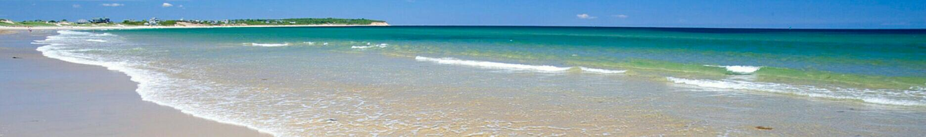Block Island:

Can you believe that this photo is from a Block Island beach? Well this is where we will be swimming at on our Block Island lay day. We will have lunch at the beach and then head to the town for afternoon visit to the zoo and other famous block island attractions. Incorporated in 1672 as the only town on the island of Block Island, New Shoreham is the smallest town in the smallest state in the United States.

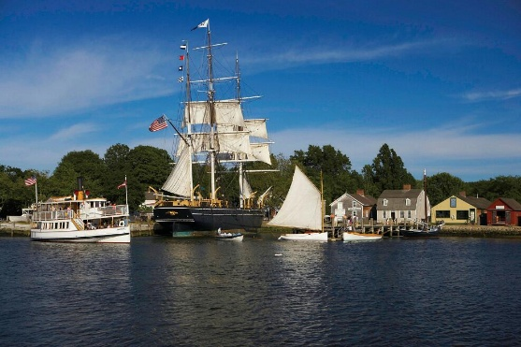Mystic Seaport:

Docking at the Mystic Seaport allows us access to all the museum exhibits during the day. We will visit the museum, and spend the day at the charming historic maritime village.

## The museum was established in 1929 as the "Marine Historical Association". Its fame came with the acquisition of the Charles W. Morgan in 1941, the only surviving wooden sailing whaler. The Seaport was one of the first living history museums in the United States, with a collection of buildings and craftsmen to show how people lived; it now receives about 250,000 visitors each year.

## Our Boat – The Resolution

Our boat is a 1968 Hinckley Bermuda 40 named “the Resolution”. She is hull number 124 of 203 of these gorgeous boats ever built. With its classic long overhangs, perfectly pitched sheer line, wide side-decks, graceful cabin profile, and distinctive near-vertical transom, the Bermuda 40 has inspired severe lust in the heart of many a cruising sailor. Designed by Bill Tripp, Jr., it is without doubt one of the most attractive production sailboats ever conceived. The B-40, as it is often called, was the very first fiberglass boat ever created by the famous Hinckley Company of Southwest Harbor, Maine.

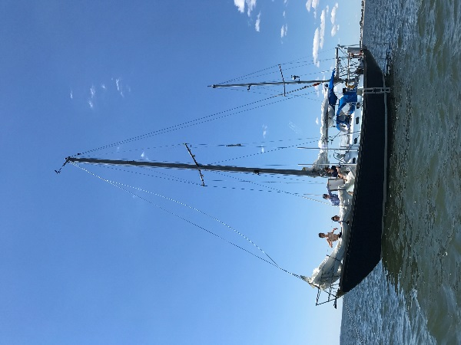

The Resolution at anchor at the Penfield beach for a swim

Unlike its contemporaries, the B-40 endured for a very long time. The first hull was commissioned in 1959 and the very last hull, number 203, was launched in 1991. So far this is the longest production run enjoyed by any fiberglass auxiliary sailboat anywhere in the world.

The hull is solid fiberglass laminate and the deck is solid glass. The strength of the deck joint is legendary. It consists of an inward flange half an inch thick and six inches wide that is both laminated and through-bolted. Hinckley crews reportedly spent two days on average making sure the fit between hull and deck was perfect before marrying the two parts together. All bulkheads are tabbed to both the deck and the hull.

All deck hardware is well bedded and mounted over generous backing plates, with stainless-steel machine screws tapped through the deck and into the plates to minimize the potential for leaks. The ballast is external lead, mounted on stainless-steel bolts at the front of the keel. The centerboard is cast bronze and is controlled by a very reliable worm gear with an override mechanism that permits the board to kick up in a grounding.

As far as performance goes, the B-40 in its prime was a competitive racer. After all the name “Bermuda 40” comes from the Newport-Bermuda race for which it was designed for. But these days would be considered relatively sedate under sail. As with any CCA design, it is not nearly as slow and heavy as its exaggerated D/L ratio might suggest. The boat tracks well with its centerboard down and has a light helm but is initially a bit tender, heeling quickly to 15-20 degrees before it firms up and builds forward momentum. The B-40’s motion, as with most boats of this type, is regular and smooth, thanks to its heavy displacement and full keel.

## Roles and Responsibilities Onboard

The long cruise is a youth led activity with adult supervision.

Each day one of the scouts is designated as the navigator and another is designated as the boatswain (boh-*suh* n). Helm time and watches are rotated among all other scouts based on the schedule set up by the boatswain.

The boatswain is in charge of the crew for the day. Under the boatswain’s leadership, the crew must move through the day’s goals as a team to be successful.

The navigator is in charge of planning the day’s course the night before and recording the boat’s progress on his or her charts and deck log during the day.

The skipper makes sure that everyone is safe and each scout is challenged at his or her appropriate level.

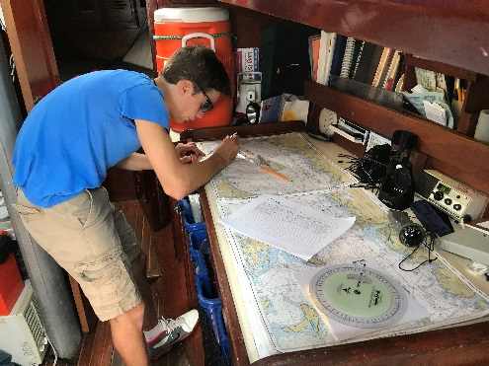

A Sea Scout navigating onboard the Resolution

While our boat is equipped with a modern electronic navigation system, the scouts use classic navigation methods with paper charts. This ensures that they have a great foundation in all forms of marine navigation. Electronic navigation is reserved for and used only by the skipper and the adult leadership to ensure safety.

## Accommodations aboard the Resolution

For long overnight trips, the Resolution can accommodate 6 sea scouts, 2 in her forward cabin, 4 in the saloon area, 2 being on floor mats. The two aft quarter births are separated from the saloon area with a door and allocated to adult leaders. With this configuration, girls, boys and adults have their own separate sleeping quarters. There is only one head (bathroom) aboard, which is shared by all.

## Cruise Requirements

CODE OF CONDUCT

All participants are to behave in a manner that is expected of all Scouts and that would bring no discredit to Scouting. No one is allowed to leave the event for any reason without permission of the Skipper or his delegate in his absence. The Guide to Safe Scouting is to be followed at all times. Scout Leaders are expected to maintain safety and discipline of their crew members. Adults are expected to observe all safety and discipline rules, enforcing the same at any time a problem presents itself, regardless of which crew members may be involved. All leaders, Adult and Youth shall hold themselves to the high standards expected of

Scouts and should at all times be a role model for younger or junior members. All discipline or safety issues are expected to be resolved at the lowest level, by the participants in a timely manner. Any situations that may rise above this level shall be resolved by the Staff and may include expulsion from the event at the offender’s own cost. The decision of the skipper is final.

HEALTH and MEDICAL DOCUMENTATION REQUIREMENTS

While underway anybody needing more than basic First Aid will be sent to the nearest medical facility for treatment.

Scouts and adult leaders must bring the completed "BSA Annual Health and Medical Record".

1. Section on, Health and Medical Record, filled out and be sure immunization record is complete and that all medications Scout is to receive at camp are listed.

2. Section on, Informed Consent and Hold Harmless/Release Agreement, filled out and signed and dated by Parent or Guardian, not more than 12 months prior to the end of the camp session

3. Section on, report of a The Examining Health-Care Provider completed, signed and dated by a licensed Physician not more than 36 months prior to the end of the camp session.

4. Copy of Health insurance card

Medical Forms must be retained on file at camp and WILL NOT BE RETURNED. Please make a copy.

Allergies: Please explain any and all allergies on the Health History. Include symptoms and necessary treatment.

Medications: All medications are administered underway MUST be listed on the Health History form at time of check in. ONLY those medications listed will be administered. All medication must come onboard in the original prescription containers. Please limit amount to seven (7) day supply. Medication not in an original container will not be administered. "Urgent use" medications, such as asthma inhalers and epi pens, may be returned to the Scout or Leader for whom they are prescribed, at the discretion of the skipper.

## What to Bring

Everything must be packed in collapsible duffle bag. Bring as little as possible to conserve space on board.

|  |  |  |
| --- | --- | --- |
| Clothes:   * Ship 84 shirt and hat * Boat Shoes / Toe Covered Sandals * Socks (4 pairs) * Underwear * T-shirts / Water Shirts * Swimsuit * Beach towel * Khaki Shorts * Long Pants * Wind breaker jacket or rain coat * Warm shirt * Pajamas | Essentials   * Water bottle * Personal grooming items * Toothbrush & toothpaste * Soap and Shampoo * Bag for dirty clothes * Tissues * Mosquito repellent * Sunscreen * Deodorant * Sleeping bag * Fitted bed sheet | Other   * Headlamp * Notebook and pencil * Pocket knife or marline spike * Small day-pack * Wallet and money   Optional   * Waterproof camera * Personal navigation tools * Sea Scout handbook * Swim goggles * Sun glasses |

What not to bring: electronics except for kindle, personal food or snacks.

## Information for Parents

Sea scouting above all, is a leadership and personal development program. Yes we have fun sailing, we learn seamanship skills, and we make new friends. But ultimately we do those things together as a team. The scouts are required to stay the full length of the cruise unless special circumstances arise.

In case of cancellations, the fee is not refundable unless another scout is on the waiting list and can fill the spot of the cancelling scout.

The fee is $470 per participant. The amount includes all meals, snacks and one or two ice cream outings. All fees go towards the trip expenses and annual boat maintenance. Adult leaders participating in the event do not receive any monetary or non-monetary compensation.

## Closing Ceremony

On the final day of the event after returning the Resolution to its mooring a closing ceremony will be held at the Pequot Yacht Club where the participants will receive their long cruise recognitions.

## Registration Requirements

Registration is on a first come first serve basis. Participation on the long cruise is subject to Skipper’s approval of the applicant’s readiness in terms of skills and maturity. To register contact the Skipper to confirm your eligibility to participate. Upon confirmation of eligibility, complete your registration by sending your fee $470.00, payable by check made out to “Ship 84”. Payment has to be received on or before May 31 for registration to be complete. In the event that more than 6 scouts apply, a waiting list will be created. In the event that there fewer than 6 Ship 84 scouts register, eligible scouts from other area ships may be accepted.