## Key Mappings for accents in the Windows SPIonic Layout

The keys have been aligned as closely as possible with the old SPIonic layout. The standard Windows Greek Polytonic reflects the layout of modern Greek typewriters, not use by English-speaking academics.

/ = acute accent = ώ ά

\ = grave accent = ὰὶὶ

( = rough breathing = ἁ

) = smooth breathing = ἀ

= is circumflex = ᾶ

| = iota subscript = ᾳ, ῃ

+ = dieresis on i and u only = ϊ ϋ

shift + 1 = smooth breathing + acute accent = ἄ

shift + 2 = smooth breathing + grave accent = ἂ

shift + 3 = rough breathing + acute accent = ἅ

shift + 4 = rough breathing + grave accent = ἃ

shift + 5 (%) = diaresis + acute = ΰ, i and u only

shift + 6 (^) = diaresis + grave, u and i only = ῢῒ

shift + comma (<) = macron = ᾱ (used only in textbooks to show long and short vowels)

shift + dot (>) = breve = ᾰ (used only in textbooks to show long and short vowels)

[ = rough breathing + circumflex = ὧ

] = smooth breathing + circumflex = ὦ

{ = rough breathing + circumflex + iota subscript = ᾧ

} = smooth breathing + circumflex + iota subscript = ᾦ

: = semi-colon = α·

*Some mappings can’t be done as they were in SPIonic. This is particular so for iota subscript. We can only use 1 dead key. So I’ve made these as ctrl-alt+ related key.*

ctrl-alt+= = circumflex + iota-subscript = ῷ [not SPIonic mapping]

ctrl-alt-/ = acute accent + iota subscript (1ffd) = ᾴ

ctrl-alt-\ = grave accent + iota subscript (00bb)= ᾲ

ctrl-alt-1 = smooth+acute+iota sub = ᾄ [not SPIonic mapping]

ctrl-alt-2 = smooth+grave+iota sub = ᾂ [not SPIonic mapping]

ctrl-alt-3 = rough+acute+iota sub = ᾅ [not SPIonic mapping]

ctrl-alt-4 = rough+grave+iota sub = ᾃ [not SPIonic mapping]

## Building a Custom Windows Keyboard Layout

h/t [Kikkervelf](https://www.reddit.com/r/languagelearning/comments/14myyks/how_to_build_a_custom_windows_keyboard_layout)

* Install the 'Microsoft Keyboard Layout Creator Tool v1.4'.
* Open it up. Change View | Font to 16 pt, so you can see the characters.
* Go to 'File >> Load Existing Keyboard' and pick your everyday keyboard layout.
* Double click on a button on the keyboard diagram to change it. You'll probably want to add the new characters to the 'Alt + Ctrl' layout, as I did, to avoid having to overwrite any in-use keys. You'll get a page up like this. Just copy + paste the character you want into the appropriate 'Code points' field, and it will automatically be converted to the equivalent unicode number once you close the window.

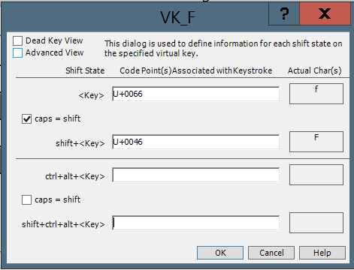

* Once you're happy with it, go to 'Project >> Test Keyboard Layout' and try it out.
* If everything is correct, then go to 'Project >> Build DLL and Setup Package'. Fill out the details here and hit OK.
* The program will then offer to take you to the new directory with the keyboard. Hit okay, and run the 'Setup.exe' file here. NOTE: You will need to use the same file to uninstall it, so don’t delete it.
* Once installed, reboot your machine.
* Then, switch your current keyboard layout. This will change a bit depending on your windows version, but in Windows 11, you can change the language in the bottom right corner.

## Notes on using MSKLC

This is a clunky old bit of code, but works fine in Windows 11.

If you want to put accents over a key, you have to define a “dead key” – one that, when you hit it, does nothing, and just stores up a value. When you then hit a white key, the dead key value changes it to something else.

So if alpha is a white key, and “/” is defined as a dead key, which adds an accent to the white key, then hitting “/” then “alpha” will produce alpha-with-an-accent. At least, it will if you tell it to!

## Useful Links

<https://www.microsoft.com/en-us/download/details.aspx?id=102134> – current location of the download.

<https://www.reddit.com/r/languagelearning/s/QzgK1cjvGy> - Reddit article that tells you how to build a custom Windows keyboard layout.

<https://msklc-guide.github.io/> - stuff not in the manual.

<https://en.wikipedia.org/wiki/British_and_American_keyboards>

<https://en.wiktionary.org/wiki/Appendix:Greek_punctuation#%CE%95%CF%81%CF%89%CF%84%CE%B7%CE%BC%CE%B1%CF%84%CE%B9%CE%BA%CF%8C_(_;_)_question_mark>

<https://www.tertullian.org/support/SPIonic.htm> - The SPIonic mappings

## How to change bunches of dead key mappings

The original Greek Polytonic has key mappings for all the stuff you need. Unfortunately these are assigned to weird keys. What we would like to do is to just change the key. Instead we have to redefine them from the start. But typing them in through the editor is simply impossibly time-consuming.

Here’s the mapping for just one key:

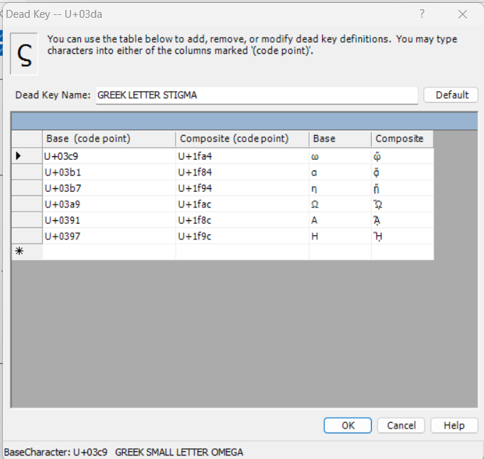

If you work with the .klc file, which is a text file, you can do this more easily. Here are the stages.

Open MSKLC. Load in the standard Greek Polytonic Keyboard.

Save the base keyboard to original.klc, using File|Save source file. Put it somewhere obvious.

In MSKLC, click on the key you want to add the accents to, as a dead key. Turn off the dead key with the check box. File|Save source file. Git commit the klc.

Open the new klc file in notepad++. (open the base keyboard klc also, in another tab.)

Back to MSKLC. Enable the dead key on the place you want it to be. Note the keycode, e.g. 003c. File|Save source file. Refresh the klc in notepad++. (Do a diff with git to see it if you forget) Move to that section – just a code with no rows. Find the material you want in the base klc somewhere. Copy it over. Save in Notepad++. Load the new klc. Project | Test.

Paste the output into word at 20 pt to make sure it looks OK.

File|Save source file. Refresh the klc. Git commit.

Then on to the next one.