**Web Technologies (OIM3690) Midterm Exam**

**Fall 2021, Professor Gordon, Nov 11, 8:00 am**

**EXAM INSTRUCTIONS:**

This is an open-book, open-notes, open-Web examination. However, you may not use email, IM, Facebook, Twitter, or any other social media and you may not communicate in any way with other people during the course of the exam.

This is an HTML/CSS/JavaScript exam. No credit will be awarded for jQuery solutions.

You have 90 minutes to complete the exam, approximately one minute per point. Use your time wisely. Partial credit will be awarded.

Download f21midtermOIM3690.zip from Canvas. Right click on the file and select Extract All from the File menu. Delete the .zip file and work in the f21midtermOIM3690 folder. When you are done, right-click on this folder and select Send to/Compressed (Zipped) folder. This will create a file with a .zip extension. Please submit this zip file at the exam link in today’s module. Make sure the original .zip file has been deleted and that the file you are submitting is the one that contains all your work.

The exam ends at 9:30. Do not make any changes to your files after 9:30. You will have an additional three minutes to upload your exam to Canvas. At 9:33, there will be a 10-point penalty and an additional 10 points will be deducted for each minute thereafter, per Canvas’s timestamp. Should you have trouble with Canvas, the timestamps of the files on your laptop can provide proof that you completed the exam by 9:33, and you will not be penalized.

The exam has three questions, each worth 33 points. One point is free. The template for each question is provided with the names index.htm, Q2.htm, and Q3.htm. Please do not change these names.

**Web Technologies (OIM3690) Midterm Exam**

**Fall 2021, Professor Gordon, Nov 11, 8:00 am**

1. Modify the index.htm page so that it appears as in the image below. The image should have a width of 400px (already set in the stylesheet) and should remain centered on the page as the width of the page changes (5 pts). The first line of each paragraph should be indented 20pt and the first letter should appear in a red font (6 pts). For full credit, these styles should be set in the stylesheet so that paragraphs added later will automatically appear the same way. The registered symbol (R with a circle around it) should appear after the word Action in the second sentence of the first paragraph (5 pts). Change the paragraph containing the question links into an unordered list, with Question 2 and Question 3 indented in a sub-list (7 pts). You will need to add the list item “Other questions.” Use the star image in the exam folder for the sub-list bullets (5 pts). The page should be valid HTML5 (5 pts).

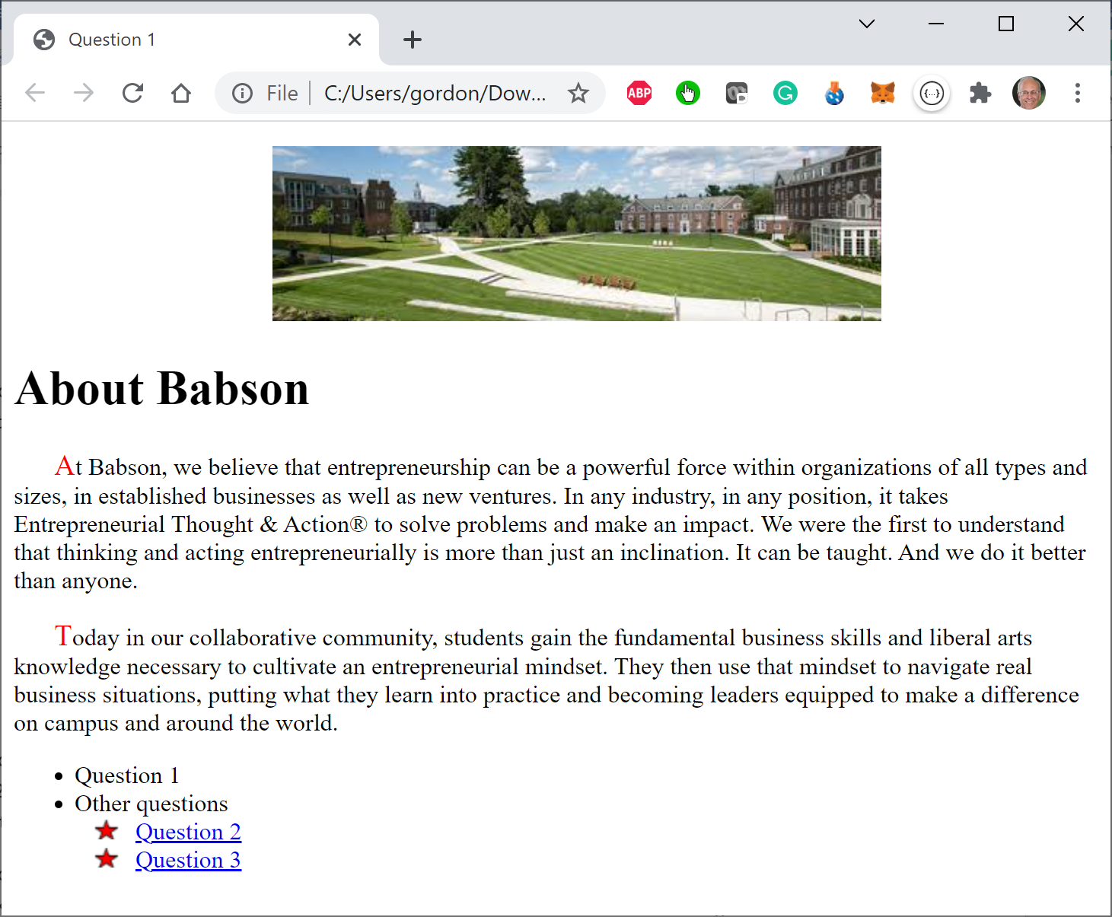

1. Modify Q2.htm so that when the user clicks on the button, the color of its (the button’s) font will change to red (8 pts) and the word “Oklahoma” will change to “the state of Oklahoma” (8 pts). When the user selects one of the colors in the dropdown list (onchange) the background color of the page will change to the color selected (9 pts). If the color selected is green, the background color of the button will also change to green (8 pts). The button’s background color does not need to change back or change again if user subsequently selects another background color.
2. Q3.htm is an animation. The text on the page describes how the animation should work. You will receive 5 points just for getting the animation to run. You will receive 8 points for having the appropriate state variables (those variables that appear outside your function). You will receive 12 points for properly calculating the year, interest amount, and investment value. You will receive 8 points for getting the animation to stop in the year 2030.

Certify your adherence to Babson’s Honor Pledge by adding, at the bottom of the index page, a paragraph stating, “I have abided by the Babson Code of Ethics in this work and pledge to be better than that which would compromise my integrity.”