**Web Technologies (MIS3690) Midterm Exam**

**Spring 2018, Professor Gordon, Section 2**

**EXAM INSTRUCTIONS:**

This is an open-book, open-notes, open-Web examination. However, you may not use email, IM, Facebook, Twitter, or any other social media and you may not communicate in any way with other people during the course of the exam. You have 95 minutes to complete the exam, approximately one minute per point. Use your time wisely. Partial credit will be awarded.

Download s18midtermSec2.zip from Blackboard. Right click on the file and select Extract All from the File menu. Delete the .zip file and work in the s18midtermSec2 folder. When you are done, ftp the entire folder into your secret folder on the class server. After completing the ftp, verify that your exam is readable by pointing your browser to:

http://mis3690-02.babson.edu/**your-id**/**your-secret-folder**/s18midtermSec2/

The exam officially ends at 11:20, but there will be no penalty until 11:24:59. At 11:25, there will be a 10 point penalty and an additional 10 points will be deducted for each minute thereafter, per the timestamp at the class web server. Do not access this folder after you leave the room or the time stamp will be changed and you will be penalized.

The exam has a total of 4 questions, each worth 25 points. The template for each question is provided to you with the names index.htm, Q2.htm, Q3.htm, and Q4.htm. Please do not change these names.

**Honor Code:**

**I pledge my honor that I have neither received nor provided unauthorized assistance during the completion of this work.**

Your Name:_________________________________________________

Signature:___________________________________________________

**Web Technologies (MIS3690) Midterm Exam**

**Spring 2018, Professor Gordon, Section 2**

1. Modify index.htm as follows: The three words reading “The First Question” should be centered on the page (6 points) and appear with a 3-pixel wide red border that just surrounds these words -- that is, the border's left side should be just to the left of the letter "T" and its right side should be just to the right of the letter "n" (7 points). The jack should be moved 125 pixels to the left and 50 pixels down (6 points). The jack should appear to be behind the ace (6 points). A picture of the correctly completed page is shown below:  
   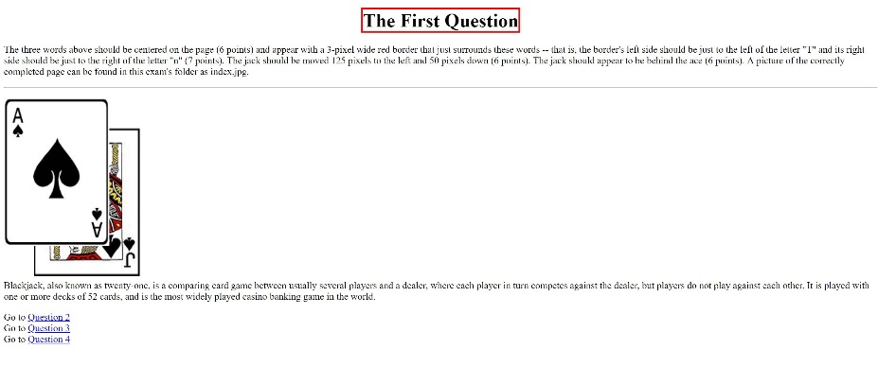
2. Modify Q2.htm so that double-clicking on the word Question in the h1 changes the text of the h1 to read as follows: Question #2 (8 pts). Clicking on the button should change the font color of this paragraph to blue and change the word in the input box to Mary (9 pts). Moving the mouse over the horizontal rule should change its height to 20 pixels and its background color to pink (8 pts).
3. Modify Q3.htm so that the following animation starts when the button is clicked (4 pts). Every 500 milliseconds, the number in the h2 tag should decrease by 1 (8 pts). When the number reaches 0, the animation should stop (8 points). HINT: I have included a variable called counter that you can use if you want. If the user had changed the ending value in the input box before clicking the button, the animation will stop when the countdown reaches that number (5 points). You may assume that the entry in the input box is an integer between 19 and 0 inclusive.
4. When the Deal key is pressed, two cards are drawn at random using letters and numbers from the ranks array (already created for you) to replace the aa and cc in the paragraph below the line, and words from the suits array (also already created for you) to replace the bb and dd in the paragraph below (15 pts). If the two cards dealt are the same, the function will deal the second card again without the user having to click the button (10 pts). It's possible that after the second deal the two cards are still the same, but that's OK.