**Web Technologies (MIS3690) Midterm Exam**

**Spring 2019, Professor Gordon, Section 1**

**EXAM INSTRUCTIONS:**

This is an open-book, open-notes, open-Web examination. However, you may not use email, IM, Facebook, Twitter, or any other social media and you may not communicate in any way with other people during the course of the exam. You have 95 minutes to complete the exam, approximately one minute per point. Use your time wisely. Partial credit will be awarded.

Download s19midtermSec1.zip from Blackboard. Right click on the file and select Extract All from the File menu. Delete the .zip file and work in the s19midtermSec1 folder. When you are done, ftp the folder containing index.htm into your secret folder on the class server. After completing the ftp, verify that your exam is readable by pointing your browser to:

http://mis3690-01.babson.edu/**your-id**/**your-secret-folder**/s19midtermSec1/

The exam officially ends at 4:35, but there will be no penalty until 4:39:59. At 4:40, there will be a 10 point penalty and an additional 10 points will be deducted for each minute thereafter, per the timestamp at the class web server. Do not access this folder after you leave the room or the time stamp will be changed and you will be penalized.

The exam has 4 questions, each worth 25 points. The template for each question is provided to you with the names index.htm, Q2.htm, Q3.htm, and Q4.htm. Please do not change these names.

**Honor Code:**

**I pledge my honor that I have neither received nor provided unauthorized assistance during the completion of this work.**

Your Name:_________________________________________________

Signature:___________________________________________________

**Web Technologies (MIS3690) Midterm Exam**

**Spring 2019, Professor Gordon, Section 1**

1. Modify the index.htm page so that it appears as in the image below. Use a float style or a table to get the image to appear to the right of the list (4 pts). The box surrounding the contents has a width of 600 pixels and a 1 pixel wide black border (4 pts). Center the <h1> in the box (2 pts). The second item in the list should become the first item in a <ul> sub-list (4 pts). The bullet for the sub-list should be the image checkmark.png (4 pts). HARD, but worth only 3 pts: The style rules for the sub-list should be placed in the internal stylesheet so that if additional list items are created under Question 2 or if sub-lists are created for any of the other questions, they would automatically be displayed the same way (3 pts). The page validates successfully as HTML5 (4 pts).

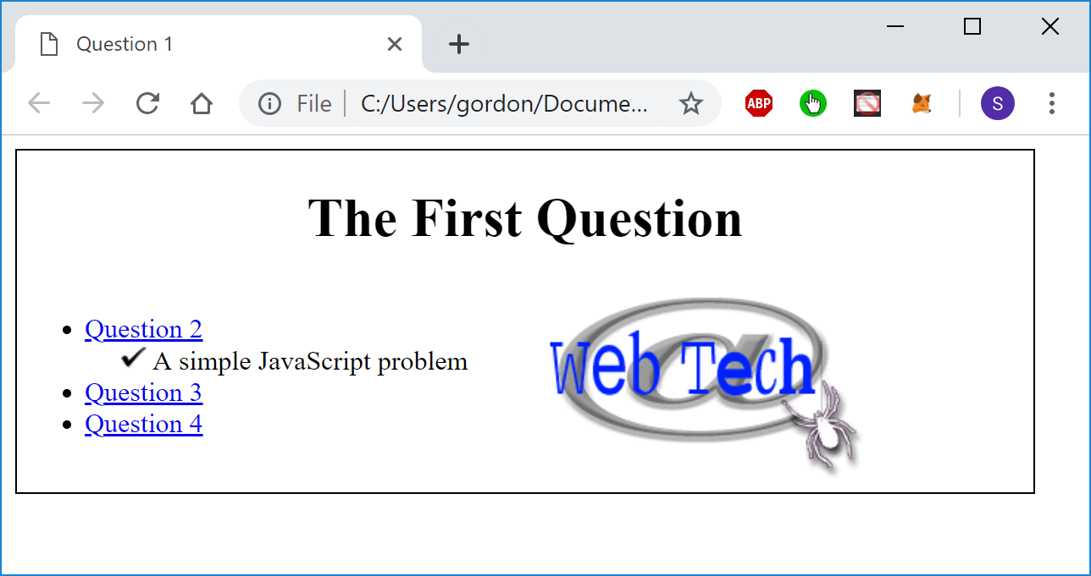

1. Modify Q2.htm so that when the user clicks on the h1, its background will turn pink (8 pts), the third word in this paragraph (user) will become bold (8 pts), and the first word of this paragraph (When) will change to If (9 pts).
2. Modify Q3.htm so that when the user clicks the “Click Me” button, the blue paragraph which currently says “Rice” will randomly say either “Snap”, “Crackle”, or “Pop” (8 pts). Its left position will change to 50px for Snap, 150px for Crackle, or 250px for Pop (7 pts). If instead the user clicks the “Animate” button, the same thing will happen every second (10 pts).
3. When the user clicks the Calculate button, a function should run that checks to make sure that the value entered for Test 4 is between 0 and 100 (both scores are legal). You may assume that the entry is not blank and that it is numeric. If the grade is not in this range, the function should alert with an error message (3 pts), delete the grade that had been entered (3 pts), place the cursor in the input box for Test 4 (3 pts), and the Average text box should remain blank (3 pts). If the grade is legal, the function should calculate the average* as (270/4) + (test 4 score/4) and should enter it into the appropriate text box (5 pts). It should then enter an A for the grade if the average is at or above 90 (2 pts), a B if it is less than 90 and at or above 80 (4 pts), and a C otherwise (2 pts).

* Note: If you try to calculate it as (80+90+100+test4 score)/4, the addition will fail because the value in the text box is treated as a string and the addition will simply create a longer string, not a number.