**Web Technologies (MIS3690) Midterm Exam**

**Spring 2020, Professor Gordon, April 9, 9:45 am**

**EXAM INSTRUCTIONS:**

This is an open-book, open-notes, open-Web examination. However, you may not use email, IM, Facebook, Twitter, or any other social media and you may not communicate in any way with other people during the course of the exam.

This is an HTML/CSS/JavaScript exam. No credit will be awarded for jQuery solutions.

You have 95 minutes to complete the exam, approximately one minute per point. Use your time wisely. Partial credit will be awarded.

Download s20midterm945.zip from Canvas. Right click on the file and select Extract All from the File menu. Delete the .zip file and work in the s20midterm945 folder. When you are done, ftp the folder containing index.htm into your secret folder on the class server. After completing the ftp, verify that your exam is readable by pointing your browser to:

http://mis3690-01.babson.edu/**your-id**/**your-secret-folder**/s20midterm945/

The exam ends at 11:20. Do not make any changes to your files after 11:20. You will have an additional five minutes to use FileZilla to upload your exam to the class server. At 11:25, there will be a 10 point penalty and an additional 10 points will be deducted for each minute thereafter, per the timestamp at the class web server. Should you have trouble with FileZilla, a screen shot of the folder on your laptop will provide proof that you completed the exam by 11:20, and you will not be penalized.

The exam has 3 questions, each worth 33 points. One point is free. The template for each question is provided with the names index.htm, Q2.htm, and Q3.htm. Please do not change these names.

**Web Technologies (MIS3690) Midterm Exam**

**Spring 2020, Professor Gordon, April 9, 9:45 am**

1. Modify the index.htm page so that it appears as in the image below. The paragraph in the div should appear in a 20pt font (3 pts) and should be aligned so that the right and left edges are straight, as shown in the picture below (2 pts). The div (which includes the h1 and the paragraph) flows around the image, which appears to its right (4 pts). The image is 60% of the page width (2 pts), and has 25px margins all around it (2 pts). The items in the table appear centered within their cells (3 pts) with 8px of space above and below them (3 pts). The borders shown are 3px wide and black (2 pts), without double lines (4 pts). The table is centered on the page (3 pts). The page validates successfully as HTML5 (5 pts).

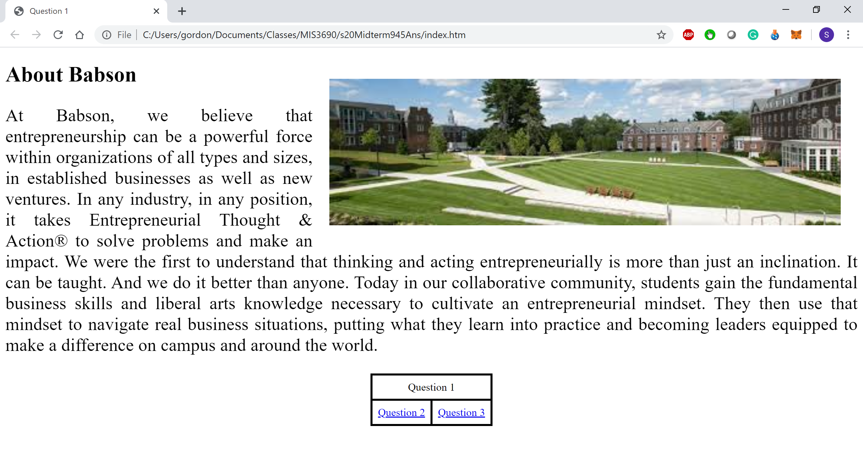

1. Modify Q2.htm so that when the user hovers over the Will Rogers paragraph, its font size will change to 24pt (11 pts). When the user clicks the button, the words “Question 2” in the h1 will appear centered on the page (11 pts) and the words in the button will say “Done” (11 pts).
2. Modify Q3.htm as follows. If the user has not entered a margin limit when the Animate button is clicked, an error message should pop up saying, “Margin limit must be entered” (6 pts). If the value entered is greater than 500, an error message should pop up when the Animate button is clicked saying, “Margin limit must be less than or equal to 500” (6 pts). In all other cases (you do not need to check if the margin limit is a number or if it’s less than zero), an animation should start that increases the right-hand margin by 5 pixels every 100 milliseconds (12 pts.). The animation should continue as long as the margin does not exceed the animation limit (9 pts).

Certify your adherence to Babson’s Honor Pledge by adding, at the bottom of the index page, a paragraph stating, “I pledge my honor that I have neither received nor provided unauthorized assistance during the completion of this work.”