BRADZ PROTOCOL
Parallel Port Communication Specification
PC to Test Fixture Interface Protocol

Document Title | Bradz Protocol — Parallel Port Communication Specification
Author | Bradley Rogers
Document Date | 2007
Revision | 1.0
Status | Released
Classification | Confidential
Interface | PC Parallel Port (IEEE 1284)
Target Device | Test Fixture with 16-Bit Registers

1. PURPOSE AND SCOPE

This document defines the Bradz Protocol — a low-level serial communication scheme for transferring data between a host PC and an attached test fixture via the PC parallel port.

Two encoding schemes are defined:
- Binary Frame Protocol — compact binary formatted frames with address auto-increment
- ASCII Character Protocol — fully ASCII-compliant encoding suitable for logging and debugging

The parallel port interface operates according to the IEEE 1284 standard. The test fixture is expected to contain 16-bit registers addressable through the protocol framing defined in this document.

2. INTERFACE OVERVIEW

2.1 Physical Connection
The protocol communicates with the test fixture through the standard PC parallel port. The parallel port provides bidirectional data transfer and is accessible through the standard LPT interface on the host computer. PC add-in board likely required for the Line Printer/IEEE 1284 Parallel port.

Figure 1 below shows the complete lab bench setup: the PC with DB-25 parallel port connector, the flat ribbon cable, the test fixture with register indicators, and a digital multimeter for verification.

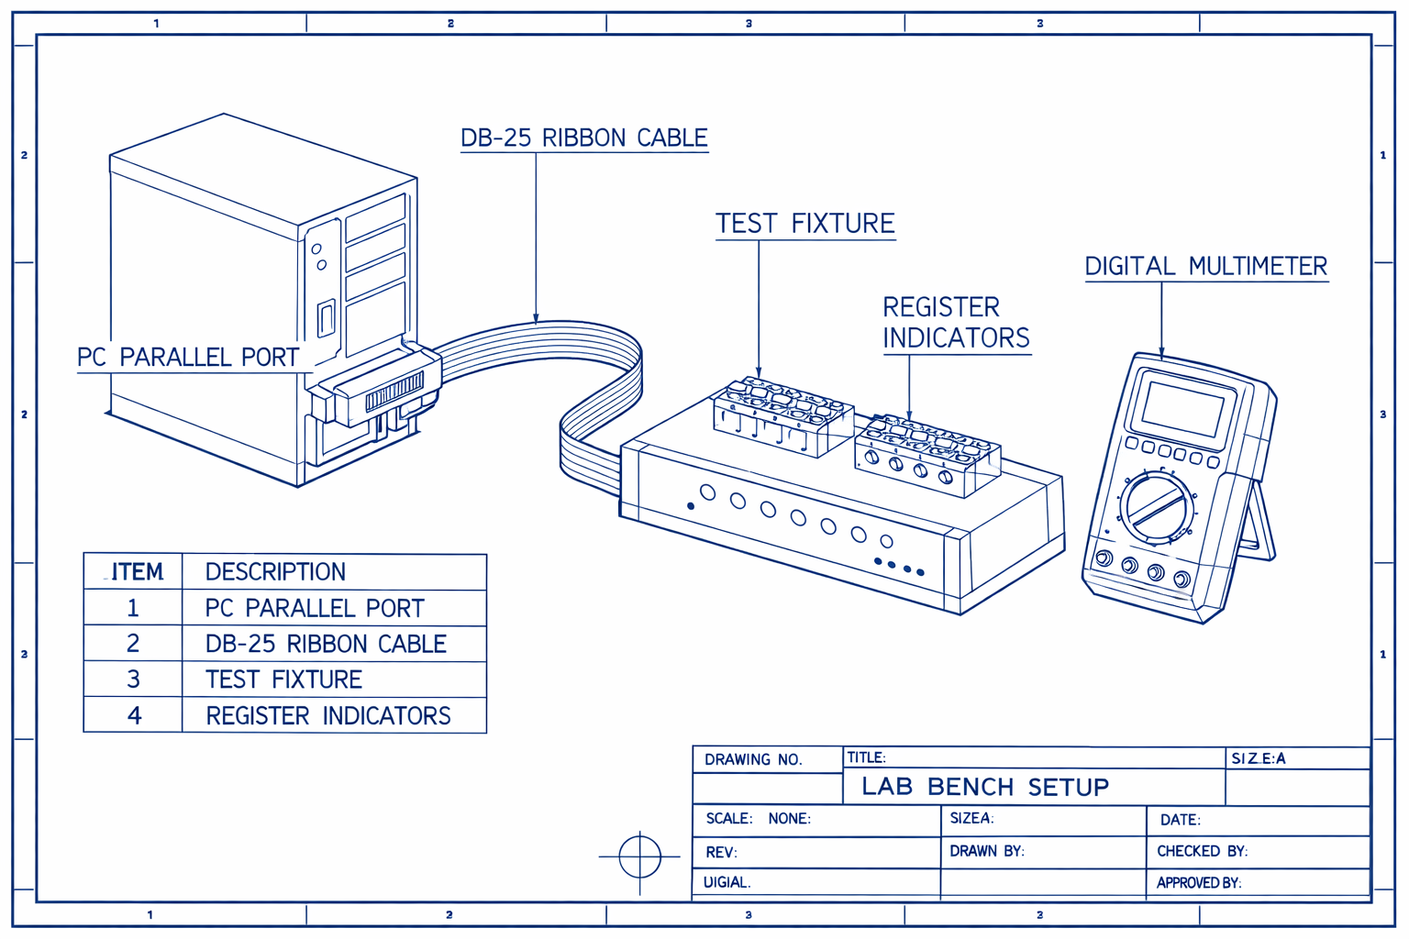
Figure 1 — Lab Bench Setup: PC Parallel Port, DB-25 Ribbon Cable, Test Fixture, Digital Multimeter

2.2 Register Architecture
The test fixture implements a register-based architecture with the following characteristics:
- Register width: 16 bits
- Register addressing: auto-incrementing after each write
- Maximum transfer size: 16 bytes per transaction
- Addressing: registers addressed by 5-bit address field (Address[4:0])

2.3 Address Auto-Increment Behavior
IMPORTANT: The address register on the slave device auto-increments after each register write. If five consecutive registers are written starting at R4, the hardware address pointer will point to R9 upon completion of the transfer.

3. CONNECTION METHOD A — BINARY FRAME PROTOCOL

The Binary Frame Protocol uses compact binary-formatted frames for high-efficiency data transfer. Each transaction consists of a two-word frame header followed by a data payload.

3.1 Frame Structure Overview
Each transaction begins with two header words that define the address, direction, command, and byte count. Figure 2 shows the complete bit-field breakdown of both words.

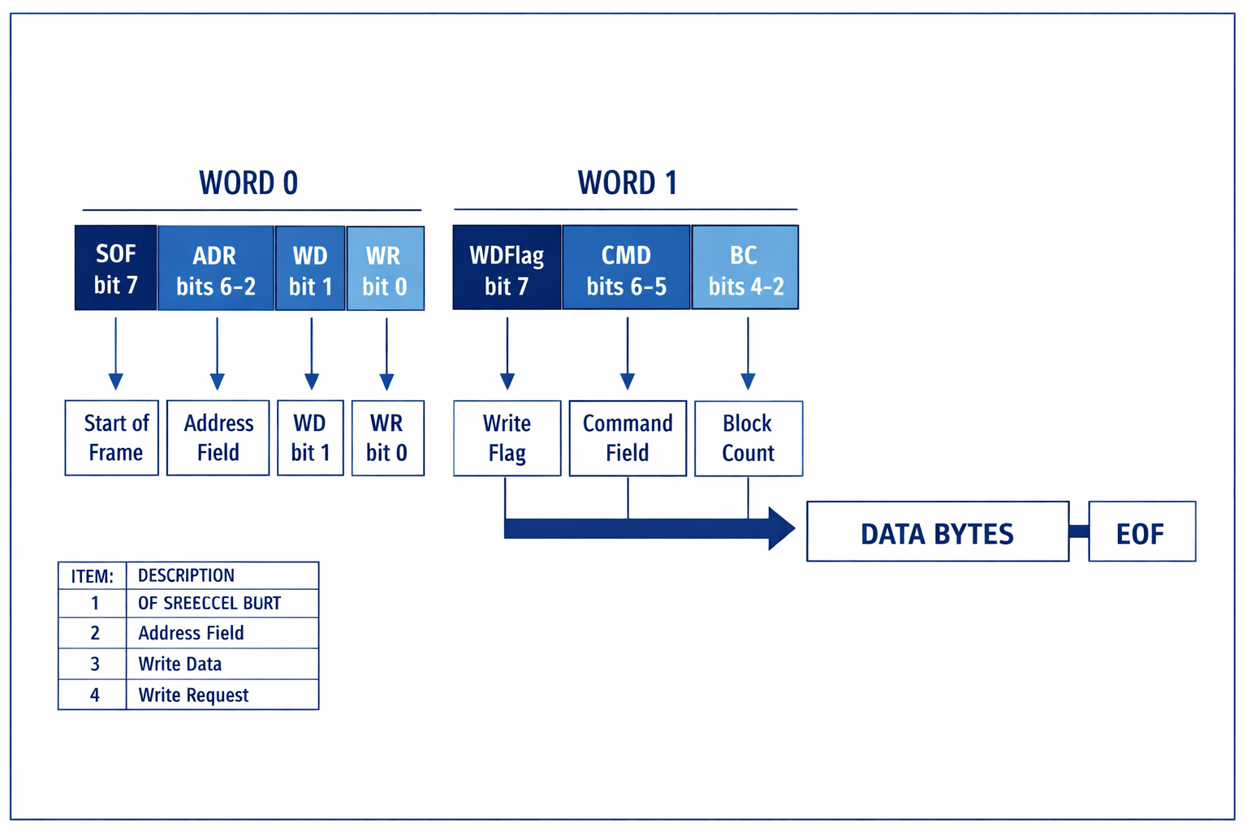
Figure 2 — Frame Structure Exploded View: WORD 0 and WORD 1 Bit Field Definitions
WORD 0 (First Word) WORD 1 (Second Word)
+---------+---------+--------+------+ +---------+---------+----------+
| SOF[7] | ADR[6:2]| WD[1] | WR[0]| | WDF[7] | CMD[6:5]| BC[4:2] |
+---------+---------+--------+------+ +---------+---------+----------+
Bit 7 Bits 6:2 Bit 1 Bit 0 Bit 7 Bits 6:5 Bits 4:2

3.2 Word 0 — Frame Header, First Word
Word 0 Bit Field Definitions
Bits | Field | Description
[7] | SOF | Start of Frame. Set to indicate the beginning of a new frame.
[6:2] | ADR[4:0] | Address of the first target register. Auto-increments after each write.
[1] | WD | Word/Data flag. Always zero (0) for the first word in a frame.
[0] | WR | Write/Read direction. WR=1: controller writes to slave. WR=0: controller requests data from slave.

3.3 Word 1 — Frame Header, Second Word
Word 1 Bit Field Definitions
Bits | Field | Description
[7] | WDFlag | Word/Data flag. Always one (1) for the second word in a frame.
[6:5] | CMD | Command field. Reserved for future use. Will cover: WRITE transfer (basic), complex READ for advanced slave.
[4:2] | BC[2:0] | Byte Count — bytes REMAINING, not counting the current byte. BC=0 allows transfer of 16 bytes. Maximum: 16 bytes per transaction.

3.4 Transfer Count (BC) Encoding
The Byte Count field BC[2:0] encodes the number of bytes remaining in the current transfer, not counting the current byte:

BC Value Bytes Remaining Total Transfer Bytes
-------- --------------- --------------------
0x0 0 1 (current byte only)
0x1 1 2
0x2 2 3
... ... ...
0xF 15 16 (maximum)

3.5 WRITE Transfer — Controller to Slave
A WRITE transfer moves data from the host PC controller to a register on the slave test fixture. Figure 3 provides a combined reference showing the lab bench, frame structure, and WRITE transaction flow together.

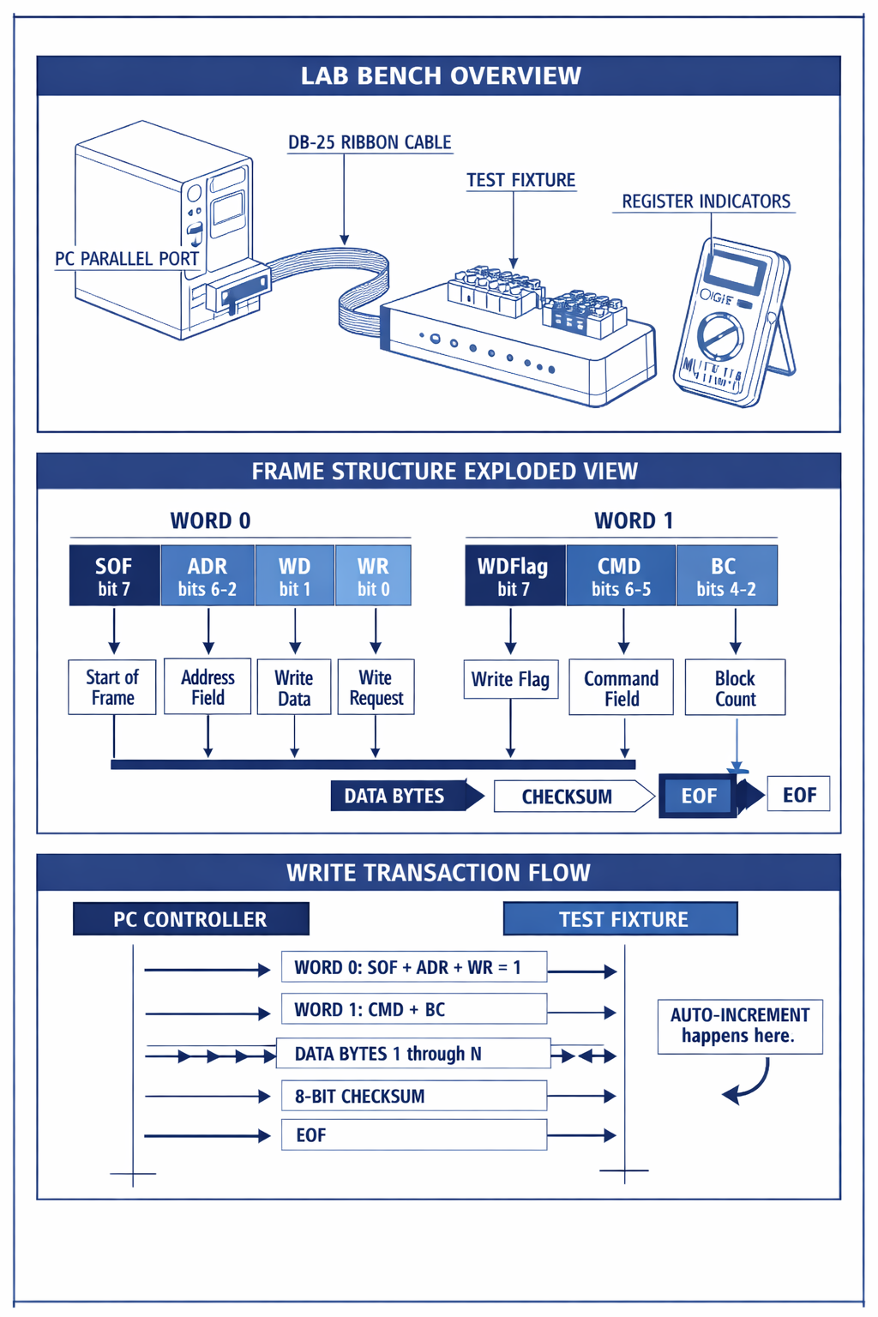
Figure 3 — Combined Reference: Lab Bench Overview, Frame Structure, and Write Transaction Flow
WRITE Transaction Sequence:

1. Controller sends WORD 0: SOF=1, ADR=target address, WD=0, WR=1
2. Controller sends WORD 1: WDFlag=1, CMD=WRITE, BC=bytes remaining
3. Controller sends DATA bytes (count per BC field)
4. Controller sends 8-bit CHECKSUM
5. Controller sends EOF character

3.6 READ Transfer — Slave to Controller
Two READ variants are defined. Figure 4 shows the Read Transaction Flow sequence diagram.

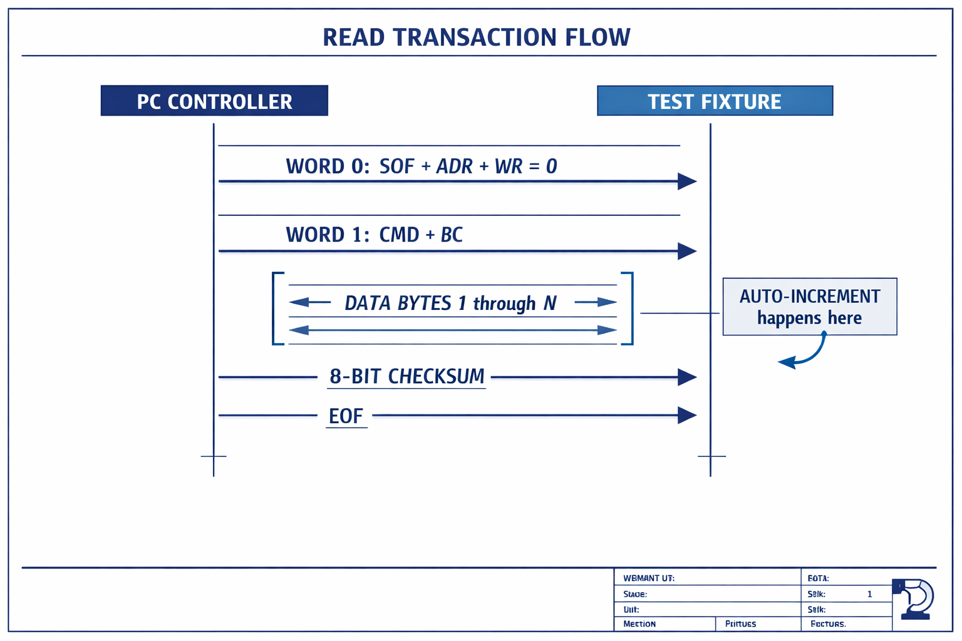
Figure 4 — Read Transaction Flow: PC Controller to Test Fixture Sequence Diagram

3.6.1 Basic READ — Simple Slave
Basic READ Sequence:

1. Controller sends WORD 0: SOF=1, ADR=target, WD=0, WR=0 (read)
2. Controller sends WORD 1 with BC specifying expected return count
3. Test fixture returns 1 to 16 data bytes (IEEE 1284 handshake)
4. Checksum byte follows data
5. EOF character terminates the transaction

3.6.2 Complex READ — Advanced Slave
Complex READ Sequence:

1. Controller sends WORD 0 with WR=0 (read request)
2. Test fixture returns multi-transfer data list with IEEE 1284 handshake
3. End of Message (EOM) indicator marks completion

NOTE: Error recovery for broken reads TBD.
EOM indicator format to be defined in future revision.

3.7 Frame Termination
Each binary frame is terminated by:
- 8-bit checksum byte covering the data payload
- EOF (End of Frame) character

4. CONNECTION METHOD B — ASCII CHARACTER PROTOCOL

The ASCII Character Protocol provides full compliance with the ASCII character set. All fields are encoded as printable ASCII characters, making transactions human-readable and suitable for logging, debugging, and serial terminal monitoring.

The test fixture shall be expected to have 16-bit registers encoded as 4 ASCII hex characters per register (e.g., register value 0x1A2B is encoded as the string "1A2B").

4.1 Command Fields
ASCII Protocol Field Definitions
Bits | Field | Description
C | Command (ASCII 0x43) | Specifies the operation type. May be a direct single-packet write or other defined command.
A | Address (ASCII 0x41) | Target register address.
L | Length | Length of the transfer. Min: 0x0000. Max: 0xFFFF.
E | End of File | Marks end of transaction. Followed by checksum in hex ASCII.

4.2 Register Value Encoding
Register values are encoded as 4-character uppercase hexadecimal ASCII strings:

Register Value ASCII Encoding
-------------- --------------
0x0000 "0000"
0x00FF "00FF"
0xFFFF "FFFF"
0x1A2B "1A2B"

Minimum value: 0x0000 -> "0000"
Maximum value: 0xFFFF -> "FFFF"

4.3 Example ASCII Transaction
Example: Write value 0x1A2B to register 0x0004

C W Command = Write
A 0004 Address = Register 4
L 0001 Length = 1 register
1A2B Data = 0x1A2B
E <checksum> End of File + checksum

5. ERROR HANDLING AND RECOVERY

5.1 Timing and Synchronization
All transactions are synchronized to the rising clock edge. Figure 5 shows the complete timing diagram including system clock, PC controller write strobe, test fixture ready flag, data bus sequencing, error flag behavior, and retry command window.

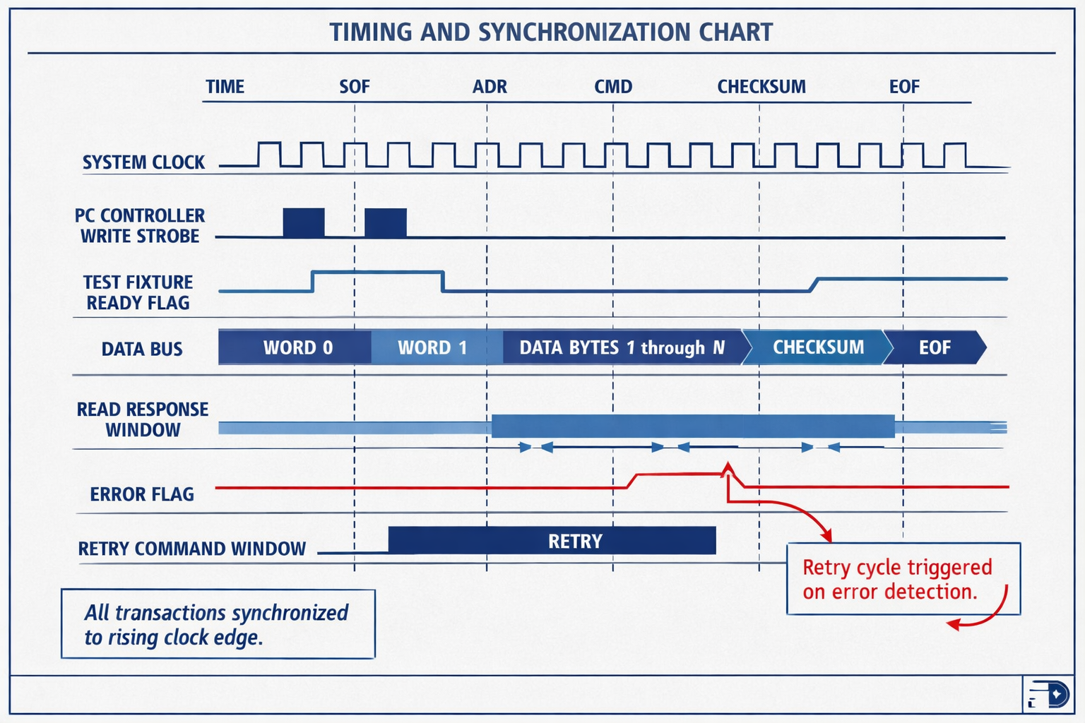
Figure 5 — Timing and Synchronization Chart: Signal Timing, Error Flag, and Retry Cycle

5.2 Checksum Verification
Both the Binary and ASCII protocols include an 8-bit checksum at the end of each transaction. The receiving device shall verify the checksum and indicate an error condition if verification fails. As shown in Figure 5, a retry cycle is triggered automatically on error detection.

5.3 Broken Read Recovery
NOTE: The procedure for recovering from broken or incomplete READ transactions is not fully defined in this revision. A future revision shall define the EOM (End of Message) indicator format and the complete recovery sequence. The retry command window shown in Figure 5 represents the current prototype behavior.

5.4 IEEE 1284 Handshaking
Return data from the test fixture follows the IEEE 1284 handshake protocol. The controller shall expect between 1 and 16 bytes in response to a basic READ request, with the exact count specified by the BC field in the outbound frame header.

6. PROTOCOL COMPARISON

Feature | Binary Frame Protocol | ASCII Character Protocol
Encoding | Binary | ASCII hex characters
Human Readable | No | Yes
Efficiency | High | Lower (4x overhead)
Register Width | Variable | 16-bit (4 ASCII chars)
Max Transfer | 16 bytes | 0xFFFF registers
Checksum | 8-bit binary | Hex ASCII
Debug Friendly | No | Yes
Use Case | Production, speed | Development, logging

7. FIGURE INDEX

Figure | Description
Figure 1 | Lab Bench Setup — PC, DB-25 Ribbon Cable, Test Fixture, Digital Multimeter
Figure 2 | Frame Structure Exploded View — WORD 0 and WORD 1 Bit Field Definitions
Figure 3 | Combined Reference — Lab Bench Overview, Frame Structure, and Write Transaction Flow
Figure 4 | Read Transaction Flow — PC Controller to Test Fixture Sequence Diagram
Figure 5 | Timing and Synchronization Chart — Signal Timing, Error Flag, and Retry Cycle

8. REVISION HISTORY

Rev | Date | Author | Description
1.0 | 2007 | B. Rogers | Initial release — Binary Frame and ASCII Character protocols defined.

9. FUTURE WORK

The following items are identified for future revisions of this specification:

- Define EOM (End of Message) indicator format for complex READ recovery
- Define error recovery procedure for broken READ transactions
- Expand CMD field definitions as command set is implemented
- Define handshake timing requirements for IEEE 1284 compliance
- Add register map for standard test fixture configurations
- Consider CRC-16 upgrade from 8-bit checksum for improved error detection

END OF DOCUMENT
Bradz Protocol Rev 1.0 | Bradley Rogers | 2007

