Quadrature Downconverter

Sriram Alluri Kushang Agarwal

*ECE* *ECE*

*IIIT – Hyderabad IIIT – Hyderabad*

Hyderabad, India Hyderabad, India

[sriram.alluri@students.iiit.ac.in](mailto:sriram.alluri@students.iiit.ac.in) [kushang.agarwal@students.iiit.ac.in](mailto:kushang.agarwal@students.iiit.ac.in)

**Abstract – The quadrature downconverter is a circuit used in modern communication methods. It can be abbreviated as QDC and we will be using this to refer to it here-on. A QDC is commonly used in wireless receivers such as WLAN, Bluetooth and Wi-Fi to name some. A down-converter converts a higher frequency signal to a signal with lower intermediate frequency and also makes sure the noise received in the final output is minimal. We are going to implement a prototype of a QDC.**

**Keywords – Quadrature Downconverter (QDC), digital, frequency.**

I. INTRODUCTION

Analog down-converting devices are used in receiver applications to down convert radio frequency (RF) signals to the desired intermediate frequency (IF) while ensuring low noise. A Quadrature Down-Converter is a type of digital downconverter used in the down-conversion of input signals with a very high frequency and outputs two quadrature waves, one in-phase and the other out of phase. The in-phase and out of phase waves constitute a phase difference of 90°.

QDC’s are used to improve the quality of communication. They reduce the interference and noise that occurs during the transmission of the information to be conveyed. The quadrature downconverter constitutes of the following components,

* Quadrature oscillator
* Switch (mixer)
* Low Pass Filter

These together can down-convert a signal and give two outputs that are intermediate frequency signals.

The working of the Quadrature downconverter is discussed below, followed by a discussion on each component.

II. WORKING

The quadrature down-converter primarily comprises three components, the quadrature oscillator, the mixer (switch) and the low-pass filter. As mentioned above, this circuit is supposed to aid us in retrieving the original signal that was up-converted for communicating over long distance. The up-converted signal is multiplied by another signal which is generated from the oscillator and then passed through a low pass filter which gives us the original signal. The role of the oscillator is to generate a signal to multiply the up-converted signal with. Mixer makes sure of the multiplication of the signals and low pass filter ensures we get the original signal. Upon multiplying two sinusoidal signals with different frequencies, we get the resultant signal which has two sinusoidal components, one with difference of the frequencies and one with the sum as the frequency. Our desired output is to extract the component with the difference of the original frequencies and the low pass filter helps us in doing so. It attenuates the other component to an extent where it is negligible, and we possess the desired signal. The detailed explanation for these processes happening with the aid of different circuits are mentioned in the following sections.

III. QUADRATURE OSCILLATOR

The quadrature oscillator is a critical component of the quadrature down converter. A quadrature down convertor, as we know, lowers the frequency of the output signal to make following radio stages in communication easier. As a result, we require a circuit that can generate two sinusoidal signals, one sin and one cos. In short, we need a 90° change between the two waves.

Without any input signal, the Oscillator turns the DC supply to an op-amp into an AC signal. A simple feedback circuit with a total phase shift of 360° is required. Another requirement for an oscillator is that the product of the gain of the amplifier and the gain of the feedback circuit be greater than 1. A black box representation of an oscillator is shown below.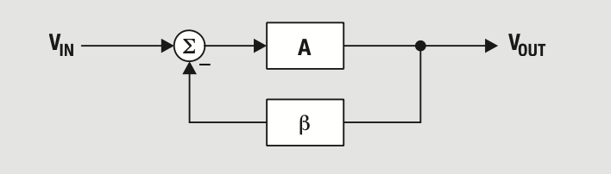

Here, the amplifier part if the circuit has a gain of A and the feedback of the circuit has a gain of B. The expression for the closed loop gain is given as,

For A < 1, our oscillations will damp while if it is A > 1 then the oscillations will increase, so to act as an amplifying circuit we prefer for A to be greater than 1.

Our total phase shift must be 360 or 0 since our output should be the same when the entire loop is completed, which will occur if there is no shift at all or if there is a shift of an entire cycle that is 360°.

Our Oscillator circuit uses 2 op-amps as integrator circuits for amplifying the DC energy and then a RC filter circuit as the feedback which is used to give the required phase shift to the feedback and filter all the noise which could potentially disturb the outputs.

Following is the schematic of the circuit,

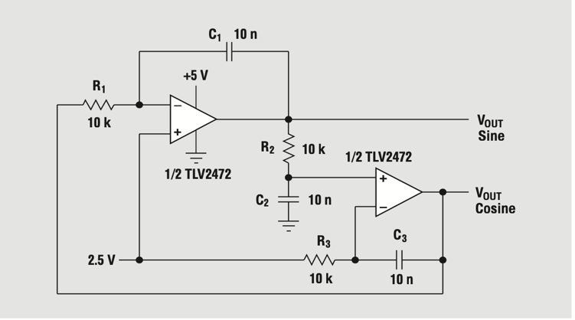

Here ,

When ,

The phase of the two op-amps cancel each other out and this is how we get a 0° phase shift

To generate sinusoids of frequency 100Khz,

On using values of R and C which satisfy these conditions however don’t give the right output i.e. we observe a considerably low frequency as compared to 100KHz. Therefore , we decided to lower the RC values in the hardware simulation and the values picked were R= and C=1nF ( based on experimenting the circuit in lab).

The recorded frequency in the simulation is around 99KHz

With this we have understood how a quadrature amplifier works and the following is the final schematic of our oscillator circuit built in LT Spice,

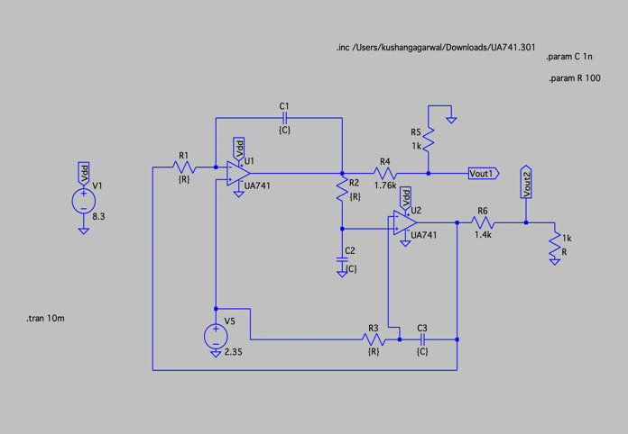

Following are the transient plots of the 2 sinusoidal signals with a phase difference.

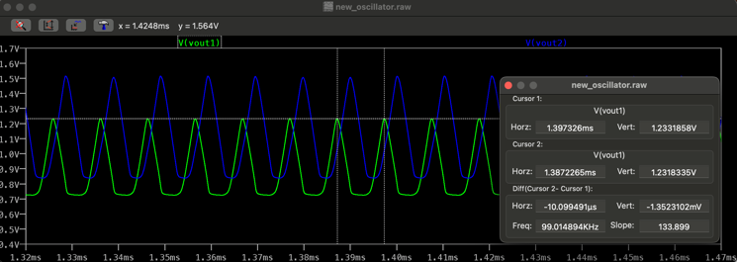

After differentiating one of the graphs, the graphs should overlap as the differentiation of sin is a cos wave and this way we can show the 90 degree phase shift.

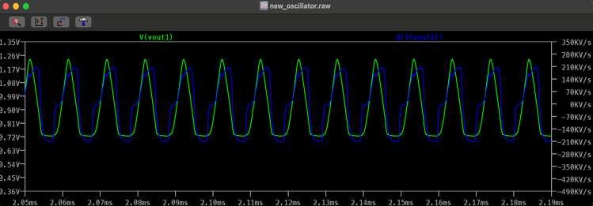

Following are the Fast Fourier Transformations of both the sinusoidal signals.

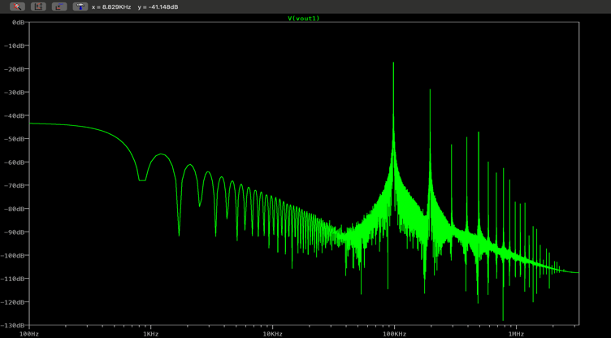

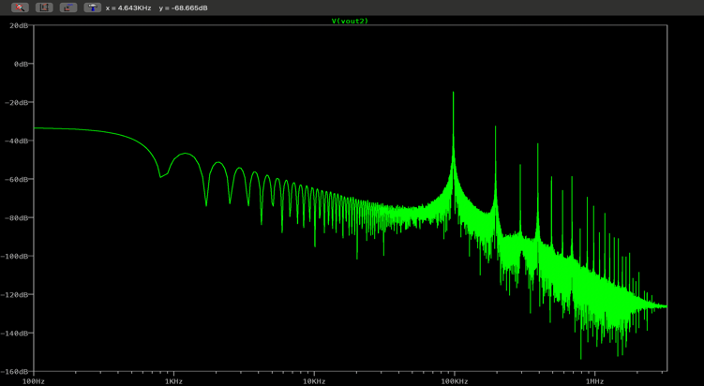

The above oscillator circuit is now realized on a breadboard but with tweaked values due to imperfections shown by the op-amp when in practical use.

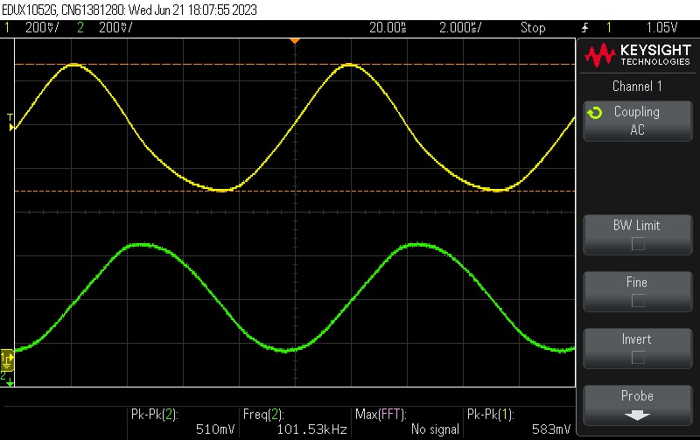

FFT of oscillator output:

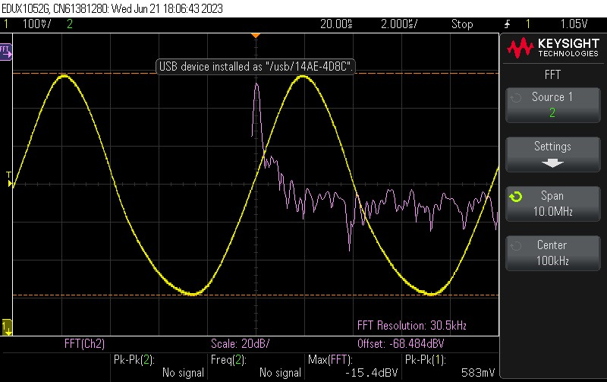

IV. SWITCH (MIXER)

The mixer circuit's primary function is to multiply two signals sent to distinct MOSFET terminals. The goal of signal multiplication is to retrieve the initial input wave that was up transformed for transmission purposes. Multiplying yields the terms cosAcosB and cosAsinB, which can be written as follows: -

We need the and at the two outputs of the quadrature down converter and the mixer aids us in obtaining those terms as a part of the signal which is passed through the low pass filter which in turn outputs only the said terms.

The functioning of the mixer can be comprehended by referring to the following circuit diagram: -

*Figure: reference circuit diagram of the switch (mixer).*

The purpose of including the capacitor (Cc) and the resistor (RBIAS) is to prevent the voltage to be directed into the ground connected to the other voltage source and to ensure the voltages add up at the terminal connected to the gate of the MOSFET. In order to prevent the above stated issue, we have to make sure that the reactance of capacitor and resistor are high so that current from Vosc doesn’t flow through R and current from VBIAS doesn’t flow through Cc. Therefore, we chose the values of R and C as 10 kohm and 0.01µF.

Multiplication of VOSC and Vin is the desired output of the mixer. For this to work, MOSFET must be outside the cut-off region. VBIAS is set to a value such that it ensures the MOSFET remains out of the cut-off region. Therefore, the value chosen for VBIAS was around 0.8as the cut-off for the NMOS in IC MC14007 is observed to be 0.7V. VOSC is taken to be a sine/cos wave passed on from the oscillator with amplitude 500mVamplitude and 100kHz frequency. Since the dc offset supplied to the gate is slightly greater than threshold voltage, the MOSFET is in saturation with VGS = VOSC – Vin + VBIAS … (1)

The output measured can be determined as IDS × RL. (Given value of RL = 1kΩ)

*\*IDS is the current flowing between drain and source*

The expression for IDS in saturation region is given by: -

IDS = (VGS – VTH )2…… (2)

Upon substituting the expression for VGS from equation (1), we get (VOSC – Vin)2 as part of the expression for IDS. Since output is IDS × RL, even the output has the (VOSC – Vin)2 term. Upon expanding the (VOSC – Vin)2 term, we obtain -2(VOSC × Vin) term that is the desired term expected at the output.  
Thus, the mixer functions as a black box that multiplies two input signals sent as inputs

Simulating the switch on LT-Spice: building the circuit we get the following circuit,

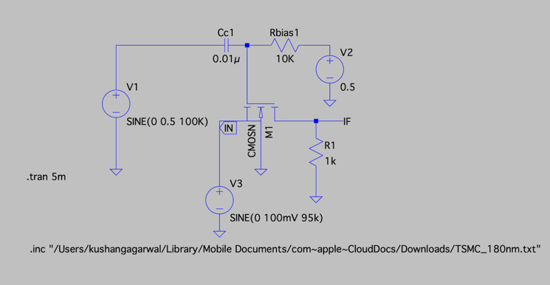

*Figure: circuit schematic of the switch (mixer).*

Plotting VIF, which is the mixer output.

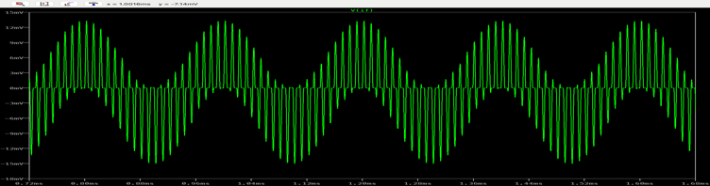

The output is a multiplication of the two input signals, VOSC and Vin.

Observing the differences in the output wave when input frequency is changed and also look at their corresponding FFTs.

* Frequency = 95 KHz

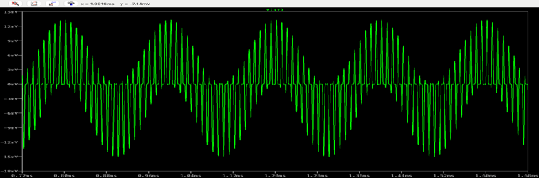

*Figure: trans plot of VIF for 95KHz.*

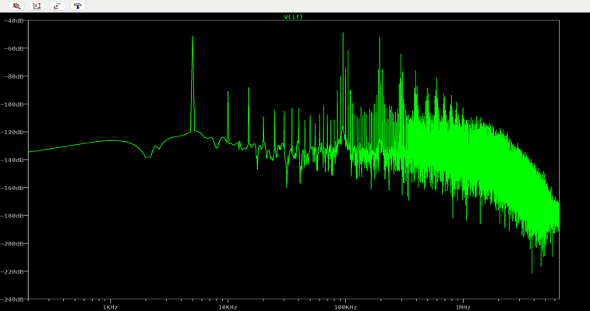

*Figure: FFT for an input signal of 95KHz.*

* Frequency = 98 KHz.

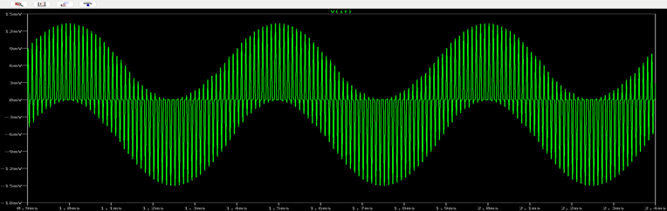

*Figure: trans plot of VIF for 98KHz.*

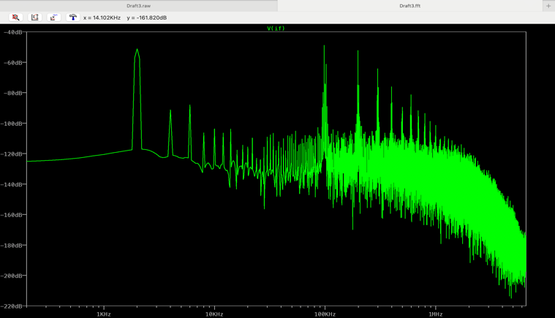

*Figure: FFT for an input signal of 98KHz*

* Frequency = 99 KHz.

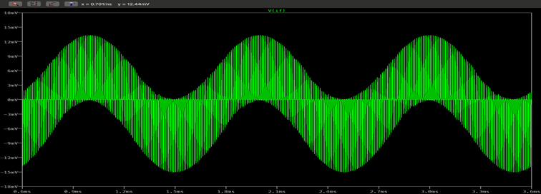

*Figure: trans plot of VIF for 99KHz*

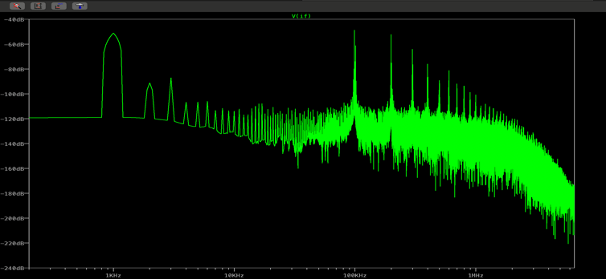

*Figure: FFT for an input signal of 99KHz.*

* Frequency = 101 KHz.

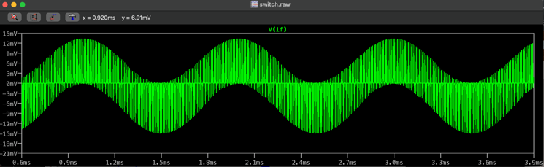

*Figure: trans plot of VIF for 101KHz.*

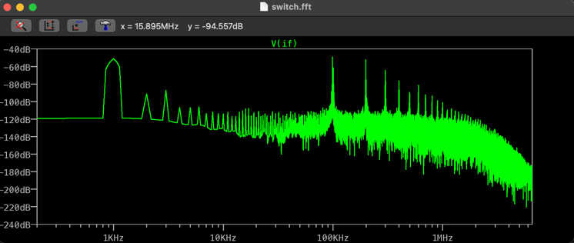

*Figure: FFT for an input signal of 102KHz.*

* Frequency = 102 KHz.

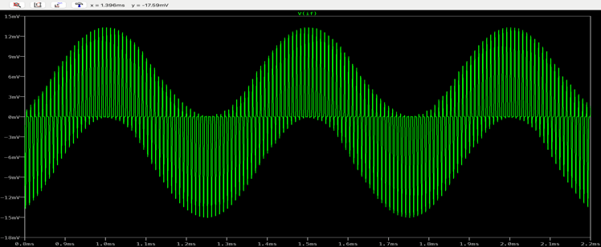

*Figure: trans plot of VIF for 102KHz.*

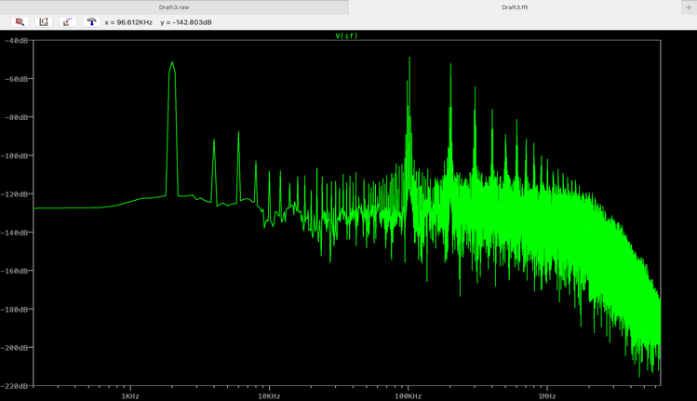

*Figure: FFT for an input signal of 102KHz.*

* Frequency = 105 KHz.

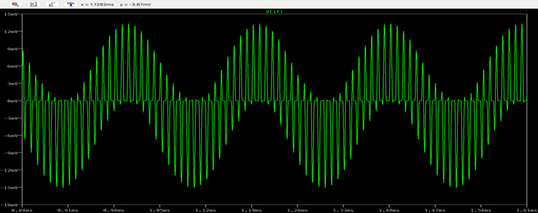

*Figure: trans plot of VIF for 105KHz.*

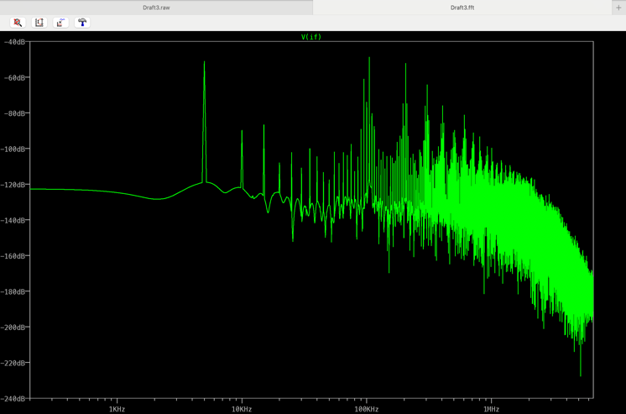

*Figure: FFT for an input signal of 105KHz.*

The basic shape of the graph is due to the switching action of the mixer. The value of VBIAS has been chosen something close to the threshold value and when the oscillator signal is added up to the biasing voltage, the MOSFET enters the cut-off region at regular intervals (when VOSC is negative) and we observe that the output signal approaches zero. But due to the high frequency being supplied, it does not reach zero, and start rising up as the VOSC switches to positive values.

From the FFT’s we can observe prominent rises in the graph when the frequencies are either a sum or difference of the input and oscillator input signals or the individual frequency of the said input signals themselves. This is expected to take place, as it can be observed upon expanding equation (2) mentioned above in this section.

Following is the plot we obtained when we made the hardware for this part of the circuit

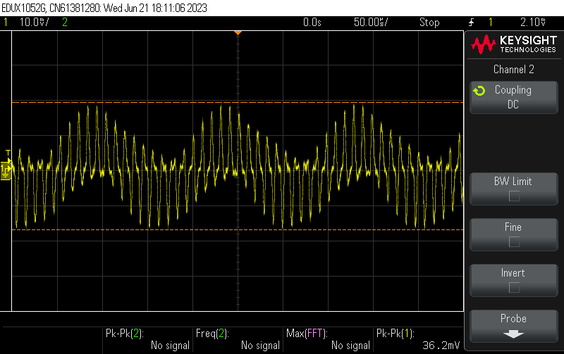

We used 1F instead of 0.01F in the hardware part of the circuit because we were getting different peaks for the positive and negative half of the wave.

*Figure: FFT of the mixer output.*

V. LOW PASS FILTER

A low-pass filter is a filter that passes signals with a frequency lower than a selected cutoff frequency and attenuates signals with frequencies higher than the cutoff frequency. An ideal low pass filter will eliminate all frequencies above the cutoff frequency but as we deal with a real filter, it attenuates i.e., lowers the amplitude of the input wave and then outputs it. Our implementation of a low pass filter makes use of a resistor and a capacitor. The circuit is shown in the figure below.

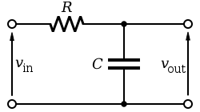

*RC implementation of a low pass filter.*

The filter works on the principle that a capacitor is a circuit element that has its behavior dependent on the frequency of the signal inputted. The capacitor exhibits reactance,

The reactance is inversely proportional to the capacitance and the angular frequency of the signal passing through it. The higher the frequency, the lower the reactance of the capacitor. When the reactance of a capacitor is low, the voltage drops across it is lesser and the output that we obtain at Vout is smaller. This gives us the effect of attenuation at higher frequencies.

The cut-off frequency of a low pass filter is the frequency below which all frequencies are passed as is and frequencies above the cutoff value are attenuated. This cutoff frequency can be calculated by using KVL.

Applying KVL,

*\*X is the reactance of the element*

As Vout is voltage across capacitor,

The corresponding ratio of Vout and Vin for a gain of -3 dB should be .

We can obtain this from the formula,

From equation (1), we get

From the above expression, we determine

Or,

*\*Where fc is the cutoff frequency*

A frequency response is the plot of gain i.e., Vout / Vin and phase vs frequency. The general frequency response of a real low pass filter is shown in the following figure.

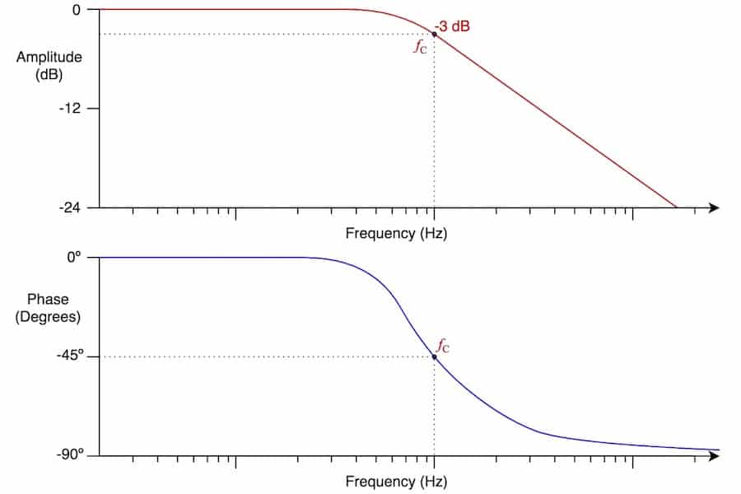

*Figure: frequency response plot.*

As we need a -3 dB cutoff frequency of 2KHz.

Taking the value of the capacitor to be 1 µF, we calculate the value of the resistance. After calculations we get,

First, we run simulations using a software called LT-Spice. Building a circuit using the values obtained above, the final circuit looks as follows.

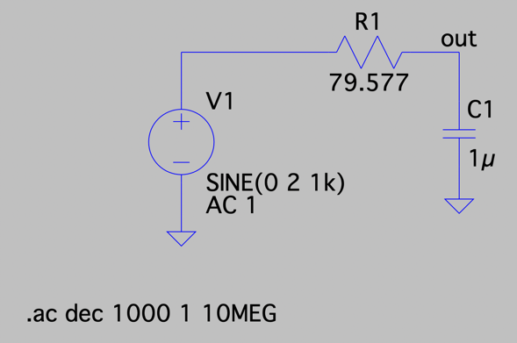

The resultant plot after running frequency analysis is shown.

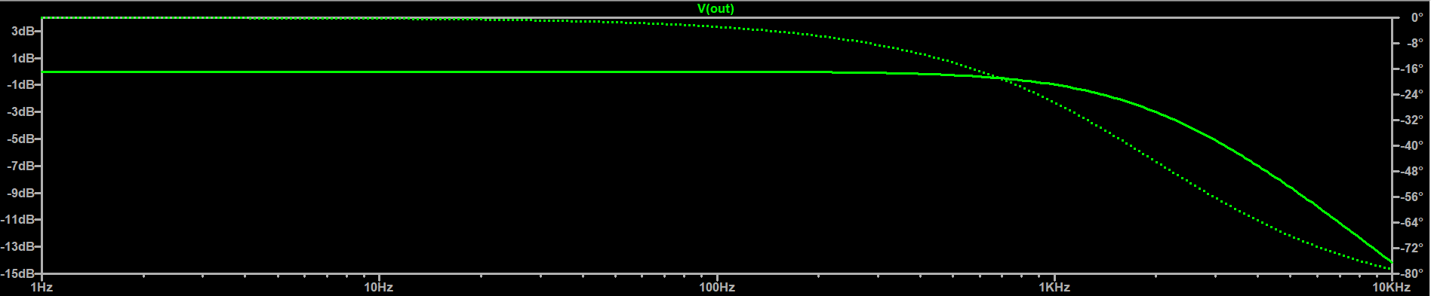

*Figure: frequency analysis simulation.*

The plot is as expected. Measuring the -3 dB frequency using cursors,

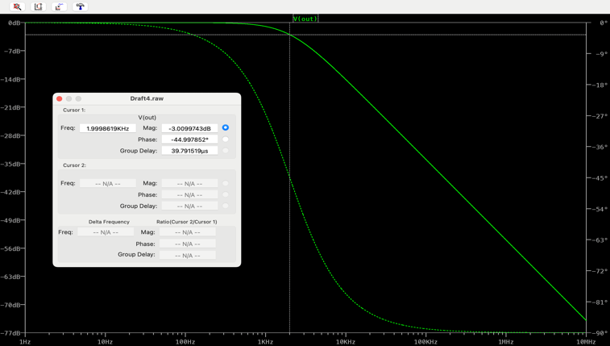

*Figure: finding cutoff frequency using cursors.*

Running transient analysis for two frequencies, one below cutoff frequency and one above cutoff frequency, we can observe the effect of attenuation and the functioning of this low pass filter.

First, we input a sine wave of amplitude 2 Vpp and frequency of 1KHz, the obtained output is shown.

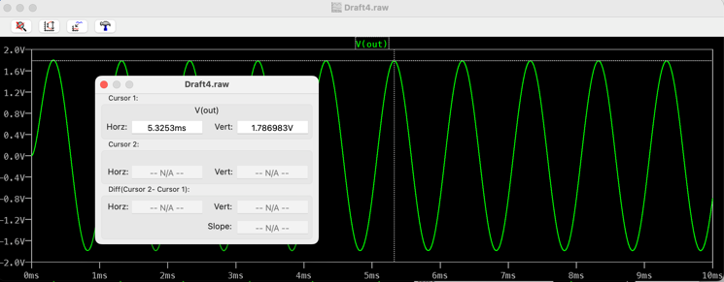

*figure: output plotted in transient analysis of 1KHz signal.*

The output is a sine wave with a slightly lesser than the input amplitude. This is in line with the property of a low pass filter of allowing signals of frequencies lesser than the cutoff 2KHz.

Now, passing an input signal of amplitude 2 Vpp and frequency of 10 KHz.

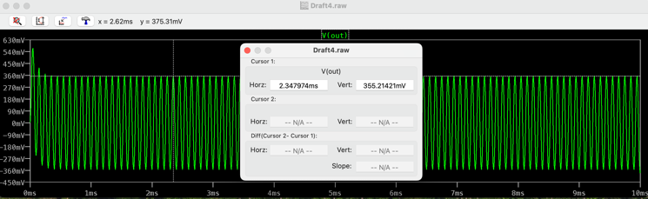

*figure: output plotted in transient analysis of 10KHz signal.*

The output wave has a much lower amplitude than the input signal, this is called attenuation. The result is as expected as 10 KHz is above the cutoff frequency of 2 KHz.

Using these values, we build our circuit and run frequency analysis. The obtained plot is shown.

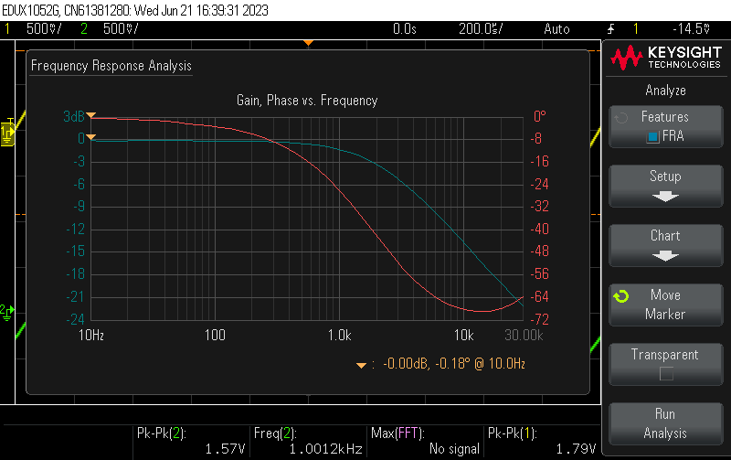

*Figure: frequency analysis of the RC filter.*

The plot is similar to one that is expected from a real low pass filter. And the – 3 dB cutoff frequency can be observed to be very close to 2 KHz. This verifies our calculations and also, we now have a low pass filter with the desired cutoff frequency.

Running transient analysis for two frequencies, one below cutoff frequency and one above cutoff frequency, we can observe the effect of attenuation and the functioning of this low pass filter.

First, we input a sine wave of amplitude 100 mVpp and frequency of 1KHz, the obtained output is shown.

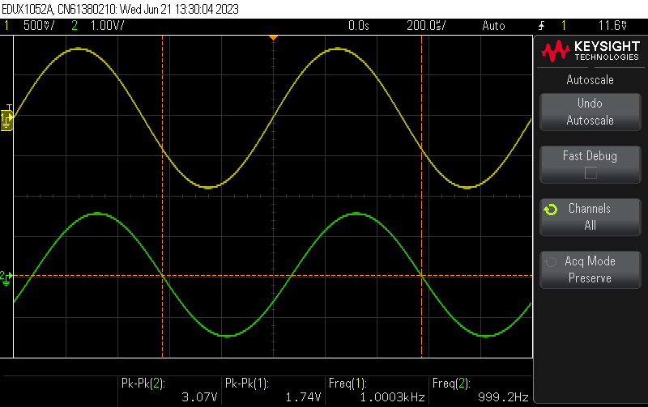

*Figure: output of the low pass filter for 1 KHz input.*

As observed the output is a sine wave of the same frequency and the amplitude of the output is similar to that of the input. We can conclude that there is minimal loss in the amplitude and attenuation is negligible.

Now, passing an input signal of amplitude 100 mVpp and frequency of 10 KHz.

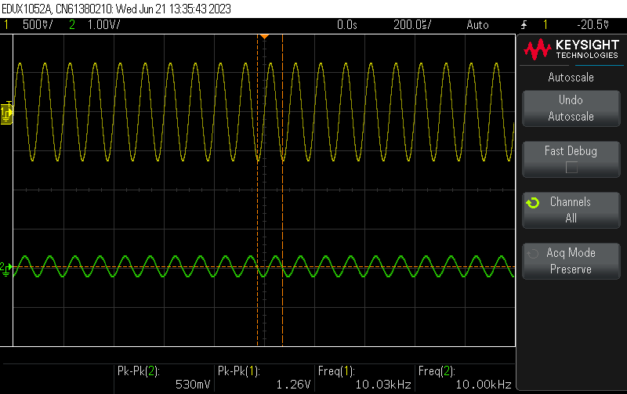

*Figure: output of the low pass filter for 10 KHz input.*

As observed the input wave is attenuated and produced as the output. The result is as expected as 10 KHz is above the cutoff frequency of 2 KHz. Hence, the resultant output signal is attenuated.

VII. COMPLETE PROTOYPE DESIGN

The process up till this point has been about creating and verifying the working of individual components that are required for a quadrature downconverter.

Combining all these components, namely the quadrature oscillator, the Mixers, the low pass filters we have the final design for our quadrature downconverter. The reference diagram for attaching all these components is given below.

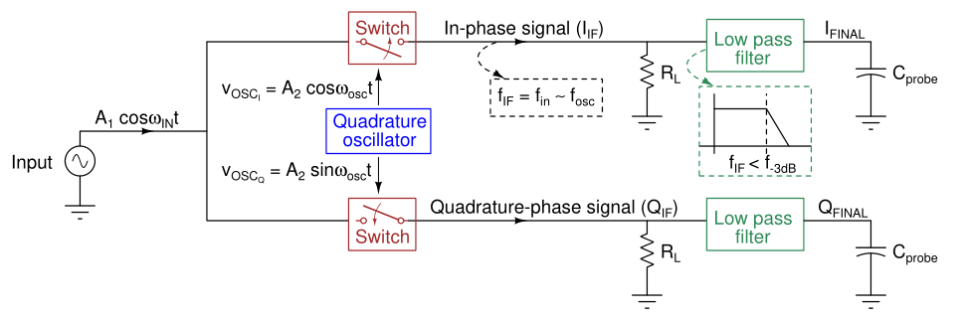

*Figure: design of prototype of the downconverter.*

We will simulate our protype circuit using LT-Spice. Following is the LT-Spice schematic of the circuit.

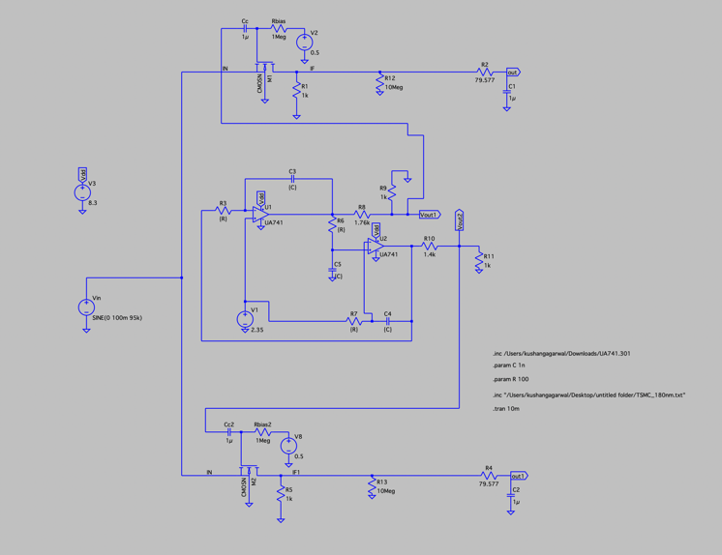

Following are the plots we obtain in our simulation for different nodes of our circuit.

Input Voltage:

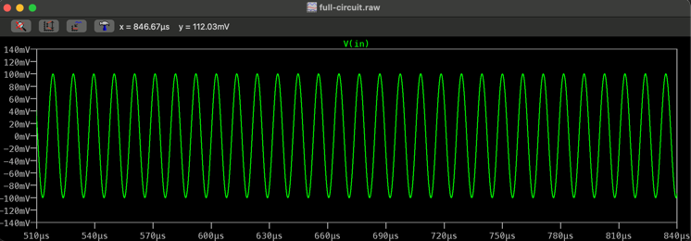

Oscillator outputs:

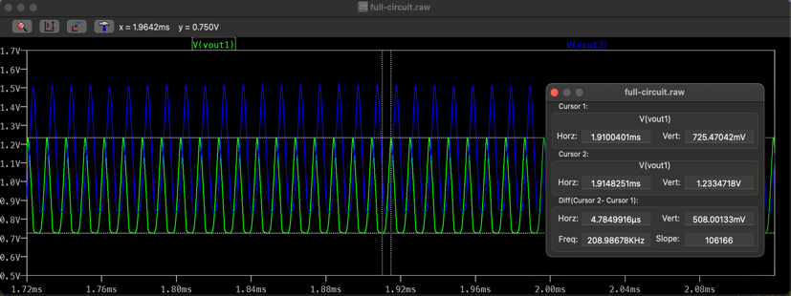

Mixer Output:

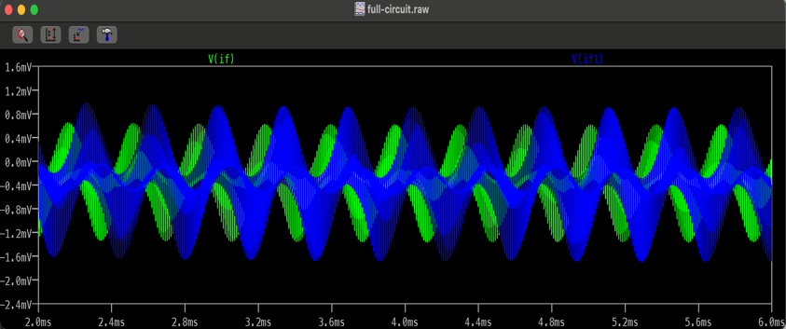

Filter output:

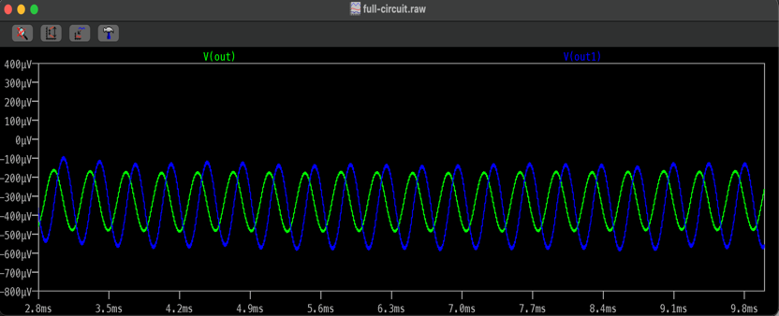

FFT of the output waves:

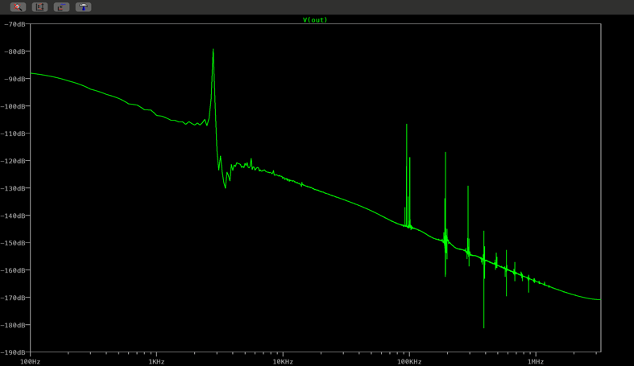

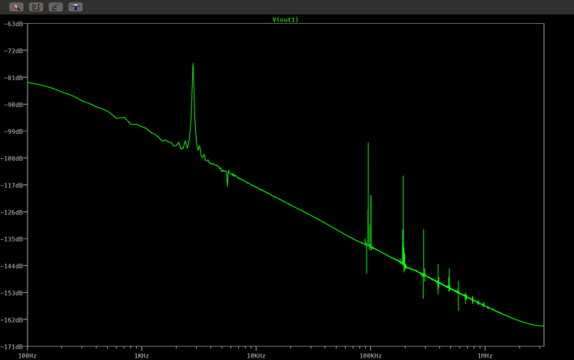

Following are the plots we obtained after connecting all the components of the quadrature down convertor on the breadboard: -

Oscillator output:

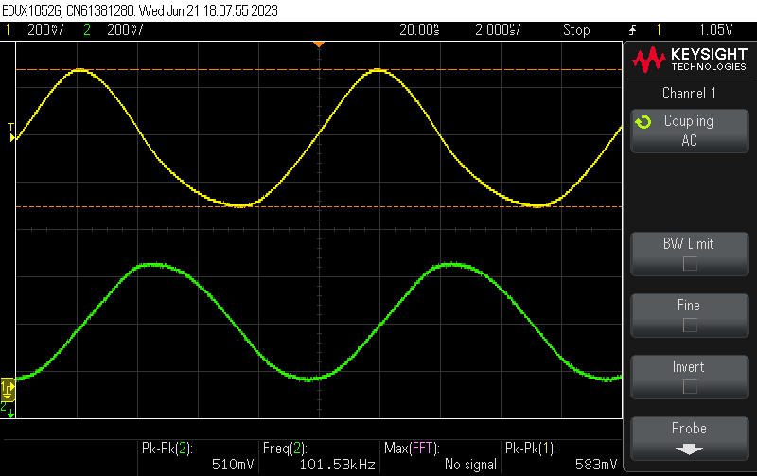

Mixer Output:

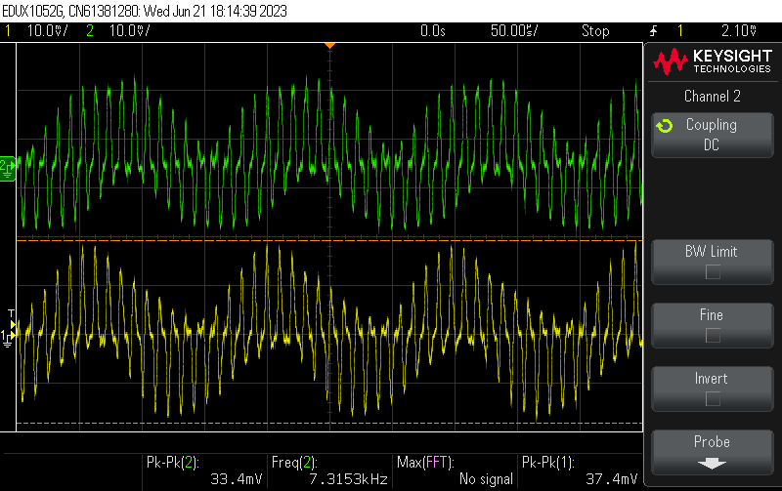

Final Output:

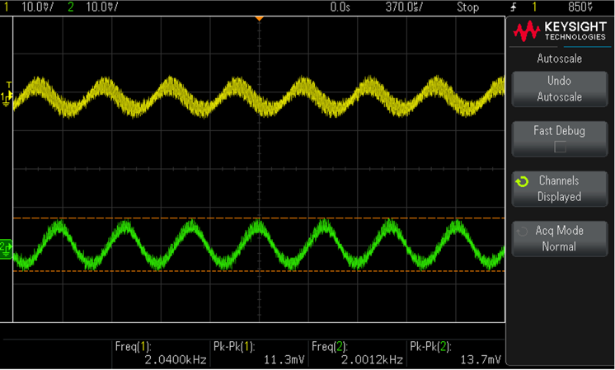

FFT of final outputs:

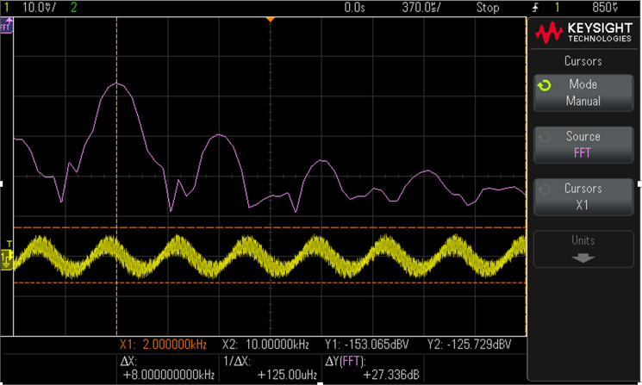

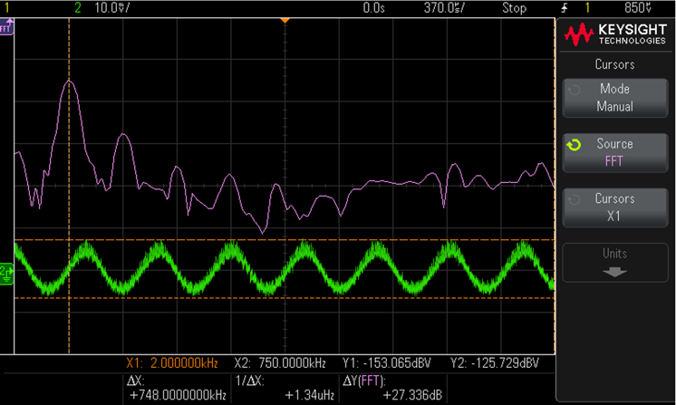

Following is a table which shows the difference between our simulations and implemented circuits.

|  |  |  |
| --- | --- | --- |
| Parameters | Simulated | Implemented |
| Oscillator frequency | 98.06 kHz | 101.53 kHz |
| Oscillator amplitude(I) | 508mV | 583mV |
| Oscillator Amplitude (II) | 508mV | 510mV |
| Oscillator phase | 91° | 73.24° |
| Cc | 0.01uF | 1uF |
| rbias | 10kΩ | 10kΩ |
| vBIAS | 0.5V | 0.55V |
|  |  |  |

VIII. CONCLUSION

The quadrature downconverter is a necessary piece of equipment in modern wireless communication. It aids in the down conversion of received signals and their output at the receiver's end in analog communication. Down conversion is the process of lowering the frequency of a signal to a considerably lower rate. This is done for convenience, as signals with frequencies higher than the carrier wave are difficult to work with.

We have built what is a prototype of a quadrature downconverter. Our model makes use of a quadrature oscillator, mixer and low pass filters. Each of these components and their working has been discussed in detail throughout this paper.

When they are combined, they produce a sinusoidal wave with a much lower frequency, which is desirable and can be used. As a result, down converters are quite crucial. We hope that this study has helped you comprehend the operation and significance of quadrature downconverters.

REFERENCES

[1] [*https://en.wikipedia.org/wiki/Low-pass_filter*](https://en.wikipedia.org/wiki/Low-pass_filter)

[2] Sedra Smith, “Microelectronic Circuits”. Chapter 2.

[3] 1_Directconversion_radio_transceivers_for_digital_ communications.pdf

[4] TI_opamp_osc.pdf