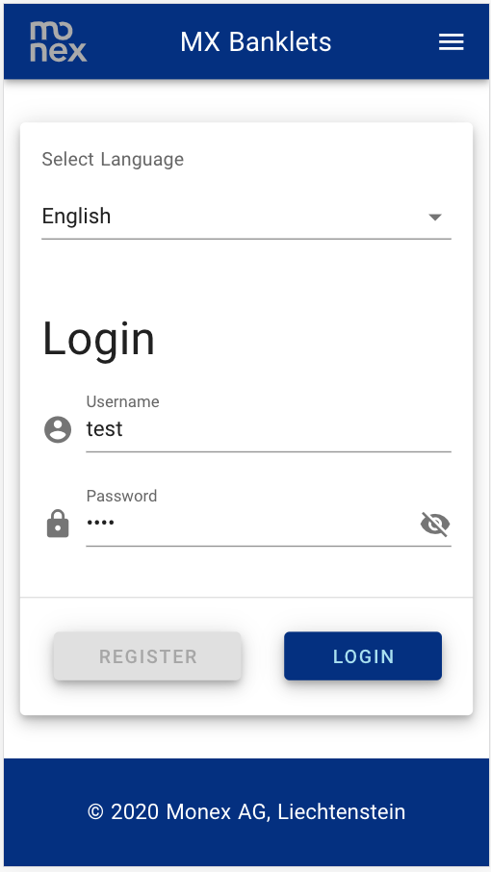

...then click on «Login» to get to the overview page...

...and the password («test»), ...

...enter your username («test»)...

After the start of the app, the login screen will show...

Select language here, ...

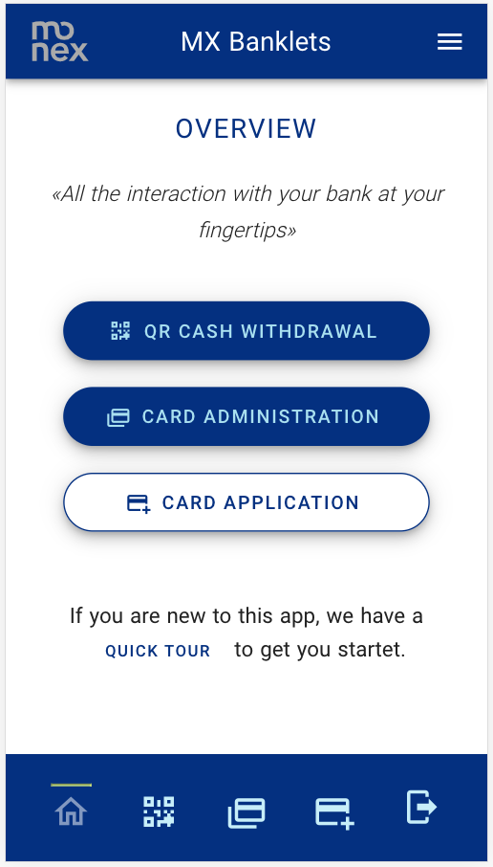

Or use the buttons in the footer to get to the appropriate pages quickly.

You can reach the main functionalities through these buttons.

The main functions are available through the pulldown menu.

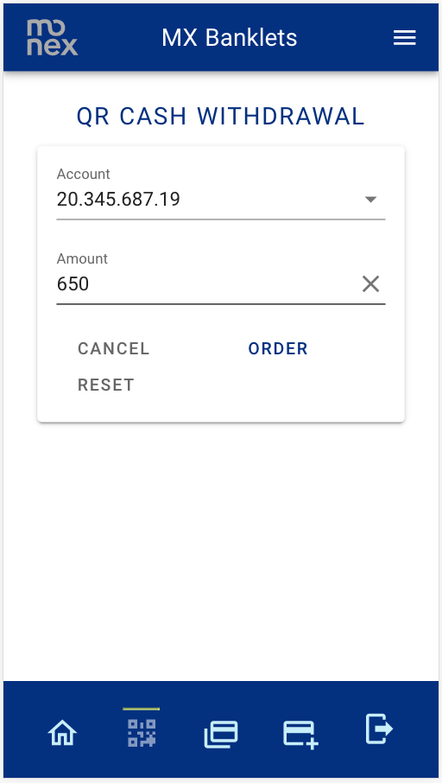

...then click «Order» to order the according QR cash withdrawal.

…enter the amount to withdraw…

Select the account from which you want to withdraw money...

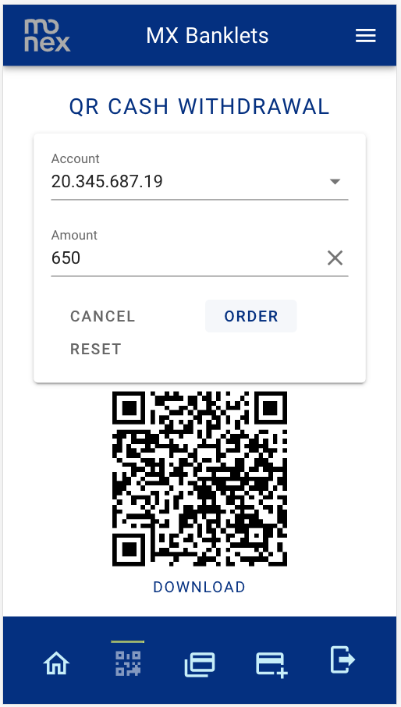

Click on reset to start all over again…

The generated QR code will be displayed.

A click on «Download» will download the QR code to a .PNG file.

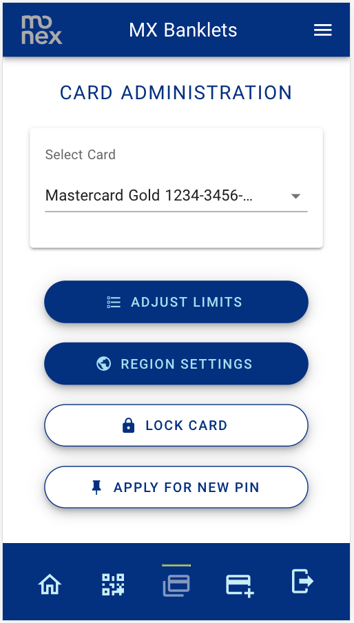

...then select the action of your desire.

Select the card you want to perform actions on...

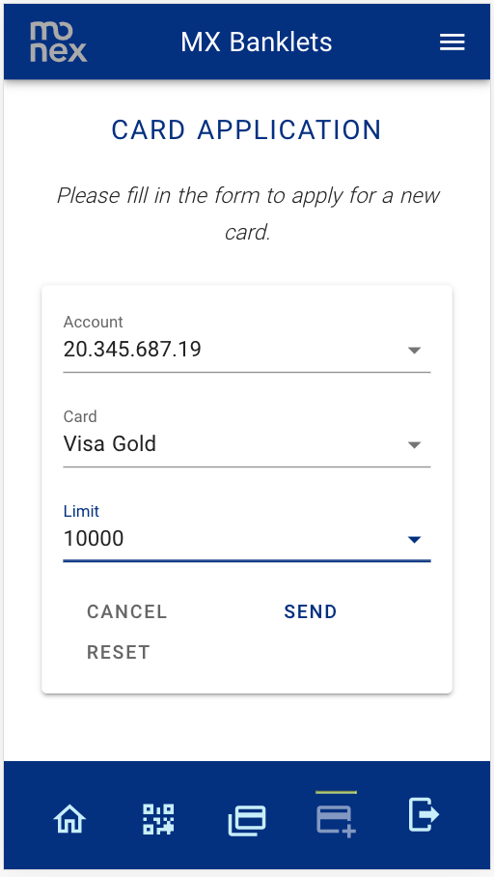

...then click «send» to send in your application.

Choose an account, the type of card and the desired limit...

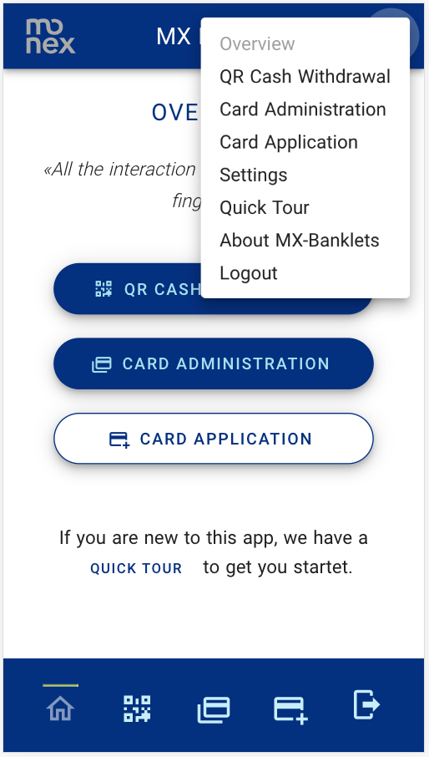

Or click the logout button to return to the login page...

Use the menu to get to further pages like “Settings”, the “Quick Tour” and the about page.



Back on the login screen after a click on «Logout».