**Resistive Network System for Neural Network Computation**

ECE 4011 Senior Design Project

Section L4A, Resistive NN Emulator Team

Project Advisor: Dr. Shimeng Yu

Team Members:

Yunfeng Xin ([yxin34@gatech.edu](mailto:yxin34@gatech.edu))

Sho Ko ([sko45@gatech.edu](mailto:sko.45@gatech.edu))

Runfeng Chen ([rchen324@gatech.edu](mailto:rchen324@gatech.edu))

William Scott (wrscott@gatech.edu)

William Trimmer (wtrimmer3@gatech.edu)

Zheyuan Xu (zxu322@gatech.edu)

Submitted

11/28/2018**Table of Contents**

**Executive Summary**…………………………………………………………………….. 3

1. **Introduction**…………………………………………………………………………. 4
   1. Objective………………………………………………………………………. 4
   2. Motivation……………………………………………………………………... 4
   3. Background……………………………………………………………………. 5
2. **Project Description and Goals**…………………………………………………….... 6
3. **Technical Specification**…………………………………………………………….... 7

3.1 Software Model Specification…………………………………………………... 7

3.2 Hardware System Specification……………………………………………….... 7

1. **Design Approach and Details**………………………………………………………..9
   1. Design Approach……………………………………………………………….. 9

4.1.1 Microcontroller………………………………………………………….. 9

4.1.2 DACs…………………………………………………………………….. 10

4.1.3 ADCs…………………………………………………………………….. 11

* 1. Standards and Constraints……………………………………………………... 13

1. **Schedule, Tasks, and Milestones**………………………………………………….. 13
2. **Project Demonstration**……………………………………………………………... 14
3. **Marketing and Cost Analysis**…………………………………………………….... 16
   1. Marketing Analysis……………………………………………………………. 15
   2. Cost Analysis………………………………………………………………….. 16
4. **Current Status**…………………………………………………………………….... 17
5. **References**…………………………………………………………………………... 18

**Appendix A - Task Table and Gantt Chart**…………………………………………... 20

**Appendix B - Detailed Task Table**…………………………………………………….. 21

**Appendix C - Project Pert Chart**…………………………………………………….... 22

**Executive Summary**

Neural networks are the foundation of modern image classification tasks. However, a typical neural network is computation-demanding and time-consuming in digital data pipelines such as Central Processing Units (CPU) and Graphics Processing Units (GPU). In order to expedite the computation, a novel accelerator that can perform efficient floating-point multiplication operation is needed. This project proposes a hardware emulating system for neural network computation that takes advantage of Ohm’s law and Kirchhoff's voltage law, which describe relationships between voltage, resistance, and current similar to floating point addition and multiplication operation, to accelerate the computation process. The system will include a resistor network that connects input ports and output ports with a series of resistors. The resistor network will take in image pixel data that are mapped to different voltage values and will output current levels representing different floating-point values. The system will also include a microprocessor to preprocess the image to be fed into the resistor network and show the final results of the resistor network computation. Since the entire system eliminates the need for time-consuming digital adders and multipliers as required in traditional CPUs and GPUs, it reduces the time needed for neural network computation. The entire system is also considered cost-effective as both major components --- resistors and a simple microcontroller --- cost no more than $100 when manufactured in great quantities. The system in this project is expected to be capable of recognizing handwritten digits, but it can be applied to other tasks as well with minor modification.

**Resistive Network System for Neural Network Computation**

1. **Introduction**

The Resistive NN Emulator Team will design a resistive neural network emulator system that aims to accelerate neural network computation by eliminating digital multiplier usage. The team is requesting $450 to develop a prototype of the system.

* 1. **Objective**

The team will design and prototype a resistor network system that emulates the floating-point multiplication operations that are essential to neural network computation. A microcontroller unit (MCU) will take in images of handwritten digits, convert the pixel data into corresponding voltage levels, and feed them into the resistor network. The resistor network, which consists of arrays of resistors with different resistance representing the weights of the nodes, will convert the voltage levels into different current levels. The microcontroller will then read the current output of the resistor network and determine which digits the original inputs represent.

* 1. **Motivation**

Most of the neural network computation tasks are carried on digital data pipelines such as CPUs and GPUs and rely on digital multipliers to perform floating point multiplication [1]. A digital multiplier unit typically takes three nanoseconds to complete such an operation, which leaves its processor unit idle for more than 10 cycles [2]. By eliminating the need for such a digital arithmetic unit, floating point operations can be less time-consuming.

Modern CPU prices range from $100 to $1000, while modern GPU prices range from $200 to $3000 [3]. However, the team anticipates that a design without such a multiplier will potentially accelerate the computation. An emulator system with resistive networks is more cost-effective when compared to digital multipliers because one floating point multiplication requires only one resistor in the proposed system, while a digital multiplier consists of more than 20,000 transistors [2].

Similar ideas exist in the fields of memory technology such as Resistive Random-Access Memories (RRAM), but most of the concepts are still under research and there are currently no similar commercial products [4]. The product can be used by users that require efficient processing of images in time-sensitive tasks such as real-time handwritten zip code recognition on envelopes and increase the throughput of the tasks.

* 1. **Background**

There has been extensive research in accelerating neural network computation with a resistive network. The idea was first proposed in 2016 for multi-layer perceptron (MLP) neural network [5]. In the past two years, similar resistive accelerator solutions have been proposed for convolutional neural networks (CNN) and recurrent neural networks (RNN) as well [6], [7]. These techniques mainly focus on semiconductor fabrication level application. Due to the non-linear nature of the fabricated devices, however, no commercial devices are publicly available [5].

There are two key building blocks in this area: applying Ohm’s law that resembles floating point multiplication and applying Kirchhoff's current law that resembles floating point addition. Ohm’s law states that the voltage across a resistor is determined by the current going through the resistor multiplied by the resistance of the resistor. This law makes performing analog floating-point multiplication possible by providing the input voltage level and resistance values and measuring the output current value as the result of the multiplication. Kirchhoff's current law states and the total current output is equal to the sum of all input current. This law makes performing analog floating-point addition possible by providing two analog current values and measuring the output current value as the result of the addition.

1. **Project Description and Goals**

The fundamental goal of the resistive neural network emulator system is to build a proof-of-concept system showing that resistor networks can act as hardware accelerators for performing neural network algorithms. Our hardware system consists of a MCU, two DACs, a resistor network, and ten ADCs which work together to represent the network data as analog voltage and current values. For the purpose of reducing hardware, the MCU in our system is used for both image preprocessing and final handwritten numbers classification. The main image preprocessing functions running on MCU will be normalization and image re-scaling. The resistor network contains 640 resistors, with 64 resistors per column and 10 columns in total. Each network column’s current reflects the confidence level of the model’s classification on the corresponding number, which is translated back to floating number through a DAC and feedback to the MCU. The MCU takes the numbers and displays the classification result on a GUI. The features of our system include:

* Accelerated hardware-based image recognition
* Cost-effective design with only one MCU in total
* Customizable neural network configuration through changing resistors
* GUI for displaying classification result

1. **Technical Specifications**

**3.1 Software model specification**

|  |  |  |  |  |  |  |  |  |  |  |  |  |
| --- | --- | --- | --- | --- | --- | --- | --- | --- | --- | --- | --- | --- |
| **Table 1.** Neural Network model specification   |  |  | | --- | --- | | **Item** | **Specification** | | Detection Accuracy | ≥ 97% | | Execution Time | < 0.1s | | Output Nodes | 10 | | Input Nodes | 64 | | Hidden Layer Number | 1 | |

**3.2 Hardware system specification**

|  |  |  |  |  |  |  |  |  |
| --- | --- | --- | --- | --- | --- | --- | --- | --- |
| **Table 2.** Resistor Network specification   |  |  | | --- | --- | | **Item** | **Specification** | | Quantization Level | 500 | | Resistor Range | 100Ω - 600Ω | | Resistor Mounting | Through Hole | |

|  |  |  |  |  |  |  |  |  |  |  |  |  |  |  |
| --- | --- | --- | --- | --- | --- | --- | --- | --- | --- | --- | --- | --- | --- | --- |
| **Table 3.** MCU Specification   |  |  | | --- | --- | | **Item** | **Specification** | | Analog Input Pin Number | ≥ 10 | | Analog Output Pin Number | ≥ 64 | | Power Supply | 5V | | ADC Resolution | 8 bits | | Interfaces | USB or Serial, I2C, SPI | | RAM | ≥ 8K bytes | |

|  |  |  |  |  |  |  |  |  |  |  |
| --- | --- | --- | --- | --- | --- | --- | --- | --- | --- | --- |
| **Table 4.** DAC Specification   |  |  | | --- | --- | | **Item** | **Specification** | | Resolution | ≥ 8 bits | | Min Voltage Range | 0V - 5V | | Interfaces | SPI | | Supply Voltage | 3V - 15V | |

|  |  |  |  |  |  |  |  |  |  |  |
| --- | --- | --- | --- | --- | --- | --- | --- | --- | --- | --- |
| **Table 5.** ADC specification   |  |  | | --- | --- | | **Item** | **Specification** | | Resolution | ≥ 8 bits | | Current range | -10mA - 10mA | | Interfaces | I2C | | Supply Voltage | 3V - 15V | |

1. **Design Approach and Details**
   1. **Design Approach**

In the resistive network layer, hardware components are used to implement the weights in a single layer of a neural network. For this design, analog voltages are passed into the matrix of resistors, producing analog output currents representing the weighted information values. To implement this, the design uses a DAC to supply the input voltages, an ADC to measure the output currents, and an Mbed microcontroller to read/write data to the DACs and ADCs.

|  |
| --- |
| **Figure 1.** Block diagram of the resistive neural network emulator system. |

***4.1.1 Microcontroller***

The Mbed LCP1768 microcontroller from NXP Semiconductor will be used to control inputs and outputs to the DACs and ADCs. This module was chosen since the students have previous experience programming it, and it has sufficient capabilities to perform the necessary I/O (via I2C/SMBUS and SPI) and processing tasks.

***4.1.2 Digital to Analog Converter (DAC)***

The design uses two AD5372 chips from Analog Devices [8] to supply the 64 input voltages. Each chip provides 32 voltage outputs, ranging from -4V to 8V. The voltage value is read from an internal register, set by the Mbed via the SPI interface. These chips were chosen for the large numbers of output pins, their voltage range, and cheap pricing.

|  |
| --- |
| **Figure 2.** Block diagram of the NXP Semiconductor Mbed LCP1768 microcontroller. |

|  |
| --- |
| **Figure 3.** Detailed functional block diagram of Analog Devices AD 5372 DAC. |

***4.1.3 Analog to Digital Converter (ADC)***

Ten PAC1921 chips from Microchip [9] read the output current values before they are shunted to ground. Each chip reads the current on a single line and stores the digital value in an internal register. The value in this register can be fetched over the PMBUS interface with the Mbed. These chips were chosen for their sufficient current sensing capabilities, and their cheap pricing that will potentially lower the cost of the entire system.

|  |
| --- |
| **Figure 4.** Detailed functional block diagram of Microchip PAC1921 ADC. |

|  |
| --- |
| **Figure 5.** Pinout diagrams of the DAC and ADC respectively. These chips will be mounted on a custom PCB to interact with the resistors and MCU. |

**4.2 Standards and Constraints**

The overarching constraint on the design is having each component communicate effectively with the microcontroller. Fortunately, the Mbed microcontroller supports many communication standards (SPI, I2C, Serial, CAN, Ethernet, USB), thus the design can utilize many unique chipsets. Another constraint is managing the currents through the resistor matrix. Each DAC can only handle a certain load resistance, as well as a maximum current output. The specific DAC and ADC chips were chosen for similar current capabilities (±16mA supplied from the DAC, ±10mA read by the ADC). The values for the resistors will be scaled to conform to these thresholds. Note the DAC can only drive a 10kΩ load from each output, so the resistors cannot exceed that value. Cost also plays a significant role in the design, as it requires many components that tend to vary in price. The specific DACs and ADCs were chosen based on their cost-effectiveness, trading hardware capable of higher power tolerances for a low-cost alternative. When searching for resistors, the team anticipates having to trade accurate resistor values for cheaper resistors (as 640 will be purchased). With less accurate resistor values the accuracy of the neural network will likely decrease, so a decision will be made on how much error is allowed.

1. **Schedule, Tasks, and Milestones**

The Resistive NN Emulator team will be designing and implementing this prototype in Spring 2019. Appendix A contains the task table and the corresponding Gantt chart outlining the time of major tasks. Appendix B contains a more detailed task table with estimated best and worst time scenarios, risk analysis, and team members assigned to the tasks. Appendix C provides a PERT chart with tasks, milestones, and critical paths shown.

1. **Project Demonstration**

The system used for the testing process of our project will be considered to be portable with multi-platform capabilities. The general testing procedure will be conducted by one or more people doing the following:

1. The user will download the machine learning algorithm (such as MLP) into the MCU.
2. The MCU will be connected to the resistive network—consisting of 640 commercially available resistors—by DAC converters, where it sends the analog voltage values.
3. The MCU will generate inputs and feed that into the resistive network. In our case, the inputs are an encoded matrix of data containing the information of an 8-pixel by 8-pixel image file.
4. After passing through the trained resistive network, the data will be read by the MCU from the ADC converters connected to the network. The output data will be collected and buffered to the PC. The data will be visualized and analyzed by the user and compared to the target output to evaluate the performance.

For better visualization, a PC and an oscilloscope should be connected to the setup:

* **Output data acquisition**: The output data can be acquired directly from the MCU by writing to a serial console on a PC and/or to external storage such as a microSD card. This would store the results of the network classification to be used for later information processing.
* **Data visualization**: The data collected can be visualized in MATLAB or other software tools with built-in graphical interface. For real-time visualization, a serial console to a PC will be used alongside LEDs to communicate current status to the user.
* **Output comparison**: The collected data will be visualized and compared with the target output, which is the result generated by running the algorithm on CPU/GPU, or even some open-sourced APIs. The difference can be used to analyze the performance of the resistive network.
* **Visualization for hidden layers**: Oscilloscopes will be used to visualize the process of running the algorithm on the resistive network by monitoring voltage/current outputs in intermediate layers between input and output layers.
* **Samples**: Due to the small size of a single sample image, multiple images will be fed into the network to provide a more thorough analysis of the performance.

1. **Marketing and Cost Analysis**
   1. **Marketing Analysis**

Most deep learning algorithms like neural networks run on digital processors such as CPUs and GPUs, which are power-hungry. Researchers are shifting towards hardware-based neural networks, such as in resistive processing units (RPUs), for speedup in the training process and reduction in power consumption. Although most RPUs are still in the phase of academic research and not commercially available, RPUs have great market potential once they are manufactured and targeted at the appropriate clients.

Compared to CPUs and GPUs, the RPUs have advantages in ways of exploiting analog components of a circuit to emulate a neural network. Specifically, the synaptic weights of the neural network can be represented by the conductance of the resistors, while in digital systems, the digitization process slows down the computation time and causes loss of accuracy. Therefore, this can be the first marketing advantage for RPUs over CPUs and GPUs. In addition, digital processors are good for general-purpose computation but are not computationally efficient at some specific neural networks, while RPUs can be application-specific in the sensor that they have a narrower range of application domain but are very powerful at the tasks in that specific domain. Thus, this makes the second marketing advantage for RPUs over CPUs and GPUs.

* 1. **Cost Analysis**

Assume there is a startup company selling RPU chips. The company hires engineers to do designing which includes system specification, architectural design, functional design, logic design, and circuit design. Assume the company hires around 40 college graduates with bachelor’s degree in either electrical or computer engineering and pay them with starting salary for engineers around $80,000 per year. The annual payment of the company is around $3,000,000. The project of designing RPU chips lasts for two year and each engineer spends ten hours in the first year working on circuit and chip design. The company also needs supplies such as power supplies and cables, which cost around $1,000,000 per year. After the design process, the company sends the design layout to another company for fabrication and packaging [10]. It usually takes around several months for the fabrication process and the cost is around $4,000,000 [11]. After the chips are fabricated and sent back, the company needs to assemble and test the units. This will take several more months in the second for the engineers to finish their work. Additionally, we also take into consideration factors such as fringe benefits, overheads and sale expenses, which cost another $1,000,000. The total cost in the two years of design, fabrication, testing, and overheads is around $12,000,000. Assume we sell the RPU chips in the period of five years and in each year, we sell around 50 thousand chips. We amortize the development costs over all this units and we get around 48 dollars. Assume we sell the chip at around 70 dollars, which is lower than most CPU prices which range from $100 to $1000 and GPU prices which range from $200 to $3000 [3]. The expected profit for each chip is around $22 and the percent profit is around 45%.

1. **Current Status**

Currently, the team has discussed and agreed on the overall functional layout of the entire resistive network and its peripheral supporting components and has listed some of the key specifications of the system as well. Based on the discussion, the team has also made some preliminary choices for the required hardware based on the specification of the system as described in section three and four. Development of the image recognition program for determining resistor values has just begun and is around 20% finished since the software program is near completion. This part is expected to be completed in January 2019, after which team can then evaluate the mapping between the voltage/current levels and the floating-point values, proceed and order the correct resistors for the network, as well as two DAC’s and ten ADC’s, and begin assembling and testing the actual hardware system implementation.

1. **References**

[1] S. Yalamanchili, ECE 8823 GPU Architecture. [Online]. Available: http://ece8823-sy.ece.gatech.edu/. [Accessed: Oct. 21, 2018].

[2] M. Olivieri, “Design of synchronous and asynchronous variable-latency pipelined multipliers,” IEEE Transactions on Very Large Scale Integration (VLSI) Systems, vol. 9, no. 2, pp. 365–376, 2001.

[3] J. Hruska, “Charting 9 Years of GPU Market Shifts Between Intel, AMD, and Nvidia,” ExtremeTech, 05-Sep-2018. [Online]. Available: https://www.extremetech.com/gaming/276425-charting-9-years-of-gpu-market-shifts-between-intel-amd-and-nvidia. [Accessed: Nov. 28, 2018].

[4] S. Yu, "Neuro-inspired computing with emerging nonvolatile memorys," in Proceedings of the IEEE, vol. 106, no. 2, pp. 260-285, Feb. 2018.

[5] A. Shafiee, A. Nag, N. Muralimanohar, R. Balasubramonian, J. P. Strachan, M. Hu, R. S. Williams, and V. Srikumar, “ISAAC: A Convolutional Neural Network Accelerator with In-Situ Analog Arithmetic in Crossbars,” 2016 ACM/IEEE 43rd Annual International Symposium on Computer Architecture (ISCA), pp. 1–4, 2016

[6] T. Gokmen, M. J. Rasch, and W. Haensch, “Training LSTM Networks With Resistive Cross-Point Devices,” Frontiers in Neuroscience, vol. 12, p. 1, 2018.

[7] T. Gokmen and Y. Vlasov, “Acceleration of Deep Neural Network Training with Resistive Cross-Point Devices: Design Considerations,” Frontiers in Neuroscience, vol. 10, p. 1, 2016.

[8] Analog Devices, “32-Channel, 16-/14-Bit, Serial Input, Voltage Output DAC”, AD5372 datasheet, Nov. 2011.

[9] Microchip, “High-Side Power/Current Monitor with Analog Output”, PAC1921 datasheet, 2016.

[10] V. Mooney, ECE 8873 Advanced Hardware-Oriented Security and Trust. [Online]. Available: http://mooney.gatech.edu/Courses/ECE4823/index.html. [Accessed: Nov. 27, 2018].

[11] G. Burton, “TSMC says 3nm plant could cost it more than $20bn,” Oct, 2017. [Online].

Available: <https://www.theinquirer.net/inquirer/news/3018890>. [Accessed: Nov. 27, 2018].

**Appendix A - Task Table and Gantt Chart**

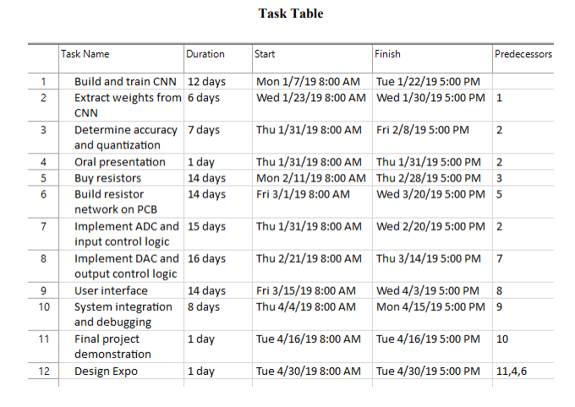

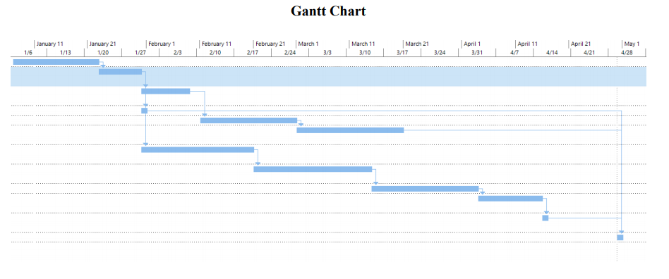

**Appendix B - Detailed Task Table**

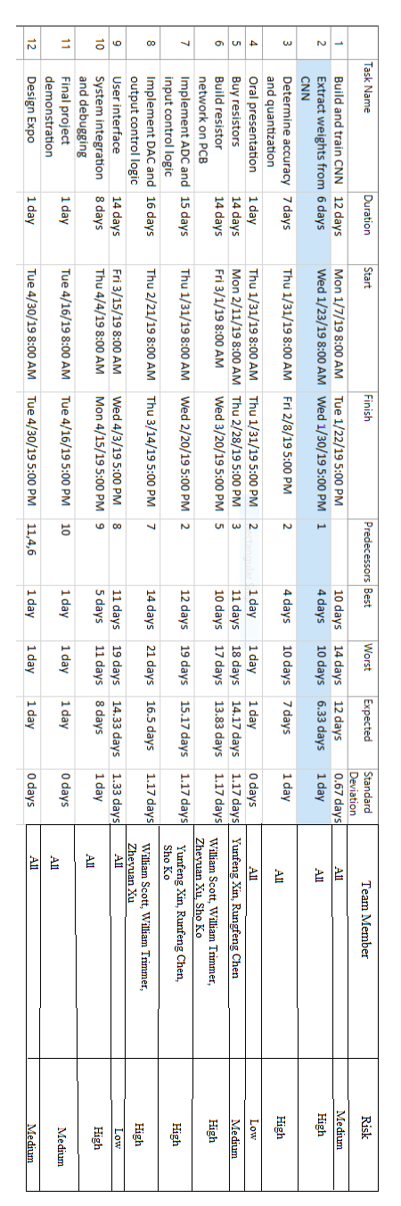

**Appendix C - Project Pert Chart**

