How to debug/Run application in Eclispe?

1. Create a Java Application in Eclipse.

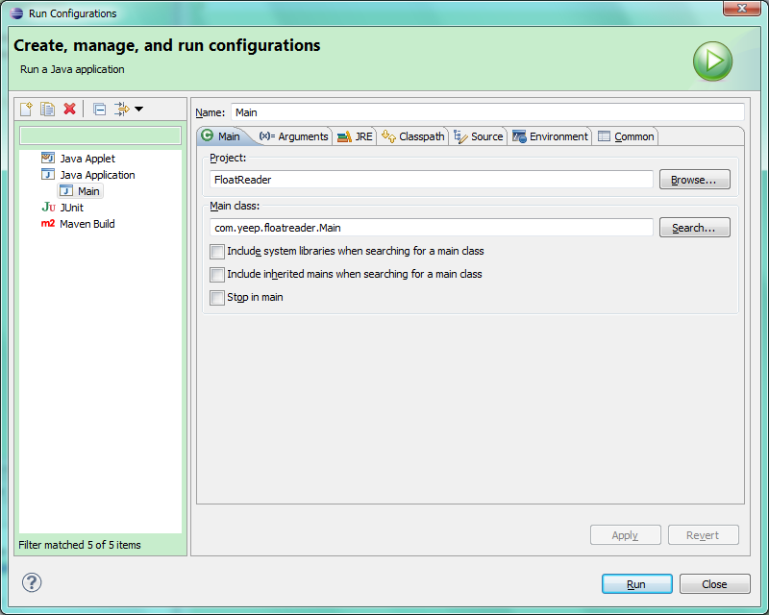

1. Set Arguments.

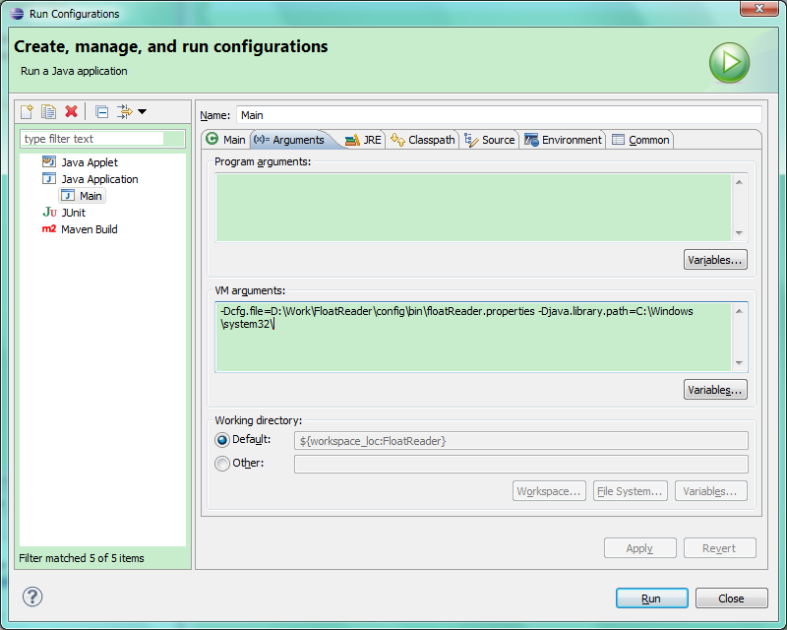

-Dcfg.file=D:\Work\FloatReader\config\bin\floatReader.properties -Djava.library.path=C:\Windows\system32\

To specify the properties file and .dll directory.