13. Develop a system using UML for BPO Management System. The system should hold the details of the customer and all approaches to it. It is managed by the central system.

Class diagram:

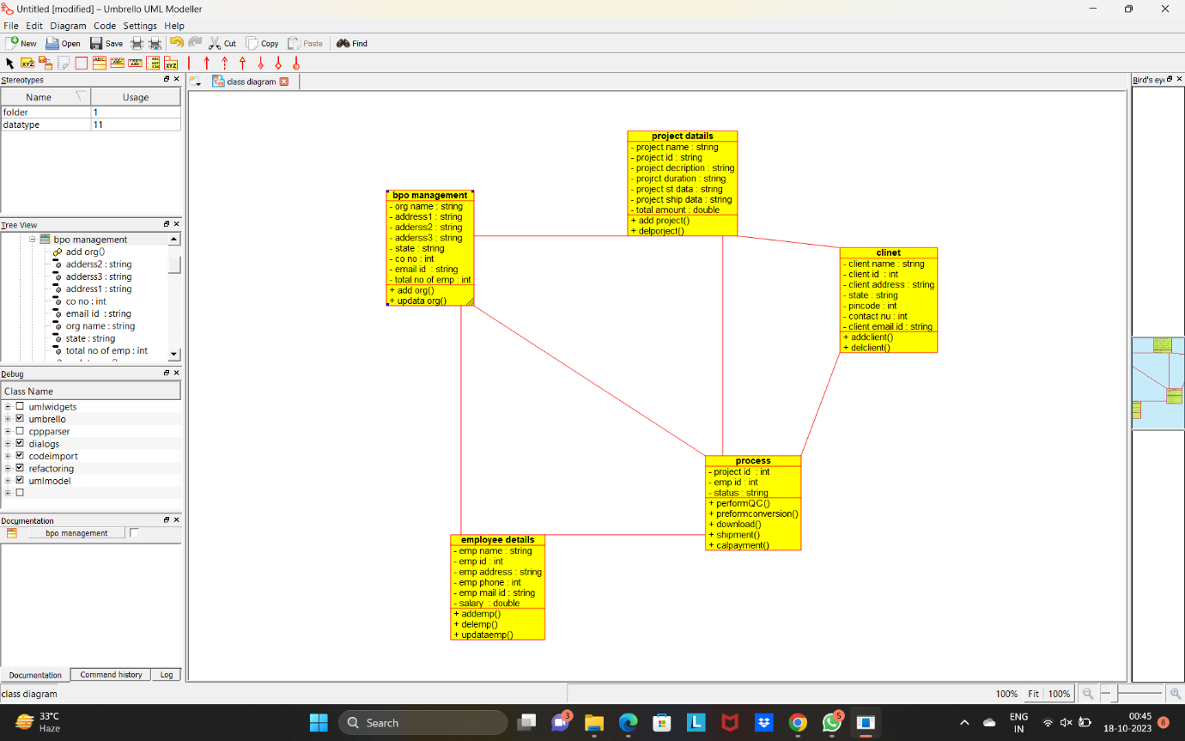

Use case diagram:

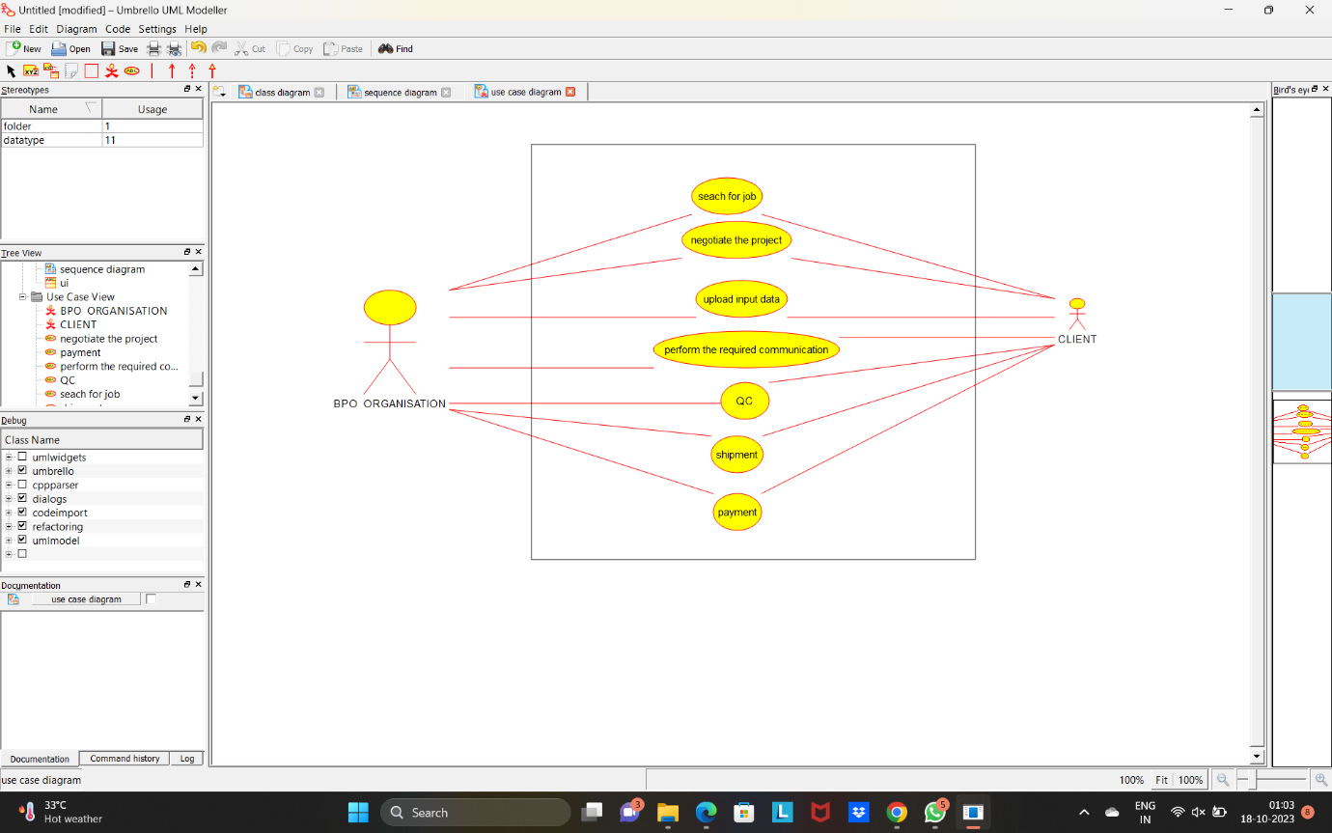

Sequence diagram:

