14. Develop a system using UML for E-Commerce Registration System, to add customers. Then a catalog should be produced for the customer to add items to the cart. The return system should be included, to allow customers to return items within a specific time.

Class diagram:

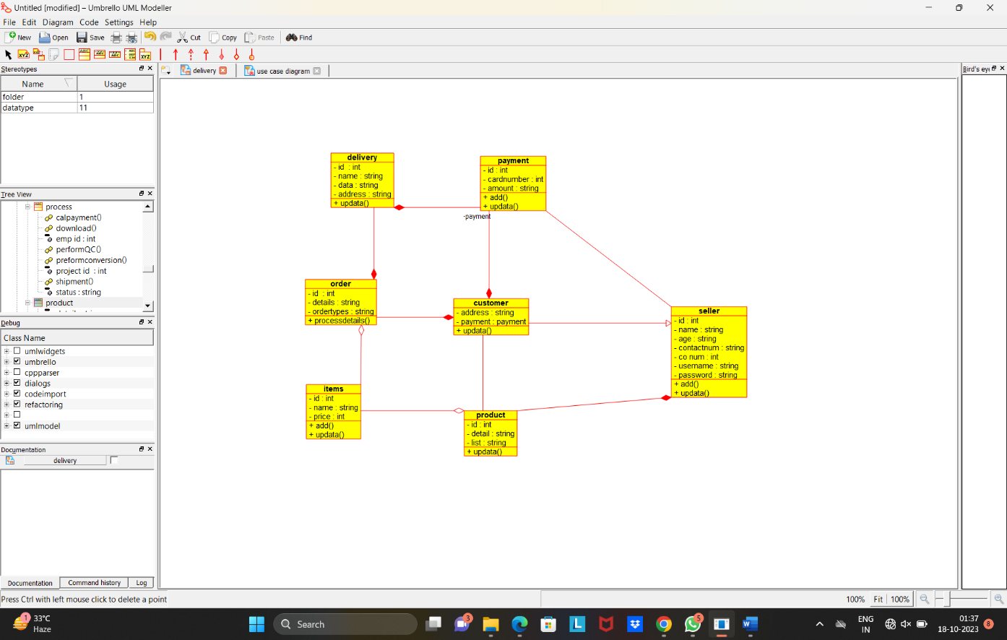

Use case diagram:

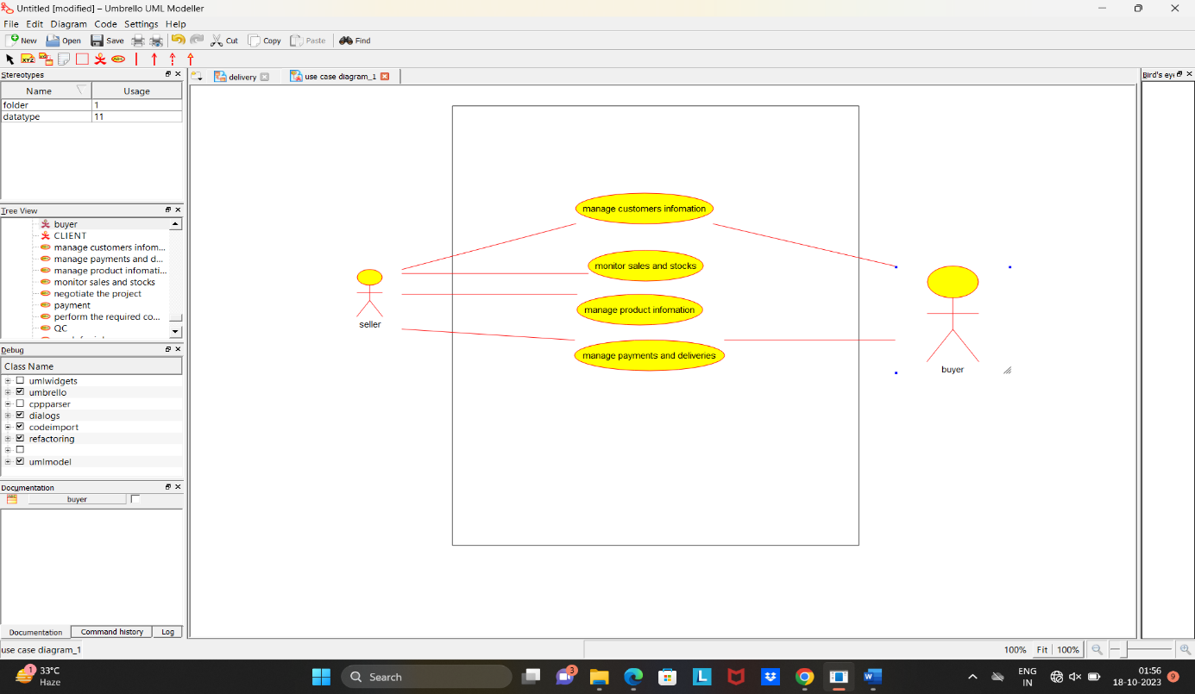

Activity diagram:

